|  |  |  |  |  |  |
| --- | --- | --- | --- | --- | --- |
| **Allocation of Platelets, Thawed Plasma or Cryoprecipitate** | | | | | |
| **Purpose** | This procedure provides instructions for allocation of platelets, thawed plasma or cryoprecipitate. | | | | |
| **Policy Statements** | Platelets, thawed plasma or cryoprecipitate may be selected and allocated based on Children’s historic blood bank records. | | | | |
| **Test Codes** | TPLT [Platelet Transfusion](http://www.childrensmn.org/Manuals/Lab/TransfusionSvc/018812.asp)  TFFP [FFP/FP (Thawed Plasma) Transfusion](http://www.childrensmn.org/Manuals/Lab/TransfusionSvc/018738.asp)  TCRY[Cryoprecipitate Transfusion](http://www.childrensmn.org/Manuals/Lab/TransfusionSvc/018717.asp) | | | | |
| **Procedure** |  | | | | |
|  | **Step** | Action | | | |
|  | 1 | Log into the Gateway.  Choose Location: R for Mpls, SP for STP | | | |
|  | 2 | Under the All tab or the Blood Bank tab, double-click on the Blood Order Processing folder. | | | |
|  | 3 | In the Lookup by box, select lookup by Patient ID, order Accession #, Patient Name or scan Container ID | | | |
|  | 4 | Enter or scan in the corresponding information and press Enter. | | | |
|  | 5 | Select the correct encounter (most St. Paul locations will have S at the end of the location) if entering by Patient ID or Name. | | | |
|  | 6 | Review the Patient Blood Bank record using the Information and Order Selection tabs:   * Record the ABO/RH, antibodies, attributes, problems, and pertinent comments on the patient’s order | | | |
|  | 7 | Click on the Order Selection tab if entering by Patient ID or Name and select the appropriate order to open the Blood Ordering Processing window. | | | |
|  | 8 | Click on the Allocation tab. | | | |
| To search for Directed Donor units:  *To find and select units assigned by patient ID*   * *In the Assigned by box, enter Patient ID.* * *In the units list, select the check boxes of the units to allocate, and then click Select.*   *To find units assigned by name*   * *In the Assigned by box, enter the Name.* * *In the Value box, type the patient’s name. Name searches are alphanumeric*   *In the units list, select the check boxes of the units to allocate, and then click Select*. | | | |
|  | 9 | Allocated units  a. In the Unit # box, scan or type the unit number  b. Scan the Supplier ID if prompted. Click OK.  c. In the Component box, select or scan the component type code as necessary.  d. In the Division # box, select the correct division as necessary  e. Click Select.    If a unit does not pass quality assurance checking, a quality assurance warning appears. Review unit selected and respond appropriately.  f. Repeat a-e for each additional unit | | | |
|  | 10 | Click in the TS test box for the first unit. | | | |
|  | 11 | Result the TS test box with one of the following:   * Transfusion Status OK, key ] * Transfusion Status NOT OK, key ) | | | |
|  | 12 | Repeat steps 10-11 for each unit. | | | |
|  | 13 | Add Unit tag comments or unit additional testing as needed:   1. Click on the specific unit to a testing/comments, or click on the first unit      1. In the Additional Test unit(s) box, do one of the following:  |  |  | | --- | --- | | **To …** | **Do this …** | | Add a test using the keyboard  E.g. Unit Tag Comments (key +) | • Press the key that is assigned to the test  • To look up the key, click Keyboard. | | Turn off the keyboard and add a test. | Type a semicolon (;). A visual indicator shows that keyboard mode is turned off.  In the test entry cell type a test code. | | Look up a blood bank  test code and add it | • Click or press F3. |  1. Select Add to a Selected unit or to Add to All units 2. Click in the test result field and enter the appropriate code or comment  * Press the key that is assigned to the result * Click Keyboard to look up a key * Type a semicolon (;) then:   + - * 1. Enter a defined code Eg. PRFI, HALF, THIRD         2. Enter a second semicolon then enter free text   comments up to 70 characters.   1. Press TAB to add another result under the same test result field or press Tab again to   complete the entry.   1. Result all test boxes for each unit.   **NOTE: All platelets that are ordered either a half or third apheresis will have unit tag comment HALF or THIRD added with half or third platelet volume written in. See Appendix A for examples.** | | | |
|  | 14 | Press Save when all units, associated tests and comments have been entered. | | | |
|  |  | | | | |
| **References** | Sunquest Users Manual, current edition. | | | | |
| **Approval**  **Workflow** | Transfusion Service/Technical Specialist | | | | |
|  |  | | | | |
| **Historical Record** | **Version** | | **Written/Revised by:** | **Effective Date:** | **Summary of Revisions** |
| 1 | | J Wenzel | 3/07/2007 | Initial Version combined TS 12.5. 12.6, 12.7 |
| 2 | | J Wenzel | 11/09/2009 | Online format |
| 3 | | J Wenzel | 4/16/2012 | Previous TS 12.3.  Added Division # selection relating to v6.4 |
|  | 4 | | S Cassidy | 09/15/2018 | Removed branching to Blood Product prep |
|  | 5 | | S Cassidy | 03/01/2022 | Added unit tag comment codes for half and third platelet orders. |

Appendix A:

Unit Tag Comment **HALF:**

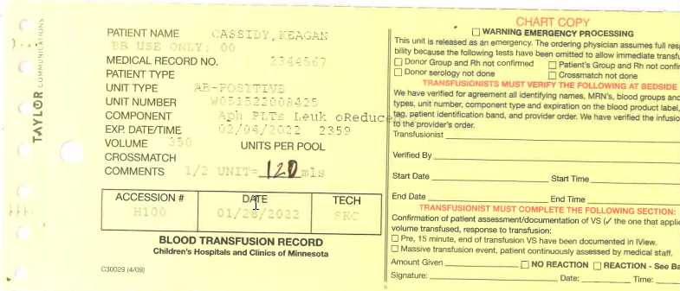

Unit Tag Comment **THIRD:**

