Temperature Monitoring

Purpose | This procedure provides instructions for daily temperature monitoring of laboratory equipment.
Policy Statements | Manual Temperature Monitoring:  Temperature regulated equipment must be checked daily, results recorded, and when appropriate, corrective action taken and documented.  If manual temperature monitoring is required, an appropriate thermometric standard device of known accuracy (certified to meet NIST Standards or traceable to NIST Standards) is available.  Thermometric standard devices must be recalibrated, recertified, or replaced prior to the date of expiration of the guarantee of calibration or they are subject to requirements for non-certified thermometers.  Thermometers should be periodically evaluated for damage (eg, separation of columns).  Thermometers with obvious damage must be rechecked for continued use.  All non-certified thermometers in use are checked against an appropriate thermometric standard device before initial use.  Automated Temperature Monitoring:  The use of automated (including remote) temperature monitoring systems is acceptable, providing that laboratory personnel have ongoing immediate access to temperature data, so that appropriate corrective action can be taken if a temperature is out of the acceptable range.  Records must demonstrate daily functionality of the monitoring system.  The Laboratory will be notified by phone when an alert occurs that needs to be addressed.
Entering Corrective Action | Step | Action | Related Document
 | 1 | Open Children’s Intranet, proceed with the following;  ● Click on Applications.  ● Scroll down to Smart Sense.  ● Log in with user name (CE number) and password, the following login’s are for each section of the lab;  Mpls;  User Name: bloodbankm  Password: Bloodbankm1!  User Name: labcorem  Password: Labcorem1!  User Name: microm  Password: Microm1!  User Name: histologym  Password: Histologym1!  User Name: sendoutsm  Password: Sendoutsm1!  St. Paul;  User Name: labsp  Password: Labsp21! | 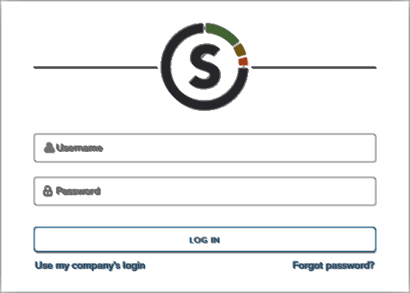
 | 2  3 | Undocumented corrective actions are found at the very top of the page. If there are no alerts you will see a green card, indicating that there are “No Active Severity Incidents.”  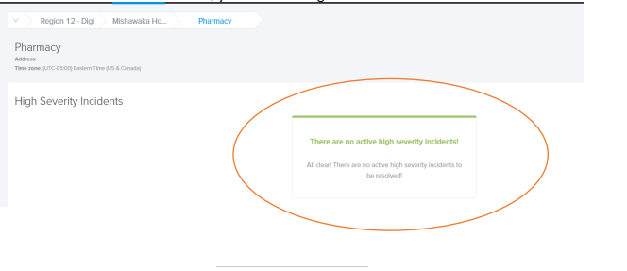  If there are actions to document, you will see the incident card listed with a red square. Select the red incident to document the corrective action.  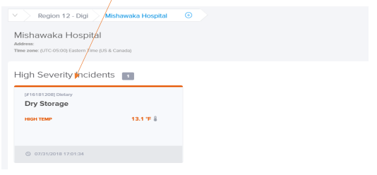  Click on the “Acknowledge” tab.  Once the pop-up appears select “Closed” from the blue drop down showing the word “New”. Then select Corrective Actions, enter the corrective action along with your tech number and save.  NEVER SELECT THE “HOLD” OPTION.  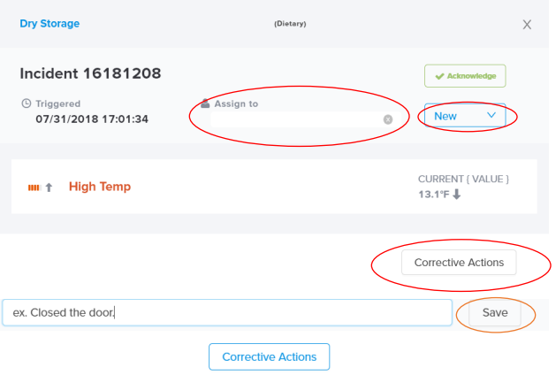
Hibernate (Maintenance Mode) | 1 | The Hibernate mode is not available to all staff.  Select the asset you wish to silence.  Select the Settings icon, then choose Maintenance Mode.  If you don’t see the Settings icon you do not have the ability to select the Hibernate mode.  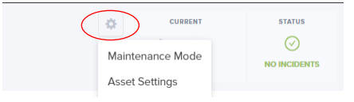
 | 2 | Choose the start date, end date and enter the reason you are hibernating.  Click DONE.  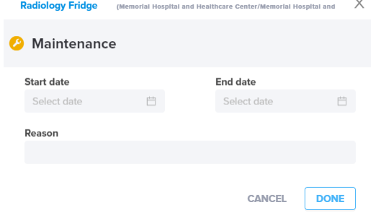
Daily Monitoring | 1 | Select Dashboard.  If there are no alerts you will see a green card, indicating that there are “No Active Severity Incidents.”  Assets can be displayed as either lists or cards;  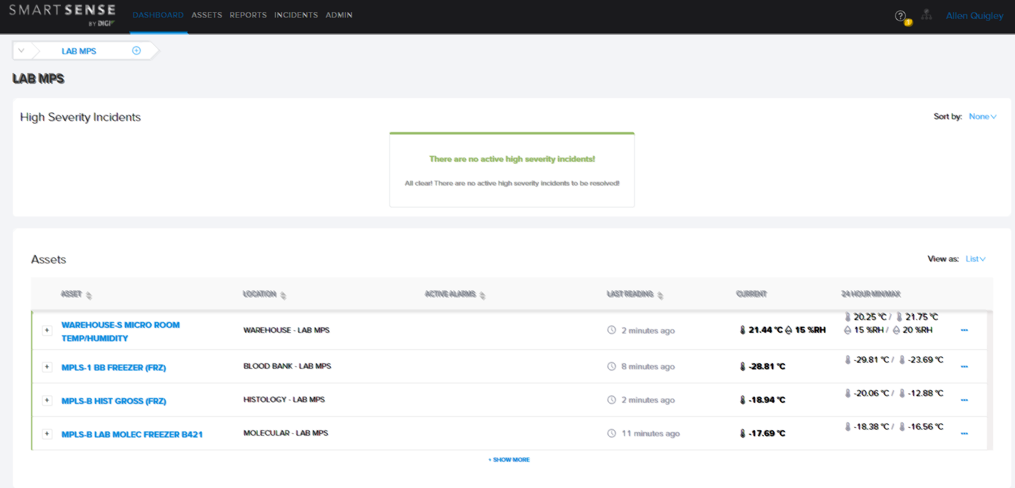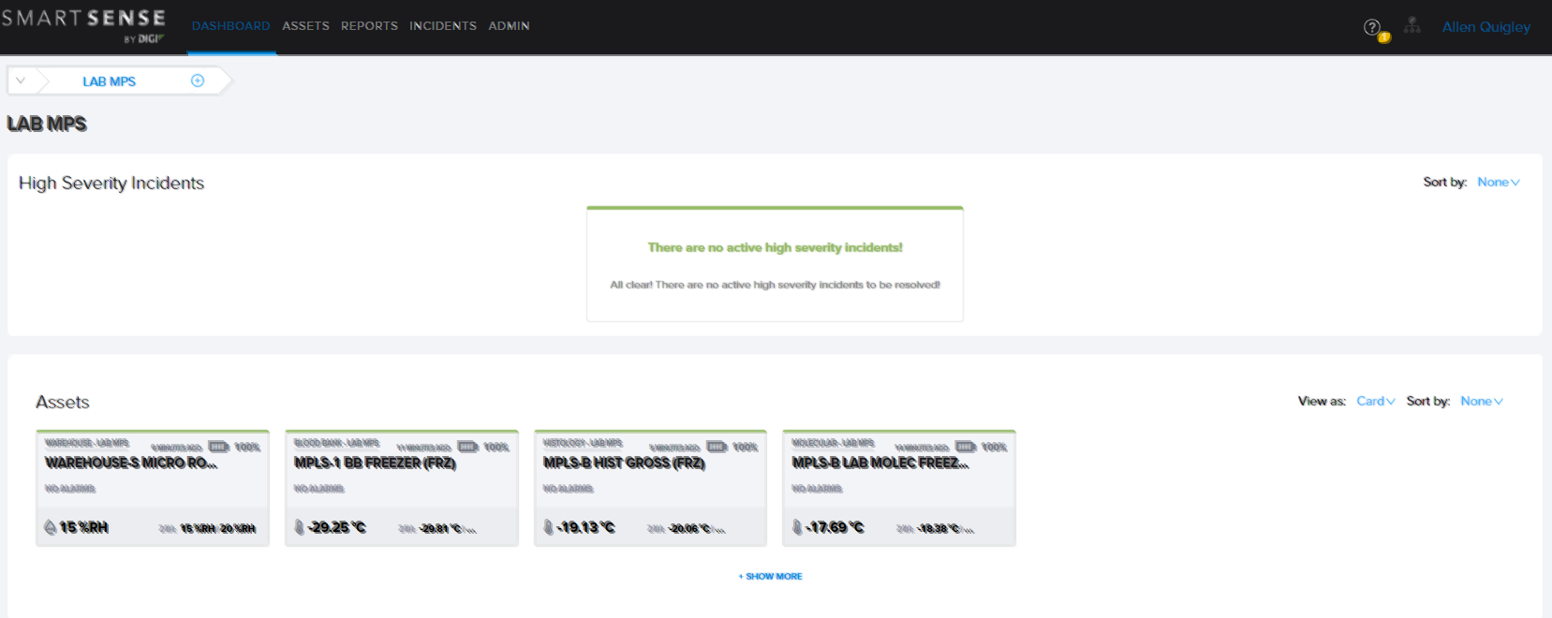  If there are alerts you will see a red card, indicating that there are “High Severity Incidents”. Multiple cards can be displayed if more than one asset is involved.  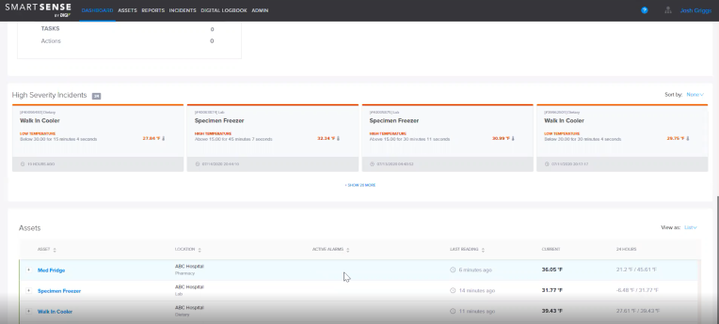
 | 2 | Select an asset to view asset history.  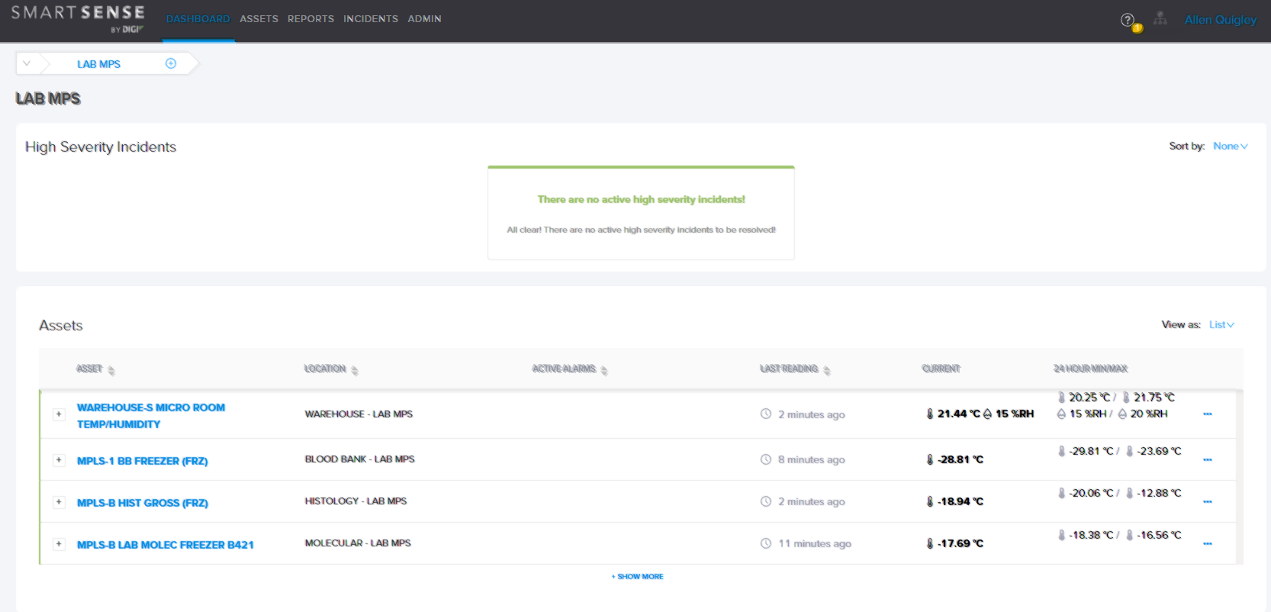
Monthly  Monitoring | 1 | Select a specific asset  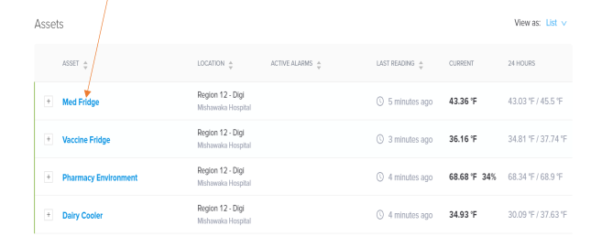
 | 2 | Select a date range by clicking on the calendar. Next select the export icon to generate a report. An excel file will down load to print or save.  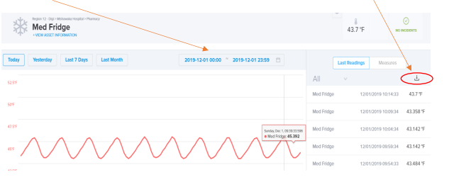
Printing  a Monthly  Graph | Step | Action | Related Document
 | 1 | Snip and Sketch or Snagit can be used to print a monthly graph.  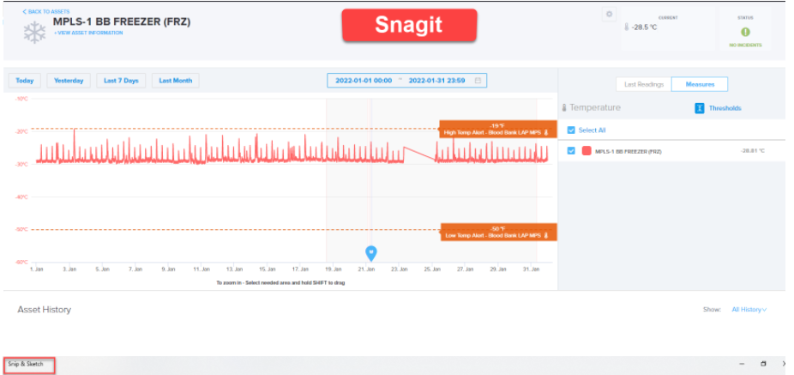
Printing  NIST Calibration Certifications | Step | Action | Related Document
 | 1 | Select the asset of choice.  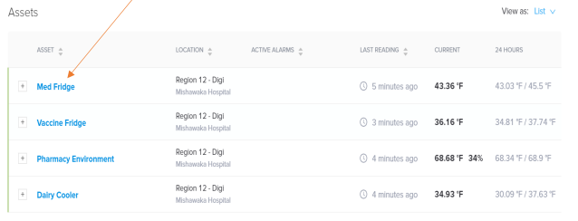
 | 2 | Scroll down until you see the Sensors section. Select the icon next to the calibration date. A PDF of the calibration certification will appear at the bottom of the screen to print or save.  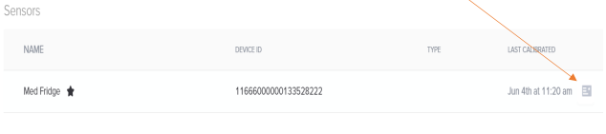
 | Step | Action | Related Document
Running  On-Demand Reports | 1 | Select Reports tab.  Select your desired report (Compliance Log is the suggested monthly report).  Enter all required information.  Select Generate at bottom right. A pdf report will then appear to print or save.  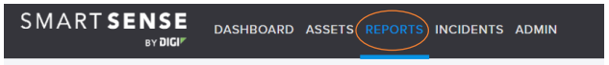  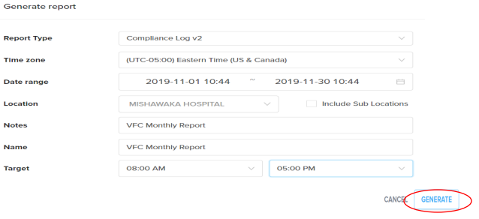
Additional notes;

Digi International Inc. has told us that the batteries on the Smart Sense units are good for 3-4 years. They will be changed by our Children’s Biomedical staff if necessary.

Any questions? Here is a link to additional manuals and instructional videos, along with Customer Support contact information.
https://helpcenter.smartsense.co/

Customer Support
digisolutionsupport@digi.com or 866-806-2653.

Real time temperature management
- SmartSense Quick Guide
- SmartSense Training Video
- VFC Checklist Guide

Historical Record | Version | Written/Revised by: | Effective Date: | Summary of Revisions
 | 1 | Al Quigley | 4/1/22 | Initial Version,  Smart Sense application

