Quality Control Review in Chemistry

Purpose | This procedure provides instructions for QUALITY CONTROL REVIEW IN CHEMISTRY. It describes the processes of submitting monthly Quality Control data or reviewing periodic or monthly Chemistry Quality Control.
Policy Statements | - This procedure applies to all chemistry personnel responsible for performing and/or reviewing quality control in chemistry.  - Quality Control data is generated daily on tests performed in the Chemistry Department.  - It is the responsibility of the daily operator to assure that Quality Control is performed, that assays are performing as expected, to take corrective action whenever required, and to respond to all QC exceptions.  - Blood Gas QC data is recorded on the Aqure portal  - All other QC data is recorded in Bio-Rad Unity Real Time Software, exceptions are presented to the operator for appropriate corrective comment, and this information is stored indefinitely.  - The Technical Specialist or designee reviews all QC data monthly. More frequent review is at the discretion of the laboratory. At Children's Minnesota, QC data is reviewed periodically in addition to the monthly review.  - QC data is retained for a minimum of two years.
Definitions | QC: refers to Quality Control, including the program, and the material used.  SD: refers to the standard deviation calculation, a measure of method accuracy.  CV: refers to the coefficient of variation, a measure of method precision.  SDI: refers to the standard deviation index, lab mean is compared to peer mean in SDs, measures bias.  CVR: refers to CV ratio, measures lab CV relative to peer group CV, or relative precision.
Materials
 | Records/Forms/Documents Required
- Radiometer reports
  - Radiometer LJ reports
  - Radiometer Uncertainty reports
- Biorad Unity Real-Time reports
  - Unity reports
  - Summary Data reports
  - Point Data reports
- Levy Jennings charts and/or individual QC point data, when necessary

Procedures: | Daily QC – Bench Review  - Enter QC results into Unity Real Time following method procedure(s).  - Do not report patient results until resolution of failed QC.  - Resolve QC issues by following basic troubleshooting steps listed below.  - If analytical error is detected, patient results reported since the most recent valid QC must be checked for clinical discrepancy.  - Repeat patient testing in reverse chronological order in batches of 2-5 samples.  - Repeat results should match +10%. If samples are unavailable, analyte is unstable, or more than 2 corrections need to be made, immediately consult with technical specialist or medical director for guidance.  - Once 2-5 consecutive sample repeats match, there is no need to go further back.  - Document investigation by printing/photocopying reported results along with repeat results and calculated differences as applicable. Deliver printed documentation to technical specialist for review & archival. Corrected results and result correction call backs will be recorded in Sunquest.  - Even if patient samples are no longer available, test results can be re-evaluated to search for evidence of an out-of-control condition that might have affected patient results. For example, evaluation could include comparison of patient means for the run in question to historical patient means, and/or review of selected patient results against previous results to see if there are consistent biases (all results higher or lower currently than previously) for the test(s) in question. Consult with technical specialist or medical director.  - Record QC problem follow-up by adding Actions to any QC data that prompt for a QC action, indicating results have exceeded laboratory defined tolerance limits.  - Describe follow up steps in detail with Comments if the available pre-determined Actions don’t fully describe the issue or follow—up steps.  Bench Review Basic Troubleshooting Steps  - Always review the Levy-Jennings chart first when QC fails. Systematic errors often become evident when the LJ chart is reviewed.  - Check the system for system errors or flags  - Rule out pre-analytical sources of error, such as:  - bubbles/short sampled QC material  - Wrong lot or level of QC material  - Expired QC material  - Improperly handled QC material (at RT for too long, or not mixed)  - Rule out post analytical sources of error, such as:  - Typos during manual entry  - Incorrect mapping between the analyzer and the QC software for auto-filed results  - Rule out Analytical sources of error, such as:  - Calibration curve issues  - The curve may have been established on an aged reagent and you are now using fresh reagent  - The calibrator may have been programmed with the wrong set-points  - The curve may have suffered from analytical imprecision due to poor mixing or bubbles, etc.  - The curve may have been established with a level or lot that wasn’t programmed correctly, or swapped levels, etc.  - Reagent issues  - Bubbles in the reagent  - Reagent that is intended to be mixed prior to use was not mixed  - Reagent was held out of temperature specifications  - Reagent was missing other defined requirements such as presence or a septum to prevent evaporation  - Reagent is expired  - Process path issues  - Attempt to rule out processes based upon which similar assays pass. For example if Alinity tests that utilize both R1 and R2 components are failing, but tests that only utilize an R1 component pass, begin by investigating the R2 pipettor and syringe  - Observe each component of the test system from the point of patient sampling, through reagent sampling, mixing, washing, reading, etc. for abnormalities such as leaking, alignment, vibrations, sounds, etc.  - Contact vendor service if unable to determine cause of error.  - Contact charge tech, section lead, or technical specialist for additional suggestions  - This is not an all-inclusive list  QC Supervisor Review  - In Unity Real Time, select Review > Supervisor Review.  - From the drop down menus, select the desired lab, instrument and lot of control  - Review data, actions, and comments for completeness  - Number and frequency of QC data should match procedure requirements.  - QC status (Accept/Reject box) should correlate with QC passing. Failed QC should not be accepted.  - Actions and Comments should be appropriate to the data failures they are attached to.  - Follow up to failures should be appropriate and match Actions and Comments. For example, failed QC with the Action “Test/Assay Repeated” should be followed by a new set of data points.  - Take note of apparent shifts, trends, high volume of failures, or very large Z scores (SDIs).  - Investigate and troubleshoot any abnormalities noted during review, especially those that have not been resolved as of the Supervisory review period.  - Document the QC review in Actions, and any investigation steps performed or corrective actions in the free text Comments field(s).  Note: Supervisor review of QC performed in any month must be completed within the first 5 days of the succeeding month in order for automatic transmission to Biorad. If this deadline is missed, complete supervisor review, then in URT, select Tools > Unity Interlab > Send/receive Data. A pop-up will appear. Check the box to send data to Biorad, then click Okay. Unity reports may be delayed.  QC Monthly Reports and Review  QC for all testing is reviewed monthly. Several different reports cover the different types of QC materials and test systems.  Radiometer blood gas instrumentation QC will be reviewed with Radiometer Uncertainty Reports or Radiometer LJ reports. All other instrumentation will be reviewed through Biorad Unity Reports, Summary Data Reports, or Point Data Reports. Reports are saved as pdf files and review notation taken within the pdf file by the notes function.  Radiometer LJ Reports (Aqure)  Radiometer LJ Reports are generated manually at the Aqure web portal.  Log into Aqure at 10.18.19.213/aqure. Once in the Aqure portal, go to the Inspection Ready Tab (1). In the Custom window, click on the option for Levy-Jennings Graph Report v2.2.0 (2).  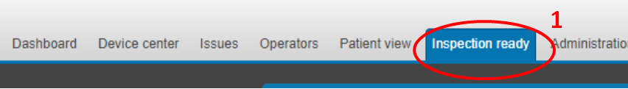  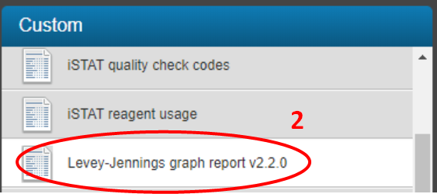  Use drop down Hospital and Device filters to select site specific instruments (3), also specify date range. Click View Report (4). Once the report is generated click the save file/export icon (5) and export as pdf.  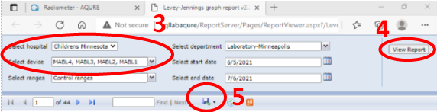  Save the resulting file in the designated G Drive folder for that month and year’s QC reviews (6). The file should be named “MMYYYY [Location] Radiometer LJ (7).  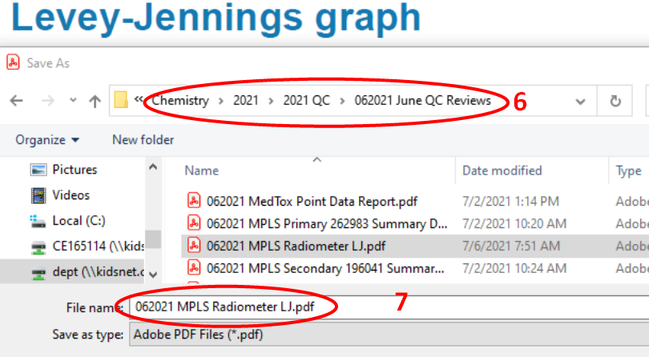  This report will list replacement and maintenance actions, as well as Levy-Jennings graphs for each analyte and level of QC. Review the replacement items list for excessive or missed replacement of solutions, sensors, etc. Review the LJ reports for QC violations. Utilize the Device Center (8) within Aqure to inspect specific data points as well as see patient testing (9) during specific time frames. Use adobe sticky notes to document review, investigation, and follow up for violations.  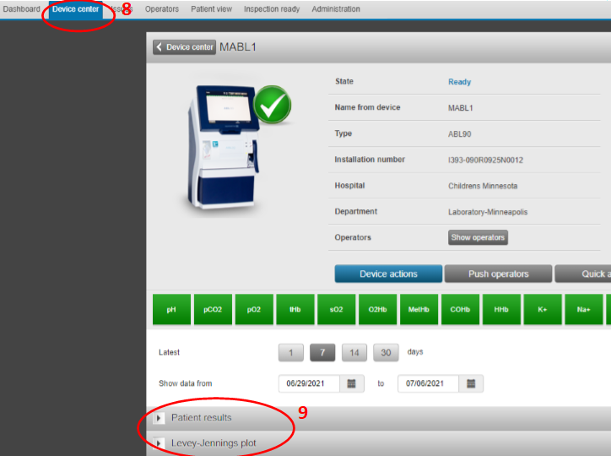  Radiometer Uncertainty of QC Measurements Reports  Radiometer Uncertainty Reports are generated manually at the Aqure web portal. Follow the same process to generate Radiometer Uncertainty Reports as for generating Radiometer LJ reports, but rather than selecting the menu option for LJ, select “Uncertainty of QC Measurement”. Filter for the previous month for each instrument, and save the resulting file in the designated G Drive folder for that month and year’s QC reviews. The file should be named “MMYYYY [Location] Radiometer Uncertainty Report”.  This report will list QC statistics including Means, CVs, SDs, and bias. Review the statistics for QC violations. Use adobe sticky notes to document review, investigation, and follow up for violations.  Biorad Point Data Reports  Biorad Point Data Reports are used to evaluate qualitative results, specifically MedTox drug screen data.  Open Unity Real Time software. In the left hand pane, select the “Instrument” tab. Expand any MedTox Instrument, and single click any assay (1). Once the assay is highlighted, go to the top menu bar and select Reports > General > Point Data Report (2).  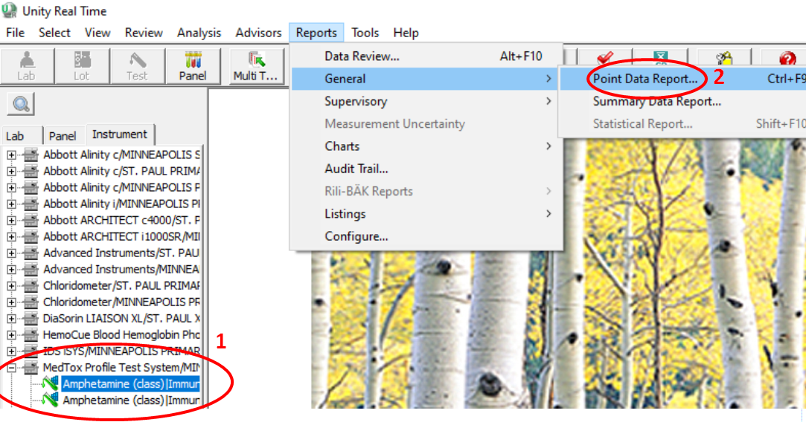  A pop-up will appear. Specify the time frame (3) as the month being reviewed. Use the radio button to select “Current Instrument” (4). This will actually create a report with all MedTox instruments. Click OK.  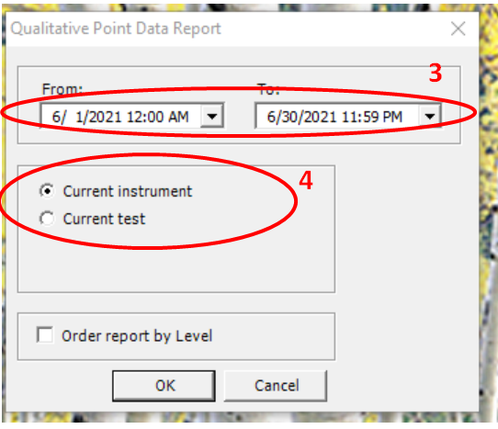  Save the resulting file in the designated G Drive folder for that month and year’s QC reviews (5). The file should be named “MMYYYY MedTox Point Data Report” (6). 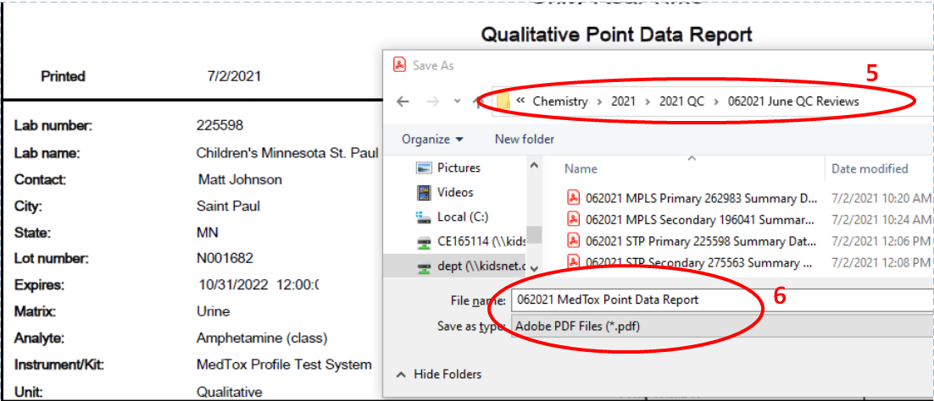  This report will contain a data point summary for qualitative results. This report will not contain statistics or data on quantitative assays.  Each page of the PDR will include analysis date range (7), instrument information (8), as well as information regarding the specific QC material, lot, and analyte summarized on that page (10).  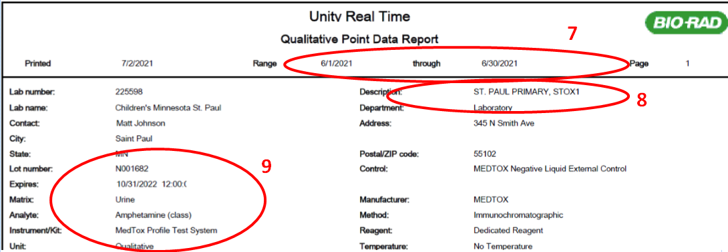  Each page will also include the point data summary for that specific lot and material (10). There should be one result weekly. Reported values should match the expected response (11).  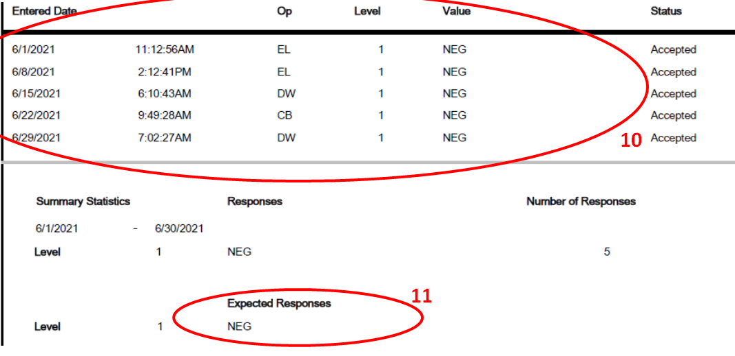  Use adobe sticky notes to document the review, investigation, and follow up for violations.  Biorad Summary Data Reports  Biorad Summary Data Reports are used to evaluate quantitative and semi-quantitative QC data for materials not manufactured by Biorad.  Open Unity Real Time software. In the left hand pane, select the “Lab” tab (1). Expand a Lab, expand a QC Material Lot, and single click any assay (2). Once the assay is highlighted, go to the top menu bar and select Reports > General > Summary Data Report (3).  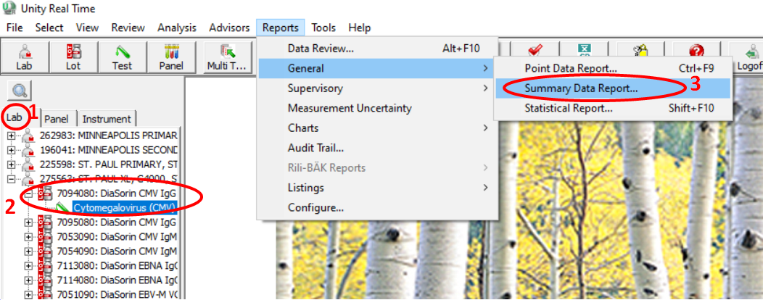  A pop-up will appear. Specify the time frame (4) as the month being reviewed. Use the radio button to select “Current Lab” (5). Click OK.  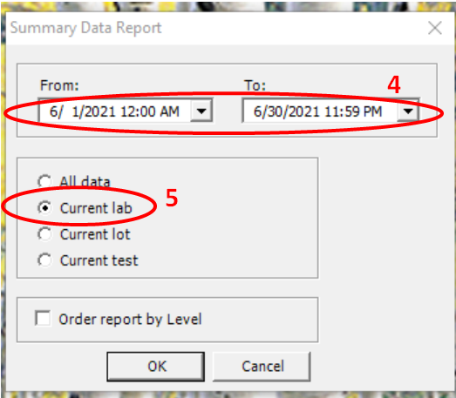  Save the resulting file in the designated G Drive folder for that month and year’s QC reviews (6). The file should be named “MMYYYY [Location] [Primary/Secondary] [Lab Number] Summary Data Report” (7). 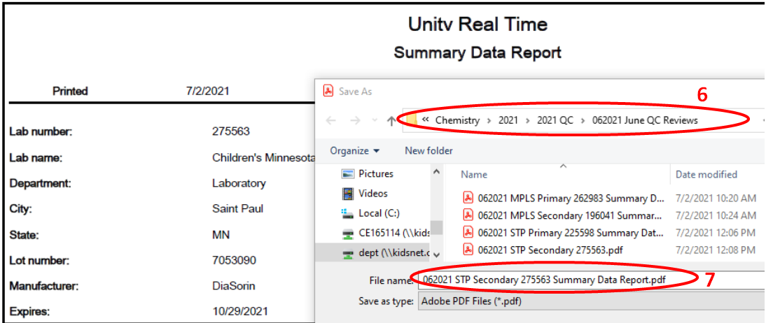  This report will contain summary statistics for both Biorad brand controls, as well as non-biorad controls. Biorad controls should be skipped over, as these will be reviewed on the Unity Data Report. This report will not contain qualitative control results (MedTox) or Radiometer (blood gas) quality controls.  Each page of the SDR will include analysis date range (8), laboratory information (9), as well as information regarding the specific QC material and lot summarized on that page (10).  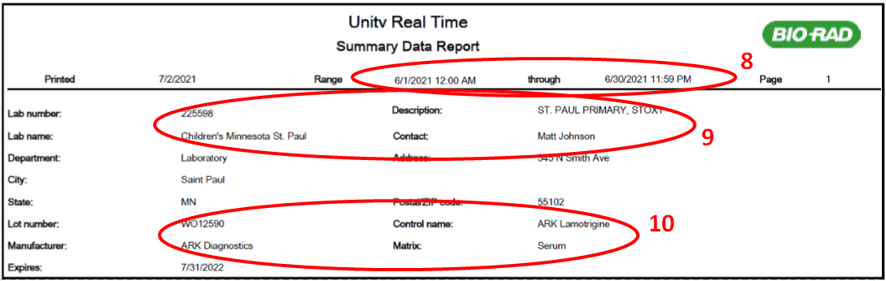  Each page will also include the summary statistics for that specific lot and material (11), and the target mean, SD, and CV (12). Summary mean should be within 1 fixed SD of the fixed mean. Summary SD and CV should not exceed fixed SD or CV for quantitative assays.  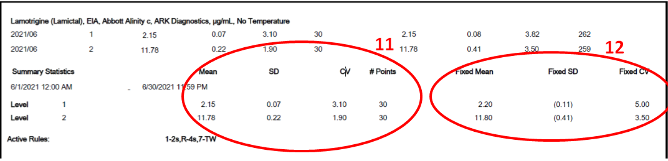  Use adobe sticky notes to document review, investigation, and follow up for violations.  Biorad Unity Reports  Biorad Unity Reports are generated automatically and available from Biorad online at QCnet.com, typically available for download between the 15th and 18th of the succeeding month. Biorad Unity Reports evaluate all Biorad manufactured QC material.  Log in to QCnet.com with username Chem1stry and password B1orad! or your personal log in information. Click the button for Unity Reports (1). Select options for your report (2). Select lab number, these correspond to the primary and secondary analyzers at each campus. For each report, also select the previous month, then select All for both Lot and Type drop down menus. The pdf will generate within the window.  Save the resulting file in the designated G Drive folder for that month and year’s QC reviews (3). The file should be named “MMYYYY [Location] [Primary/Secondary] [Lab Number] Unity Report”.  This document will be organized by lot number of each material. Each lot will include several sections:  - Monthly Evaluation – If lab data exceeds 2 SDI or 2 CVR it will be flagged in this section and will require investigation and/or follow up. If no data was submitted the lot will require notation such as “Lot no longer in use”, “Lot not yet in use”, or data may need to be re-sent to Unity Interlab within URT software.  - Laboratory Performance Overview – This section provides SD and CV comparisons to peer and method groups in easy to read graphs.  - Laboratory Comparison Report – This section provides SD and CV comparisons to peer and method groups in graphs and summary statistics tables.  - Laboratory Histogram – This provides a year’s summary of SD and CV comparison data in bar graph form.  - Statistical Profile – This section provides lab quarterly and yearly comparison data in several formats.  - Bias and Imprecision Histogram – This section provides bias and imprecision data for the past year.  Use adobe sticky notes to document the review, investigation, and follow up for violations. Flagged tests in the Monthly Evaluation section require investigation or follow up. Other sections are supplemental to aid in investigation and review, though it is recommended to review all available data to prevent future failure.

Interpretation/ Results/Critical Values | - QC data should be reviewed for failures, including trends or systematic error.  - Review for significant variations in actual mean or standard deviation, and appropriate action comments.  - Refer unresolved QC failures, and inappropriate QC action comments to the Technical Specialist or the Medical Director.
Limitations | In some cases, large CVs are expected. Record Supervisory review directly in Action comments under each test system. The Actions and Comments By Instrument function may be used to facilitate recording this information. See the Unity Real Time General User procedure for details.
References | - College of American Pathologists, Chemistry and Toxicology Checklist, August 2018  - Westgard, James O, Basic QC Practices, 2nd Edition, 2002
Historical Record
 | Version |  | Written/Revised by: | Effective Date: | Summary of Revisions
 |  |  | L. Lichty | 9/2003 | Initial Version
 |  |  | L. Lichty | 6/2005 | Revised
 |  |  | L. Lichty | 8/2007 | QC Review, modified for Biorad QC
 |  |  | D. Helfinstine | April 1, 2011 | New format, renumbered from CH 0.22
 |  |  | L. Lichty | August 25, 2014 | Updated, minor revisions.
 |  |  | Erin Bartos | June 1 2017 | Updated, minor revisions
 |  |  | Erin Bartos | July 2, 2019 | Updated for Unity Real Time software
 |  |  | Erin Bartos | February 2, 2021 | Added Login information to print BioRad Unity Reports
 |  |  | Matt Johnson | 9/14/2021 | Added and revised sections on monthly report generation and review. Reformatted document order from Daily to Supervisor to Monthly review.
 |  |  | Matt Johnson | 4/1/2022 | Radiometer WDC reports removed due to discontinued service, replace with Aqure report “Uncertainty of QC Measurment”. Also added basic troubleshooting steps under Bench review section.
 |  |  | Matt Johnson | 4/8/2022 | Revised section on QC corrective action for analytical error.

