Isohemagglutination Titer

Purpose | This procedure provides instructions for determining the amount of IgM and IgG Anti-A and/or Anti-B present in a patient's serum. Isohemagglutination Titer
Policy Statements | - The test is inappropriate for patients less than 4 months of age, and may be inconclusive for patients less than 12 months old. Normal individuals may not reach full antibody titer until 5 years of age.  - Isohemagglutination titers will be performed on patient’s that are going to receive an ABO incompatible heart transplant regardless of age.  - Testing performed on Minneapolis campus only.
Test Codes | TIA (key F) = Titer of Anti-A  TITB (key D) = Titer of Anti-B  TA15 (key u) =Titer of Anti-A 15 minute incubation  TB15 (key v) = Titer of Anti-B 15 minute incubation  TAAH (key m)=Anti-A Titer AHG  TBAH (key o)=Anti-B Titer AHG  CTIA=Credit of Anti-A titer  CTIB=Credit of Anti-B titer
Related  Documents | TS 4.8 Grading and interpretation of tube reactions
Materials | Equipment |  |  |  | Reagents |  |  | Supplies
 | - Centrifuge  - Pipettes (50μl and 100μl)  - Optical aid |  |  |  | - Biotestcell A₁ and B |  |  | - 10 x 75 test tube  - Normal saline  - IgG Gel Cards
Sample | No special preparation of the patient is required prior to specimen collection. Blood should be collected and labeled according to approved policies and procedures. Collection of Patient Specimens  EDTA or clotted specimen should be tested within 10 days and stored at 2-8°C.
Quality Control | Reagents must be evaluated each day of use with appropriate controls. Refer to TS 18.2 Daily Reagent Quality Control
Before  You Begin | 1. Perform an ABO grouping and Rh typing on the patient specimen.  Testing is not required on group AB patients or Group O, A, or B patient that do not demonstrate a  backtype reaction at immediate spin Only for test ABTI.. See Interpretation section.
Procedure
 | Step |  | Action
Test ABTI | 1 |  | Determine titer(s) to be done:  If Then  Patient's ABO is O titer Anti-A and Anti-B.  Patient's ABO is A titer Anti-B.  Patient's ABO is B titer Anti-A.  Patient's ABO is AB No titers to be done.
 | 2 |  | Label ten 10x75 test tubes for each titer to be done.  PI PI PI PI PI PI PI PI PI PI  1 2 4 8 16 32 64 128 256 512  U U U U U U U U U U  Replace PI with the patient's initials. Indicate A₁ or B cells.
 | 3 |  | Deliver 0.1ml of saline into all tubes except for the first tube (1:1).
 | 4 |  | Deliver 0.1ml of patient’s serum/plasma into tubes labeled 1:1 and 1:2 using a clean pipette tip.
 | 5 |  | Using a clean pipette tip, mix the contents in the 1:2 tube 5 times.
 | 6 |  | Transfer 0.1ml of the dilution from the 1:2 tube to the 1:4 tube.
 | 7 |  | Using a clean pipette tip, mix the contents in the 1:4 tube 5 times.
 | 8 |  | Transfer 0.1ml of the dilution from the 1:4 tube to the 1:8 tube.
 | 9 |  | Continue this process for each remaining tube using a clean tip each time.
 | 10 |  | Remove 0.1ml of diluted plasma/serum from the final tube (1:512) and save in another labeled tube in case additional dilutions are required.
 | 11 |  | Add 50μl of A₁ or B cells to each tube appropriate for the titer dependent on the patient’s ABO grouping.
 | 12 |  | Centrifuge for the appropriate time for saline reactions as indicated on the centrifuge.
 | 13 |  | Gently dislodge the red cell button from the 1:512 tube and observe macroscopically for agglutination.
 | 14 |  | Continue reading each tube from 1:512 to 1:1.  Note: If >1+ reactions is noted in the 1:512 tube, additional dilutions are required.
 | 15 |  | Record reactions and interpretation.
 | 1 |  | Perform an ABO grouping and Rh typing on the patient specimen regardless of patient’s age.
 | 2 |  | Determine titer(s) to be done:  If Then  Patient's ABO is O titer Anti-A and Anti-B :initial ,15 minute incubation and AHG  Patient's ABO is A titer Anti-B : initial , 15 minute incubation and AHG  Patient's ABO is B titer Anti-A : initial ,15 minute incubation and AHG  Patient's ABO is AB No titers to be done.
Test ABTIH  Initial and 15 minute incubation | 2 |  | Label ten 10x75 test tubes for each titer to be done.  PI PI PI PI PI PI PI PI PI PI  _{IN or}  ₁₅  1 2 4 8 16 32 64 128 256 512  U U U U U U U U U U  Replace PI with the patient's initials. Indicate A₁ or B cells and IN(initial spin) or 15 (15 Incubation).
 | 3 |  | Deliver 0.1ml of saline into all tubes except for the first tube (1:1).
 | 4 |  | Deliver 0.1ml of patient’s serum/plasma into tubes labeled 1:1 and 1:2 using a clean pipette tip.
 | 5 |  | Using a clean pipette tip, mix the contents in the 1:2 tube 5 times.
 | 6 |  | Transfer 0.1ml of the dilution from the 1:2 tube to the 1:4 tube.
 | 7 |  | Using a clean pipette tip, mix the contents in the 1:4 tube 5 times.
 | 8 |  | Transfer 0.1ml of the dilution from the 1:4 tube to the 1:8 tube.
 | 9 |  | Continue this process for each remaining tube using a clean tip each time.
 | 10 |  | Remove 0.1ml of diluted plasma/serum from the final tube (1:512) and save in another labeled tube in case additional dilutions are required.
 | 11 |  | Add 50μl of A₁ or B cells to each tube appropriate for the titer dependent on the patient’s ABO grouping.
 | 12 |  | Incubate room temp titers for 15 minutes and centrifuge after incubation and centrifuge initial spin titers right away.
 | 12 |  | Centrifuge titers for the appropriate time for saline reactions as indicated on the centrifuge.
 | 13 |  | Gently dislodge the red cell button from the 1:512 tube and observe macroscopically for agglutination.
 | 14 |  | Continue reading each tube from 1:512 to 1:1.  Note: If >1+ reactions is noted in the 1:512 tube, additional dilutions are required.
 | 15 |  | Record reactions and interpretation.
AHG Titer | 1 |  | Label 12 x 75 tubes 2 through 512.  PI PI PI PI PI PI PI PI PI  2 4 8 16 32 64 128 256 512  U U U U U U U U U
 | 2 |  | Deliver 0.1ml of saline into all tubes
 | 3 |  | Deliver 0.1ml of patient’s serum/plasma into tube 1:2 using a clean pipette tip.
 | 4 |  | Using a clean pipette tip, mix the contents in the 1:2 tube 5 times.
 | 5 |  | Transfer 0.1ml of the dilution from the 1:2 tube to the 1:4 tube.
 | 6 |  | Using a clean pipette tip, mix the contents in the 1:4 tube 5 times.
 | 7 |  | Transfer 0.1ml of the dilution from the 1:4 tube to the 1:8 tube.
 | 8 |  | Continue this process for each remaining tube using a clean tip each time.
 | 9 |  | Make a 0.8% dilution out of 3% A1 and/or B cells.  1. Pipette 300 μL of each 3% cell suspension into a separate labeled 12 x 75mm tube.  2. Add 15 drops of MTS Diluent 2 into each tube.  3. Centrifuge for one minute to pack the cells  4. Remove supernatant leaving a dry red cell button.  5. Dispense 700 μL of MTS Diluent 2 into each tube of packed red cells  6. Mix gently to resuspend the cell button.  7. Visually compare suspension with 0.8% Selectogen cells. Note:if the suspension is not correct, prepare a new red cells suspension starting with step 1….
 | 10 |  | Label IgG card  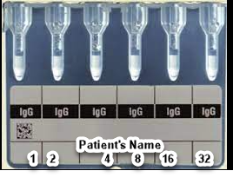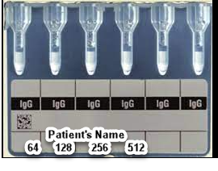
 | 11 |  | Dispense 50 μL of 0.8% reagent red cells to wells labeled 1 through 512.
 | 12 |  | Add 25 μL of patient serum or plasm to well 1 through 512.
 | 13 |  | Incubate anti-IgG cards for 15 minutes at 37°C.
 | 14 |  | Spin all card in the MTS centrifuge
 | 15 |  | Read and interpret and record results immediately after centrifugation
 | 16 |  | If titer is being performed while patient is surgery for heart transplant call the titer result to XXXXX
 | 17 |  | Freeze a labeled (1-2 mL) aliquot of serum or plasma upon completion of testing the -30 freezer on xx shelf. If there is not enough specimen to freezer add a blood bank comment under testing accession number.
Interpretation | Result the titer as the dilution value of the first tube that produces a 1+ macroscopic agglutination reaction. E.g. Result titer as DI32 for the reaction pattern illustrated below.  512 256 128 64 32 16 8 4 2 1  U U U U U U U U U U  0 0 0 w+ 1+ 1+ 2+ 3+ 3+ 4+ tube reaction  Group O, A, or B patient that do not demonstrate a backtype reaction at immediate spin:  - Enter a reaction result of NT for "Not Tested" for all tubes  - Enter interpretation as DI0  - Credit the resulted titers. CTIA for Anti-A and CTIB for Anti-B  Group AB patients:  - Enter a reaction result of NT for "Not Tested" for all tubes  - Enter interpretation as DI0  - Credit the resulted titers. CTIA for Anti-A and CTIB for Anti-B
Limitations | Individuals produce different titers of isohemagglutinin antibodies based on genetics and state of health. The typical range observed for anti-A is a titer of 32, while anti-B is 8. However, no reference range can be established since the clinical significance of the titer results are a function of the individual patient’s titer increasing or decreasing and should not be used in abstract.
Result Reporting

 | Step | Action
 | 1 | Enter Blood Order Processing by the patient sample accession number.
 | 2 | Click on the Patient Specimen tab.
 | 3 | Add the appropriate test for the titer(s) performed into the Add spec. test box, by entering a semi-colon and test code (TIA, TITB, TA15, or TB15) or by selecting the test from the keyboard.  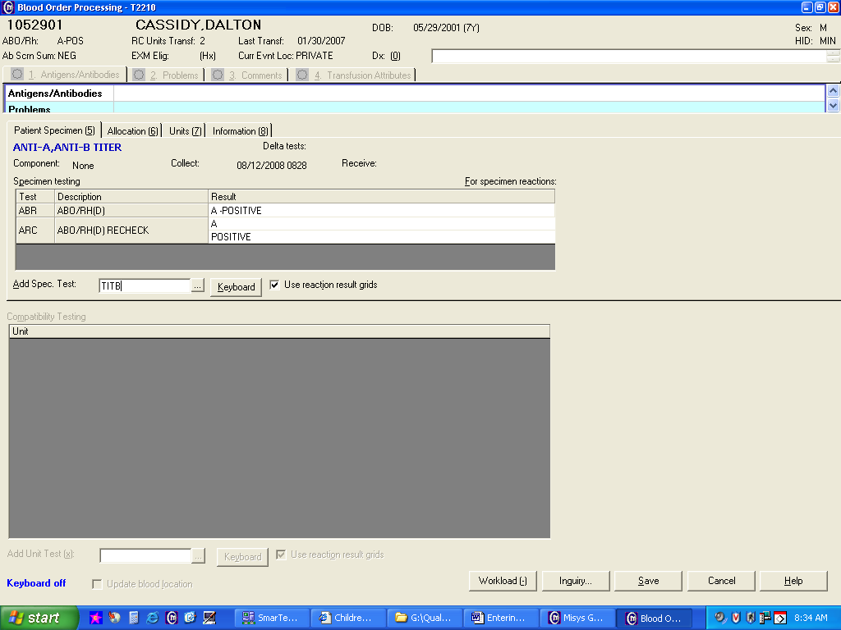
 | 4 | Press the “Home” key or click in the D512 cell in the result field.
 | 5 | Enter the graded agglutination for each dilution tube.
 | 6 | Click in the Interp. Cell and enter the interpretation of the titer.  - Enter a semi-colon  - Enter DI then the titer value of first tube showing 1+ agglutination. Example: ;DI32  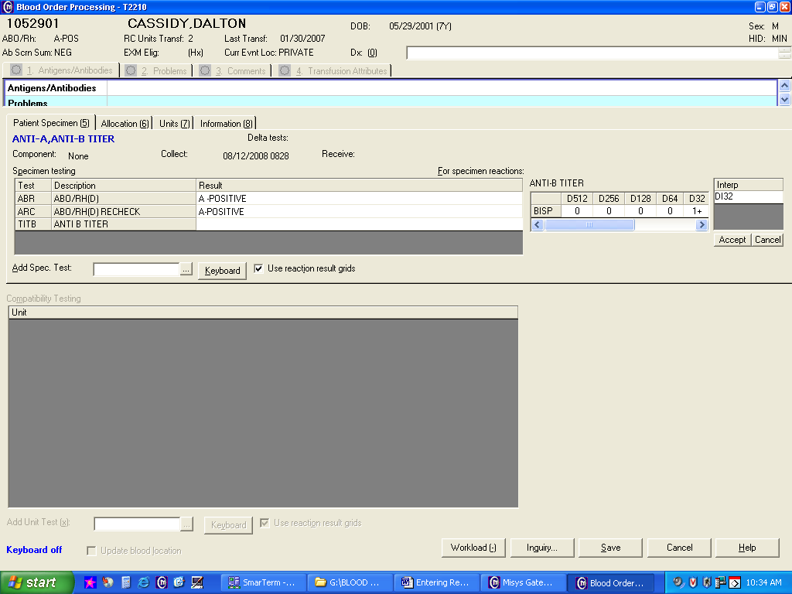
 | 7 | Press Tab twice to file results.
 | 8 | Repeat result entry procedure for the second titer if applicable.
 | 9 | Save results.  Note: Sunquest maintenance for test TIA, TITB, TA15, TB15, TAAH, and TBAH assumes the first tube with any positive reaction to be the dilution interpretation value. If the first positive tube shows only a w+ reaction a QA failure will result as the first tube with a 1+ reaction must be reported as the final interpretation. Respond to QA failure resulting from w+ reactions not corresponding to final end point by entering Reason code WRX-Weak reaction not used to determine titer.
References | Product Insert, Biotestcell A₁ and B, Bio-Rad Medical Diagnostics, current edition  AABB Technical Manual, current edition  Cambridge Biomedical Research Group. www.cambridgebiomedical.com/
Approval  Workflow | Transfusion Service/Laboratory Director
Historical Record | Version |  |  | Written/Revised by: |  | Effective Date: | Summary of Revisions
 | 1 |  |  | K. Hartley |  | 1978 | Initial Version
 | 2 |  |  | J. Wenzel |  | 8/1990
 | 3 |  |  | J. Wenzel |  | 5/1994 | Dec’d testing in 1995
 | 4 |  |  | J. Wenzel |  | 5/1997 | Reinstated in SOP
 | 5 |  |  | J. Wenzel |  | 9/1999
 | 6 |  |  | J. Wenzel |  | 7/24/2001 | New Format
 | 7 |  |  | S. Cassidy |  | 10/27/08 | New Format
 | 8 |  |  | J. Wenzel |  | 8/22/2011 | BioRad reagents  Added Result Reporting steps previously in TS 5.19  QA Reason code WRX
 | 9 |  |  | S. Cassidy |  | 3/15/2019 | Added steps for test ABTIH
 | 10 |  |  | S. Cassidy |  | 06/13/2022 | Added steps for AHG testing for ABTIH

