Quick Backtype-Heart Transplant

Purpose | This procedure provides instructions for the tube testing of patient ABO group antibodies to determine if a heart transplant patient needs to have a plasma apheresis before heart transplant surgery.
Policy Statements | - Testing the patient’s plasma/serum for expected antibodies with A₁ and B reagent  - Testing will be performed on all patients who are going to have an ABO incompatible heart transplant regardless of age.  - The patient should have a previous blood type on file.  - This is a STAT test.
Test Codes | BTHT
Materials | Equipment |  |  | Reagents |  |  | Supplies
 | - Centrifuge  - Agglutination Viewer |  |  | - Biotestcell A₁ and B |  |  | - 10 x 75 mm test tubes  - BB Pipettes  - Marker
Sample | Fresh patient samples of EDTA or clotted whole blood collected following general blood collection procedures are acceptable. See Collection of Patient Specimens.  The specimen should be tested as soon as possible after collection. If test is delayed, the EDTA or collated specimen should be stored at 2-6°C and may be tested within 10 days from collection.  Specimens exhibiting gross hemolysis or contamination should not be used.
Quality Control | Refer to TS 18.2 Performing Daily Reagents Quality Control  Reagents must be evaluated each day of use with appropriate controls.
Before  You Begin | - Confirm sample acceptability and review patient history per procedure  - Label tubes per TS 4.6 Labeling Tubes
Procedure
 | Step | Action
Backtype | 1 | Pipette 2 drops of the patient plasma/serum to the corresponding labelled tube.
 | 2 | Add 1 drop of reagent red cells to tubes to the corresponding labelled tube.
 | 3 | Mix all tubes.
 | 4 | Centrifuge for the posted optimal time in a calibrated serologic centrifuge
 | 5 | Remove the tubes from the centrifuge and confirm the tube ID with the request and on the computer screen or downtime worksheet
 | 6 | Gently resuspend the cell button and examine macroscopically for hemolysis and agglutination immediately after centrifuging.
 | 7 | Immediately record the grade reactions in the computer or on the downtime worksheet.
 | 8 | Call CVOR with result.
 | Step | Action
Entering results for Quick Backtype | 1 | Enter Blood Order Processing by the patient sample accession number.
 | 2 | Click on the Patient Specimen tab.  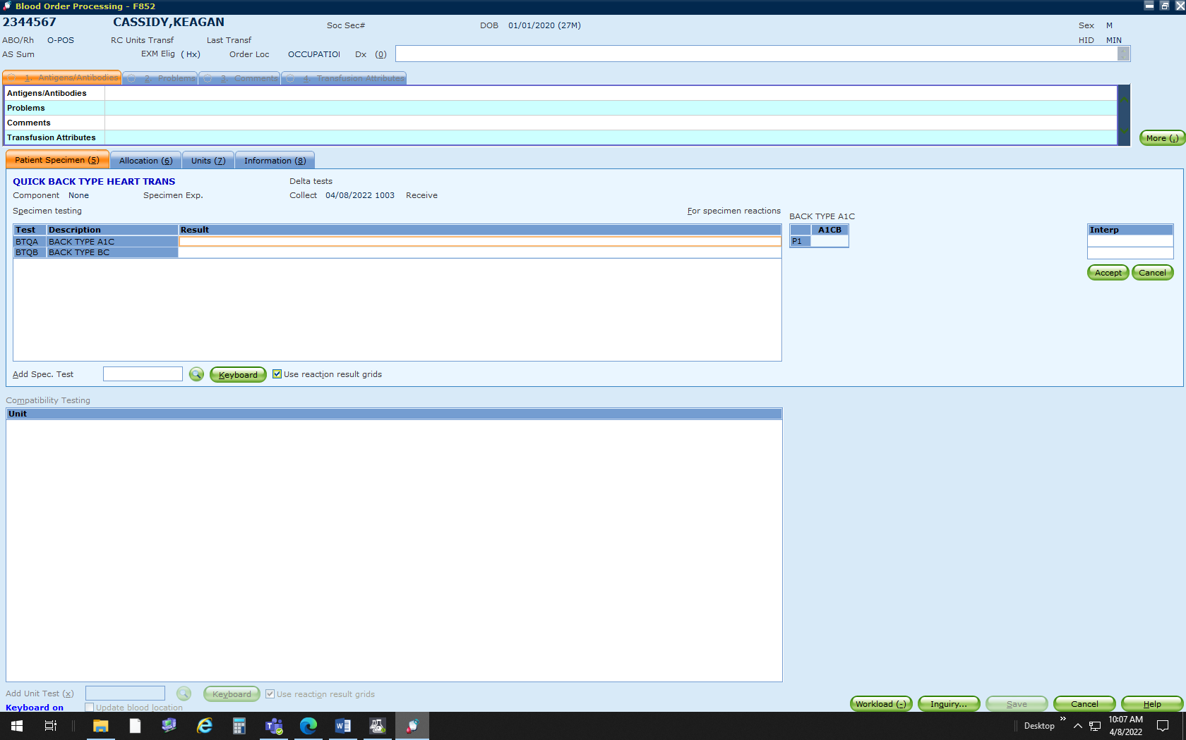
 | 3 | Enter the grading of the tube agglutination reading in the appropriate grid cell.  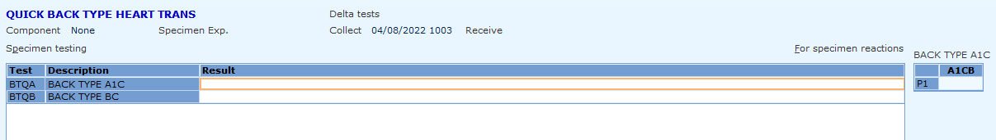  Grid Cells  BTQA=A₁C  BTQB= BC  You need to use these codes or you will get QA failures. These codes post reaction results as numbers in Cerner which is need for ABO incompatible transplants.  A1CB/BCB Grid Results  Keyboard Key Reaction  ! (P1) 1+  @ (P2) 2+  # (P3) 3+  $ (P4) 4+  ) (N0) 0
 | 4 | Record the backtype interpretations in the interpretation field according to the testing procedure.  Interpretations  P1BT 1+  P2BT 2+  P3BT 3+  P4BT 4+  N0BT 0  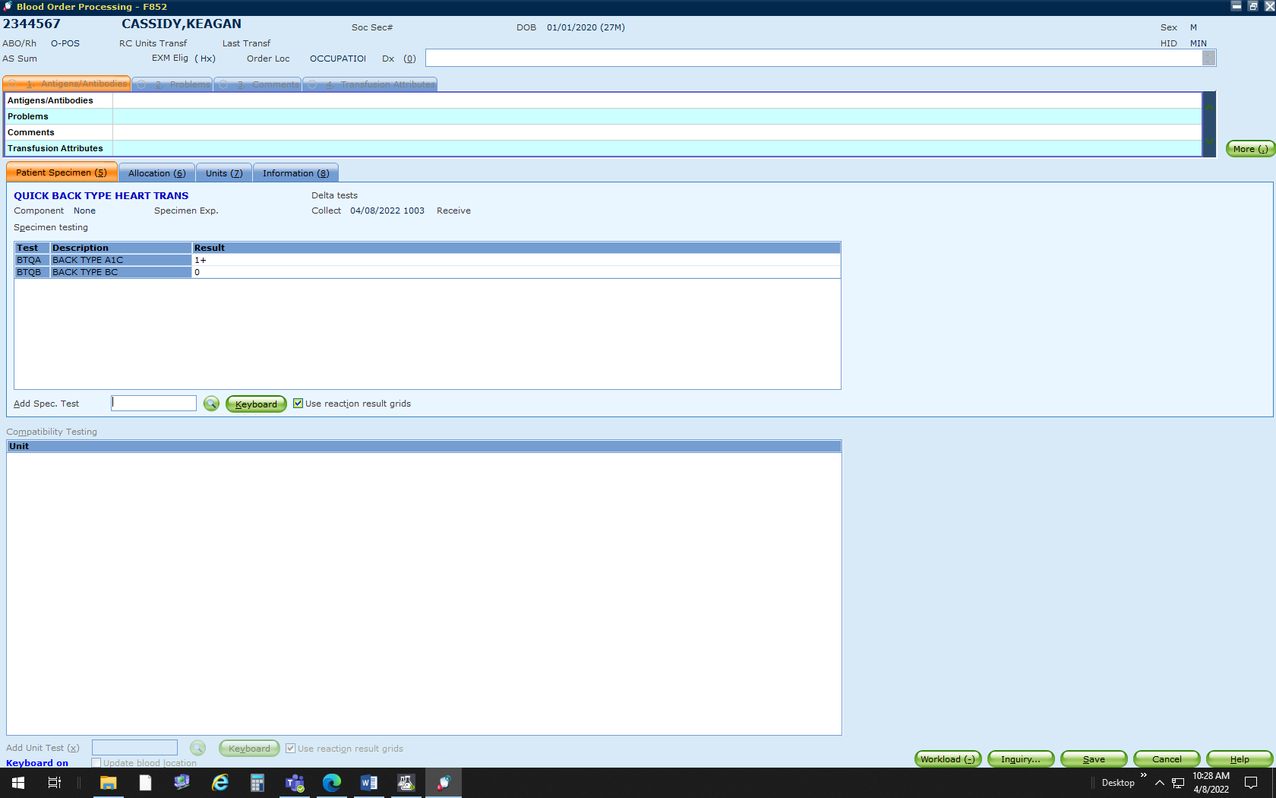
 | 5 | Review tube reaction results and interpretation entry if QA failures occurs.  If Then  An enter error was made Re-enter tube reading results and/or interpretation.  Entry confirmed - Acknowledge QA warnings. All QA failures have to be reviewed and responded by a second tech. - Respond to QA failures with a reason code or free text entry.
 | 6 | Save Results
Limitations | Tubes should be read immediately following centrifugation and delays may cause a dissociation of antigen-antibody complexes resulting in false negative or weak positive reactions.  Cold agglutinins, a positive direct antiglobulin test, or rouleaux may cause false positive reactions
References | - Product Insert, Biotestcell A₁ and B, Bio-Rad Medical Diagnostics, current edition  - AABB Standards, current edition
Approval  Workflow | Transfusion Service/Lab Director
Historical Record | Version |  | Written/Revised by: |  | Effective Date: | Summary of Revisions
 | 1 |  | S. Cassidy |  | 06/17/2022 | Initial Version

