GeneXpert CT/NG Assay

Purpose | This procedure provides instruction for performing the Xpert CT/NG assay on the Cepheid GeneXpert system.
Principal and Clinical Significance | This qualitative test is intended for use to detect Chlamydia trachomatis (CT) and Neisseria gonorrhoeae (NG) DNA to aid in the diagnosis of chlamydial and gonorrheal disease.^{[1]}  Chlamydia trachomatis are gram-negative bacteria that exist as obligate intracellular parasites. It is the one of the most prevalent sexually transmitted infections (STI). The CT species is comprised of at least 15 disease causing serovars; serovars D through K are the major cause of genital chlamydial infections. If left untreated, CT can cause non-gonococcal urethritis, epididymitis, proctitis, cervicitis, and acute salpingitis. Untreated disease in women can result in pelvic inflammatory disease (PID) and infertility (40% and 20%, respectively).^{[1, 2]}  Neisseria gonorrhoeae are gram-negative diplococcic that cause gonorrheal disease, which is the second most commonly reported bacterial STI. Males with a urethral NG infection typically produce symptoms that prompt them to seek treatment. Women often do not produce symptoms until further complications (e.g. PID) occur.^{[1, 2]}  The GeneXpert Instrument System automates and integrates sample purification, nucleic acid amplification, and detection of the target sequences using real-time PCR. The system requires the use of single-use disposable cartridges that hold the PCR regents and host the PCR process.^{[1, 3]}  The Xpert CT/NG Assay includes reagents for the 5’ exonuclease real-time PCR detection and differentiation of CT and NG. Reagents for the detection of a Sample Processing Control (SPC), a Sample Adequacy Control (SAC), and a Probe Check Control (PCC) are also included in the cartridge. The SPC is present to control for adequate processing of the target bacteria and to monitor the presence of inhibitors in the PCR reaction. The SAC reagents detect the presence of a single copy human gene and monitor whether the specimen contains human DNA. The PCC verifies reagent rehydration, PCR tube filling in the cartridge, probe integrity, and dye stability. The primers and probes in the Xpert CT/NG Assay detect chromosomal sequences in the bacteria. One target is detected for CT (CT1) and two different targets are detected for NG (NG2 and NG4). Both NG targets need to be positive for the Xpert CT/NG assay to give a positive NG result.^{[1, 3]}  The Xpert CT/NG Assay is designed for use with first-catch male and female voided urines, endocervical, vaginal, throat, conjunctival and anal/rectal specimens collected in specific Xpert Urine and Swab Specimen Collection Kits designed to preserve patient specimens to allow transport to the laboratory for analysis with Xpert CT/NG Assay and GeneXpert System.^{[1, 4, 5]}  The specimen is run by briefly vortexing the collection tube and transferring specimen to the sample chamber of the Xpert CT/NG cartridge using the supplied transfer pipette (filled to mark). The GeneXpert cartridge is loaded onto the GeneXpert System, which performs hands-off, automated sample processing, and real-time PCR for the detection of DNA in approximately 90 minutes.^{[1]}
Policy Statements | This procedure applies to Microbiologists who perform testing on the GeneXpert.
Test Code | CGPCR
Materials
 | Reagents |  | Supplies |  |  |  | Equipment
 | - Household bleach  - 70% ethanol |  | - Xpert Vaginal/Endocervical Specimen Collection Kit  - Xpert Urine Specimen Collection Kit  - Xpert CT/NG Assay cartridges  - Transfer pipettes  - Sample racks  - Cartridge transfer tray  - Gloves |  |  |  | - Biosafety Hood  - Cepheid GeneXpert Instrument and computer  - Printer
Specimen | - Acceptable specimens:  - First-catch male and female urine (NEAT or collected in Xpert Urine Specimen Collection Kit)  - Any of the following specimens collected with the Xpert Vaginal/Endocervical Specimen Collection Kit:  - Endocervical  - Vaginal  - Throat  - Anal/rectal  - Conjunctival  - SDES codes/Specimen type:  - UR- Urine, collect method not specified  - VOID- Voided urine  - VAG-Vagina  - ENDC-Endocervix  - THR - Throat  - RECT - Rectal  - ANAL – Anal  - CONJ - Conjunctival  - Specimen Collection and Transport:  - Refer to Lab Test Directory on StarNet  - Specimen assessment:  - Refer to the policy MCVI 2.1 Specimen Rejection Criteria.  - Specimen Storage  - First-catch male and female urine:  - Stability, NEAT:  - Room temp (2-28°C): 24 hours  - 4°C: 8 days  - Stability, in Cepheid Xpert Urine Transport Reagent (7mL):  - Room temp (2-28°C): 3 days  - 2-15°C: 45 days  - Transfer NEAT urines to Xpert Urine Transport Reagent as soon as possible after collection.  - Endocervical, vaginal, throat, and anal/rectal swabs collected with the Xpert Vaginal/Endocervical Specimen Collection Kit  - Stability in Xpert Swab Transport Reagent:  - 2-30°C: 60 days  - Conjunctival swabs collected with the Xpert Vaginal/Endocervical Specimen Collection Kit  - Stability in Xpert Swab Transport Reagent:  - 2-30°C: 7 days  - Specimens should be stored at 4-8°C (refrigerated)
Special Safety Precautions | Microbiologists are subject to occupational risks associated with specimen handling. Refer to the safety policies located in the safety section of the Microbiology Procedure Manual.  - Biohazard Containment  - Biohazardous Spills  - Safety in the Microbiology Laboratory
Storage | Store kits at 2-28°C. Kits are stable until the expiration date printed on the outer box.
Quality Control | Daily Quality Control:  Once an Xpert cartridge has been loaded and before the sample processing steps begin, the software checks the optics, the readiness of the module’s mechanical components, and the ambient temperature of the module to assure proper performance of PCR, and the physical integrity of the cartridge.  Each test includes a Sample Processing Control (SPC), a Sample Adequacy Control (SAC), and a Probe Check Control (PCC).  - SPC: Ensures the sample was correctly processed. It contains DNA from Bacillus globigii and verifies the sample processing and target amplification. The SPC verifies that binding and elution of target DNA have occurred if the organisms are present and verifies that sample processing is adequate. Additionally, this control detects sample-associated inhibition of the real-time PCR assay. The SPC should be positive in an analyte negative sample and can be negative OR positive in an analyte positive sample.  - SAC: Ensures that the sample contains human cells or human DNA. The SAC signal is only to be considered in an analyte negative sample. A negative SAC indicates that no human cells are present in the sample due to insufficient mixing of the sample or because of an inadequately taken sample.  - PCC: Performs a check on the amplification portion of the assay. Before the PCR reaction starts, the GeneXpert instrument measures the fluorescence signal from the probes to monitor bead rehydration, reaction-tube filling, probe integrity, and dye stability. Therefore, it controls for missing or incompletely hydrated beads of enzyme and target specific reagent. It also controls for the generated fluorescence which must meet internal acceptance criteria.  External Quality Control:  - Perform QC using external positive and negative controls every 30 days. Record results in the CGPCR and TVPCR Quality Control and Inventory Log.  - See IQCP document.  - See Quality Control Procedure.  New Lot/Shipment Quality control:  - Perform QC using external positive and negative controls with each new lot or shipment before putting into service. Record results in the CGPCR and TVPCR Quality Control and Inventory Log.  - See Quality Control Procedure  Wipe Testing control:  - Perform wipe testing every 30 days to monitor for contamination. Record results in the CGPCR and TVPCR Quality Control and Inventory Log.  - See Quality Control Procedure.  NOTE: External quality control may be performed on an as needed basis if certain circumstances arise. Examples include:  - Drift in results (e.g., increasing/decreasing positivity rates)  - Potential contamination (negative control)  - After drastic system maintenance
Procedure | Cartridge preparation:  - Clean hood with 10% bleach dilution (made daily) followed by 70% ethanol.  - Change gloves.  - Obtain one CT/NG Assay cartridge and one transfer pipette for each sample to be tested.  NOTE: Do not use cartridge if white precipitate is present, it appears wet or has leaked, the lid seal has been broken or the reaction tube has been damaged. Collect damaged cartridges so they can be credited back to our account. (See GeneXpert Maintenance procedure)  - Label the side of the cartridge with a bar-coded foot-label that contains container ID (CID).  - Open the cartridge lid.  - Vortex the sample for 10 seconds.  - Open the sample and draw up specimen into the transfer pipette until the upper fill mark is reached. (See Figure 1).  - Insert pipette to the bottom of the sample chamber of cartridge (see Figure 2) and empty the pipette’s contents into the cartridge.  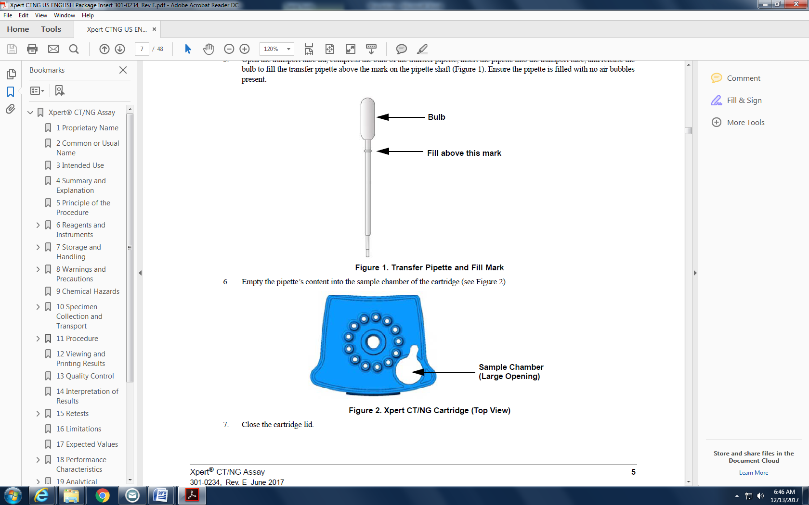  - Close the cartridge lid, and set onto the cartridge transfer tray.  - Change gloves and proceed to prepare additional samples or start the test.  NOTES:  -Hood surfaces must be cleaned between samples with 10% bleach dilution followed with 70% ethanol if there were any splashes, spills, or uncertainty of cleanliness.  -Start the test within 30 minutes of adding sample to the cartridge.  Starting the test:  - Ensure clean gloves are on before stepping to the computer work space.  - If instrument and computer are turned off, start up the instrument by flipping the power switch located in the back of the instrument. Turn on the computer next.  - Log onto the appropriate Windows account:  - User: Cepheid-Admin  - Password: cphd  - The GeneXpert software will launch automatically. If it doesn’t double-click the GeneXpert Dx software shortcut icon on the desktop.  - Log onto the software using own unique username and password.  - In the GeneXpert System window, click Create Test.  - When Scan Sample ID Barcode box appears, scan or manually enter Container ID (CID) from cartridge.  - When Scan Cartridge Barcode box appears, scan the barcode on the cartridge.  NOTE: if the barcode on the cartridge does not scan, then repeat the test with a new cartridge.  - Verify appropriate assay (Xpert CT-NG) is chosen under the Select Assay field.  - Enter specimen source under the Other Sample Type field.  - Enter additional information under the Notes field (day of QC, collect date, etc.) if needed.  - Click Start Test.  - Enter your username and password, if requested.  - Open the instrument module door with the blinking green light.  NOTE: when setting up for testing you may opt to use any available module.  - With the barcode facing towards you, set the cartridge into the module and close the door.  - Wait for the test to start and the light to stop blinking. The test will run for 90 minutes.  - Ensure printer is on.  - Once testing is complete (the light will be off and the system will release the door lock), remove the used cartridges and dispose of into a biohazard bag. Place biohazard bag into biohazard sharps bin.  - Clean any equipment used (pipettes, racks, transfer tray, etc.), hood, and counters (including keyboard, scanner, and mouse) at the end of the day.  NOTE: Sample processing, testing, and cleaning should follow a unidirectional work-flow to avoid contamination
Interpretation / Results | - Reports will print automatically after testing has been completed.  - If report doesn’t print, check that printer is on.  - To reprint reports: Click View Results from the top menu bar of the GeneXpert Dx software, select Report from the bottom menu bar, select report you want to print, click Preview PDF, and click printer icon to print.  - Place large patient label on results.  Results Interpretation:  - The results reported are interpreted automatically by the GeneXpert Instrument System.  - The Xpert CT/NG assay provides results based on the detection of the following gene targets:  - CT1 needs to be positive for the detection of CT (Chlamydia trachomatis).  - NG2 and NG4 both need to be positive for the detection of NG (Neisseria gonorrhoeae).  - Table 1 below lists all the possible final test results.  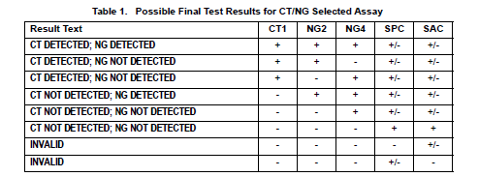  - Table 2 below lists possible results and interpretations.  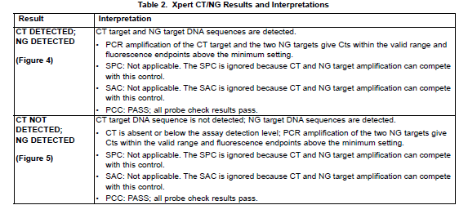  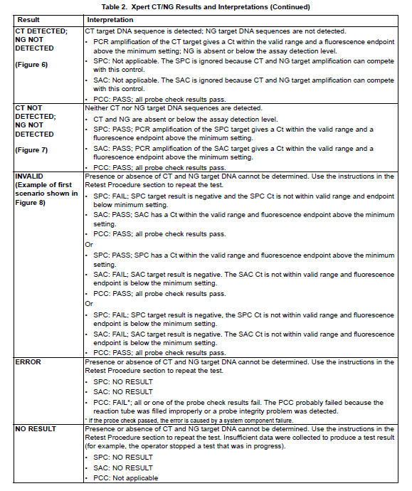  - Review reports for results of INVALID, ERROR or no RESULT and repeat testing if necessary.  Reasons to retest the original sample:  - An INVALID result (SPC and/or SAC fail). This may indicate:  - The sample was inadequate.  - The sample was not properly processed.  - PCR was inhibited.  - An ERROR result (PCC fail). This may indicate:  - The reaction tube was filled improperly.  - A reagent probe integrity problem was detected.  - The maximum pressure limit was exceeded.  - A valve positioning error was detected.  - A NO RESULT:  - This result indicated that insufficient data was collected (e.g. test stopped while in progress or power failure occurred).  NOTE: Record any failures, errors, and repeat testing in the “GeneXpert Maintenance and Problem Logs” binder.  Retesting procedure:  - Obtain the original sample and a new cartridge.  - Retest the sample according to the procedure in this SOP.  - Report results according to Table 3 below.  Table 3: Retesting results and interpretation  Initial result Repeat Result Report  INVALID INVALID Unresolved  VALID Valid results  ERROR ERROR or INVALID Unresolved  VALID Valid results  NO RESULT NO RESULT, ERROR or INVALID N/A- repeat testing  See the instructions below for reporting unresolved results.
Limitations | - With endocervical and patient-collected vaginal specimens, assay interference may be observed in the presence of: blood (>1% v/v) or mucin (>0.8% w/v).  - Because the detection of CT and NG is dependent on the DNA present in the sample, reliable results are dependent on proper sample collection, handling and storage.  - Erroneous test results might occur from improper specimen collection, technical error, or sample mix-up.  - False negative results may occur if the organism(s) is present at levels below the analytical limit of detection.  - With urine specimens, assay interference may be observed in the presence of: blood (>0.3% v/v), mucin (>0.2% w/v), bilirubin (>0.2 mg/mL), or Vagisil feminine powder (>0.2% w/v).  - The effects of other potential variables such as vaginal discharge, use of tampons, douching, and specimen collection variables have not been determined.  - A negative test result does not exclude the possibility of infection.  - The Xpert CT/NG Assay should not be used for the evaluation of suspected sexual abuse or for other medico-legal indications. Additional testing is recommended in any circumstance when false positive or false negative results could lead to adverse medical, social, or psychological consequences.  - The Xpert CT/NG Assay provides qualitative results. No correlation can be drawn between the magnitude of the Ct value and the number of cells in an infected sample.  - The predictive value of an assay depends on the prevalence of the disease in any particular population. Positive results in a low prevalence population should be evaluated carefully.  - The Xpert CT/NG Assay should not be used to monitor therapeutic success as residual target nucleic acid may persist for up to three weeks.  - Xpert CT/NG Assay performance has not been evaluated in patients less than 14 years of age. During validation testing a total of nine patients under the age of 14 had samples submitted for testing (6 urine, 2 vaginal, 1 conjunctival). All sample results were negative and in agreement with the comparator method, with the exception of one that was invalid. Due to a low frequency of testing this population and availability of resources, a more thorough evaluation was not possible.  - Xpert CT/NG Assay performance has not been evaluated in pregnant women, or in patients with a history of hysterectomy.  - The Xpert CT/NG Assay has not been validated for use with vaginal swab specimens collected by patients at home. The patient-collected vaginal swab specimen application is limited to healthcare facilities where support/counseling is available to explain procedures and precautions.  - The Xpert CT/NG Assay has not been evaluated with patients who are currently being treated with antimicrobial agents active against CT or NG.  - Collection and testing of urine specimens with the Xpert CT/NG test is not intended to replace cervical exams and endocervical sampling for diagnosis of urogenital infection. Other genitourinary tract infections can be caused by other infectious agents.  - Mutations or other changes within the regions of the bacterial genomes covered by the primers and/or probes in the Xpert assay may result in failure to detect the target organisms.  - Results from the Xpert CT/NG Assay should be interpreted in conjunction with other laboratory and clinical data available to the provider.^{[1]}  - The NG4 target appears to have some homology to sequences in some N. mucosa and N. subflava strains.^{[6]}
Method Performance Specifications | According to the manufacturer (per the package insert):  Female Swabs CT NG  Vaginal: Sensitivity 99.5% 100%  Vaginal: Specificity 99.1% 99.9%  Endocervical: Sensitivity 96.0% 100%  Endocervical: Specificity 99.6% >99.9%  Rectal Swabs  Sensitivity 86.0% 91.2%  Specificity 99.4% 99.6%  Throat Swabs  Sensitivity 95.9% 94.7%  Specificity 99.7% 98.8%  Urine  Female: Sensitivity 98.1% 94.4%  Female: Specificity 99.8% >99.9%  Male: Sensitivity 98.5% 98.3%  Male: Specificity 99.8% 99.9%  The LODs were determined by using two serovars of CT and two strains of NG. Testing was performed on patient collected vaginal swabs and male urines.  CT Serovar (eb/mL) D CT Serovar (eb/mL) H NG Strain (cfu/mL) #19424 NG Strain (cfu/mL) #49226  Vaginal swab 84 161 1.5 1.6  Urine 75 134 2.7 1.2  Rectal swab 88 161 4.9 5.3  Throat Swab 161 225 7.1 6.4  Conjunctival Performance Specifications based on in-house validation:  CT NG  Positive % Agreement (95% CI) 100% (73.54 – 100.0%) 100% (71.51 – 100.0%  Negative % Agreement (85% CI) 100% (76.84 – 100.0% 100% (78.20 – 100.0%)  LOD 300 cp/mL 3 CFU/mL
Result Reporting | - Negative results will auto-file.  - Positive results need to be released. Log into Sunquest Laboratory to release results.  - Select Result Entry from Menu options 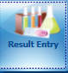  - In the Configuration field select CGX from the dropdown box.  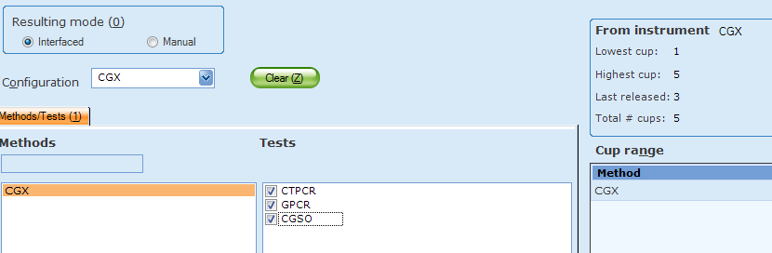  - Click on the button located in the lower right corner to populate the transmitted results.  - Review messages located on the top and results. Compare results to the GeneXpert report.  - Record provider notification if reporting any semi-urgent or unresolved result. (See Alert Values and/or Reporting Invalid (unresolved) Results sections)  - Check the release box. 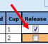  - Click button located on the lower left corner. Click when the “Verify Release Destination” window opens.  NOTE: conjunctiva and eye source codes will trigger the MFDA comment to append automatically (see below).  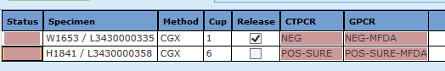  MFDA: Modified FDA approved test: The performance characteristics of this test have been determined by Children’s Hospitals and Clinics of MN  - At the end of the shift, call a completed worksheet for CGPCR, check results, and staple to GeneXpert Reports. Place in the “GeneXpert CT/NG results” binder.  - Store samples in fridge:  - Mark positive samples on side of caps (1 line: CT, 2 lines: NG, 3 lines: dual positive).  - Discard old samples after 2 weeks.
Alert Values | - Positive results from urine, endocervical, vaginal, rectal/anal, and throat swabs collected from patients that are 12 years old and younger are considered Semi-urgent Alert Values.  - Positive results from conjunctival swabs are considered Semi-urgent Alert Values.  - The code SURE (Semi-urgent result) will automatically append. These results must be called to the provider. Add the code CAL, press tab, enter semi-colon, and record who the result was phoned to, along with the time and date.  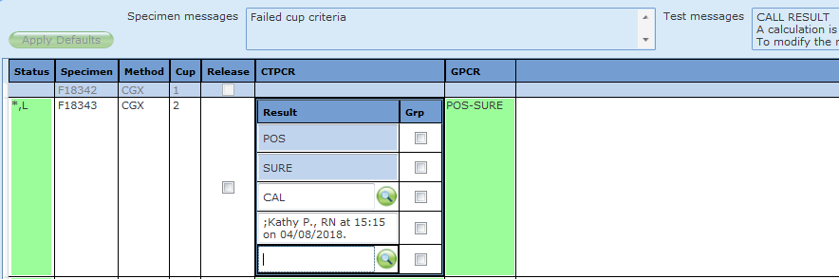
Reporting Invalid (unresolved results) | - IF an invalid result is repeated AND a valid result is obtained, select and only release the valid result interpretation in Result Entry.  - IF an invalid result is repeated AND an invalid result is obtained, select only one of the invalid results to release in Result Entry.  The CGPCR result will be reported as unresolved (UNRE) and the following code SIA will automatically append: “This sample is inhibitory to amplification and the results are inconclusive. Consider repeat collection if clinically indicated.”  The provider must be notified of these results.  Add the code CAL, press tab, enter semi-colon and record who the result was phoned to, along with the date and time.  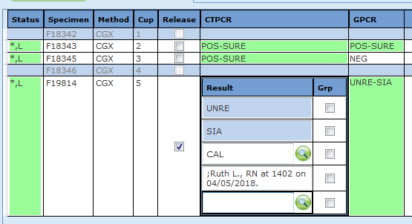
Correcting Results | To change an incorrect result:  - Open Result Entry and select the Manual resulting mode (top left corner). From the configuration drop down select CGPCR. Click in the lower right corner.  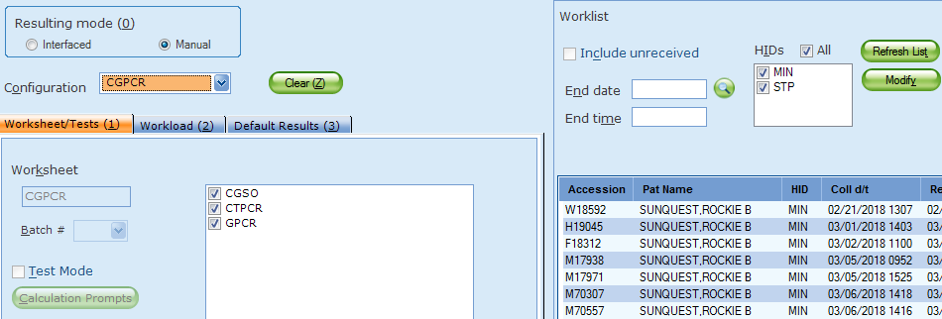  - Enter the Accession Number in the Specimen ID box, enter Tab and click Yes to modify the result.  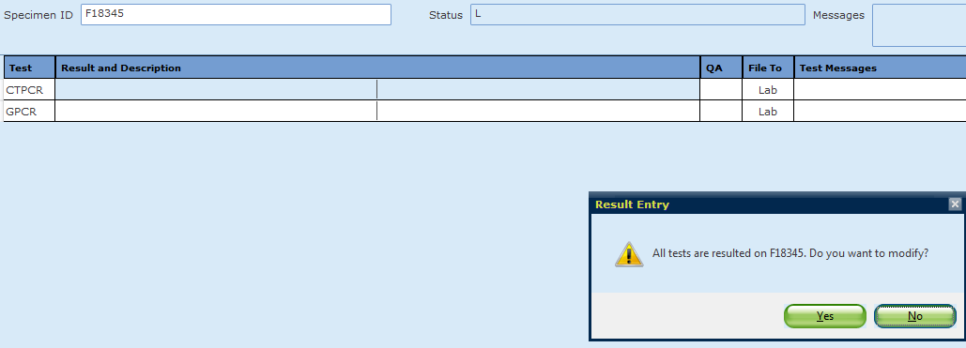  - Change the incorrect result. The corrected result comment will automatically append. The provider must be notified of this change. Add the CAL comment, press tab, enter a semi-colon and record who the result was phoned to, along with the date and time.  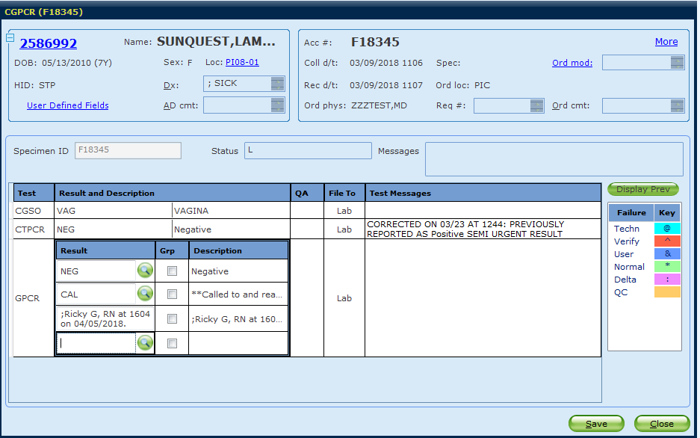  - Click . Click when the “Verify Release Destination” window opens.
Alternate Methods | - Hologic Chlamydia trachomatis Amplified RNA Assay (Mayo Medical Laboratories, collected in Aptima Collection Kit)  - Hologic Neisseria gonorrhoeae Amplified RNA assay (Mayo Medical Laboratories, collected in Aptima Collection Kit)  - GC culture  - Genital culture
References | 1. Cepheid. Xpert Swab Specimen Collection Kit Package Insert, 302-0175, Rev B, HPC135A Rev. 01. Sunnyvale, CA, 2019.  2. Sexually Trasmitted Diseases. In. Atlanta, GA: Centers for Disease Control and Prevention.  3. GeneXpert Dx System Operator Manual: Software Version 4.8, 3010045, Rev. K. In. Sunnyvale, CA: Cephied Inc.; 2016.  4. Xpert Urine Specimen Collection Kit Package Insert, Rev. 01. In. Sunnyvale, CA: Cepheid Inc.; 2016.  5. Cepheid. Xpert CT/NG Assay Package Insert, 301-0234, Rev J. Sunnyvale, CA, 2019.  6. Tabrizi SN, Unemo M, Golparian D, Twin J, Limnios AE, Lahra M, et al. Analytical evaluation of GeneXpert CT/NG, the first genetic point-of-care assay for simultaneous detection of Neisseria gonorrhoeae and Chlamydia trachomatis. Journal of clinical microbiology 2013; 51(6):1945-1947.
Training Plan/ Competency Assessment | Training Plan |  |  |  | Initial Competency Assessment
 | - Employee must read the procedure.  - Employee will observe trainer performing the procedure.  - Employee will demonstrate the ability to perform procedure, record results and document corrective action after instruction by the trainer. |  |  |  | - Direct observation.
Historical Record
 | Version | Written/Revised by: |  | Effective Date: |  | Summary of Revisions
 | 1 | J. Laramie/H. Stefan |  | 04.16.2018 |  | Initial Version
 | 2 | J. Laramie |  | 09.01.2018 |  | Edited pc log-in information
 | 3 | J. Laramie |  | 08.20.2019 |  | Added anal/rectal, throat, and conjunctival specimens as acceptable sources, updated alert values.
 | 4 | J. Laramie |  | 11.4.2019 |  | Switched from inverting sample to vortexing
 | 5 | J. Laramie / J. Berg |  | 05.11.2020 |  | -Added recording specimen description in computer when starting test  -Removed checking error tab and graphs for exponential growth on computer when testing is finished
 | 6 | J. Laramie |  | 08.23.21 |  | -Added MFDA comment for conj/eye screen shot
 | 7 | Susan DeMeyere |  | 6/27/2022 |  | Added auto-file for negative results

