Abbott Alinity Operating Procedure

**Purpose**

This document provides operating instructions for Abbott Alinity automated instrumentation for the chemistry department. The Alinity System c processing module is a chemistry *in vitro* diagnostic analyzer that processes up to 900 photometric and 675 potentiometric tests per hour. The Alinity System i processing module is an immunoassay *in vitro* diagnostic analyzer that processes up to 200 tests per hour measured by chemiluminescent microparticle immunoassay (CMIA) methodology.

The Alinity ci‑series of analyzers has a scalable design to provide full integration of multiple clinical chemistry and immunoassay systems, all of which are controlled by one user-friendly interface. This intuitive user interface provides a real-time display of each system’s status and a to-do list of scheduled maintenance activities, which minimizes system interaction and optimizes productivity. The Alinity ci‑series analyzers have also incorporated numerous features to prevent and reduce errors and to increase walkaway time.

A multi-module system includes multiple processing modules in different combinations of chemistry and immunoassay processing modules. The Alinity c‑series can be configured to process samples by using photometric and potentiometric methods. The Alinity i‑series uses the chemiluminescent microparticle immunoassay (CMIA) method. Alinity c and i instruments may be set up stand-alone or combined as integrated analyzers such as cc, ci, or ii.

An Alinity ci‑series has three primary components:

* **System control module (SCM)**

Provides a common user interface among all Alinity products.

* **Reagent and sample manager (RSM)**

Transports reagents, samples, calibrators, and controls through the Alinity ci‑series. Each system has one primary RSM regardless of the type and number of processing modules.

* **Processing modules (c or i)**

Performs all sample-processing activities from sample aspiration to final result reporting.

**Alinity c‑series**

The ICT (integrated chip technology) is the potentiometric method the c System uses to simultaneously measure sodium, potassium, and chloride. ICT methodology uses solid state ion-selective electrodes contained in a single chip (ICT module), which reduces the maintenance required to perform electrolyte measurements.

The ICT consists of 4 electrodes.

1. Sodium portion uses a Crown Ether ionophore incorporated into an ion-selective plastic membrane.
2. Potassium utilizes Valinomycin incorporated into an ion-selective plastic membrane.
3. Chloride uses a solid silver chloride (AgCl) disk.
4. Reference portion is a silver/silver chloride electrode in a potassium chloride (KCl) gel inner solution, separated from the sample by a porous ceramic tube.

The photometric assays use both end-point and rate assay reactions. The end-point assay reactions are reactions that are allowed to react until all reactant is depleted and the absorbance is stable. When the reaction is complete, the system measures the absorbance readings used for calibration and calculating results. For the end-point assays, the system calculates the concentration using the absorbance data obtained during the main read time specified on the Configuration assay parameters window Reaction Definitions view.

The rate assay reactions are reactions that are allowed to reach a stable rate in which the change in absorbance between readings is constant. The system performs several readings during this time, calculates absorbance changes per minute (rate), and then uses the rate to calculate results. For rate assays, the system uses the linear least squares to calculate the change of absorbance per minute (^Abs/min) during the main read time specified on the Configure assay parameters window Reaction Definition view. The calculation must include at least three photometric points to receive a result without a flag. The maximum number of photometric points is 38.

**Alinity i‑series**

Chemiluminescent microparticle immunoassay (CMIA) technology is used to determine the presence of antigens, antibodies, and analytes in samples. CMIA technology utilizes paramagnetic micropaticles coated with capture molecules (antigens, antibodies, or viral particles) that are specific to the analyte being tested, acridium-labeled conjugate, pre-trigger solution, and trigger solution. Incubation and wash steps are followed by measurement of the chemiluminescent emission of light by the CMIA optical system.

**Policy Statements**

* This procedure is intended for all personnel responsible for the operation of the Abbott Alinity c or Abbott Alinity ci system.
* Personnel operating the Alinity c or ci must demonstrate competence in its operation and maintenance.

**Instrument**



**Minneapolis Alinity ci: MACC/MACI**

Abbott Alinity c Serial Number: AC02664, **Service Number: 171608 “MACC”**

Abbott Alinity i Serial Number: AI04487, **Service Number: 171609 “MACI”**

Abbott Alinity System Control Module (SCM) Serial Number: SCM04091 **Service Number: 171610**

Children’s Minnesota- Minneapolis Customer # 56447626

Abbott Technical Support, available 24/7: 1-877-4-ABBOTT

**St Paul Alinity c: SALIC**

Abbott Alinity c Serial Number: AC02663 **Service Number: 171606 “SALIC”**

Abbott Alinity System Control Module Serial Number: SCM04090 **Service Number: 171607**

Abbott Customer Number for St. Paul: 50066117

**Minneapolis Alinity c: MALIC**

Abbott Alinity c Minneapolis Serial Number: AC01508 **Service Number: 158591 “MALIC”**

Abbott Alinity System Control Module Serial Number: SCM02042 **Service Number: 158592**

Abbott Customer Number Minneapolis: 56447626

**Table of Contents – click the link below to go directly to that section**

**Sample**

**Safety Precautions**

**Materials**

**Calibration**

**Quality Control**

**Procedures**

**Program Sample Data**

**Maintenance**

**Daily maintenance**

**Weekly maintenance**

**Monthly maintenance**

**Quarterly maintenance**

**Shutdown**

**Startup**

**Logging in**

**Consumables**

**Loading Reagents with and without barcodes**

**Generating 1D bar code for reagents**

**Removing and Disposing of reagent**

**RSM status Indicator**

**Loading Samples**

**Manual Patient Orders**

**Instrument Patient Dilution**

**Manual Patient Dilution**

**Result Reporting**

**References**

**Alternate Methods**

**Sample**

Refer to the Specimen Collection Manual for detailed instructions on specimen collection.

**Type:** Specimens for assay on the Abbott Alinity include serum, plasma, urine, CSF, and body fluids. Collection containers include microtainers and evacuated collection tubes suitable for serum or plasma. See individual analyte procedures for specific test requirements.

**Volume:** See the reagent manufacturer's assay specific documentation (such as a package insert or reagent application sheet).

* Insufficient sample in a sample cup could cause incorrect results.
* See individual analyte procedure for specific test volumes required.



**Stability:** See individual analyte procedures for specific sample stability.

**Criteria for Rejection:** Unlabeled specimens will be rejected. Refer to the individual analyte procedures for additional rejection criteria.

**Interfering substances:**  Refer to the individual analyte procedures and product inserts for specific interferences.

**Sample Preparation:** Refer to the [Specimen Collection Manual](http://khan.childrensmn.org/References/labsop/index.php?view=folder&folder=gen) for pre-analytic handling procedures. Once specimens are delivered to the laboratory, the following steps are taken:

1. Electronically receive the sample into the Laboratory computer system. ([SCM 5.0](https://starnet.childrenshc.org/References/labsop/index.php?view=folder&folder=is))
2. Prepare sample for separation. (See individual assay procedures.)
3. Refer to the processing procedure manual for proper labeling of sample tubes and cups.
4. Aliquot sample to a properly labeled, appropriate sample container.
5. Evaluate specimen integrity (See individual assay procedures.)

**Safety Precautions**

* Follow standard precautions for protection from biohazards when placing specimens on instrument and when performing maintenance and troubleshooting procedures.
* All components that come in contact with patient specimen should be considered potential biohazards and should be treated accordingly.
* Proper personal protective equipment should be used at all times when operating the Abbott Alinity

**The following reagents and supplies must be disposed of in hazardous waste containers.**

**Recap and dispose of in Alkaline/caustic waste container**

* + Alkaline wash
  + Detergent A
  + Detergent B
  + Total protein reagent
  + Glucose reagent
  + Creatinine reagent
  + Trigger

**Recap and dispose of in Acid waste container**

* Direct bilirubin reagent
* Total bilirubin reagent
* Phosphorus reagent
* Acid Probe Wash Solution
* Acid Wash
* Testosterone reagent kit assay specific diluent
* Pre-trigger

**Dispose of in Methanol Waste Container**

* Vitamin D Reagent Kit assay diluent

**Dispose of in regular trash bin**

* All other empty reagents

**Dispose of in Regulated Medical Waste (RMW) (red biohazard trash)**

* Mulitconstituent calibrator
* Clinical Chemistry calibrator
* Other reagents when not empty

**Materials**

**Records/Forms/Documents**

* Test orders
* Pending Logs
* Assay Procedures

**Reagents**

* All reagents are liquid and ready for use on the instrument; some calibrators and quality controls require reconstitution before use.
* Refer to individual assay procedures for information regarding reconstitution of calibrators, specific quality control materials, and calibrator verification materials, where applicable.
* Some reagents are third party reagents and require configuration and preparation of a reagent cartridge prior to loading. See below for instructions on how to print a 1D barcode for this purpose

**Supplies**

* Numerous supplies and consumables are needed to operate the Abbott Alinity
* View the [Operations Manual](https://starnet.childrenshc.org/References/labsop/chem/operator/alinity-ci-series-operations-manual.pdf) for more information.
* Avery 5520 Waterproof Address Labels are needed for 1D reagent barcodes

**Equipment**

* Abbott Alinity c analyzer
* Abbott Alinity i analyzer
* Children’s Minnesota Laboratory network printer

**Calibration**

Each day, ensure all methods have enough calibrated reagent available for the next 24 hours’ test requirements.

Calibration must be performed when:

* A new reagent lot number is used
* Assay documentation states that a calibration is required when a reagent cartridge is changed
* A new assay file that requires a calibration is installed
* The calibration has expired
* Major instrument parts are replaced
* As required or requested by Abbott technical support or Field Service Engineer
* ICT calibration is needed every 24 hours

**Order a calibration that does not utilize barcoded vials:**

1. On the menu bar, select Orders
2. Select “Create Order”
3. On the top of the screen, select the Calibration tab
4. Under Sample Data

* Assign your rack by either scanning the barcode or manually entering the rack number
* Select your starting position. ***Your samples must be set up sequentially. The analyzer will automatically assign level 1 calibrator to the starting spot and assign all the of the following calibrators in the following spots numerically***

1. Select the assay to calibrate
2. Check calibrator lot number for accuracy. If incorrect, select assay options 🡪 Calibrator lot drop down box, and pick the correct lot number. If the lot number is not listed, follow steps to configure a new lot, as described below.
3. Select Add Order

**Onboard Calibrators:**

1. To add new calibrators, remove the old rack, if loaded, by viewing the Reagent Carousel, selecting the rack, and touching Unload.
2. Place the new calibrator(s) in a YELLOW rack.
3. Put the rack on the instrument.

The ICT calibrator is required every 24 hours. It will run automatically if it is onboard.

Please do not store new calibrators onboard unless instructed by the Technical Specialist or designee

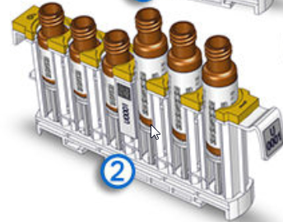

Calibrators must be configured in the Alinity ci software prior to calibrating assays.

**Configure a New Calibrator Lot from a Bar Code**

Supervisor access is required**. Login: ADMIN password: 8642**

This capability is specific to some single-constituent and multi-constituent calibrators. (To identify calibrators that have this capability, see the product documentation.)

1. On the menu bar, select System, then select Configure.
2. Select the Assay tab.
3. Select Calibrator Set.
4. From the list, select a calibrator set.
5. Select View/Edit to display the calibrator data for the default lot number.
6. In the Master Lot drop-down, select “New Lot”.
7. Use the bar code scanner to scan the bar code on the calibrator carton. The system automatically creates a new calibrator lot with the lot number and expiration date from the calibrator carton.
8. To configure the new calibrator lot as the default, select the **“Default**” check box.
9. The default lot can be changed when the instrument status is Running or Processing if no orders are present for the calibrator set and, for c-series assays, if the calibrator set is not loaded in the reagent carousel. The data must be defined for all assays and all levels of the default lot. You MUST verify that the barcoded targets match the package insert because the barcodes do not always upload the correct assay target values.
10. To save the calibrator lot settings, select “Save”, or, to delete the calibrator lot settings, select “Cancel”.
11. To return to the list of calibrator sets on the Calibrator Set screen, tap Done.

**Import Calibrator Data (c-series)**

Supervisor access is required**. Login: ADMIN password: 8642**

Instrument must be in Idle Status.

Calibrator data files may be accessed at <https://www.corelaboratory.abbott> or through Abbott Mail.

1. On the menu bar, select System, then select Configure.
2. Select the Assay tab.
3. Select Calibrator Set.
4. Select the appropriate calibrator set. Tap Import.
5. On the “Import Calibrators” screen, ensure the “Hard Drive” button is selected.
6. Select the appropriate calibrator data file to import.
7. If the calibrator data file is located on a USB flash drive, perform the following steps:
   1. Insert the USB flash drive.
   2. Tap the USB Flash Drive button.
   3. Tap the appropriate folder.
   4. Tap the calibrator data file to import.
8. The assay names and assay numbers for the data in the file and for the corresponding system assays are displayed with an import status. Data for all calibrator levels is imported for assays that have a status of “OK”. No data is imported for assays that have a status of “No Assay” or “Previously Defined”. These statuses are displayed in red text.
9. For the selected calibrator data file, perform one of the following steps:
10. If no data is available to import because the assays have a status of “No Assay” or “Previously Defined”, tap Done to return to the Calibrator Set screen and end the procedure.
11. To import the data for assays that have a status of “OK”, select “Import”.
12. Under Calibrator Set Configuration on the Calibrator Set screen, select the Default check box to configure the calibrator lot as the default.
13. The first configured lot number is designated automatically as the default lot number. The default lot number can be changed when the instrument status is Running or Processing if no orders are pending for the calibrator set and the calibrator set is not loaded in the reagent carousel. For all assays and all levels of the default lot number, the data must be defined.
14. To delete the selected calibrator lot number, select the lot from the drop down box and perform the following steps:
    1. Tap Delete.
    2. When a confirmation message is displayed, tap Continue.
    3. **NOTE**: A calibrator lot number cannot be deleted if the lot number is the default or if the calibrator is loaded in the reagent carousel.
15. To save the edits to the calibrator lot settings, tap Save. To delete the edits to the calibrator lot settings, tap Cancel.
16. To edit another calibrator lot number, tap a lot number in the Lot drop-down list, and then repeat steps 7 through 13. You must double-check calibrator target values against the package insert. The calibrator lot downloaded may not match the current package insert. You must verify the entries prior to calibrating.
17. To return to the list of calibrator sets on the Calibrator Set screen, tap Done.

**Quality Control**

QC assessment is required on each method each day of patient testing. Refer to the procedure [CH 2.17](https://starnet.childrenshc.org/References/labsop/chem/quality/ch-2.17-unity-real-time-qc-review-general-user.pdf) Unity Real Time QC Review, General User*,* [CH 2.08 Quality Control Review](https://starnet.childrenshc.org/References/labsop/chem/quality/ch-2.08-quality-control-review.pdf),and the individual assay procedures for specific information on Quality Control frequency, materials and handling, requirements, and response codes.

QC is performed after all PMs and replacements of critical components of the analyzer to ensure optimum performance.

**Perform QC Using a Barcode**

1. Place a sample cup into the bar coded tube
2. Dispense the appropriate amount of required QC material into the cup
3. Place the rack onto the analyzer. The RSM will pick up the rack, take a picture of the barcode, and perform ALL tests on that barcode, unless programmed otherwise.

**Manually Program QC**

1. On the menu bar, tap create Orders.
2. Tap the Control tab.
3. Under Orders on the Control tab
   1. If bar-coded samples are used the rack ID and the position number are not required
   2. If a non-bar-coded sample is used, enter the rack ID by scanning the barcode on the rack
   3. Assign a Position on the rack for the specific QC material to be run
4. Under Control Data:
   1. **Control Name**: Use the drop down list to select the appropriate control
   2. **Control Lot:** Confirm the lot is correct, if not use the drop down list to select the correct lot
   3. **Control Level:** Use the drop down list to select the correct control level
5. Under Assays you can either select a panel or run an individual assay. You must program a single or multiple assays when using a QC barcode or the instrument will run all assays applicable to that barcode.
6. Tap Add Order

**Configure Quality Controls**

1. Select System 🡪 Configure 🡪 Assay tab
2. Select Quality Control
3. Select the control to configure
4. Tap View/Edit
5. Lot Number: tap and select new lot
   1. Lot number: Type in the master lot number
   2. Expiration date: Expiration date of the Master Lot
6. Click Save.

**Note**: Do not enter ranges or stability for any of the levels of QC. All ranges are set in URT.

**Procedures:**

Primary Operators should be familiar with the Manufacturer’s instructions and refer to them as needed. The on-instrument Operations Manual, the Quick Reference Guide (located on StarNet Chemistry Manual), and online Operations Manual (located on StarNet) should all be referenced for help. Abbott Technical Support is available 24 hours a day and should be called whenever there is a question about instrument function at 1-877-4-ABBOTT. The Minneapolis and St. Paul Customer Number is located under the “Instrument” portion of this procedure.

**Program Sample Data:**

The Abbott Alinity system is interfaced with Sunquest LIS via ASTM connection on a segregated network. For interfacing issues, please contact the LIS department for troubleshooting.

**Maintenance**

For access to the Maintenance screens, select the Procedures icon on the lower left corner of the Alinity instrument monitor. Place each module (Alinity i, Alinity c, and RSM) into Idle status. Turn the key for the selected module to the ON position (WHITE DOT). Click on the procedures tab 🡪 Select a module (c or i) 🡪Select Maintenance tab 🡪 click the desired maintenance 🡪 click perform 🡪 follow on screen instructions. Please do not remove any of the procedure keys from the instrument.

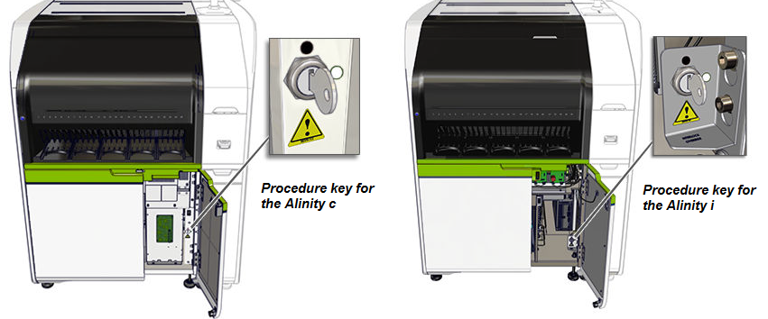

For more information refer to [Operations Manual](https://starnet.childrenshc.org/References/labsop/chem/operator/alinity-ci-series-operations-manual.pdf) 🡪 section 9 🡪Maintenance procedure descriptions and the [Alinity Quick Reference Guide Maintenance section](https://starnet.childrenshc.org/References/labsop/chem/operator/alinity-quick-reference-guide.pdf) p.51.

**NOTE:** **Because there is no paper maintenance log, comments must be entered under maintenance items for any failed or repeated procedures, or any other pertinent instrument items requiring documentation. To enter a comment for the electronic maintenance log, please refer to page 855 in the** [**Alinity ci series Operations Manual**](https://starnet.childrenshc.org/References/labsop/chem/operator/alinity-ci-series-operations-manual.pdf)**.**

**Daily maintenance**

**Check reagent stability and volume.**

**To check stability:**

Reagent🡪 Module All🡪 tap on onboard stability tab (This will sort all the reagents by stability). Stability is measured in days on the instrument. Add a new reagent if the stability is <1 and there are no other packs onboard.

**Check Test Volume:**

Select Reagent 🡪 Module 1 Tab🡪 Tap the Remaining column to sort in ascending order.

If volume is low, add another reagent pack. The instrument will automatically unload packs that are empty. Ensure that there is another pack onboard before discarding the cartridge to ensure continuity of testing.

**Replace Maintenance Solution (c-series):**

Maintenance Solution is required for daily maintenance. The large bottle of the maintenance cartridge is filled with Water Bath Additive, an antimicrobial solution used to reduce microbial contamination in the water bath. During maintenance, the solution is dispensed into the water bath. The Alinity c maintenance solutions are supplied as a three component kit. 1) Lyophilized Cleaning Solution bottle. 2) Cleaning Solution. 3) Maintenance Solution Cartridge.

**To reconstitute Lyophilized Cleaning Solution**:

Remove the cap to the Lyophilized Cleaning Solution bottle. 🡪 Add 12 mL of the Cleaning Solution to the lyophilized cleaning solution bottle, recap and mix gently. 🡪Transfer the contents of the Bottle to the R2 position of the Maintenance Solution Cartridge, (under the yellow cap).

**Replace onboard wash solutions: (Acid Probe Wash and Detergent A – c-series)**

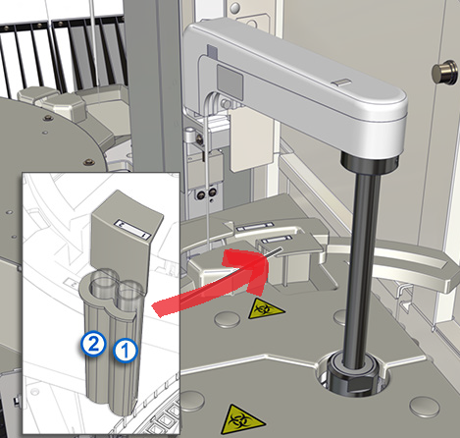

1. Transition instrument into Idle status
2. Lift the rear processing center cover.
3. Locate and remove the sample wash solution holder. See picture above
4. Discard the used sample tubes and their contents as indicated in the **Safety precautions** section.
5. Add 1-2 mL **Acid Probe Wash to** **position one (1)** in a 16mm x100 mm sample tube, **make sure to label tube**
6. Add 1-2 mL **Detergent A to** **position two (2)** in a 16mm x100 mm sample tube, **make sure to label tube**
7. On the touch screen menu bar, tap Supplies
8. Scan the 3D barcode for the Acid Probe Wash
9. Repeat for Detergent A.
10. Check that the stability hours have updated to 24. If not repeat step 8.

**5501 Daily Maintenance (c**‑**series)**

* Perform this Daily maintenance procedure to complete the following tasks:
* Flush the water lines of the sample, the reagent, and the cuvette washer.
* Exchange the water in the water bath.
* Add Water Bath Additive to the water bath.
* Wash the ICT module with ICT Reference Solution and Cleaning Solution.
* Drain and fill the ICT Reference Solution cup.
* Wash the sample and reagent probes and the mixers with Acid Probe Wash and Detergent A.
* Clean the sample probe, the R2 probe, and the mixers with Cleaning Solution.

**Estimated time** 12 minutes

**2500 Daily Maintenance (i**‑**series)**

* Clean and condition the sample pipettor probe.
* Clean wash zone 1 probes and wash zone 2 probes with 0.5% sodium hypochlorite solution.
* Flush and prime the Pre-Trigger Solution and the Trigger Solution

**Estimated time**: 23 minutes. This procedure may require an additional 5 minutes to 25 minutes if a bulk solution transfer is necessary.

**Weekly maintenance**

**5601 Clean Cuvettes with Detergent A (c**‑**series)**

**Estimated time** 30 minutes

**5901 Clean Wash Cups (c**‑**series)**

**Estimated time** 15 minutes

***2620 Manual Pipettor Probe Cleaning (i‑series)***

Estimated Time 4 minutes

***2625 Manual Wash Zone Probe Cleaning (i‑series)***

Estimated Time 4 Minutes

***2630 Manual Wash Cup Cleaning (i‑series)***

Estimated Time 8 minutes

Refer to the Alinity on-screen instructions after selecting the Procedures icon, highlighting this item on the Weekly Maintenance tab, and selecting Perform.

**Monthly Maintenance**

**5701 Clean ICT Drain Tip (c**‑**series)**

Perform this Monthly maintenance procedure to clean the ICT drain tip.

**Estimated time** 2 minutes

Refer to the Alinity on-screen instructions after selecting the Procedures icon, highlighting this item on the Monthly Maintenance tab, and selecting Perform.

**5908 Clean Cuvette Washer Nozzles (c**‑**series)**

Perform this Monthly maintenance procedure to clean the cuvette washer nozzles.

**Estimated time** 5 - 10 minutes

Refer to the Alinity on-screen instructions after selecting the Procedures icon, highlighting this item on the Monthly Maintenance tab, and selecting Perform.

**Quarterly and Semiannual Maintenance**

Refer to the Alinity on-screen instructions after selecting the Procedures icon, highlighting each item on the Quarterly Maintenance tab, and selecting Perform. It is not necessary to perform all items on the same day, but it is recommended.

**5801 Sample Syringe Maintenance (c‑series)**

Perform this Quarterly maintenance procedure to replace the sample syringe O-ring and sample syringe seal tips 1 and 2.

**Estimated time 12 minutes**

**5802 Wash Solution Syringe Maintenance (c‑series)**

Perform this Quarterly maintenance procedure to replace the wash solution syringe O-ring and wash solution syringe seal tips 1 and 2.

**Estimated time 22 minutes**

**5803 Reagent Syringe Maintenance (c‑series)**

Perform this Quarterly maintenance procedure to replace the reagent syringe O-rings and reagent syringe seal tips 1 and 2.

**Estimated time 22 minutes**

**5804 Change 1 mL Syringes (c‑series)**

Perform this Quarterly maintenance procedure to change the 1 mL syringes on the following pumps:

* ICT Reference Solution pump
* ICT aspiration pump
* Wash solution pump

**Estimated time 14 minutes**

**5805 Check and Change ICT Check Valves (c‑series)**

Perform this Quarterly maintenance procedure to change the ICT aspiration check valve and to confirm the functionality of the ICT Reference Solution check valves.

**Estimated time 18 minutes**

**5806 Change Lamp (c‑series)**

Perform this Quarterly maintenance procedure to change the lamp.

**Estimated time 15 minutes**

**5808 Inspect Wash Cup Tubing (c‑series)**

Perform this Quarterly maintenance procedure to inspect the wash cup tubing.

**Estimated time 5 minutes**

**Semiyearly Maintenance**

**2850 Air Filter Cleaning (i‑series)**

Perform this Semiyearly maintenance procedure to remove manually the dust buildup from the processing module air filters. Rotating between two sets of air filters is recommended because the filters must be dry when they are reinstalled.

**Estimated time** 10 minutes

**Shutdown**

Perform this procedure to cycle power to the system.

1. Instrument must be in Idle or stopped.
2. On the menu bar, tap the Home icon.
3. On the Home screen, tap Shutdown.
4. When a confirmation message is displayed, tap “Yes”.
   1. The user interface (UI) computer powers off when the system software completes the shutdown.

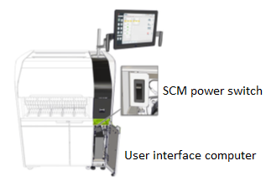

1. Open the SCM front door 🡪Move the SCM power switch downward
   1. When the SCM power switch is turned off, the power is turned off to the RSM for all processing modules in a multimodule system. Open the front electronics door of each Alinity processing module in the system.
2. Locate the power switch for Alinity c and Alinity i processing module

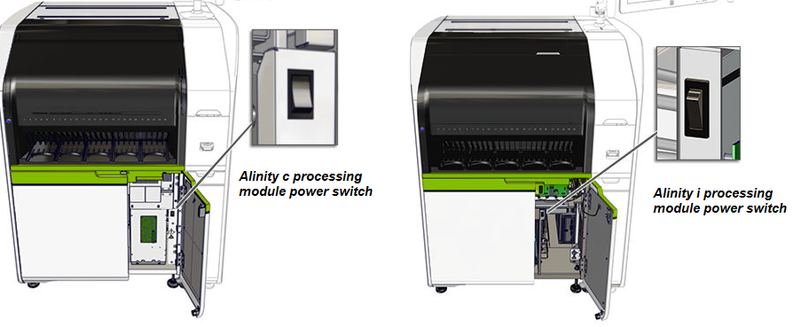

1. Move the power switch downward to power off each Alinity c and Alinity i processing module.
2. Ensure that each processing module remains powered off for 1 minute.

**Start up**

The following steps will turn the computer and instrument on. The Alinity Quick Reference Guide Job Aides section describes each step in detail.

1. Power on the UI computer.
2. Wait for the Log On screen to display on the UI computer.
3. Move the SCM power switch upward to power on the RSM and the SCM bar code scanner.
4. Move the power switch upward to power on each processing module.
5. After the power is turned on, the RSM and the processing modules initialize and the instrument statuses transition to Stopped.
6. Log on to the system software.
7. To transition the instrument statuses to Idle, start the RSM and each processing module. If the sequence was not followed correctly, the instrument will remain in Stopped status indefinitely. Perform a cycle power procedure again, starting with shutdown. Follow each step exactly.

Close the front door of each module.

**Logging in**

It is important that all employees who use the Abbott Alinity are logged into their defined user name. This is important for maintenance log sheets as there will not be a paper copy for daily signoff. The Maintenance Log will be printed and reviewed once per month by the Technical Specialist or Designee. Corrective actions should be recorded in the instrument under any maintenance activity by selecting a maintenance activity performed the day of (OR select an activity from the day before if maintenance activities have not yet been performed on that day) any required corrective actions. Enter a comment in Notes, being as descriptive as possible.

**Defined User name: tech code**

**Defined Password: 1234 or defined by the employee**

**Replacing and Disposing of Consumables**

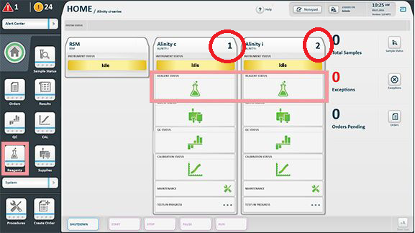

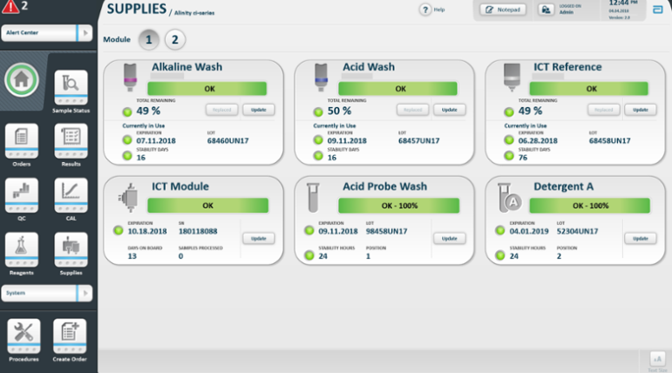

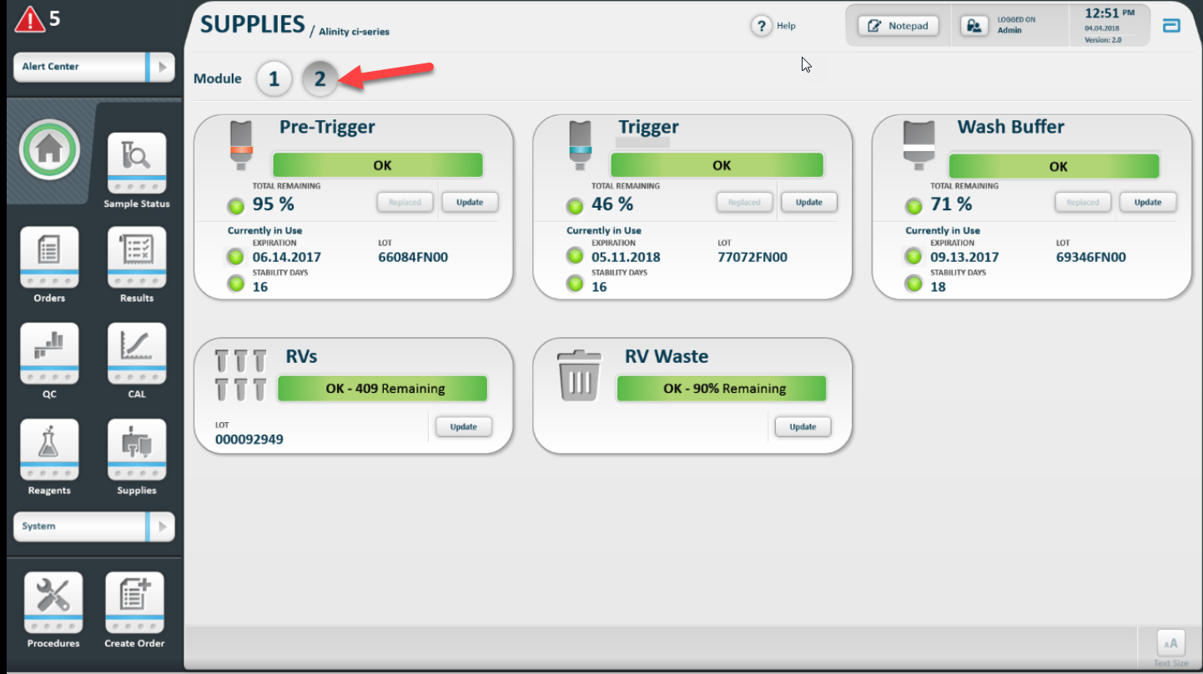

**Alinity c and Alinity i**

**Replace Bulk Solutions And Update the Inventory**.

1. Put instrument into Idle status
2. On the menu bar, tap Supplies, then choose the correct module, i or c
3. Scan the bar code on the new bulk solution bottle using the bar code scanner. Repeat for each bulk solution that is being replaced
4. Open the bulk solution door. Press the bottle release button to disengage the empty bulk solution bottle from the bottle holder.
5. Press the colored circle next to the consumable bottle to remove and discard the empty bulk solution bottle according to the safety precautions section of this procedure.
6. Remove the protective cover from the cap of the new bulk solution bottle. Invert the new bulk solution bottle several times to mix prior to loading, and while the nozzle is facing down, place it in the bottle holder and push down until it locks.
7. Close the bulk solution door. When the bulk solution door is closed, the door sensor confirms that the bottle was replaced. To confirm manually that the bottle was replaced, tap Replaced on the Supplies screen.

**Alinity c consumables**

Bulk solutions are liquid solutions that are provided in large quantities for use during sample processing. The Alinity c‑series uses three bulk solutions. Each bulk solution bottle is loaded on the bulk solution door. **Do not allow solutions to expire onboard.** If this occurs, the reservoir will need to be manually emptied, fluids flushed in Diagnostic procedures, and a cycle power sequence may be required.

1. Alkaline Wash
2. Acid Wash
3. ICT Reference Solution

**Alkaline Wash (0.5 L bottle)**: An alkaline wash solution that is used by the cuvette washer to clean the cuvettes after sample analysis. Alkaline Wash is stored at a temperature of 15°C to 30°C and is stable on the system for 30 days.

**ICT Reference Solution (975 mL in a 1 L bottle):** A mid-concentration standard solution that is aspirated and analyzed by the ICT module before and after each sample. The solution provides a reference potential that is used in result calculation. ICT Reference Solution is stored at a temperature of 15°C to 30°C and is stable on the system for 90 days.

**Acid Wash (0.5 L bottle):** An acidic wash solution that is used by the cuvette washer to clean the cuvettes after sample analysis. Acid Wash is stored at a temperature of 15°C to 30°C and is stable on the system for 30 days.

**ICT module**

The ICT module is an integrated chip that is a component of the ICT unit and contains the sodium (Na+), potassium (K+), chloride (Cl-), and reference electrodes. The Abbott warranty for the ICT module is 20,000 samples or 3 months after installation, whichever occurs first. The ICT unit can be used past its expiration date if it is installed on the analyzer prior to the printed expiration date. The ICT module can also continue to be used until the slope of the K, Na, or Cl calibrations falls below 45%, even if the Abbott warranty expires. The ICT module for the Architect and Alinity platforms are the same product and thus may be used interchangeably. One ICT module should be kept on hand at each Children’s Minnesota Laboratory site to be used for either the primary or secondary instrumentation, whichever needs replacement first.

**Alinity i Consumables**

**RVs (i-series) 500 RVs per bag**

Reaction vessels (RVs) are disposable containers in which the CMIA reaction occurs.

Pictured is location of RV hopper. Do not replace until a full bag (500) of RVs can be loaded (the hopper is nearly empty when opening the door and inspecting visually.)

**Remove RV Waste (i-series)**

* 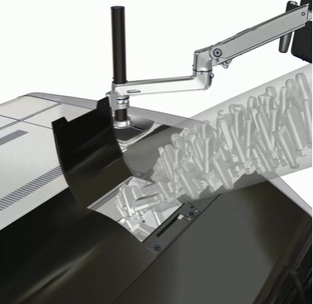Open the bulk solution door
* Pull out the RV waste storage tray
* Empty the contents of the bin into red biohazard (Regulated Medical Waste) trash in the lab. The Biohazard bag liner of the bin should be replaced when it becomes grossly soiled.
* Replace the bin and push the waste drawer all the way in. Close the bulk solution door
* On the menu bar, tap Supplies🡪 tap i-series module number
* Tap update for the RV waste
* Under supply details tap the emptied RV Waste check box
* Tap Done

**Pump Drawer:**

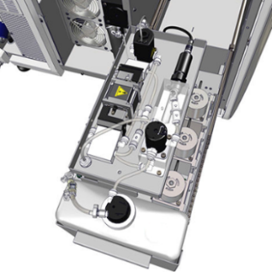The Pump Drawer is located in the rear of the instrument. The pump drawer contains a **diluted wash buffer reservoir** located at the front of the drawer that holds diluted wash buffer for use during assay processing

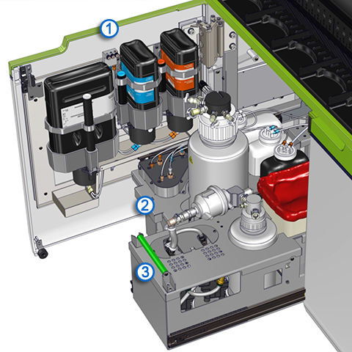**Bulk solution:**

**Trigger solution** (1L bottle). A solution that contains 0.35N sodium hydroxide solution that produces the chemiluminescent reaction that provides the final read

**Pre trigger solution** (1L bottle) A solution that contains 1.32% (W/V) hydrogen peroxide solution that separates the acridium dye from the conjugate that is bound to the microparticle complex. This action prepares the acridium dye for the addition of Trigger Solution.

**Concentrated wash buffer** (2L bottle) A solution that contains phosphate-buffered saline and antimicrobial agents.  This solution is diluted tenfold by the system and then is pumped to sample and reagent pipettor assemblies and to wash zones during assay processing

1. Bulk solution storage area.
2. Bulk solution reservoir area
3. RV waste storage area

**Loading Reagents With and Without Barcodes**

**All i-series reagents must be mixed upon receipt into the laboratory by fully inverting the box and fully returning upright at least 5 times.** After mixing, reagents must be stored for at least 1 hour prior to use to allow bubbles to dissipate. Some reagents require a longer time for bubbles to dissipate; review assay specific procedures or package inserts for details.

**Immediately prior to loading the reagent onto the analyzer and before removing the caps, all therapeutic drugs must be mixed by gentle inversion 5 times, taking care to not create foam or bubbles. After removing the caps, ensure any bubbles that may have formed have been removed using a stick or pipette. Do not remove any reagent volume.**

**To load a reagent that has a barcode:**

1. Verify that the reagent is within the expiration date.
2. Remove all tabs from the top of the reagent
3. Place Cartridge into a slot at the front of the machine. The RSM will read the bar code and put it into the appropriate onboard refrigerated c-side or i-side reagent storage area.

**Loading diluent saline, HIL Ref, and other non-barcoded reagents**

1. Retrieve an empty cartridge from stock, a new bottle of reagent or an aliquot of 74 mL of blood bank saline for diluent saline or HIL Ref, and a pre-printed label if available.
2. Check the reagent/saline lot and expiration against the pre-printed labels.
   1. If this is a new lot, generate a new sheet of barcodes for this specific lot. Refer to next section: **Generate 1D Barcode for Cartridges**
3. Affix the 1D bar code to the empty cartridge. Using a sharpie, write the onboard date and your initials or Tech code on the cartridge.
4. Pour R1 into the R1 slot and R2 into the R2 slot. See picture for reference.
   1. Saline and HIL Ref (blood bank saline): Pour 74mL into R1 position.
      1. If using a clear cartridge, fill up to “max fill line” instead of measuring.
   2. For assay reagents, refer to individual assay procedure for amounts of R1 and R2.
5. Place Cartridge into machine, the machine will read the bar code.

**Note:** Both tabs on the top of the cartridge must be removed before placing onto the analyzer.

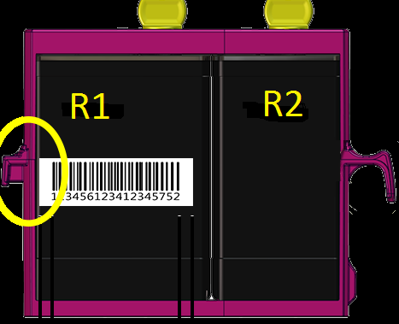

**Generate 1D Barcode for Cartridges**

**Generate and Print 1D Barcode:**

1. Touch Systems dropdown 🡪 Configuration🡪 Select the General Tab 🡪 Touch Reagent and Supplies.
2. Choose by highlighting the diluent or reagent that needs to be replaced. Saline and HILref are onboard diluents which utilize blood bank saline. Ensure that the lot number and expiration date are valid.
3. Tap Print 1D bar Code 🡪 choose the correct printer.
4. In Label Options enter the reagent or saline lot number, expiration date, serial number, and the number of labels.
   1. Serial Number: enter 0001
   2. Number of labels: enter 30
5. In the Report Selection drop down list, select 1D Bar Code Report – 5520.
   1. Make sure to load a sheet of Avery 5520 Waterproof Address Labels, then select print.

Store the printed labels with the reagent, or with the empty cartridges for diluent saline and HIL Ref.

**Removing and Disposing of reagent and consumables**

How to remove Reagent Cartridges:

Click on Reagent 🡪 highlight the reagent that need to be unloaded by clicking on it 🡪 tap unload at the bottom of the screen.

Refer to section **Safety precautions** for special Disposal needs.

**RSM status Indicator**

|  |  |
| --- | --- |
| **Indicator** | **Description** |
| Light is off | No rack or cartridge is inserted in the position. |
| Green (steady) | The rack or cartridge is inserted but is not in process. The rack or cartridge can be accessed. |
| Amber (steady) | The rack or cartridge is in process. The rack or cartridge cannot be accessed. |
| Green (blinking) | Processing is completed. The rack or cartridge can be accessed.  If a test is added or a rerun is scheduled before the rack is removed from the loading area, the status indicator for the position changes to amber and the rack cannot be accessed. |
| Amber/Green (alternating) | A bar code scan error or other error occurred. The rack or cartridge can be accessed. |
| Amber (blinking) | Unloading of a cartridge or vial rack is in process. The position is reserved and is unavailable to load a rack or cartridge. |
| Blue | The RSM position is designated as a STAT position. |

**Loading Samples**

Verify sample integrity, sufficient volume, and approved sample type per assay-specific package inserts. Short samples place into a Abbott Sample cup (shown in the **Sample**

**Sample**

**Sample**

**Sample** section)

1. Place the sample in the carrier so the bar code label is visible in the bar code window
2. Verify both of the indicators lights below the desired section are off.
3. Push the carrier into the priority or the routine section until the indicator illuminates. If the lights alternate blinking orange and green, there is an error or the RSM module is not ready. Withdraw the rack and try again.

**Removing Samples**

Wait until the Indicator light is blinking Green, then it is safe to remove the rack from the instrument.

**Note:** If the indicator light is alternating between green and amber a barcode or other error has occurred. It is safe to remove the rack from the instrument and troubleshoot the error.

**Create Manual Patient Orders**

Refer to page 30 in the Alinity Quick Reference Guide

1. On the menu bar, select “Create Orders”.
2. Under “Sample Data” on the Specimen tab of the Create Order screen:
3. Enter the SID and two patient identifiers.
4. Enter the rack ID and the position number. (If bar-coded samples are used, the rack ID and the position number are not required. If a rack and a position are entered and the bar code on the sample is not read, the system automatically uses the scanned rack ID as the unique rack ID and the sample is processed as entered.)
5. If the specimen was diluted manually, type the dilution factor in the “Manual Dilution” box.
   1. For more details see **Order Manual Patient Dilution** below
6. To display the STAT processing code for the SID, tap the Designate Sample STAT check box. Samples that are designated as STAT must be loaded into one of the priority/STAT lanes (lane 1-5) in order to be processed as a STAT sample.
7. In the Comments box, type additional information that is associated with the sample. (Optional.) Comments are displayed and are printed with each test that is ordered for the sample.
8. Under Assays, select an assay panel to run or select individual assays to run.
9. For assays with an available onboard, automated dilution, you may add it at this point by selecting Assay Options
   1. In the Standard dilution field, click the drop down box and change replicates to 0
   2. Choose the desired dilution, click the drown down box and change the replicates to 1
   3. Select Done
   4. For more details see **Order Instrument Patient Dilution** below
10. Tap Add Order

**To order a calculated assay, perform one of the following steps**:

1. Tap only the calculated assay.
   1. The system automatically orders the assays that are necessary to complete the calculation but does not release or report the results ordered by the system.
   2. Constituent assays for some calculated immunoassays that are installed from an assay file (assay numbers 3000 through 3999) cannot be ordered automatically by the system and must be ordered separately. For specific assay requirements, see the assay documentation.
2. Tap the calculated assay and one or more of its constituent assays.
   1. The system automatically orders the additional constituent assays that are necessary to complete the calculation but does not release or report the constituent results ordered by the system.
3. Tap the calculated assay and all of its constituent assays.
   1. The system releases and reports all results.
4. Tap Assay Options.
5. For each selected assay in Assay Options, perform the following steps if these situations occur:
   1. If more than one processing module of the same type is configured for a system, under Module Selection, tap Module to specify a processing module, and then tap the appropriate module check boxes to override the system module scheduler.
   2. Under Dilution Protocols/Number of Replicates, if the default number of replicates for one or more dilutions is incorrect, tap the correct number of replicates for each dilution.
6. For i-series assays, do not order more than 10 tests for each sample that is loaded in sample cups.
7. For c-series ICT assays, do not order more than 15 tests for each sample that is loaded in sample cups or tubes.
   1. The total number of tests for each sample includes all assays, replicates, dilutions, and available reagent lots for the order.
8. To save the assay option selections, tap Done.
9. Tap Patient Details, enter the patient demographic information.
10. To save the patient demographic information, tap Done.
11. To save the specimen order, tap Add Order.
12. To view the specimen order, tap Order Status

**Order Instrument Patient Dilution**

For Assays that have an onboard dilution:

1. Follow steps above in **Create Manual Patient Orders**,step 9

**Note:** If the SID and barcode are different, turn the bar code so it is not read.

**Order Manual Patient Dilution**

Assays that need a manual dilution follow these steps:

1. From the “HOME SCREEN”, select <CREATE ORDER>.
2. Select <SPECIMEN> tab.
3. Enter the SID/rack/position in the correct fields.

**Note**: Use an SID that WILL NOT auto file so that if the manual dilution can be reviewed prior to patient reporting.

1. Enter the manual dilution factor.

**Note**: If the Dilution Factor is not entered, multiply the result by the dilution factor. Enter this result into Sunquest and record on the manual dilution worksheet and so another tech can review the manually calculated and reported result.

1. Select the desired assay.
2. **Required**: Select <PATIENT DETAILS> to add two patient identifiers for tracking purposes. (Name, DOB, or MRN)
3. Select <DONE>.
4. Select <ADD ORDER>.
5. Place sample on the instrument
6. Refer to individual assay procedure for maximum dilution.

**Result Reporting**

Refer to [Result Reporting Procedure CH 7.03](http://khan.childrensmn.org/Manuals/Lab/SOP/Chem/Result/201891.pdf) and individual assay procedures.

**References**

1. [Abbott Alinity ci Operating Manual](https://starnet.childrenshc.org/References/labsop/chem/operator/alinity-ci-series-operations-manual.pdf)
2. [Abbott Alinity Quick Reference Guide](https://starnet.childrenshc.org/References/labsop/chem/operator/alinity-quick-reference-guide.pdf)

**Alternate Methods**

* Each location must have at least one Chemistry system operational at all times. The alternate (backup) instrument maintains limited method calibrations. In the event both systems fail on the same site, or the primary instrument is inoperable for an extended period, samples should be transported to the opposite campus as soon as possible.
* Notify the Operations Supervisor(s), Chemistry Technical Specialist, and in the case of extended downtime, the Medical Director
* Refer to assay procedures or published job aides for assay menus, appropriate QC and calibrators for each assay, and backup methods in case of downtime.

**Training Plan/ Competency Assessment**

* Use [CH 1.04.T1 Abbott Alinity Training](https://starnet.childrenshc.org/References/labsop/chem/train/ch-1.04.t1-abbott-alinity-training.pdf) for initial employee training.
* StaffReady will be used to perform Competency Assessments after initial training on the Abbott Alinity instrumentation

**Historical Record**

|  |  |  |  |
| --- | --- | --- | --- |
| **Version** | **Written/Revised by:** | **Effective Date:** | **Summary of Revisions** |
| 1 | Stephen Gripentrog, Elauteria Earnhardt, Erin Bartos | October 19, 2020 | Initial version |
| 1.1 | Erin Bartos | December 15, 2020 | Clarified HIL ref under 1D barcodes |
| 2 | Matt Johnson | July 1, 2022 | Merged CH 5.108 Alinity c into CH 5.109 Alinity ci. Revised 1D barcode procedure for unbarcoded reagents. Other minor edits, reformatting. |