Sweat Collection by Macroduct Pilocarpine Iontophoresis

Purpose | This procedure provides instructions for SWEAT COLLECTION BY MACRODUCT PILOCARPINE IONTOPHORESIS. Do not attempt sweat collection without thorough familiarity with this procedure. The Wescor Macro-duct sweat collection system utilizes fully automatic battery powered pilocarpine iontophoresis through an electrical potential gradient; the drug is transported through a limited area of skin to the sweat gland where it has a stimulating effect on eccrine secretion. This method is the approved guideline for the collection of sweat for the quantitative measurement of chloride in the diagnosis of cystic fibrosis.
Policy Statements | - Sweat testing is performed on patients who are > 48 hours old  - Sweat testing is not performed on patients receiving oxygen by an open delivery system  - This procedure and related policies regarding disinfection of equipment and facilities are reviewed at least biennially.  - Children’s Biomed department annually inspects battery units for current leakage and current control. Biomed maintains the documentation.  - The incidence of insufficient sweat samples is monitored routinely
Sunquest Test Code | SWCL: sweat chloride  SWCD: sweat chloride collection duration
Records/Forms/  Documents | Maintenance Log for Wescor collector system
Materials | Reagents |  | Supplies |  | Equipment
 | - Pilocarpine gels |  | - Alcohol prep pads  - Gauze  - Deionized water  - Hospital-approved Disinfectant wipes  - Sweat Collectors  - Sealable containers |  | Wescor Macroduct system containing  - Various sizes of Velcro straps for collectors  - Red and black electrodes  - Velcro straps  - Webster battery pack sweat inducer  - Nippers
Safety & Precautions | - Pilocarpine may cause inflammation. Do not ingest. See MSDS for more information.  - Burn possibilities are reduced by using undamaged pilogel disks, appropriate strap pressure so disks are not crushed, and leaving the skin moist where the electrode is to be placed.  - Always use PPE when working with or handling blood and body fluids.
Sample | Patients suitable for sweat collection are:  - Must be at least 48 hours old.  - Preferred criteria for newborns: Newborns greater than 36 weeks’ corrected gestational age and >2 kg (4.4 lbs) body weight with a positive CF newborn screen, or positive prenatal genetic test, should have sweat chloride testing performed as soon as possible after 10 days of age, ideally by the end of the neonatal period (4 weeks of age).  - Well-hydrated  - Clinically stable  - Free of acute illness  - Not receiving mineralocorticoids  - Not on oxygen by open delivery (headbox or nasal prong is OK)  - Free of diffuse skin inflammation, such as eczema, which can increase contamination of sweat with serous fluid after stimulation.  Postpone sweat collection on patients that do not meet these criteria. Consult patient’s provider.
Procedures:
Sweat Inducer Maintenance | Step | Action |  |  |  | Related Document
 | 1 | Clean the stainless steel electrode fascia with an alcohol pad each day of use.
 | 2 | Inspect the battery pack for tight fittings.
 | 3 | Inspect the electrodes and wires for continuity.
 | 4 | Check the low battery light after the unit is turned on. (Refer to Section 4 in the Wescor Instruction Manual.)
 |  | If |  | Then
 |  | Low battery light is lit |  | Replace batteries
 |  | Consistently low sweat volumes are observed |  | Replace batteries, even if light is not yet on
 | 5 | To troubleshoot a malfunctioning inducer, place 3 quarters between the red and black electrodes. Connect the fitting to the battery pack. Switch the toggle to “on.”
 |  | If |  | Then
 |  | Green light comes on. |  | Current check OK.
 |  | Light does not come on. |  | Check the batteries, cord and battery housing to make sure all points are connected.
 | 6 | For additional troubleshooting, refer to manufacturer’s instruction manual and/or Children’s Biomed department.
Infection Control | Step | Action |  |  |  | Related Document
 | 1 | After each patient collection, use a hospital-approved disinfectant wipe to clean the switch and surfaces of the sweat inducer, the cables, the nippers, the Velcro bands, and any other re-usable equipment. Document on Daily Maintenance Log. |  |  |  | SA10.7.3 Cleaning Laboratory Equipment
 | 2 | Leave the collection tray outside the patient’s room if the patient is in transmission-based precautions. Take only the required supplies into the patient’s room.
 | 3 | Patient rooms and facilities are maintained according to organizational policy. |  |  |  | Org Policy #1201.09  Worksite Cleanliness for Infection Prevention and Control.

Patient and Family Preparation | Step | Action |  |  |  | Related Document
 | 1 | Prior to stimulation educate the patient and family about the procedure and possible risks involved.  - A sweat-inducing drug called pilocarpine is delivered through the surface of the skin to the sweat glands by means of a small electric current.  - Most children will exhibit sensitivity to pilocarpine that manifests as “redness” under the electrodes.  - Occasionally one or more blister like welts may form as a reaction to the pilocarpine and will disappear in 2-3 hours.  - Although the incidence is very rare (less than 1 in 50,000), minor skin burns are a possibility with this procedure.  - You or your child may be referred to Children’s Emergency Department after consulting your physician in the event of a reaction.
 | 2 | Please direct ALL questions regarding CF disease and diagnosis to the patient’s physician. Refrain from discussing anything other than the collection procedure with the family.
 | 3 | Advise families that have concerns about the procedure to consult with their physician before proceeding with the sweat stimulation.
Stimulation | Step | Action |  |  |  | Related Document
 |  | All sweat orders are bilateral collection, i.e. stimulation and sample collection from both the left and right arms. Stimulate one site and begin collection, then stimulate and collect from the second site during the collection from the first site.
 |  | Always wear powder-free gloves to prevent contamination.
 | - 1 | Attach electrodes to the sweat inducer.
 | - 2 | Place one pilocarpine gel firmly into each of the red and black electrodes. Do not use disks that have been frozen or are cracked.
 | - 3 | Choose the site to stimulate collection. The lower arm or upper leg is to be used for collection sites, and the skin must be intact and free from diffuse inflammation or rash. Avoid areas where tendons or bone are prominent. Iontophoresis current must not cross the heart.
 | - 4 | Cleanse the site thoroughly using alcohol, and then Clinical Laboratory Reagent Water (CLRW) on gauze. Some patients’ skin is resistant to stimulation; scrub the site to remove dry skin.
 | - 5 | Apply the electrodes containing the gels firmly to the site using the color-coded Velcro bands.  - Leave the skin moist after cleaning to reduce the possibility of burns and to insure good contact or  - Place a drop of DI water on the skin or surface of the gel before attaching.  - First, the red electrode should be placed on the inner flexor surface of the forearm, or the inner thigh, in an area that will accommodate the collection device following stimulation.  - Second, the black electrode should be placed next to, but not touching the red electrode. Make sure it is not wet between the two electrodes, or bridging will occur and the patient will not sweat properly.
 | - 6 | Begin the induction by turning the switch on the battery unit to the “RUN” position and hold until a “beep” is heard. The green light will become bright. The instrument is programmed to deliver 1.5 mA of current for 5 minutes. When it is complete an audible tone will alert the operator.
 | - 7 | If a continuous alarm sounds, it indicates the circuit has been broken. Turn switch to STOP, correct fault, and begin again. Refer to Section 4.1 in the Wescor Instruction Manual.
 | - 8 | Remove the electrode and gels when the tone sounds.
 | - 9 | Wash the arm with distilled reagent grade (CLRW) water, and dry using clean gauze.
 | - 10 | Pilocarpine is a POISON and ingestion must be prevented. Dispose of gel in a non-patient care area, or in a patient safe sharps container. |  |  |  | See MSDS for more information.
Collection | Step | Action |  |  |  | Related Document
 |  | Attach an appropriate sized Velcro strap to the collection device, threading it through the end slits. Avoid touching the collecting surface of the coil, which could contaminate the sample. Gloves should be used to prevent contamination.
 |  | Fasten the collector directly over the iontophoresed area (red electrode) securing the device by threading the other end of the strap through the remaining slit. Firmly tighten while spreading the skin under the collector so as not to pinch, and secure the Velcro strap.
 |  | Record the start of each collection on the patient’s label and use a multi-channel timer to document collection duration. Start the timer when blue indicator begins to flow into macroduct tubing, this may take up to 7 minutes after stimulation ended.
 |  | The collection device may be further held in place by use of an elastic bandage or parafilm.
 |  | Encourage the patient to sit quietly. Feeding or nursing the baby can increase sweat production.
 |  | Sweat should be collected for a maximum of 30 minutes. The minimum sample volume collected must be 15uL, or 3 complete revolutions in the microbore tubing. The only time a collection device can be removed before the maximum time of 30 minutes is if there are greater than 4 complete revolutions of sweat in the tubing to ensure adequate sample.
 |  | To remove the collection device, press down firmly on the device while lifting off the plastic cover and carefully prying up the free end of the tubing slightly. With the nippers, nip the other attached end of the tubing as close to the base as possible. This is to prevent loss of specimen under the device. Do not attempt to remove the entire collector assembly from the patient before separating the tubing. Vacuum could cause a loss of specimen.
 |  | Record the actual time each collector is removed and total collection time on the patient’s label. Make sure each specimen is adequately marked to ensure proper identification.
 |  | Label the collection with the patient’s name, and transport promptly to the lab in a sealed plastic bag to prevent evaporation and minimize exposure to air. NOTE: In St Paul Outpatient Lab, if there are many patients waiting to be drawn and time does not allow for transport to the lab, call the Operations Supervisor or main lab number and ask someone to pick up the specimens.
 |  | The chemistry lab tech must evaluate samples for adequate and inadequate specimen(s). Submit all collection devices to lab in a sealed plastic transport bag, appropriately labeled with patient information and times collections were started and stopped.
 |  | If only one of the two collections produces an adequate volume, this is adequate for testing. If neither of the two collections produce an adequate volume, contact the ordering provider to determine if a second collection is required. If so, an order must be placed, then attempt one more bilateral sweat collection.
 |  | If attempting a second Bilateral sweat collection place a new order for SWCL. Use the same provider that was used for the original order. In the Bill To line enter NC for No charge. 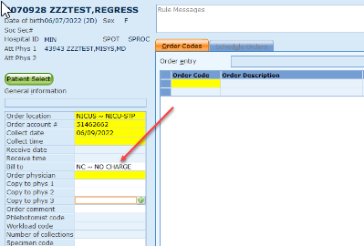More information consult lab SOP LIS 1.2 Order Entry In Sunquest
 |  | For Genetics Patients, contact the On Call Genetics Provider through AMION and notify them of Patient Delay due to Second Collection Attempt.
 |  | If a second collection attempt also fails to produce an adequate volume of sweat (samples are both less than 2 revolutions), postpone further attempts until the patient is better hydrated, and have another technologist perform the subsequent repeat collection if possible. Again, notify the patient’s provider if the second collection attempt was unsuccessful.
 |  | Inform families that inquire about results, “You can speak with your physician or the genetics counselor at your appointment today about the availability and meaning of the sweat chloride results.”
 |  | Cancel SWCL in GUI, General Laboratory only if no collection is attempted (for example, the patient failed to arrive for the appointment).
Sweat collection  Order Receipt | Step | Action |  |  |  | Related Document
 | 1 | When receiving the sweat collection in GUI, function General Laboratory complete the following:  Arrow 1)  - Enter the start time under collection time then TAB down to Phlebotomist code  - PHLEBOTMIST CODE: Enter tech code  - ORDER WORKLOAD CODE: enter SWC for Sweat Collection  Arrow 2) click the receive button  Arrow 3) Add test SWCD
 | 1.a | 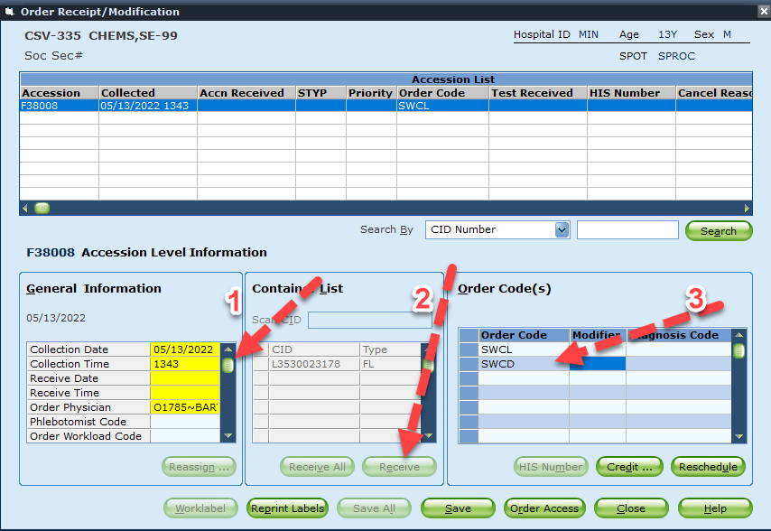
 | 2 | After selecting save a secondary box will appear. Enter the Following information about collection times:  See 2.a  BGIN1: enter the time the first collection device was placed on the patient  BGIN2: enter the time the second collection device was placed on the patient  END1: enter the time the first collection device was removed from the patient  END2: enter the time the second collection device was removed from the patient  This difference between the Begin Time and End Times must not exceed 30 minutes.
 | 2.a | 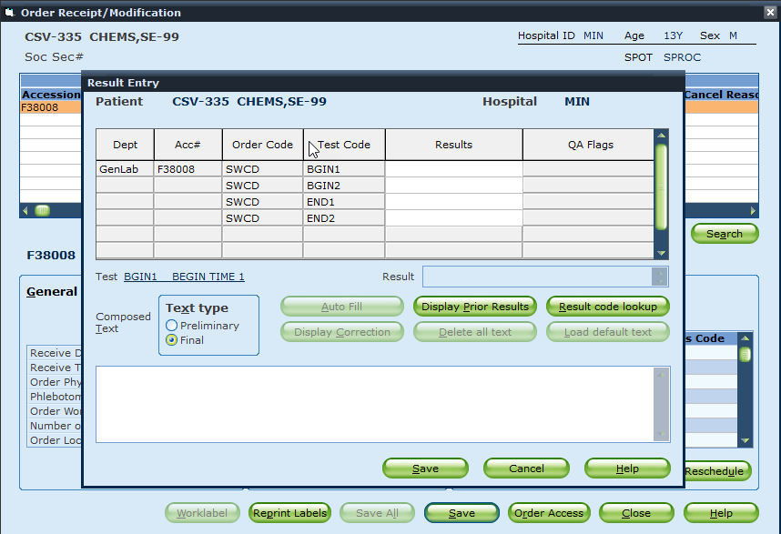
Limitations | - Repeat testing may be performed when practical, even the same day. The rate of sweating varies from day to day.  - Burn possibilities are reduced by using undamaged pilogel disks, appropriate strap pressure so disks are not crushed, and leaving the skin moist where the electrode is to be placed (or adding a drop of water to the disks.)  - While allergic reactions to Pilocarpine iontophoresis are unusual, if diffuse inflammation, burns, or urticaria (hives) occurs:  - Immediately discontinue the procedure  - Contact the patient’s physician  - Notify the Pharmacy.  - Complete an on-line Patient Safety Report, and include a description of the appearance of the area, and any conversation with the family.  - Do not assay the sweat sample due to possible contamination with serous fluid.  - If the patient is experiencing discomfort during the iontophoresis, it is probably due to an uneven current distribution. This can be corrected by tightening the bands to apply even pressure across the gel.  - Collections from more than one site should never be pooled.  - Iontophoresis current must never cross the patient’s trunk.  - The minimum rate of sweating is 1 gm/m²/minute. A longer collection time would require a larger volume of sweat. The 15 μL sample size corresponds to a maximum 30-minute collection time for the area stimulated by the Macroduct system.  - The incidence of insufficient samples must be measured, investigated and resolved if it exceeds 5% for ages >90 days, and if it exceeds 10% for ages <90 days. Only when there are 2 QNS samples in one collection will it be counted in the collection failure rate, per CLSI and CF Foundation guidelines.  - If one arm yields an acceptable sweat collection volume but the other arm is <15uL or unable to perform, run and report the acceptable sweat collection. An attempt to stimulate the child at least once more should be made to gain 2 sweat results for the Genetics team.
References | - College of American Pathologists, Chemistry and Toxicology Checklist, revised January 4, 2012.  - Cystic Fibrosis Foundation Sweat Testing guidelines.  - Clinical and Laboratory Standards Institute (CLSI). Sweat Testing: Sample Collection and Quantitative Chloride Analysis; Approved Guideline-Third Edition. NCCLS document C34-A3. Clinical and Laboratory Standards Institute, 940 West Valley Road, Suite 1400, Wayne, PN, 19087, 2000.  - Macroduct Sweat Collection System Model 3700 SYS, Instruction/Service Manual, Wescor, Inc., M 2551-7 rev A, © 2004.  - Macroduct Supply Kit Product Insert, Information for Parents, Wescor, Inc. 370 West 1700 South, Logan, UT 84321, 6/13/2008  - Vicky A. Le Grys DrA, MT(ASCP), NACFC 2020 Quality Improvement Consortium, “Improving the Quality of Sweat Testing in the NBS+ Macroduct Era”, NACFC 2020 | the Quality Improvement Consortium - YouTube, accessed 7/20/2022 timestamp 1:05:41
Appendices | 8.07 Sweat Chloride Collection Training Documentation
Historical Record
 | Version |  | Written/Revised by: | Effective Date: | Summary of Revisions
 | 1 (MPLS) |  | Minneapolis | January 1991 | Initial Version
 | 1 (SYSTEM) |  | Kristine Carlson | October 13, 1998 | Chloride, Sweat Collection and Assay
 |  |  | Kristine Carlson | March 8, 1999 | Macroduct System
 |  |  | L. Lichty | April 16, 2002 | Sweat Stimulation and Collection
 |  |  | L. Lichty | February 5, 2004 | Sweat Collection
 |  |  | L. Lichty | July 6, 2005
 |  |  | L. Lichty | January 4, 2006 | Notify Pharmacy and complete Patient Safety Report for reaction to pilocarpine.
 |  |  | L. Lichty | September 11,2007 | Sweat Collection, added inform family of burn risk, and conditions of iontophoresis
 |  |  | L. Lichty | February 21, 2011 | New format. Added safety section, revised infection control, revised procedural risk, renumbered from CH 0.23
 |  |  | L. Lichty | January 7, 2013 | Notify patient physician in case of burn or reaction, storage conditions
 |  |  | L. Lichty | November 17, 2014 | Added CVIS steps to collection, revised Infection Control language.
 |  |  | L. Lichty | September 30, 2015 | Added SWCD test code to document collection duration
 |  |  | L. Lichty | 8/1/2016 | Notify provider of collection failure
 |  |  | Erin Bartos | 3/1/2017 | Changes to Patient and Family Preparation. Deliver patient specimen in a sealed plastic bag. Changes to crediting, and QNS failure rate counting. Changes to who cancels testing. All samples should be submitted to lab.
 |  |  | Stephen Gripentrog, Matt Johnson | 7/20/2022 | Removed old collection receipt language and added our current practice. Adding information for Collecting a second Bilateral collection, Reorder and notifying Provider. Reviewed infection control. Updated protocol for immediate re-stimulation when one or two QNS.

