Sickle Cell Patients Red Cell Orders

Purpose | This process describes how to provide red cells blood products that are negative for the Kell, E and C antigens and negative for Hgb S to patients with Sickle Cell Disease.
Policy Statements | - Patients with known Sickle Cell Diseases shall receive leukocyte reduced red cells meeting the following criteria for all non-emergency transfusions.  - Antigen negative for K, big C, and big E [unless the patient’s phenotype indicates the patient is K, C or E positive.]  - Negative for hemoglobin S.  - Red Cells ≤14 days  - Antigen typing and Hgb S testing may be performed by the blood center or by Children’s Transfusion Service. Note: Only Mpls Transfusion Service performs antigen typing in-house  - A minimum of one O Rh negative leukocyte red cell unit negative for Kell, C, and E antigen, and Hgb S negative shall be maintained in the Minneapolis blood inventory at all times.  - Antigen typing and Hgb S cell testing may be deferred in life-threatening emergency situations where the need for transfusion outweighs the benefits of these other requirements.
Process
 | Activity |  |  | Key Considerations |  |  | Related Document
 | 1 | Indicate in the patient’s BAD file the patient’s special needs |  | - Enter the Problem Patient comment KECS-Use K neg, C neg, E neg, Sickle Negative Blood.  - Enter CEKS into attribute field |  |  | TS 5.4 Making Changes to a Blood Administration Record
 | 2 | Review inventory for K, C, E and HgbS negative tested units |  | If Then  Product available and labeled as K, C, E and HgbS negative Proceed to step 4  Historically antigen negative unit(s) available (Mpls) Proceed to step 3  Not available Order from blood center or screen for units |  |  | TS 7.3 Ordering Products-MBC  TS 7.4 Ordering products-ARC
Adhere pink SICKLE NEGATIVE and NEGATIVE FOR K, C and E ANTIGEN labels on each unit upon receipt or completion of in-house testing. | 3 | Perform antigen typing and Hgb S testing |  | Add unit attribute CEKS in BPE-Modify Unit Information for units testing negative. |  |  | TS 7.16 Sickle (Hgb S) Testing Red Cell Products  TS 7.17 Antigen Typing Red Cells Products  TS 7.20 Modifying BPE Information
 | 4 | Perform patient pre-transfusion testing as needed and allocate unit (s). |  | Add Unit Tag comments: NKEC and NSIK
Result test AO with antigen typing results-NKEL, NBGE, NBGC  Result MAI or ARCAG with number of tests -;3 | 5 | Bill for testing at product allocation, issue or release from allocation. |  | - SICT-Hgb S testing done by MBC [key M]  - SICA-Hgb S testing done by ARC [key %]  - SIC-Hgb S testing done in-house [enter test result as ;NEG]  - MAI-Antigen typing done by MBC [enter number antigen tested per unit]  - ARCAG-Antigen typing done by ARC [enter number antigen tested per unit]  - AO-Antigen typing done in-house [enter antigen typing codes]  (Credit codes: CSICT, CSICA, CSIC, CMAI, CANTG, CAO)
 | 6 | Store product until issue. |  | Notify the patient care unit that the product  is ready. |  |  | TS 7.18 Storage of Blood Products
RBCs volume communication to HOC | Step Action  1 Transfusion service will place RBC order in BloodHub. Add all patient demographics into the BloodHub order. Including patient’s full name and MRN. 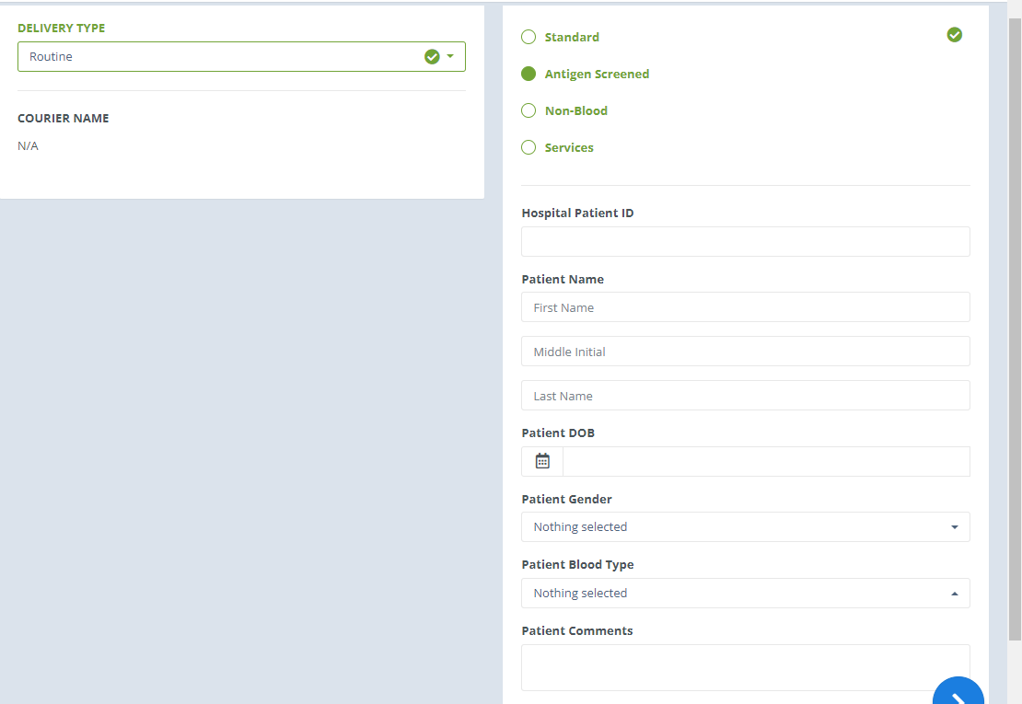  2 When RBCs are received, weigh the units, write volumes next to the units received for the patient and place sheets into the file folder next to the pneumatic tube station. Continue entering the units into Sunquest per procedure TS 7.08 Entering Products into Sunquest. 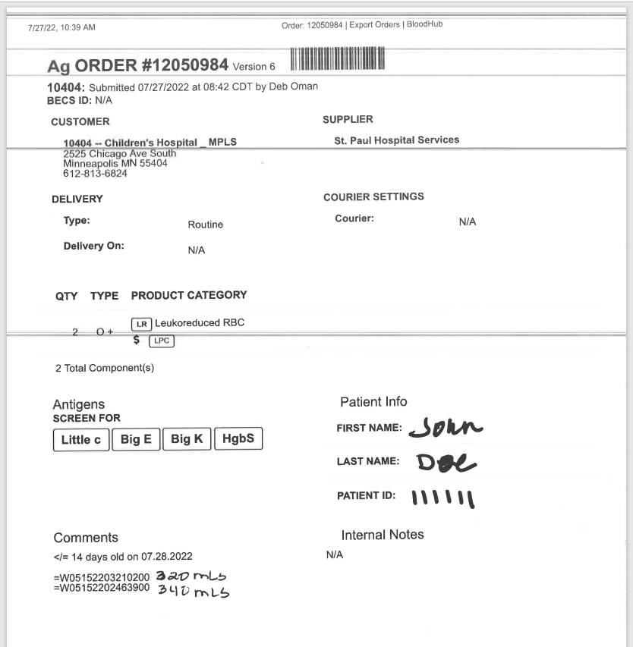  3 Day of the patient’s transfusion, tube all MBC order sheets for the patients that are having transfusion that day before 8:30am to HOC.  4 Providers will determine the volume to be transfusion to patient, if the volume to be transfused deviates from what is ordered the provider will place a Blood Bank Communication order stating the volume to be transfused.
Approval  Workflow | Transfusion Service/Medical Director
Historical Record | Version |  | Written/Revised by: |  | Effective Date: | Summary of Revisions
 | 1 |  | B Busall |  | 11/1997 | Initial Version
 | 2 |  | J Wenzel |  | 9/14/1999 | Merger
 | 3 |  | J Wenzel |  | 7/01/2002
 | 4 |  | J Wenzel |  | 11/25/2008 | Online format, SICA billing
 | 5 |  | J Wenzel |  | 4/10/2012 | Billing code changes for antigen typing.
 | 6 |  | S Cassidy |  | 12/01/15 | Added age limit of RBCs
 | 7 |  | S Cassidy |  | 08/19/2022 | Added steps to handle HOC notification of blood volumes

