Chronically Transfused Patient Red Cell Orders

Purpose | This process describes how to provide red cells blood products for patients that are chronically transfused (i.e. thalassemia, Diamond-Blackfan anemia, or other transfusion dependent patient).
Policy Statements | - Patients who are chronically transfused shall receive leukocyte-reduced red cells meeting the following criteria for all non-emergency transfusions.  - That are antigen matched for K, and Rh (C, c D, E, e)  - When available and phenotypically matched Apheresis RBCs < 14 d (if 2 or more RBC ordered in order to limit donor exposure) or  - Single donor RBC ≤14 days  - Patients will have either an extended RBC phenotype (if not been transfused in the last 3 months) or RBC genotyping once.  - When possible, the transfusion plan will be shared with the blood supplier well in advance to allow for availability of fresher matched cells, including both number of units and antigen typing (including ABO type) required.
Process
 | Activity |  |  | Key Considerations |  |  | Related Document
 | 1 | Indicate in the patient’s BAD file the patient’s special needs |  | - Enter the phenotyping or genotyping antigenic results  - Enter requires ≤14 days RBCs |  |  | TS 5.4 Making Changes to a Blood Administration Record
 | 2 | Review inventory |  | If Then  Product available and labeled as negative for antigens in patient’s BAD file Proceed to step 4  Historically antigen negative unit(s) available (Mpls) Proceed to step 3  Not available Order from blood center or screen for units |  |  | TS 7.3 Ordering Products-MBC  TS 7.4 Ordering products-ARC
 | 3 | Perform antigen typing |  | Add unit antigens results BPE-Modify Unit Information for units testing negative. |  |  | TS 7.17 Antigen Typing Red Cells Products  TS 7.20 Modifying BPE Information
 | 4 | Perform patient pre-transfusion testing as needed and allocate unit (s). |  | Add Unit Tag comments: for the antigens unit is negative for:  - NKEL-negative for K  - NBGE-negative for E  - NBGC-negative for C  - NLTC-negative for c  - NLTE-Negative for e
Result test AO with antigen typing results-  Result MAI or ARCAG with number of tests -;3 | 5 | Bill for testing at product allocation, issue or release from allocation. |  | - MAI-Antigen typing done by MBC [enter number antigen tested per unit]  - ARCAG-Antigen typing done by ARC [enter number antigen tested per unit]  - AO-Antigen typing done in-house [enter antigen typing codes]  (Credit codes: CSICT, CSICA, CSIC, CMAI, CANTG, CAO)
 | 6 | Store product until issue. |  | Notify the patient care unit that the product  is ready. |  |  | TS 7.18 Storage of Blood Products
RBCs volume communication to HOC | Step Action  1 Transfusion service will place RBC order in BloodHub. Add all patient demographics into the BloodHub order. Including patient’s full name and MRN. 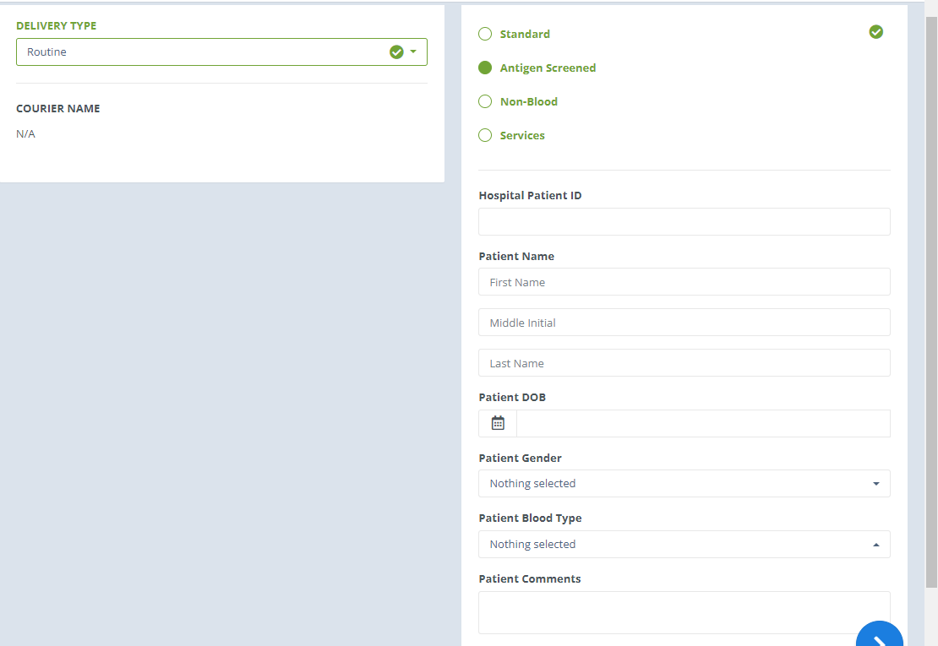  2 When RBCs are received, weigh the units, write volumes next to the units received for the patient and place sheets into the file folder next to the pneumatic tube station. Continue entering the units into Sunquest per procedure TS 7.08 Entering Products into Sunquest. 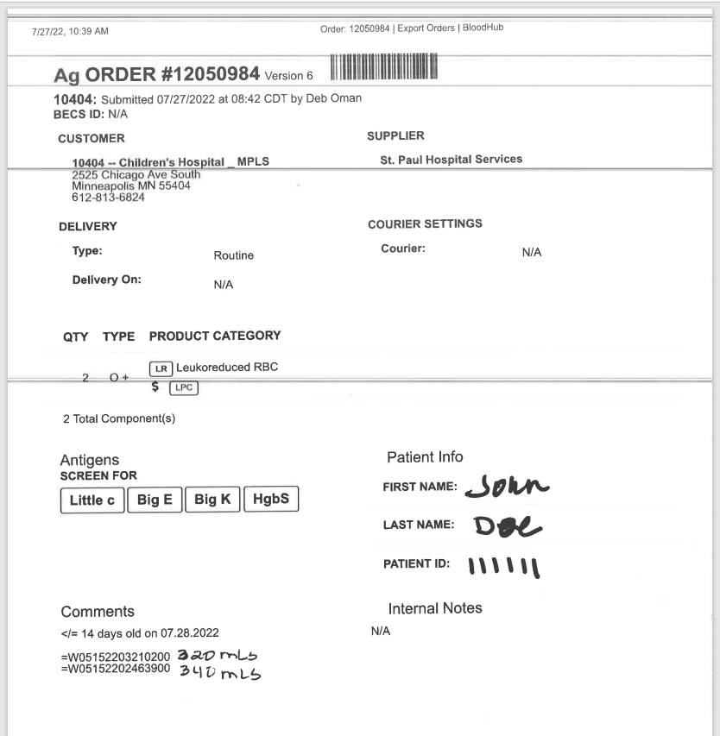  3 Day of the patient’s transfusion, tube all MBC order sheets for the patients that are having transfusion that day before 8:30am to HOC.  4 Providers will determine the volume to be transfusion to patient, if the volume to be transfused deviates from what is ordered the provider will place a Blood Bank Communication order stating the volume to be transfused.
Approval  Workflow | Transfusion Service/Medical Director
Historical Record | Version |  | Written/Revised by: |  | Effective Date: | Summary of Revisions
 | 1 |  | S. Cassidy |  | 01/02/2017
 | 2 |  | S Cassidy |  | 08/19/2022 | Added steps to handle HOC notification of blood volumes

