MC 6.02 AST-XN08 Susceptibility Reporting Guidelines

Purpose | This procedure provides instruction and guidance for requested testing and reporting of Antimicrobial Agents / organism groupings for the AST-XN08 Vitek card for patient testing. This procedure also provides instructions for a rolling validation for lowering breakpoints to be consistent with CLSI M100 edition 29 published in 2019. Organisms with intrinsic resistance to antimicrobial agents will not be reported.
Principal and Clinical Significance | The decisions for the most appropriate antimicrobial agents to test and report are made with input from Pharmacy, Infectious Disease and the Clinical Laboratory. The goal is to provide clinically relevant information that will decrease the chance of developing antibiotic resistance, harmful effects of inappropriate antimicrobial use and avoid reporting results that could adversely affect patient care.
Policy Statements | This procedure applies to Microbiologists who perform plate reading.
Special Safety Precautions | Microbiologists are subject to occupational risks associated with specimen handling.  - Biohazard Containment  - Biohazardous Spills  - Safety in the Microbiology Laboratory
Procedure | - The AST-XN08 card follows CLSI guidelines and breakpoints.  - Only report antibiotics that are requested.  - Perform testing to report Meropenem on all Pseudomonas aeruginosa isolates.  - Perform testing on Proteus spp., Morganella spp. and Providencia spp. isolates to report Meropenem when Imipenem, Piperacillin/Tazobactam, Ceftriaxone and Ceftazidime are resistant.  - Click on the Online tab. Do not click on Select all online susceptibility results. Instead, click on the requested antibiotics as shown in Figure 1 & 2. Then, click on Accept Selected.  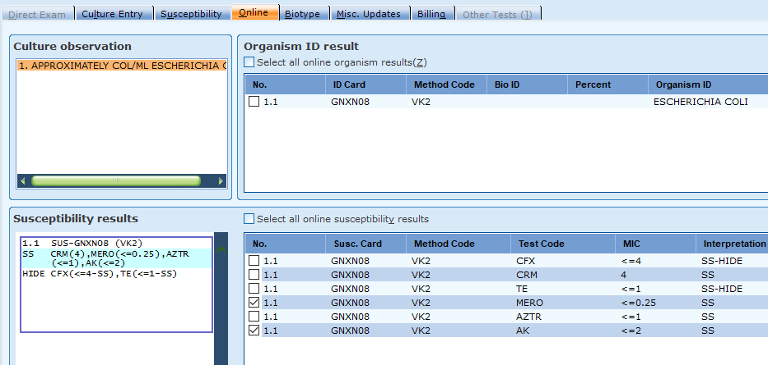  Figure 1  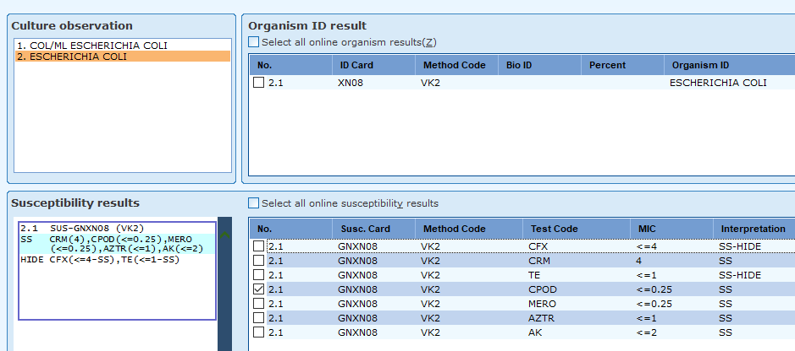  Figure 2  - Only the selected antibiotics will be reported. See Figure 3 & 4.  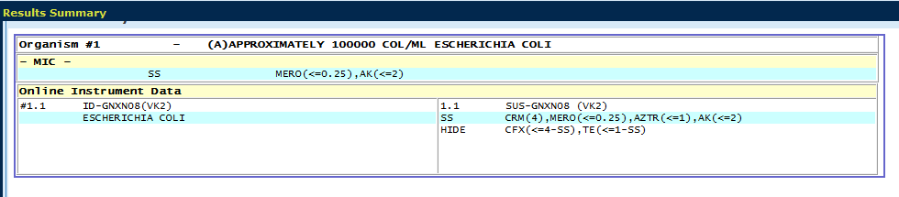  Figure 3  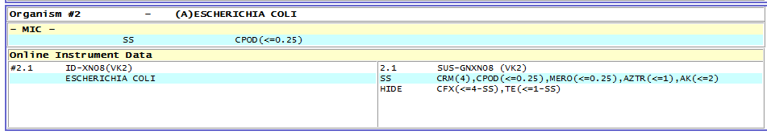  Figure 4  - If you run both the AST-GN95 and AST-XN08 at the same time, it will cross into Sunquest as an AST-NS16 and all the results will be combined. Do not click on Select all online susceptibility results. Instead, click on the desired antibiotics.  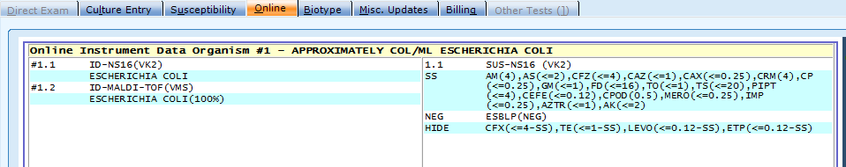  Figure 5  - Perform and report KB or MicroScan results for antimicrobial agents that have card  limitations for patient testing following organism tables below.
Lowering Breakpoints Validation | - CLSI M100 edition 29 has updated 2019 breakpoints on Pseudomonas aeruginosa and Acinetobacter spp. for Meropenem. To validate the 2019 breakpoints, we will perform KB and enter results into Sunquest for patient testing. Vitek MIC results for Meropenem will be visible on the Vitek printout but will not cross into Sunquest. Do not manually enter results.  - Using the results from the AST-XN08 card and the KB results, we will perform a rolling validation. Enter Vitek and KB results into the spreadsheet to collect data to validate the lower breakpoints. GN95 XN08 Rolling Validation.  - If results are discrepant, report the KB results. For validation purposes, repeat both KB and XN08, freeze organism and notify supervisor.
Antibiotics reported from card and Product Limitations | Antibiotic Product Limitations  Amikacin Perform alternate method on Acinetobacter baumannii  Aztreonam Perform alternate method on Pseudomonas spp.  Cefoxitin  Cefpodoxime Perform alternate method on Morganella morganii, Serratia spp.  Ceftolozane/ Tazobactam Perform alternate method on Morganella morganii, Providencia rettgeri, Serratia marcescens Perform alternate method on resistant Citrobacter koseri, Proteus mirabilis, Proteus vulgaris and Serratia liquefacians  Cefuroxime  Meropenem Perform alternate method on resistant Aeromonas spp  Tetracycline  Table 1  For Non-Enterobacteriaceae, perform MicroScan if alternate method is required. There are no CLSI guidelines for KB with Non-Enterobacteriaceae.
Validation for lowering breakpoints | Antibiotic Validation for lowering breakpoints- perform KB  Meropenem Perform KB for validation of breakpoints on Pseudomonas aeruginosa and Acinetobacter spp.  Table 2  Enter results into the spreadsheet to collect data to validate the lower breakpoints. GN95 XN08 Rolling Validation.
References | Vitek AST-XN08 Gram Negative Susceptibility Card bioMerieux 2017/11  CLSI M100 edition 29 Performance Standards for Antimicrobial Susceptibility Testing 1/2019
Training Plan/ Competency Assessment | Training Plan |  |  |  |  | Initial Competency Assessment
 | - Employee must read the procedure.  - Employee will observe trainer performing the procedure.  - Employee will demonstrate the ability to perform procedure, record results and document corrective action after instruction by the trainer. |  |  |  |  | - Direct observation.
Historical Record
 | Version | Written/Revised by: |  | Effective Date: |  |  | Summary of Revisions
 | 1 | Susan DeMeyere |  | 4/14/2020 |  |  | Initial version
 | 2 | Susan DeMeyere |  | 9/19/2022 |  |  | Added additional situations to test for Meropenem.

