Performing CS-5100 Monthly / As Needed Maintenance

Purpose | This procedure provides instructions for PERFORMING CS-5100 MONTHLY MAINTENANCE.
Policy Statements | - This procedure applies to all laboratory technologists who operate the CS-5100, and to the section supervisor.
Materials | Supplies |  |  |  | Equipment
 | - Vacuum or other method for removing dust from filter. |  |  |  | - N/A
 | Follow the activities in the table below for PERFORMING CS-5100 MONTHLY / AS NEEDED MAINTENANCE.
Procedure | Step | Action |  |  |  |  | Related Document
 |  | Clean the filter, left side.
 | 1 | Open the light shield lid.
 | 2 | Push the top of the filter, then pull it out.
 | 3 | Use a vacuum or similar tool to remove dust  from the filter.
 | 4 | Re-install a clean filter, close the light shield lid.
 |  | Clean the filter, right side
 | 1 | Push the top of the filter cover, remove the cover by tilting it slightly toward you.
 | 2 | Remove the filter mount.
 | 3 | Use a vacuum or similar tool to remove dust from the filter.
 | 4 | Attach a clean filter to the filter cover.
 | 5 | Install the filter cover.
 | 6 | Close the filter cover.
 | 7 | Document manual maintenance in Operation Panel.  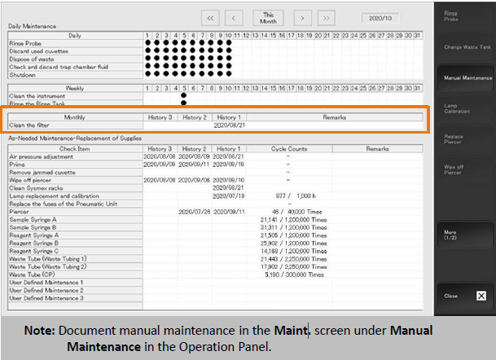
 | 6 | Directions for performing any other “as needed” maintenance can be found in the Sysmex CS-5100 Training Workbook, pages 63 – 74.  CS-5100 System Training Workbook
References | - SysmexCS-5100 Training Workbook, EffectiveDate:14-Jan-2021JobAid HOOD05162003158941  CS-5100 System Training Workbook
Historical Record | Version |  | Written/Revised by: | Effective Date: |  | Summary of Revisions
 | 1 |  | Al Quigley | 9/19/22 |  | Initial Version

