Performing CS-2500 Daily Maintenance

Purpose | This procedure provides instructions for PERFORMING CS-2500 DAILY MAINTENANCE.
Policy Statements | - This procedure applies to all laboratory technologists who operate the CS2500, and to the section supervisor.
Materials | Supplies |  |  |  | Equipment
 | - Sysmex CA Clean I, 50 ml bottle, product # 10445689  - Distilled water  - CA Clean II 5.0 L box, product # 10445690  - Cuvettes, Reaction Tubes, 3000/box, product # 10488059  - Liner, Trash CS-2500,  Product # 10628682 |  |  |  | - N/A
Procedure | Follow the activities in the table below for PERFORMING CS-2500 DAILY MAINTENANCE.
 | Step | Action ( Shut Down ) |  |  |  |  | Related Document
 | 1 | Verify CA Clean I vial is loaded on the Reagent Table.
 | 2 | Press Shutdown icon. Select option: Turn the Main Unit OFF.
 | 3 | Press O.K. Cleaning will take 5 minutes. Wait for IPU computer to automatically shut down.
 | 4 | Press analyzer power switch off, this is located on the upper left side of the analyzer.
 | 5 | Check Trap Chamber for fluid. Remove fluid if present.
 | Step | Action ( Start Up )
 | 1 | Press power button on IPU computer. Computer starts up.
 | 2 | The Logon dialog box appears when the startup is complete.
 | 3 | Enter User password (Customer+2020). Instrument software starts up.
 | 4 | Select Logon icon, enter password (admin).
 | 5 | Press analyzer power switch on.
 |  | Tasks to complete
 | 1 | Select Status to check rinse, waste, cuvettes. Empty cuvette trash box, replace liner if necessary. Reset trash counter.
 | 2 | Press Maint. Icon. Empty waste tank: Press Change Waste Tank Key. Empty waste. Press O.K.
 | 3 | Check / Replace DI water.
 | 4 | Check / Replace detergent (CA Clean II box).
 | 5 | Add cuvettes to the hopper if necessary. Do not fill above the red line.
 | 6 | Select Manual Maintenance key: check off completed tasks.  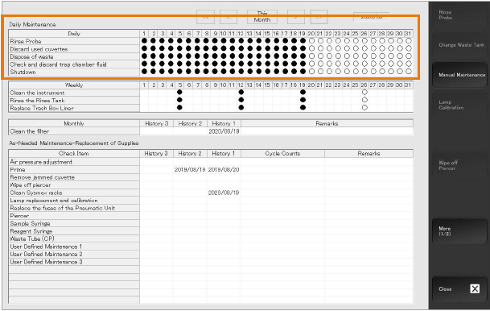
 | 7 | Press the Menu icon to view the Main Menu.
 | 8 | Replace reagents and QC as needed.
 | 9 | Run QC for assays.
References | - SysmexCS-2500 Training Workbook, EffectiveDate:14-Jan-2021JobAid HOOD05162003158941  Sysmex CS-2500 Training Workbook
Historical Record | Version |  | Written/Revised by: | Effective Date: |  | Summary of Revisions
 | 1 |  | Al Quigley | 9/19/22 |  | Initial Version

