Performing CS-2500 Weekly Maintenance

Purpose | This procedure provides instructions for PERFORMING CS-2500 WEEKLY MAINTENANCE.
Policy Statements | - This procedure applies to all laboratory technologists who operate the CS-2500, and to the section supervisor.
Materials | Supplies |  |  |  | Equipment
 | - Deionized water  - Clean towel  - 70% Isopropyl Alcohol (2-Propanol) CHC# 15609, Ricca Chemical, Vendor Item # 4210-1, Cardinal Health. Gallon Jugs Available.  Do not use this product for cleaning surfaces of the analyzer. |  |  |  | • N/A
Special Safety Precautions | Dispose of 70% Isopropyl alcohol into a waste container in the flammable cabinet. When this container is ¾ full it should be taken to the hospital disposal site for hazardous waste and replaced with an empty container in the Flammable cabinet.
Procedure | Follow the activities in the table below for PERFORMING CS-2500 WEEKLY MAINTENANCE.
 | Step | Action |  |  |  |  | Related Document
 | 1 | Shut down the Main Unit
 | 2 | Clean the instrument exterior and interior.  Wipe the instrument with a moistened paper towel with water and a neutral detergent.
 | 3 | Clean the rinse tank.  2. Use water or isopropyl alcohol to wash the inside of  the tank and float switch, then rinse with distilled multiple times with  distilled water.  3. Replenish the rinse water,  4. Attach the float switch and tighten the cap.
 | 4 | Document completed maintenance in Operation panel.  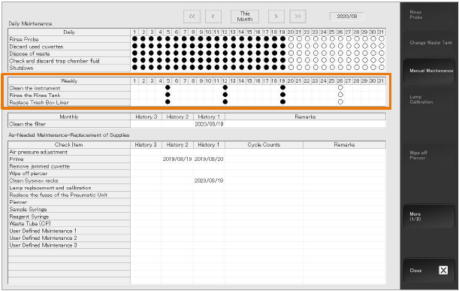
References | - SysmexCS-2500 Training Workbook, EffectiveDate:14-Jan-2021JobAid HOOD05162003158941  Sysmex CS-2500 Training Workbook
Historical Record | Version |  | Written/Revised by: | Effective Date: |  | Summary of Revisions
 | 1 |  | Al Quigley | 9/19/22 |  | Initial Version

