Procedure

Purpose | This procedure provides instructions for CREATING A NON-PATIENT ENCOUNTER IN CERNER REQUIRED TO ACTIVATE A FUTURE ORDER FOR A REMOTELY COLLECTED GENETICS TESTING SPECIMEN.
Policy Statements | - The scope of this procedure is limited to Sendouts Laboratory staff for the purpose of activating orders for remotely collected Genetics testing specimens:  - for which the laboratory has a result report or  - for which the laboratory has been notified by another institution that a patient’s blood has been collected and shipped to Children’s Lab or a reference lab.  - This procedure may only be completed by Children’s Sendouts Laboratory staff when the patient already has a Children’s Minnesota medical record number (i.e., is already a registered patient with demographics and guarantor information completed in Cerner and GE Centricity).  - Children’s Laboratory staff may not create encounters for patients who drop off specimens in-person at a Children’s facility. Children’s Laboratory staff may not create encounters for outpatients presenting for a visit. Encounters for such needs must be created by Children’s Registration.
 | Step | Action |  |  |  |  |  | Related Document
Procedure to Create a Non-patient encounter | 1 | Log into Powerchart (Cerner)
 | 2 | Prepare for encounter creation by gathering the following data from the result report or remote kit collection confirmation:  - Patient name, date of birth and MRN (if available)  - Date of specimen collection  - Name of ordering Provider  If a result report will be scanned, recording the collection time and specimen type at this point is also useful.
 | 3 | Before creating encounter, verify that there is an appropriate existing Future Order available in the patient’s chart in Cerner. If not, stop and contact the Genetic Counseling team to request that an order be placed. Email gc_on-call@childrensmn.org
 | 4 | Click Conversation Launcher from action bar in Cerner  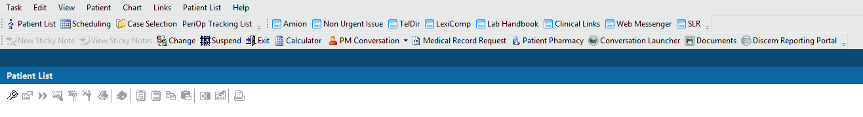
 | 5 | Click General Reg OP from pop up box then click OK  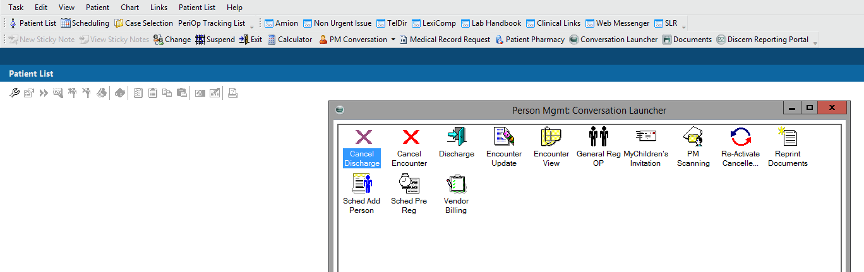
 | 6 | Enter partial patient name in the pop up search box (suggested: first three letters of last name,first three letters of first name)
 | 7 | Single click on the correct patient after confirming full name, date of birth. Confirm medical record number (MRN), if available, also matches.
 | 8 | Click Add Encounter button in bottom right of pop up box  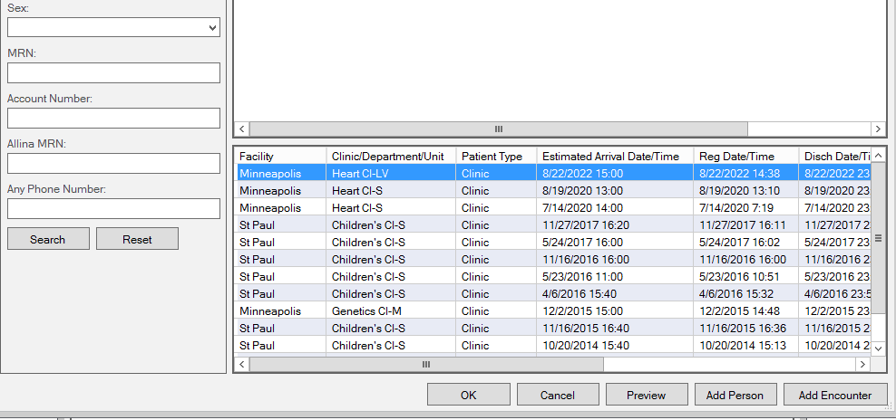
 | 9 | Choose location (St Paul or Minneapolis) as appropriate for workflow.  Type * to bring up all the options  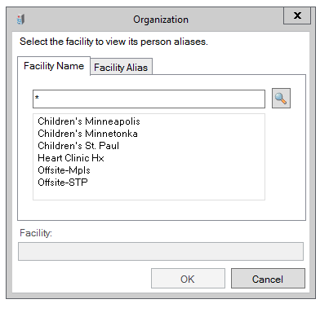
 | 9 | There are several required fields in the Guarantor and Encounter tabs in the Gen Reg OP pop up box  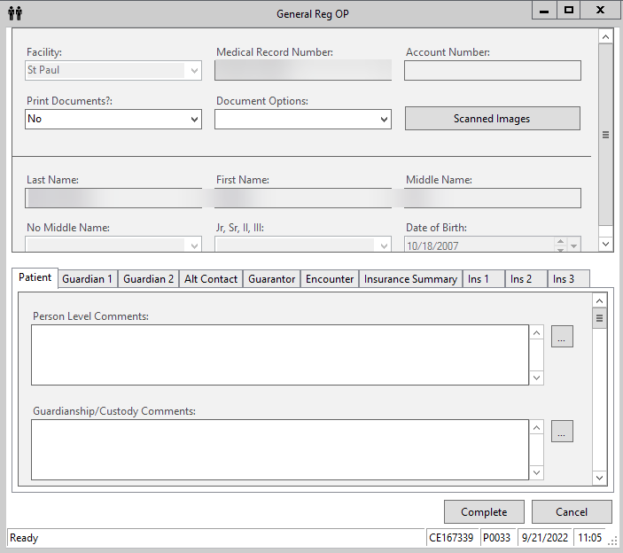  - Skip the Patient tab  - Make a note of the relationship of the Guardian #1 (need for later)  - Skip the Guardian #2 tab and skip the Alt Contact tab  - In Guarantor tab Relationship to Patient field, select the relationship from Guardian #1. For example, if the Guardian #1 is Mother, select Mother from the drop down box in the Guarantor Relationship to Patient field. This should autofill the required Guarantor Address box near the bottom of this tab.  - DO NOT CLICK COMPLETE YET. Continue to the next page of this procedure for Encounter tab instructions.  NOTE: When you move out of the Guarantor tab, you may get a pop up about consent. You may proceed to Encounter tab - See step 10 l) below for further information.
 | 10 | In the Encounter tab of the Gen Reg OP pop up box  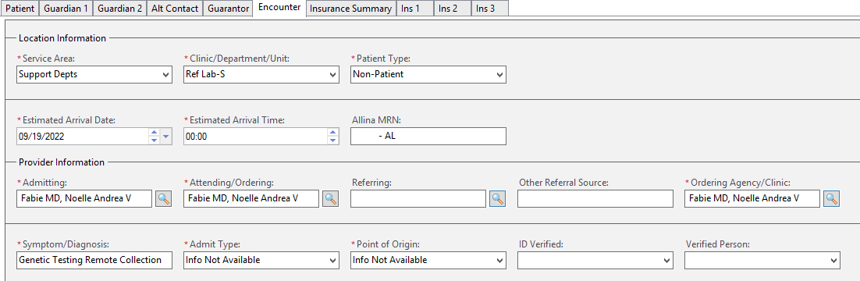  - Service Area = Support Depts  - Clinic = Ref Lab (NOT Lab)  - Patient type = Non-patient  - Estimated Arrival date = Date of specimen collection (this is NOT where the desired encounter date comes from, see step m) below). Time doesn’t matter.  - Estimated arrival time (tab through to autofill)  - Admitting Provider = Type in Ordering provider (you may need to check the Future Cerner order to determine who this is. The provider on a result report may be outdated especially if you are working with an Amended report from an old collection date)  - Attending Provider = same Ordering provider  - Ordering Agency/Clinic = same Ordering provider  - Symptoms/Diagnosis = freetext “Genetic Testing Remote Collection”  - Admit type = Info not available  - Point of Origin = Info not available  - Consent Information: Most of the time you will not need to enter something here. If it is already filled in, leave it. If you received a pop up warning earlier that the consent has expired, you can disregard. However, If a required field is blank and you can’t move past it, select NO. If a date is required, enter date from one year ago (e.g., if today is 09/01/2022, enter 09/01/2021). Summary: make as little change to the consent fields as allowed, registration staff will attend to it the next time the patient is seen.  ***IMPORTANT***  - You will need to scroll down to the Registration Date field. It will be autofilled with today’s date and not highlighted yellow. You must change the date to the date of collection here. This is what creates the desired encounter date. The time doesn’t matter. 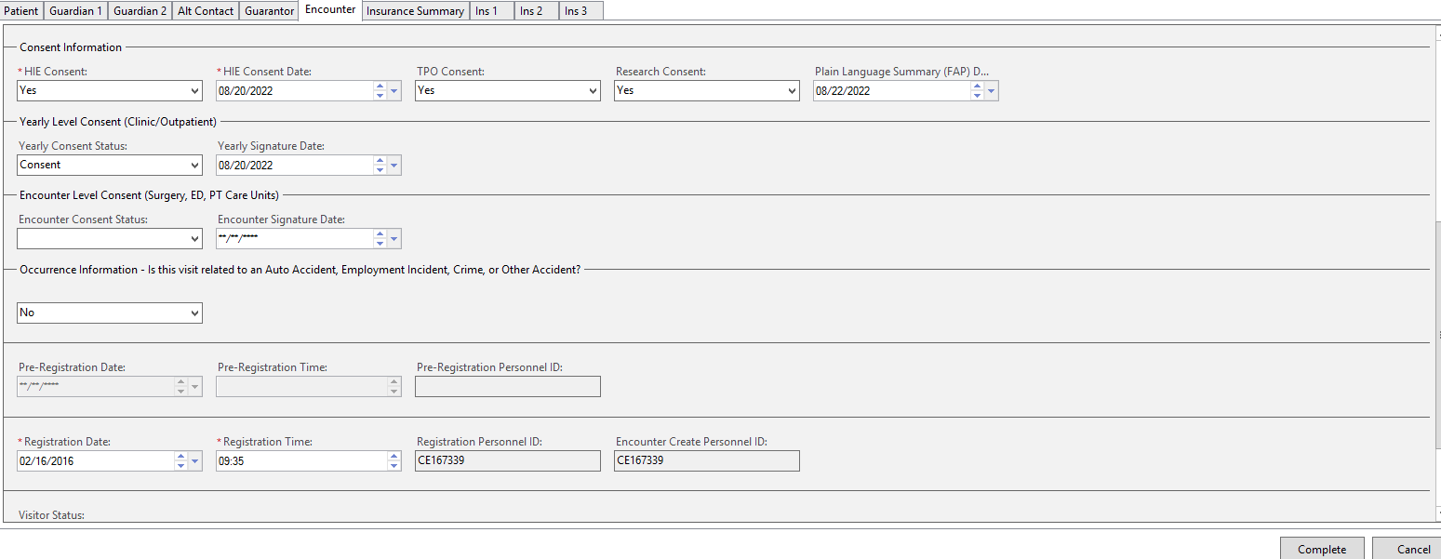
 | 11 | Click complete. You should get a pop up that says the “alias has been assigned” and you will see the FIN (encounter number). If any required fields were missed, you will be prompted to edit them.  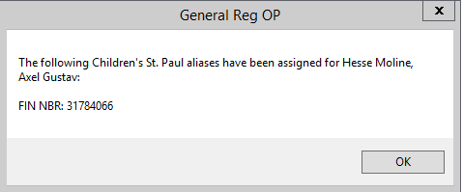  If you have difficulty, contact technical specialist or Genetics Counseling Assistants to help troubleshoot.
 |  | You may now proceed with activating Future order, receiving/completing in Sunquest, and/or scanning, as applicable.  Important:  To active the Future order, do NOT pull up the patient by selecting from your “recent patients” because you will be brought to the incorrect encounter. You must re-search by typing in name or MRN then select the Non-patient encounter you just created. |  |  |  |  |  | LIS 1.22 Activating Future On-hold Orders (childrenshc.org)  LIS 1.26 Order Receipt Modify (GUI ORM) (childrenshc.org)  SO 1.01 Scanning Documents (childrenshc.org)
Historical Record | Version |  | Written/Revised by: |  | Effective Date: | Summary of Revisions
 | 1 |  | Sandra Tekmen |  | 9/30/2022 | Initial Version

