SCD 312 Verification

Equipment Serial Number_________________ Biomed Number___________________

In-Service Date_______________________

Action/Procedure | Expected Result | Actual Result | Pass or Fail | Initials & Date
- Turn on POWER switch.  - After turning on the SCD the:  - Fan will start | Instrument turns on and fan starts. | Fan started  □ Yes □ No | □ Pass  □ Fail
Weld Integrity Inspection:  - Compare weld to those illustrated below.  - No Misalignment is acceptable  - Shows misaligned weld is not acceptable  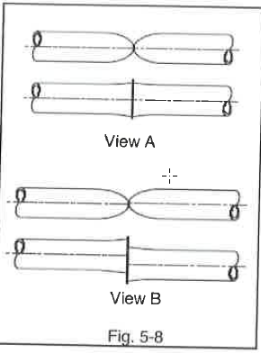  - Pinch or roll tubing unit fluid pathways opens.  - Check weld for leakage. | Weld looks like view A. | Weld is not misaligned  □ Yes □ No  Fluid Pathway Opens  □ Yes □ No  The weld does not leak  □ Yes □ No | □ Pass  □ Fail

Approval Signatures for SCD 312 Sterile Tubing Welder Operational Qualification:
Operational Qualification acceptable?
□ Yes □ No If no, Describe father action to be take and by whom.
Transfusion and Tissue Service Technical Specialist | Date:
Transfusion and Tissue Service Medical Director | Date

