Filling Out Transfusion Service Forms and Training Documents

Purpose | This procedure provides instructions on how to fill out the multiple transfusion service forms and training documents
Policy Statements | - Records shall be complete, retrievable in a period for time appropriate to the circumstances, and protected from accidental or unauthorized destruction or modification
Procedure
 | Step | Action
Training Documents | 1 | Have new trainee fill out their name and transfusion start date.
 | 2 | Trainer fill out each section of the training document.  - Place a check mark after you reviewed the procedure with new trainee  - Trainee initial and date when info received.  - Competence measure, add letters that corresponds what was measured  - Discuss-D  - Direct Observation-DO  - Case Study-CS  - Quiz-Q  - Trainer initials and date when completed  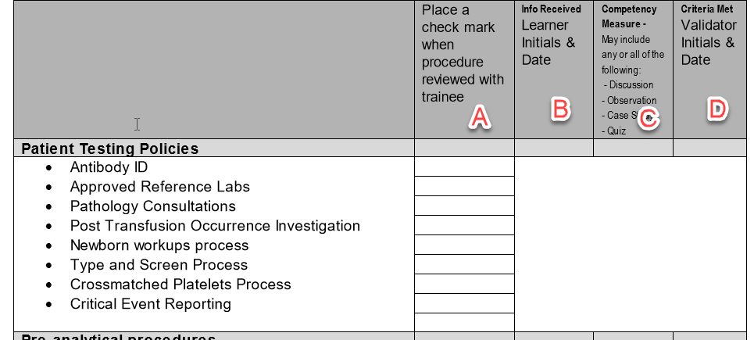
 | 3 | Trainee sign and date document when training is completed.
 | 4 | Tech Specialist:  - Sign and date when trainee is completed training and deemed competent to perform patient testing unsupervised.  - Check initial training box and the date completed.  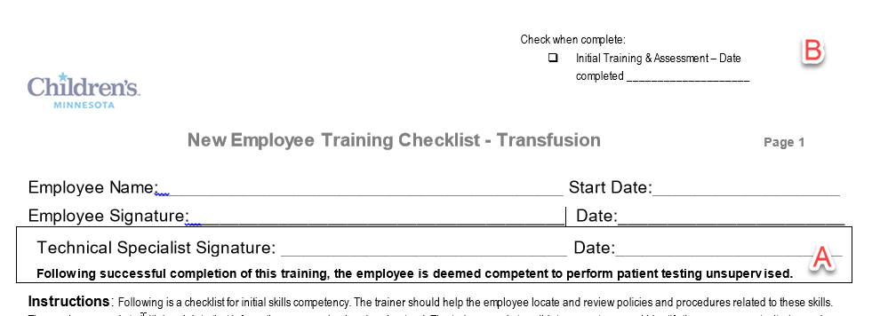
 | Step | Action
Transfusion Service Forms | 1 | Thermometer QC:  - Add year and site location  - Add NIST serial number  - Date of performed  - Serial number of thermometer being QC’d  - Thermometer reading  - NIST Reading  - Add check mark if acceptable or corrective action if not acceptable  - Tech who performed check  - Supervisor Review initials and date  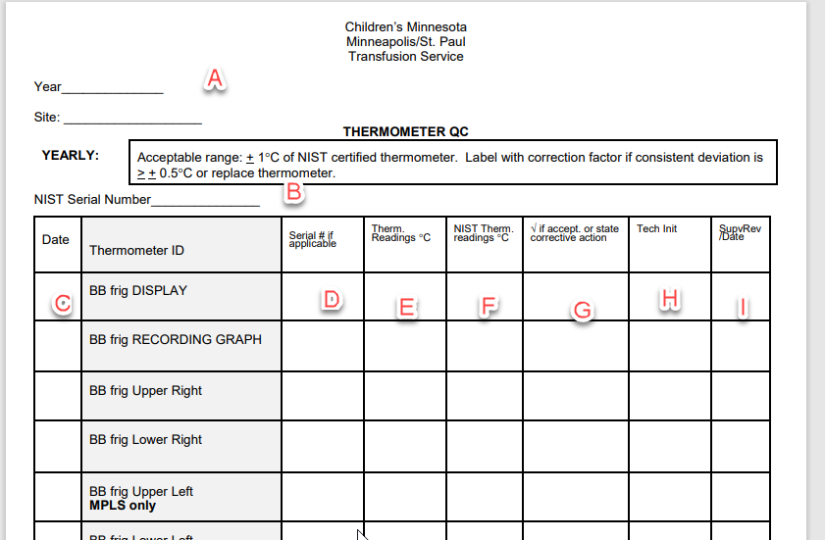
 | 2 | Correlation of Gel and Tube AHG testing:  - Tech initials performing task  - Specimen Acc#  - Gel Results (0, 1+, 2+, 3+, 4+)  - Date task performed  - Tube results (0, 1+, 2+,3+,4+)  - Date task performed  - Acceptable: Yes or No  - Tech Specialist review and date  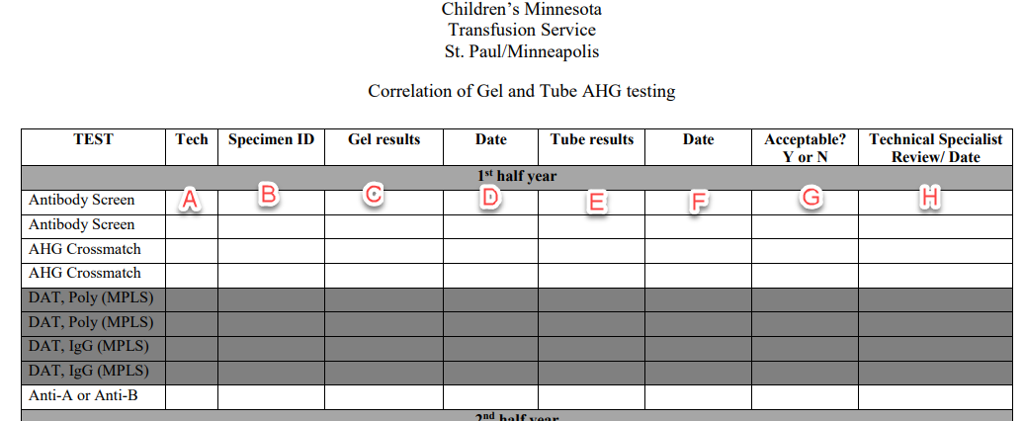
 | 3 | Equipment Maintenance-Service Record:  - Equipment Description h. Tech who filling out form and date  - Biomed number i. Description of problem  - Campus j. Service contacted  - Manufacturer k. Problem resolution  - Model number l. Revalidate Yes or No  - Serial Number m. Corrective action if any  - Installation Date n. Tech and date who filled out resolution  o. Supervisor review and date  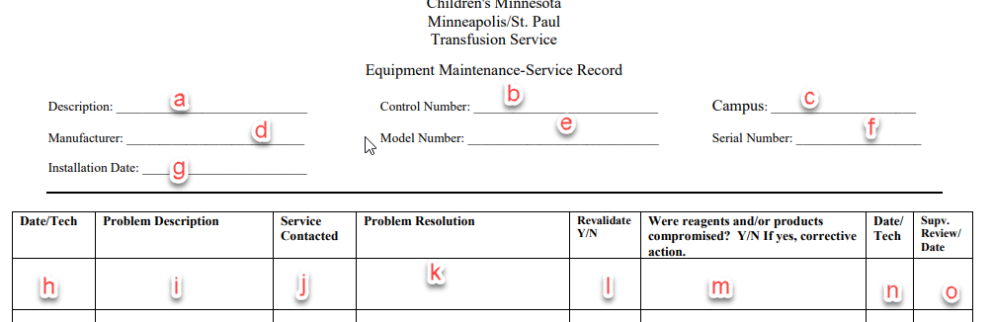
 | 4 | Quarterly Alarm testing for refrigerators, freezers, platelet incubators and plasma thawers forms:  - Site, equipment name if needed, and equipment control number if need.  - Date when task was performed  - Alarm Activation  - Refrigerators and Platelet incubator  - Record high and low alarm  - Freezers  - Alarm Activate? Yes or No  - Temp of activation of alarm  - Liquid Nitrogen freezer-alarm activate in security  - Plasma thawers  - Audible alarm activated  - Temp of activation  - Check mark if results are acceptable or state correction action  - Tech initials who performed task  - Supervisor Review and Date
 | 5 | Refrigerated Centrifuge:  - Add year h. Centrifuge setting  - Equipment serial number I. stopwatch reading  - BioMed number j. Put check mark if everything pass or corrective action  - Stopwatch serial number k. Tech initials who performed task  - NIST ID l Supervisor initials and date  - Tach ID  - Date tasked performed  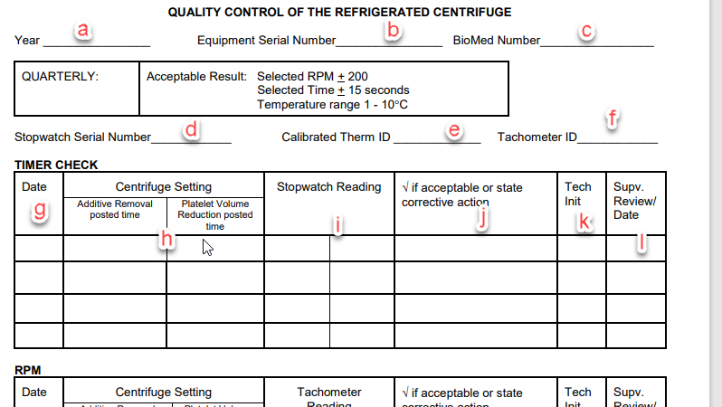
 | 6 | IEC Serofuge:  - Equipment serial number g. record tach RPMs  - BioMed Number h. Place check mark if pass or add correct action  - Tach serial number i. tech initials who performed task  - Stopwatch serial number j. Supervisor initials and date  - Date task performed  - Record stopwatch time  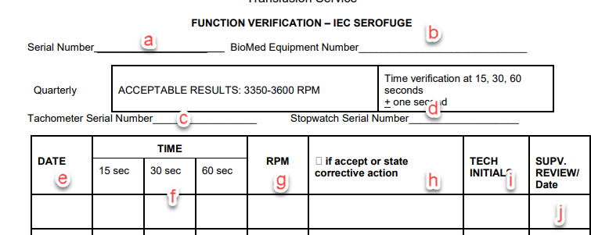
 | 7 | Dietetic Scale:  - MIN or STP  - Date task performed  - Scale ID  - Write weights for each weight measurement  - Add check mark if passed or add corrective action  - Tech initials who performed task  - Supervisor initials and date  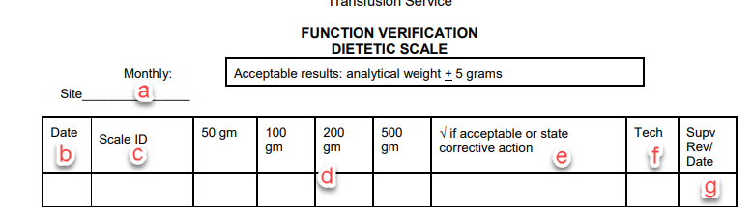
 | 8 | Monitoring System Data Integrity:  - Date tasked performed  - Patient’s Name  - Add a check number for criteria met  - Add any other action taken  - Tech initials performed task  - Supervisor initials and date of review  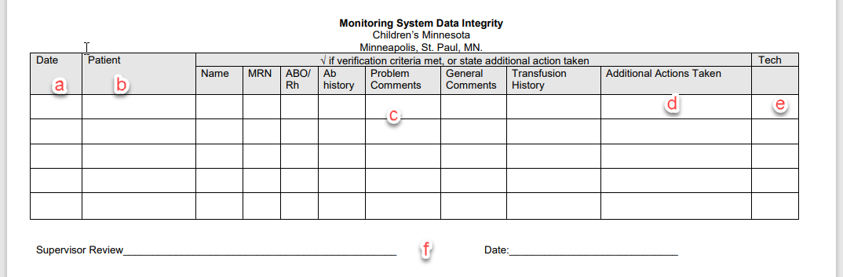
 | 9 | BB transport Cooler check:  - Date task performed  - Cooler number  - Check mark for Visual inspection  - Check mark cleaning cooler  - Corrective action if cooler does not pass inspection  - Tech initials of who performed task  - Supervisor initials and date of review  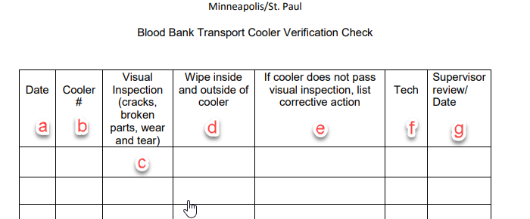
Approval  Workflow | Transfusion Service/Lab Director
Historical Record | Version |  | Written/Revised by: | Effective Date: | Summary of Revisions
 | 1 |  | S. Cassidy | 12/15/2022 | Initial Version

