Order of Draw
Purpose | Laboratory testing methods are based on scientific principles involving biology, chemistry, and physics. Very small quantities of substances (analytes) are measured by sophisticated techniques. Because the quantities are small, other substances can readily interfere with the accuracy of the test result. If a patient’s test result is not accurate, the patient may not receive the appropriate care and treatment.  The purpose of the order of draw is to avoid possible test result error due to cross contamination from tube additives. While it might seem impossible for the very small amounts of additives in tubes to cause inaccurate test results, extensive research has been performed that indicates this is possible.  There are two orders of draw, one for venipuncture and another for skin or capillary puncture. The orders of draw are followed regardless of what equipment is used – syringe/needle, winged infusion set/evacuated tubes, and tube holder with needle/evacuated tubes.
Policy Statements | - This procedure is to ensure the proper order of draw or order of fill for blood tubes during collection for laboratory analysis.  - This procedure applies to all laboratory and hospital staff responsible for collecting blood specimens.
Procedure | Follow the activities in the table below for ORDER OF DRAW.  Venipuncture:  Order of draw Picture Color or type of tube Additive  1 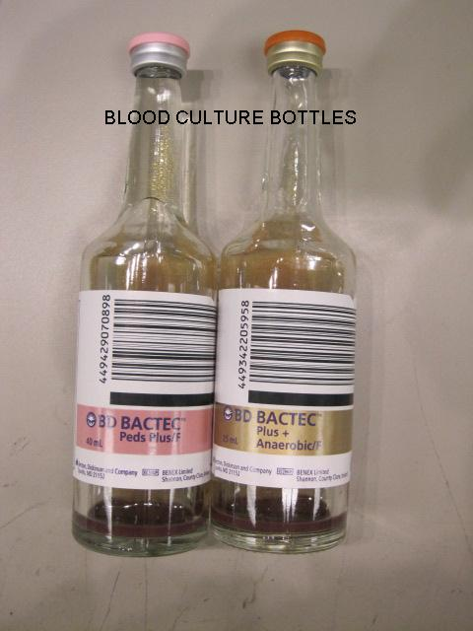 Blood culture, sterile specimens Varies  2  Light blue Sodium Citrate  3 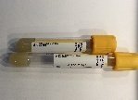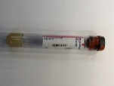 Gold or red/black (marble) gel  4 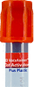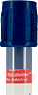 Red and/or Royal blue with red stripe none  5 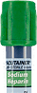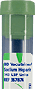 Green Heparin  6 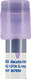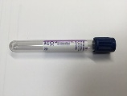 Lavender and/or Royal blue with lavender stripe EDTA  7 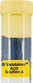 Yellow Citrate ACD  8 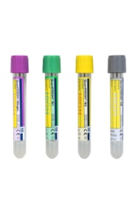 QuantiFERON -TB Gold Plus Blood Collection See package insert  Skin or capillary puncture:  Order of draw Picture Color or type of tube Additive  1 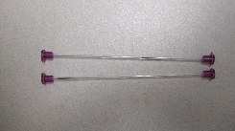 safeCLINITUBES Heparin  2 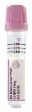 Lavender EDTA  3 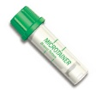 Green Heparin  4 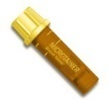 Gold gel  5 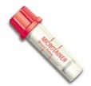 Red none
References | - CLSI. Procedures and Devices for the Collection of Diagnostic Capillary Blood Specimens; Approved Standard – Sixth Edition, H04-06. Clinical and Laboratory Standards Institute, Wayne, PA. 2008.  - CLSI. Collection of Diagnostic Venous Blood Specimens7th ed. CLSI standard GP41.Wayne, PA: Clinical and Laboratory Standards Institute 2017  - Phlebotomy Handbook, 8th edition.  - Ernst, Dennis & Ernst, Catherine,The Lab Draw Book, 2nd edition, 2017  - Center for Phlebotomy Education, Inc.

