NOVA STATSTRIP GLUCOSE METER

Purpose | Whole blood glucose test results obtained with a Nova STAT Strip glucose meter are used as a screening tool in patient assessment and for monitoring. Results should not be used as the sole basis for primary diagnosis.
Scope | Level of Personnel: All staff on file in Telcor QML who have completed initial training and fulfilled the specific competency requirements as stated in this procedure.  Testing sites: Minneapolis Hospital, St. Paul Hospital, Children’s Minnetonka Ambulatory Surgery Center, Children’s MN NICU –Mercy.
Indications | The StatStrip Glucose Meter can be used to test all patients in all hospital and all professional healthcare settings (including intensive care settings, surgery, ED, etc.) for the quantitative determination of glucose using:  - Venous whole blood  - Arterial whole blood  - Neonate arterial whole blood  - Neonate heel stick specimens  - Capillary finger stick  - Capillary finger stick cannot be used for patients defined as critically ill by bed codes of “ICU status”.  - Capillary specimens should not be used in patients receiving intensive medical intervention because of the potential for pre-analytical collection error and specifically in patients with decreased peripheral blood flow, as it may not truly reflect the patient’s true physiological state. Examples include, but are not limited to: severe hypotension, shock, hyperosmolarhyperglycemia (with or without ketosis) and severe dehydration. See chart in specimen collection section for further guidance.  - A capillary whole blood glucose test does not correlate exactly with the plasma glucose. The capillary value should be evaluated in the context of the individual patient, their prior glucose values, underlying medical conditions, pharmacological interventions, and a variety of other patient-specific criteria.  StatStrip Glucose is NOT intended for use with:  - Neonatal cord blood specimens  - Neonatal venous blood specimens (defined as patients located in one of the neonatal units or any patient <30 days of age if located outside a neonatal unit)  Neonatal venous specimens will be sent to the main lab for testing or tested via iSTAT where available  - For the diagnosis of or screening for diabetes mellitus  NOTES:  - Patients with bed status of “intermediate” status may use capillary, venous or arterial samples for point of care testing as per current practice.  - Neonates may utilize heel sticks as per current practice in the NICU’s.  - Patients in non-critical care units who require resuscitation will utilize ISTAT for POCT.  - Indicated for use in determining dysglycemia.
Limitations | - The system has not been FDA cleared for use with neonate venous blood.  - Do not use serum or plasma.  - Test results may be inaccurate when test strips are stored outside of the storage and handling conditions.  - Venous and capillary blood may differ in glucose concentration by as much as 70 mg/dL, depending on the time of blood collection after food intake. Shock, administration of vasoactive reagents and other factors affecting peripheral circulation may also cause discrepancies between venous and capillary glucose results.  PRECAUTIONS:  - Discard used test strips into biohazard waste.  - Remove the test strip from the vial only when ready to test.  - Do not use the test strip if the expiration date has passed, for this may cause inaccurate results.  - The StatStrip Glucose Meter uses a Class 2 laser that can cause retinal damage. Do not look into the beam of light or point it towards anyone’s eyes while scanning a barcode.  - The StatStrip Glucose meter uses a rechargeable lithium ion battery. Do not store above 60ºC (140ºF). Do not incinerate. Do not use if damaged. Follow proper disposal procedures.
Materials | All materials/reagents must be dated when opened. All supplies will be received and processed by POC at the main hospital lab. Mercy NICU and Minnetonka ASC will request supplies from the main stock.  - Nova STAT Strip Test Strips – obtained from lab. Store at 15-30°C.  - Open expiration 180 days  - Unopened – good until date printed on label.  - Nova STAT Strip High and Low Quality Control – delivered to departments quarterly. Store at 15-30°C.  - Open expiration 90 days  - Unopened - good until date printed on label.  - Nova STAT Strip Linearity Test Kit. Store at 15-30°C.  - Open expiration 90 days  - Unopened – good until date printed on label.  POC lancets - These are the ONLY approved lancets to be used with the glucometer  Two finger glucose lancets are available (for children >12 months of age): Pink (21G, 1.8mm) Medium Flow and Purple (30G, 1.5mm) Low Flow Obtain from Materials Management CHC# 24558 CHC# 12659  NICU heel glucose lancet (for infants not yet walking): Obtain from Materials Management CHC# 23752
Specimen Collection  Capillary collection | Utilize proper standard PPE whenever working with any body fluid.Gloves must be worn during testing events, hand hygiene performed, and gloves changed between patients, according to Standard Precautions.  Routine venipuncture, arterial puncture, or line draw specimens can be used when collected initially in a syringe and a drop of blood is applied directly to the test strip. Capillary blood can be obtained from puncturing the fingertip or heel using auto-disabling single-use devices.  Problem Potential Impact Recommendation  Patient has peripheral vascular disease or a condition that impairs/decreases circulation to the periphery False low glucose Fingerstick collection not recommended  Patient is dehydrated False low glucose Fingerstick collection not recommended  Patient is in shock False low glucose Fingerstick collection not recommended  Patient has severe edema False low glucose Fingerstick collection not recommended  Patient is hypotensive False low glucose Fingerstick collection not recommended  The sites approved by Children’s MN are the heel for infants not yet walking, or a fingertip for children >12 months of age.  Select the puncture site.  If Then  an infant’s heel is to be punctured The site shall be on the plantar surface medial to a line drawn posterior from the middle of the great (big) toe to the heel, or lateral to a line drawn posterior from between the 4th and 5th toes to the heel. In most infants the heel bone is not located beneath these areas. Do not puncture the posterior curvature of the heel, the area of the arch, edematous tissue or previous puncture sites.  the site is bruised, edematous, or traumatized select another site.  the infant’s heel has become macerated due to multiple heel stick procedures; or there is evidence of infection or hematoma; or the patient is experiencing poor peripheral circulation or hydration consult the patient’s caregiver for permission to perform the procedure.  a patient’s finger is to be punctured Use the palmar surface of the middle or ring finger, or medial aspect of the great toe.  - Wash hands thoroughly and put on gloves  - Warm heel or fingertip for an increase in blood flow.  - In outpatient areas and non-neonatal units, cleanse the site with a 70% isopropyl alcohol wipe, unless contraindicated. Allow site to dry completely.  - In the neonatal units, use a Chloroprep® Chlorhexidine Gluconate (CHG) pad.  - Directions for CHG use: Clean the site with pad for a minimum of 30 seconds using friction in a back and forth, vertical, horizontal, and diagonal pattern. Allow antiseptic to remain at site and completely air dry (approximately 30 seconds).  - NOTE: The Chloroprep® (CHG) pad package instructions state “15 seconds”, however Children’s Policy 1230.00 Skin Antisepsis states “30 seconds”. Follow Children’s policy.  - Refer to Children’s Policy 1230.00 Skin Antisepsis.  - Residual alcohol or CHG may contaminate and/or hemolyze the sample, as well as create a burning sensation felt by the patient when the skin is punctured. Blowing on the site is not recommended.  - Using appropriate lancet, prick the site.  - Wipe away the first drop  - Apply second drop to strip.  - Apply pressure to site and bandage per department guidelines.
Calibration | The Nova STAT Strip Glucose Meter is calibrated by the manufacturer before distribution.
Quality Control | Nova Low and High Glucose Control Solutions should be used as follows:  - Training of each new operator  - Each new or replacement meter  - Every 24 hours prior to patient testing - The meters have a QC Lockout function that prevents patient testing unless the QC is performed  - If a patient test has been repeated and the blood glucose results are still lower or higher than expected  - If there are other indications that the system is not working properly  - Whenever problems (storage, operator, instrument) are identified or anytime there is a concern the accuracy of the meter may have been affected by rough handling (such as dropping the meter).  Procedure:  - Check strip and QC expiration date  - Press the Login button. “Enter Operator ID” will appear at the top of the screen  - Press Scan and scan the user barcode.  - Scanner is a camera. Hold light 3-5 inches from barcode and light will flash  - Press the QC key.  - Follow prompts on the top of screen in blue bar  - Scan Strip and QC lot numbers  - Insert the test strip into the meter strip port (gold end first) until “Apply Sample” appears  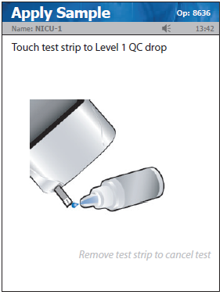  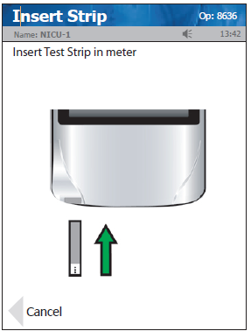  - Mix QC, discard first drop and fill strip from the tip until you hear a beep and the meter counts down.  - If Results PASS, press Accept and run next level.  - If Results FAIL:  - Verify that strips or QC is not expired  - Repeat with a new strip. Mix vials well.  - If second test fails, inspect and clean the meter according to the Cleaning section of this procedure.  - If third test fails, contact the Point of Care department.  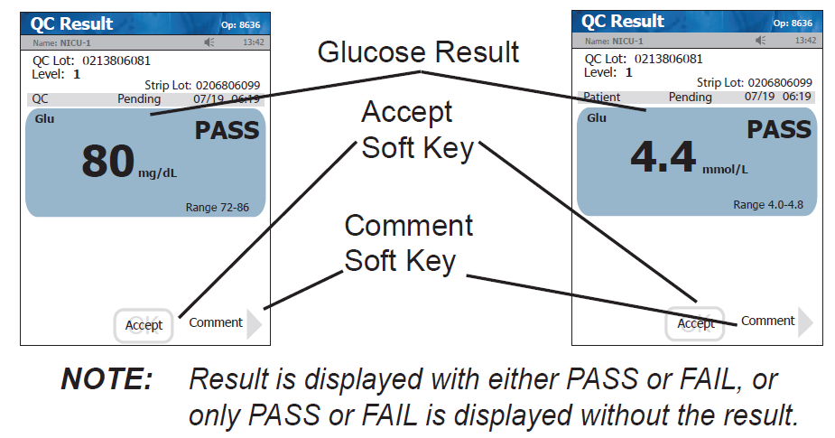
Procedure | Running a Patient Sample:  - Check strip expiration date  - Press the Login button. “Enter Operator ID” will appear at the top of the screen  - Press Scan and scan the user barcode.  - Scanner is a camera. Hold light 3-5 inches from barcode and light will flash  - If the padlock symbol appears with the words “Glu Locked,” this means that QC has not been performed in over 24 hours and the meter will not allow patient testing until completed.  - Touch Accept to begin test. Scan Strip lot. Scan patient MRN on armband attached to patient.  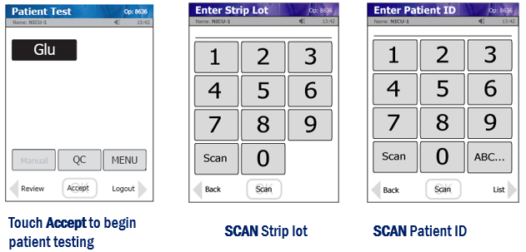  - If the patient ID is valid, the screen will display the patient demographics. Verify the patient information on the screen is correct and press Accept.  - If the screen displays Invalid Patient, compare the MRN to the patient’s armband. Select “Downtime Override” and continue to test. The result will post to the chart.  - For a STAT test on a non-registered patient (transport, prior to admit, non patient code): Type in a fake MRN “111111” or “123456” and use downtime override. Notification must be sent to the Point of Care Coordinator in the lab.  - Select sample type screen – choose appropriate sample type  - Insert the test strip into the strip port at the bottom of the meter, gold end first. The “Apply Sample” screen will appear when strip is inserted correctly.  - Perform the finger or heel stick procedure.  - Touch the end of the test strip to the blood drop, maintaining contact until the 6-second countdown begins.  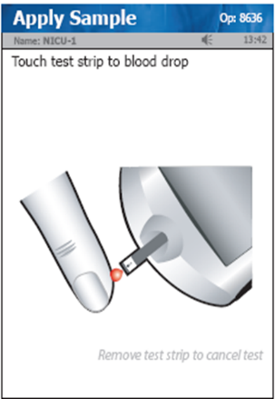  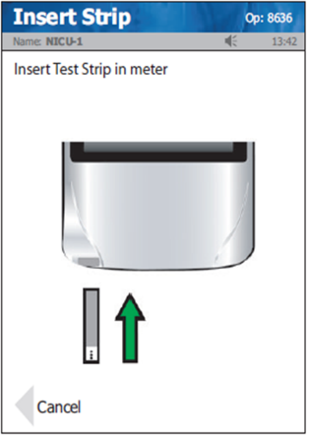  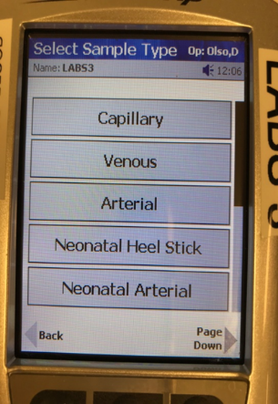  - The test strip must fill completely upon touching the blood droplet. If the strip does not fill completely, do NOT touch a second time. Discard the strip and repeat with a new strip.  - Once the result appears, remove the strip manually or use the strip ejector at the back of the meter.  - Select Accept to accept the result unless a comment is necessary.  - To add a comment, press the Comment key. Select appropriate comment(s), Accept comment, Accept result.  - Clean and Disinfect the meter following the cleaning procedure below.  - Dock the meter when not in use to keep the battery charged and to ensure the most up-to-date meter configurations. Make sure the meter is securely seated in the dock and that all lights are illuminated.
Interpretation of Results | Measurement Range: 10 mg/dL to 600 mg/dL  - Results below 10 mg/dL will display “LO” in red with a double down arrow.  - Results above 600 mg/dL will display “HI” in red with a double up arrow.  - If the result is below 10 mg/dL or above 600 mg/dL the result must be confirmed by the main lab. The laboratory at the provider’s discretion can confirm test results of any value.  Reference Range:  Age Glucose  Premature newborns 20 - 60 mg/dL  Neonates 30 - 60 mg/dL  Full term 0 – 1 day 40 - 60 mg/dL  1 to 364 days 50 - 80 mg/dL  1 – 18 years 60 - 100 mg/dL  60 – 89 years 82 - 115 mg/dL  >90 years 75 – 121 mg/dL  - If result is higher or lower than expected, run a control solution test to confirm test strip performance. If a patient test result is higher or lower than expected after verifying the test strip performance, perform glucose test using an alternate method and consult healthcare professional.  - All abnormal neonatal values should be confirmed by a clinical laboratory test method.  - Results within the Reference Range of 70 to 100 mg/dL will display in blue. Results outside of the Reference Range will display in red and will display a single up arrow or a single down arrow.  Critial Values: <50 mg/dL or >300 mg/dL  - All critical values need to be communicated to the provider and documented in the meter
Interferences | Hematocrit: No interference between 20-70%  pH: No interference between 6.6 – 8.0  The Stat Strip Hospital Glucose meter system has been evaluated for interferences from a multitude of drugs and physiological conditions commonly found in patients in intensive care settings with complex medical conditions and drug regiments. An extensive list of tested concentration levels can be found in the Instructions for Use Manual.
Transmitting Results | Wireless meters: Wireless transmission or via docking station  Transport Team: Wireless function turned off. Use wired docking station at hospital  - Results are transmitted to the patient chart via the wireless network when result is accepted.  - Hardwired docking stations are available for charging and as a wireless backup  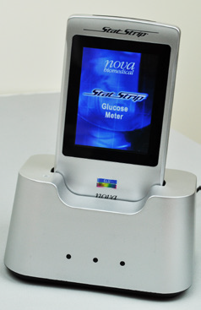  LEFT LIGHT: GREEN WHEN CONNECTED TO NETWORK  MIDDLE LIGHT: GREEN WHEN DATA IS FLOWING  RIGHT LIGHT: GREEN WHEN FULLY CHARGED, RED WHEN CHARGING  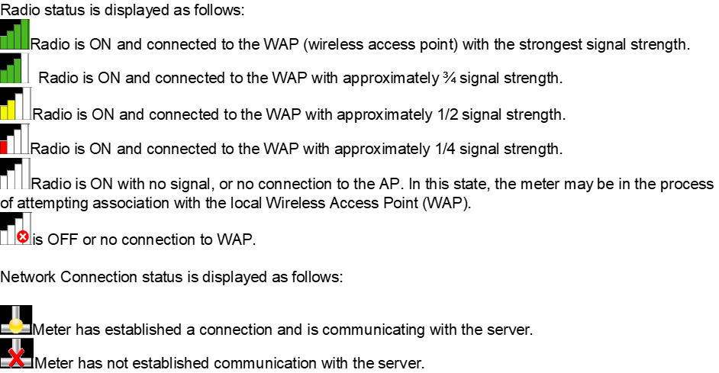
Cleaning | CLEAN and DISINFECT THE METER BETWEEN EACH PATIENT USE  - Using a new, fresh germicidal wipe, thoroughly wipe the surface of the meter (top, bottom, left, and right sides) a minimum of 3 times horizontally and 3 times vertically avoiding the meter’s bar code scanner and electrical connector.  - Gently wipe the surface area of the test strip port making sure that no fluid enters the port.  - Ensure the meter surface stays wet for appropriate time per Children’s cleaning wipe guidelines and then is allowed to air dry.  - DO NOT immerse the meter or hold the meter under running water.  Cleaning the Strip Port – only when necessary  - Use a 70% isopropyl alcohol wipe to clean out strip port. Use a test strip to move wipe around in port.  - Let dry completely (20 minutes)  - Run QC to verify function
Trouble  Shooting | Meter freezes or will not scan  - Remove the battery from the back of the meter. Place battery in the base to charge it. Take the spare battery from the base and place it in the meter. Wait for the meter to re-boot.  Common Error Messages  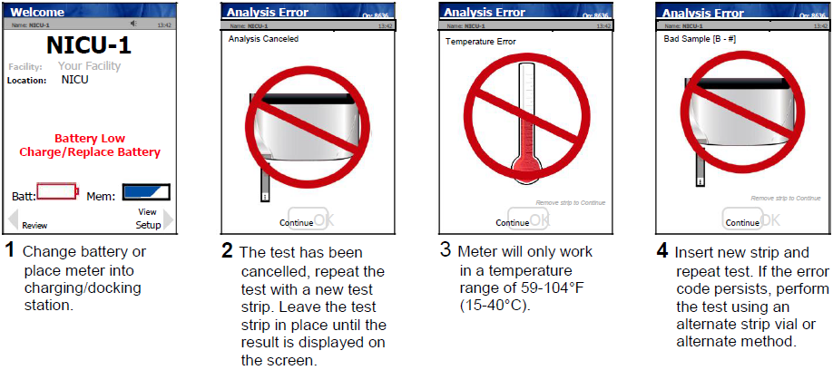  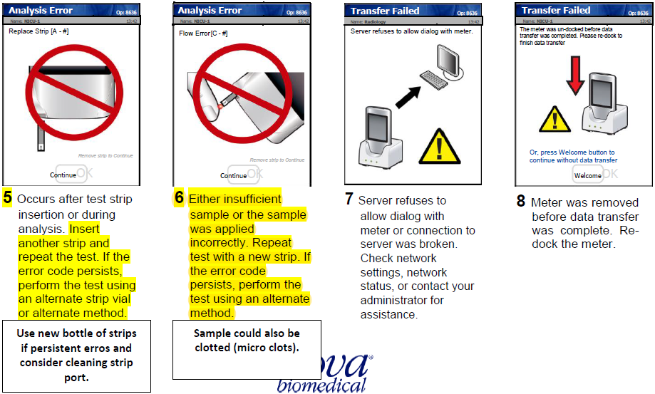
Proficiency Testing | - Performed 3 times a year and samples are purchased from a COLA approved provider.  - All Survey results are to be handled and reported in the same manner as clinical results following the directions on the package insert. Actions or decisions must be documented.  - Participation must be random and not assigned to specific individuals.  - The Point of Care Department will submit results for Minneapolis and St. Paul hospital sites. Minnetonka and Mercy will submit results on site.  - Results will be reviewed and appropriate actions taken by the Point of Care Coordinator.  - Scores less than 80% require a comprehensive investigation and documentation of remedial action of unsuccessful challenges. Scores of less than 80 percent may jeopardize a sites ability to continue to perform testing.  - Should a site fail proficiency, they will be required to immediately perform a comprehensive investigation and document remedial action. Operator re-training may be required.  - Each site is responsible for completing survey challenges when they arrive. Neither samples or results may be shared between CLIA sites.
Competency | The competency of each person to perform the duties assigned must be assessed following training before the person performs patient testing. After an individual has performed testing duties for one year, competency must be assessed annually. Retraining and reassessment of employee competency must occur when problems are identified with employee performance. Elements of competency assessment may include but are not limited to:  1. Direct observations of routine patient test performance, including, as applicable, patient identification and preparation; and specimen collection, handling, processing and testing  2. Monitoring the recording and reporting of test results, including, as applicable, reporting critical results  3. Review of intermediate test results or worksheets, quality control records, proficiency testing results, and preventive maintenance records  4. Direct observation of performance of instrument maintenance and function checks, as applicable  5. Assessment of test performance through testing previously analyzed specimens, internal blind testing samples or external proficiency testing sample  6. Evaluation of problem-solving skills  Training and Competency is covered in depth in the Point of Care Testing Training and Competency Assessment Policy.  Expired Operators:  Operators that fail to meet yearly competency requirements will be locked out of the system. They will be required to undergo retraining and competency assessment according to above.
References | - NOVA StatStrip Glucose Test Strips package insert, 7/2018  - Stat Strip Glucose Hospital Meter System Instructions for Use, 9/13/18  - POCT12-A3 CLSI document, Point of Care Blood Glucose Testing in Acute and Chronic Care Facilities, 1/2013  - Glucose in Whole Blood on the Nova StatStrip® System CLSI document, 2/17/2015

Version | Written/Revised by: | Effective Date: | Summary of Revisions
12 | Danyel Olson | 4/10/2020 | - Updated interference section  - Removed reference to wireless totes  - Removed reference to specific wipes in cleaning section  - Updated troubleshooting  - PT entry – specifics added Mtka/Mercy  - Updated references
13 | Danyel Olson | 6/20/2022 | - Name change SCN to Mercy NICU.  - Defined supply process  - Update reference ranges to match core lab

