Vitek Densichek

Purpose | This procedure provides instruction for using the Vitek Densichek.
Principal and Clinical Significance | The Vitek Densichek instrument measures microorganism suspensions for AST and ID testing in support of the Vitek 2 Systems. The instrument provides values in McFarland units, proportional to the microorganism concentration. It measures the McFarland value of a suspension prepared in 0.45-050% saline in a polystyrene test tube, with a reading range of 0.00 to 4.00 McFarland. The Vitek Densichek instrument contains a base unit with a detachable optical interface, the Pod. With the Pod, the user can visually examine samples with optical readings that are transmitted automatically to the base unit.
Policy Statements | This procedure applies to Microbiologists who perform plate reading.
Materials
 | Reagents |  | Supplies |  |  | Equipment
 | - Vitek Densichek McFarland Reference Kit |  | - Sterile saline 0.45%-0.50%  - 12x75 polystyrene test tubes  - Swabs  - Culture growth on media |  |  | - Vitek Densichek Pod  - Vitek Densichek Display Base  - Dual USB 2.0 USB connector to Micro-USB Cable  - Single USB 2.0 to Micro USB Cable  - A/C Power Adapter
Special Safety Precautions | Microbiologists are subject to occupational risks associated with specimen handling. Refer to the safety policies located in the safety section of the Microbiology Procedure Manual.  - Biohazard Containment  - Biohazardous Spills  - Safety in the Microbiology Laboratory
Environmental Conditions | - The Vitek Densichek must be used on a flat, horizontal surface and operated in an area free of dust.  - Operating temperature: 15$°$C to 30°C  - Relative humidity: 20%-80% non-condensing
Quality Control | McFarland Reference Checks  - McFarland Reference Checks are performed monthly and after cleaning the device.  - Ensure the test tubes are free of damage, scratches and debris before use.  - Zero the Pod:  - Insert the 0.0 McFarland Reference into the instrument so that the tube with the McFarland Reference value faces you and is in the front tube location of the Pod. The device illuminates the tube and measures the McFarland Reference. Either a McFarland value or X.XX in red appears on the screen, along with the LOT number of the McFarland Reference.  - Press and hold the button on the back of the Pod until the Tube Light flashes and the two second reading period begins. After the reading period ends, the McFarland value appears as 0.00 on the screen.  - The Pod is zeroed.  - Check Remaining McFarland Reference Standards  - Insert the next McFarland Reference into the instrument. The instrument illuminates the tube and measure the McFarland Reference, during the two second reading period. The corresponding McFarland value and status of the McFarland Reference appears on the screen.  - When the screen displays the McFarland value, confirm that the value displays with a green colored meter gauge. If the meter gauge displays as the color red, the McFarland Check has failed. Clean the McFarland Reference tube and try again. If the problem persists, try another McFarland Reference set or contact bioMerieux Support for assistance.  - Ensure all McFarland References are within the Acceptable Range.  - Remove the McFarland Reference.  - Repeat steps 1-4 for each McFarland Reference (0.5, 2.0, 3.0).  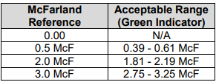
Zeroing Saline-Filled Test Tube | Zeroing Saline-Filled Test tubes  - Frequency  - After receiving a new shipment of test tubes.  - After performing a McFarland Reference check.  - As a part of routine monthly maintenance  - At the beginning of each session  - Insert a saline-filled tube, free of scratched or smudges into the front tube location of the Pod and press it all the way down.  - Rotate the tube for a full 2 second reading period, indicated by the dots on the screen. A numerical value is displayed.  - If a value of 0.00 is not displayed, press and hold the button on the back of the Pod for approximately 3 seconds. The Tube Light will flash and the 2 second reading period begins.  - Rotate the tube for the full 2 second reading period, and 0.00 will appear on the screen.
Procedure | Pod Preparation  - Ensure to Pod is paired with the base by verifying that the Pod and base both have the same solid color pairing light.  - To pair a base to a Pod, place the Pod on the base and wait for the light to change color.  - Ensure the Pod is charged.  - Zero the Pod at the beginning of each session as described in the Zeroing section.  - Ensure the test tubes are free of damage, scratches and debris before use.  Display Base Preparation  - Press the Card Type button on the Display Base Screen, until the desired card type appears. Card type options:  - GP – GN  - ANC – CBC - NH  - BCL – YST  - N/A  - If the correct card type is not selected, then an acceptable McFarland range will not appear on the meter. The correct card type must be selected in order for the appropriate McFarland meter to appear.  Inoculum Preparation  - Select a tube and fill it with 3 ml of saline.  - Add microorganism to the saline-filled tube and vortex the suspension in the tube until a homogenous solution is achieved.  - Insert the prepared sample into the front tube location of the Pod and press it all the way down.  - Once the instrument begins the 2 second reading period, designated by the dots on the Display Base screen, rotate the tube for the full 2 seconds.  - Ensure that the sample test tube is rotated at least one full rotation and continuing to turn during the entire 2 second reading period.  - The McFarland value is measured and displayed.  - A green light on the Pod and meter indicates that the suspension is within the selected card type performance range.  - A red light indicated that the suspension is above the selected card type performance range.  - A yellow light indicated that the suspension is below the selected card type performance range.  - If the McFarland is out of range, perform one of the following solutions and then re-measure the suspension.  - Out of range-High  - Discard the tube and repeat the previous steps to create a new suspension, or  - Dilute the over-inoculated sample with saline  - Remove the sample tube from the Pod before adding saline to the suspension.  - Out of range-Low  - Add microorganism to the saline filled tube and manually mix the suspension in the tube with a swab.  - Once an acceptable McFarland value appears in the screen, remove the suspension tube from the Pod.  - Perform this procedure with additional sample specimen tubes.
Maintenance | Cleaning the Pod Windows  - Perform as needed  - Remove Pod from base  - Dampen a cotton swab with 10% bleach, and then squeeze out any excess liquid.  - Carefully wipe each window of the front tube location, shown in the image below. Be cautious not to bend any of the parts inside.  - Carefully wipe the RFID window of the back tube location.  - Carefully wipe the tube light windows at the base in the front tube location.  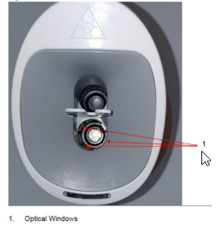  - Visually inspect the tube locations to ensure no debris remains.  - Allow Pod to completely air dry.  - Perform McFarland Reference Check as described in the Quality Control Section.  - Perform the Zeroing Saline Filled Test Tube as described in the Zeroing Section.  Cleaning the Touch Screen  - Perform as needed.  - Wipe the Display Base Touch Screen using paper towels that are dampened with water.  - Do not spray any cleaner directly on the screen.  - Dry with a soft clean cloth.  Cleaning the Base and Pod  - Perform as needed  - Wipe the base and the Pod using paper towels or wiped that are dampened with 10% bleach.  - Allow device to dry.  - Perform McFarland Reference Check as described in the Quality Control section  - Perform the Zeroing Saline Filled Test Tube as described in the Zeroing Section.
Configure the Display Base Setting | Customize the Display Base screen to select LED colors, adjust brightness and more.  - Place the Pod on the Display base unit. (Display base with no tube inserted)  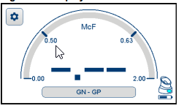  A solid colored light on the Pod matching that of the base indicates that the Pod is synced to the base unit.  - Tap the Configuration button. (see blue arrow above)  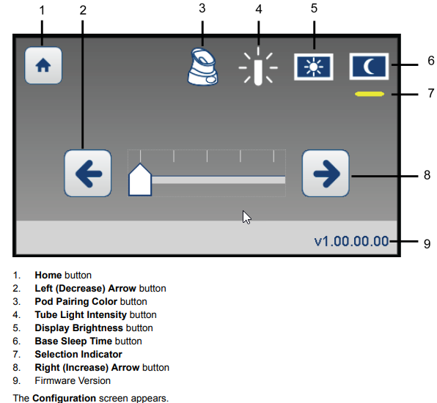  - Tap the Pod Pairing Color button (#3 above) and tap the left arrow or right arrow button to change the pairing LED color. Options are cyan, pink, white, green or yellow.  - Tap the Tube Light Intensity button (#4 above) and tap the left arrow to decrease the LED brightness or tap the right arrow button to increase LED brightness.  - Tap the Display Brightness button (#5 above) and tap the left arrow to decrease the LCD screen brightness and the right arrow to increase the LCD screen brightness.  - Tap the Base Sleep Time (min) button (#6 above) and tap the left arrow button to decrease the amount of time before Power Save mode automatically turns on or tap the right arrow button to increase the amount of time before the Power Save mode automatically turn on. The incremental marks represent 0, 5, 10, 20, 30 minutes.  - Tap the Home button (#1 above) to return to the McFarland Reading screen.
References | VITEK DENSICHEK Instrument User Manual, Reference number 048641-01 Durham, North Carolina, November 2018
Training Plan/ Competency Assessment | Training Plan |  |  |  |  | Initial Competency Assessment
 | - Employee must read the procedure.  - Employee will observe trainer performing the procedure.  - Employee will demonstrate the ability to perform procedure, record results and document corrective action after instruction by the trainer. |  |  |  |  | - Direct observation.
Historical Record
 | Version | Written/Revised by: |  | Effective Date: | Summary of Revisions
 | 1 | Susan DeMeyere |  | 12/27/2022 | Initial version

