How to Print Barcodes for Chemistry QC

Purpose | This procedure provides instructions for printing barcodes for use with Chemistry QC material.
Policy Statements | This procedure applies to all laboratory technical staff responsible for running Quality Control in the Chemistry Department. This procedure may be used as-needed. Some instrumentation will be supported by pre-barcoded QC material, or for convenience non-barcoded QC material may also be used.

Materials | Product Description
- Computer with web browser
- Paper or labels
- Printer
- Vials for control material aliquot
Procedure | Step | Activity
 | 1. | Use a web browser to go to https://blg.qcnet.com, then enter data per the screenshot below.
 | 2. | This example is for Architect BNP QC, lot 44K23722, levels 1, 2, and 3.  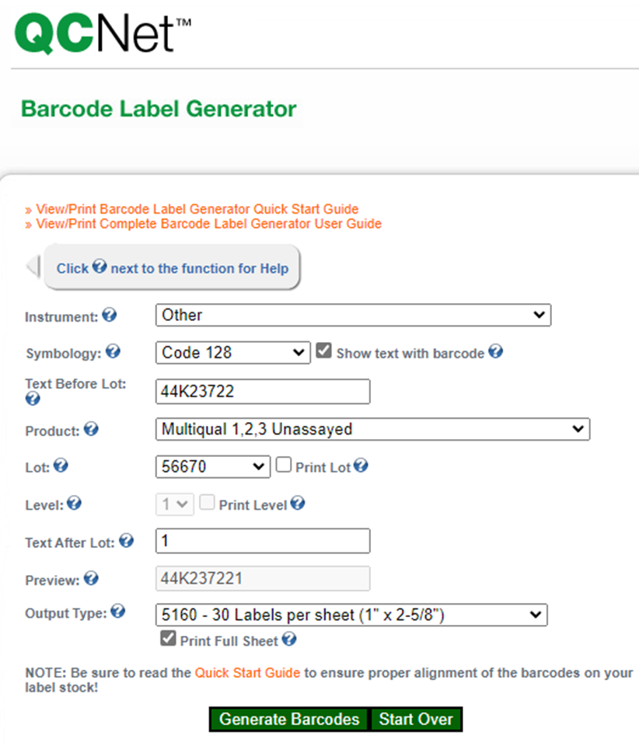
 | 3. | Fill in each filed per these instructions:  Instrument: Always select Other.  Symbology: Always select Code 128.  Text Before Lot: Enter the lot number here, this is case sensitive.  Product: Select any product, this doesn’t matter but must have an entry.  Lot: Select any of the lots, this doesn’t matter but must have an entry. Un-check the “Print Lot” button.  Level: Skip this field.  Text After Lot: Enter your specific level here, for example 1, 2, 3, etc.  Preview: Verify this looks like what you want.  Output type: Choose 5160 – 30 labels per sheet.
 | 4. | Click “Generate Barcodes” to create a pdf.
 | 5. | You may print the pdf to paper or labels. Repeat this process for all levels and affix the barcoded labels to the quality control vials.

Limitations | - Other processes to produce barcodes may be used, including barcodes supplied by manufacturers of QC material.
Historical Record | Version | Written/Revised by: | Effective Date: | Summary of Revisions:
 | 1. | Matt Johnson | 1/1/2023 | New Document

