IH-COM User Management for IH Reader-24

Purpose | This procedure provides instructions to ensure that each operator of the IH-Reader 24 has a unique user ID and password with assigned user access.
Policy Statements | - The IH-Reader 24 software allows for assignment of access right at various levels  - This procedure applies to any individual who will use the IH-Reader 24  - Each Operator assigns their own password.
Procedure
 | Step | Action
Creating a User Account | 1 | From the IH-Com software, open ‘Configuration’ from the menu bar and the ‘User administration’.  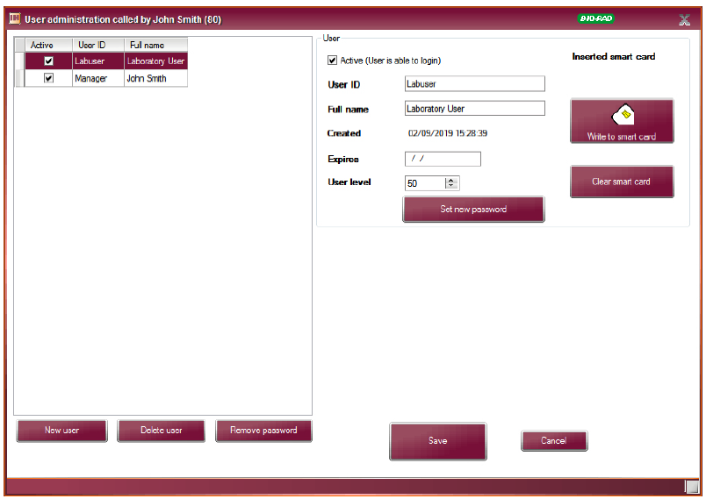
 | 2 | Select the ‘New User’ button.  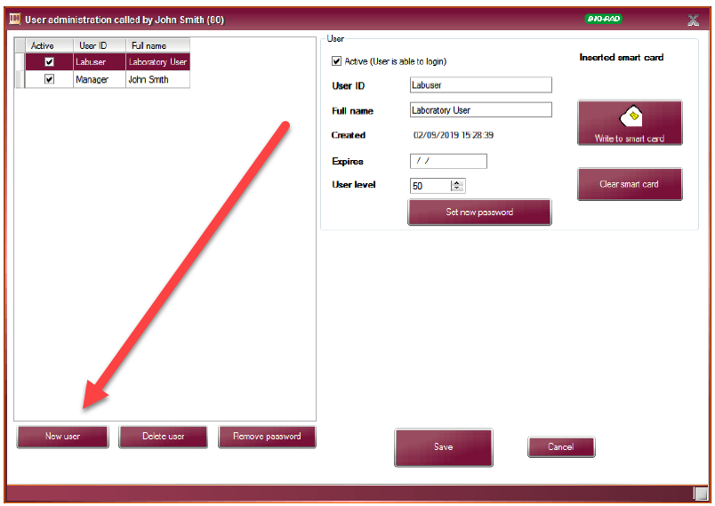
 | 3 | Enter the operator’s Unique Identifier (employee tech code) in the ‘User ID” field
 | 4 | Enter the operator’s full name in the ‘Full name’ field.
 | 5 | Enter the user’s level.  - Levels in IH-Com:  - 42-can change or confirm results, cannot accept results  - 52-Normal User; can change and confirm results and validate  - 62-Same as 5 above; can also do additional validation and configure QC  - 90-Limited admin rights without database functions
 | 6 | Select the ‘Set New Password Button to enter a password.
 | 7 | Enter the password in the ‘New Password’ field and again in the ‘Repeat Password’ field
 | 8 | Select the ‘set Password’ button to confirm
 | 9 | Select ‘OK’, then ‘Save’ to except the user account
 | Step | Action
Changing a Password | 1 | In IH-Com, select ‘Configuration from the menu bar and then ‘User Administration’.
 | 2 | Select the User ID that requires a password change.
 | 3 | Select the ‘Set New Password’ button
 | 4 | Enter the new password in the ‘New Password’ field and then again in the ‘Repeat Password’ field.
 | 5 | Select the ‘Set Password’ button
 | 6 | Select ‘OK’ then ‘Save
Limitations | - Passwords must be a minimum of 8 characters, include a capital letter and a special character or number.  - User ID is limited to 20 characters.  - If a password is not defined when a user is added, the user will be prompted to create a password when logging in for the first time.  - A user must have an access level of 62 or higher in order to create user accounts.  - Authorization levels cannot exceed that of the logged in user. A user level of 99 has full administrator access to all menus in IH-Com.
References | - IH-Com User Manual NA V1.2-02/2021 Chapter D, Sections 1.1 to 1.7
Approval  Workflow | Transfusion Service/Lab Director
Historical Record | Version |  | Written/Revised by: | Effective Date: | Summary of Revisions
 | 1 |  | S. Cassidy | 02/17/2023 | Initial Version

