Operating IH-Centrifuge L

Purpose | This procedure provides instructions for operating IH-Centrifuge L.
Procedure
 | Step | Action
Startup | 1 | Switch On the instrument. Main switch at the rear of the instrument.  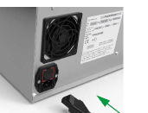
 | 2 | Wait for the end of the user interface initialization. The main screen with the last settings used is displayed.  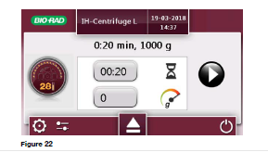
 | Step | Action
Shutdown | 1 | Shutdown the instrument.  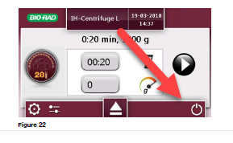  Make sure that no process is running before shutting down the instrument.
 | 2 | A confirmation message appears.  
 | 3 | Switch OFF the instrument. Main switch (1) at the rear of the instrument.  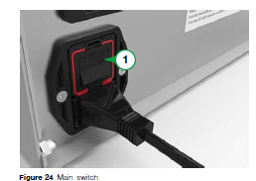
 | Step | Action
Emergency Stop | 1 | Switch OFF the instrument to stop the centrifugation in an emergency. The instrument immediately interrupts the ongoing centrifugation and stops the centrifuge head rotation.  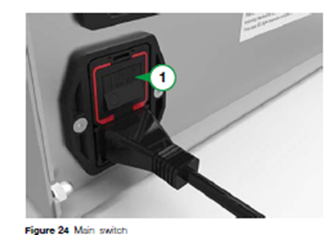  Incomplete or interrupted centrifugation can lead to erroneous test results. Tubes or gel cards should be discarded.
 | Step | Action
Centrifugation interrupted by the Centrifuge | 1 | The acceleration, vibrations and nominal speed are automatically monitored by the centrifuge. If the centrifuge detects a fault:  - The centrifugation is automatically interrupted;  - The instrument issues an audible and visual alarm for centrifugation interruption.  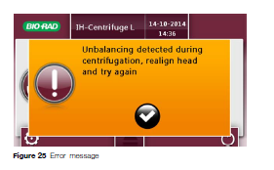  Incomplete or interrupted centrifugation can lead to erroneous test results. Tubes or gel cards should be discarded.
 | Step | Action
Preparing and Loading Tubes | 1 | Load the centrifuge head evenly to ensure that the centrifugation is not automatically interrupted by the integrated vibration sensor.  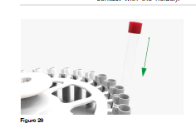
 | 2 | If few than the maximun number os amples tubes are loaded, refer to the following loading options. Sample tubes filled with water can be used to balance the head  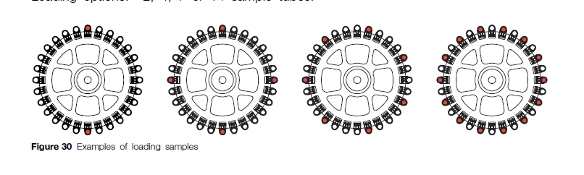
 | 3 | Open the lid  
 | 4 | Carefully insert the head (1) guiding it along the spindle (2) until it audibly engages. The diver pin of the centrifuge head automatically slides into the drive spindle.  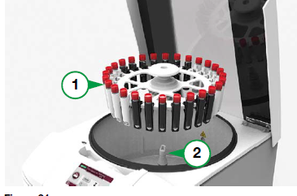
 | 5 | Close the lid. A click indicates the lid is closed. The head detection sensor recognizes the type of head (after approximatively 5 seconds) and select the default settings.  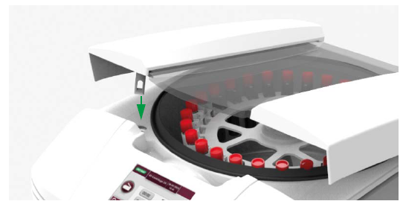
 | 6 | Start the centrifugation.
 | 7 | Open the lid when the centrifugation cycle is completed.  
 | Step | Action
Preparing Head 2 Racks | 1 | Load the head 2 racks evenly with the gel cards to be processed. To ensure that centrifugation is not automatically interrupted by the integrated vibration sensor.  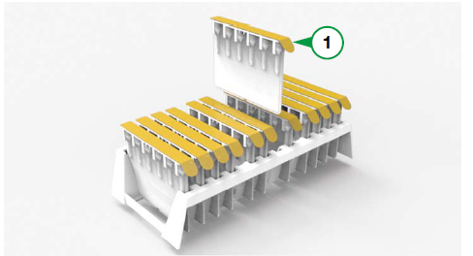
 | 2 | Load the rack in the Head 2 Racks.  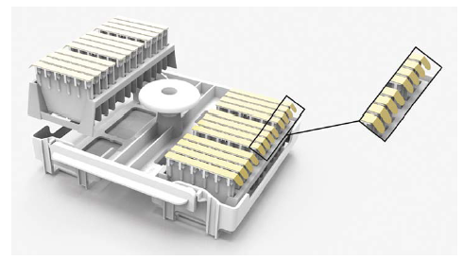
 | 3 | Open the lid
 | 4 | Carefully insert the head (1) guiding it along the spindle (2) unit it audibly engages. The driver pin of the centrifuge head slides into the driver spindle.  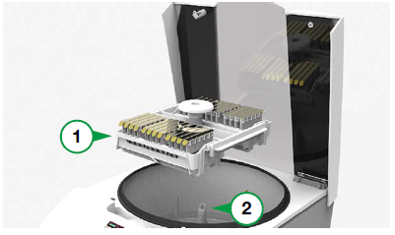
 | 5 | Close the lid. A click indicates the lid is locked. The head detection sensor recognizes the type of head (after approximately 5 seconds) and selects the default settings.  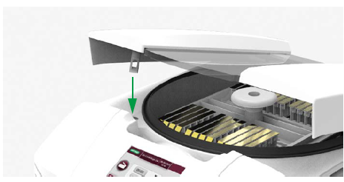
 | 6 | Start the post-transportation centrifugation.  - Centrifugation time: 5 minutes  - Centrifugation speed: maximum 85 g.
 | 7 | Open the lid when the centrifugation cycle is completed.
 | Step | Action
Preparing Card Head | 1 | Load the card head with the gel cards to be processed.  For a correct positioning of the gel cards, insert them completely in the head. Orientate all protection foil strips facing outwards (1).  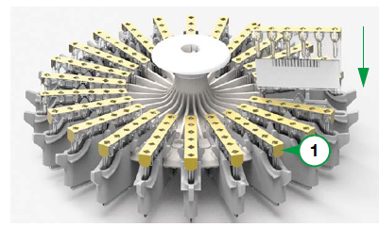
 | 2 | If fewer than the maximum number of gel cards are loaded, refer to the following loading options. Loading options: 2, 3, 4, 6, 8, 12 or 24 gel cards.  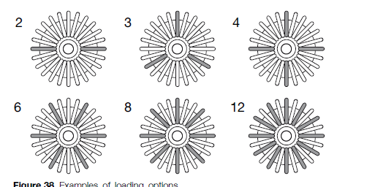
 | 3 | Open the lid
 | 4 | Carefully insert the head (1) guiding it along the spindle (2) unit it audibly engages. The driver pin of the centrifuge head slides into the drive spindle.  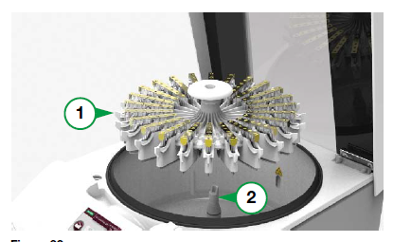
 | 5 | Close the lid. A click indicates the lid is locked. The head detection sensor recognizes the type of head (after approximately 5 seconds) and selects the default settings.  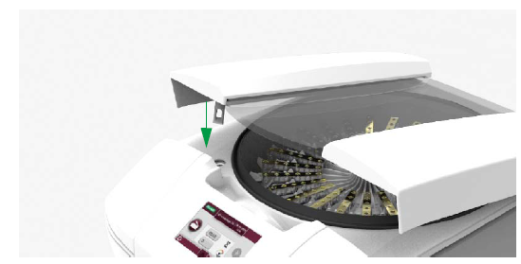
 | 7 | Open the lid when the centrifugation cycle is completed.
References | - IH-Centrifuge L User Manual, current addition
Approval  Workflow | Transfusion Service/Lab Director
Historical Record | Version |  | Written/Revised by: | Effective Date: | Summary of Revisions
 | 1 |  | S. Cassidy | 02/17/2023 | Initial Version

