Chemistry Stocking Procedure

Purpose | This procedure provides instructions for stocking supplies in the Chemistry department.
Policy Statements | This procedure applies to all staff removing products from the receiving area and placing them in the chemistry areas.
Materials | Supplies  Handheld date labeler with stickers
Receiving Area Procedure | Step | Action |  |  |  | Related Document
 | 1 | Affix dated sticker to product as near as possible to Lot/product information. Don’t cover the lot/product information or place in an area that will be removed.
 |  | 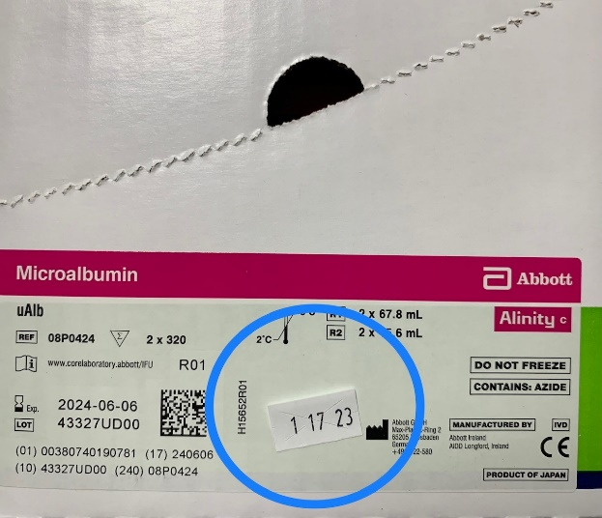
 | 2 | Bring product to sequestered area of the chemistry department based on product temperature.
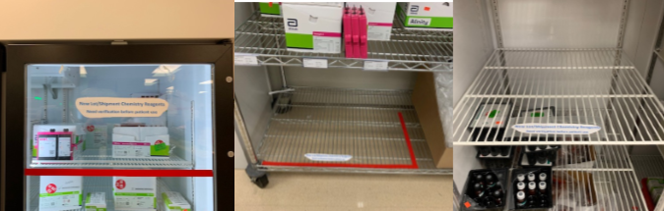
Minneapolis fridge, room temp (wire rack), and freezer sequestered areas.
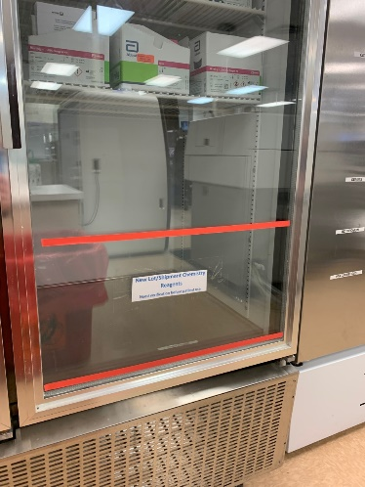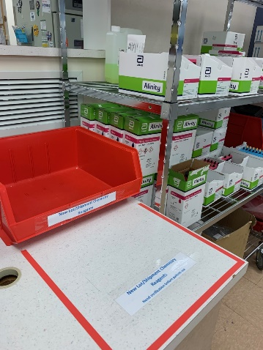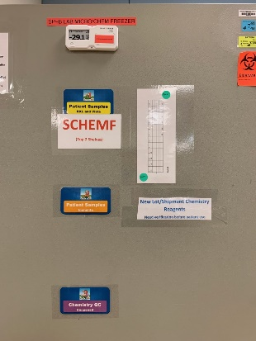
St. Paul fridge, room temp, and freezer sequestered areas.
 | 3 | Notify department staff of urgent items including:  Obviously damaged items  Proficiency Testing Materials
Procedure  Chemistry Area | Step | Action |  |  |  | Related Document
 | 1 | Based on the type of product, follow procedure steps below to remove from the sequestered area and stock in the chemistry department for use.
 | 2 | IF product is |  | THEN
 |  | Reagent |  | Follow Procedure CH 2.99 Confirmation of Acceptability. For information on which reagents require confirmation of acceptability, see CH 2.99.f3 Reagent CoA Guide Chart. Once CoA is complete, stock new products on the shelf with in-use products, making sure to place the newest materials behind any existing stock. |  | CH 2.99 Confirmation of Acceptability  CH 2.99.f1 CoA Form  CH 2.99.f2 CoA Downtime Form  CH 2.99.f3 Reagent CoA Guide Chart
 |  | Quality Control Material |  | Notify department technical specialist or lead. Include material name, lot number, expiration, quantity, expected means, standard deviations, or ranges. Stock new products on the shelf with in-use products, making sure to place the newest materials behind any existing stock.
 |  | Calibrator, bulk solution, part, or any other product |  | Stock new products on the shelf with in-use products, making sure to place the newest materials behind any existing stock.
Historical Record | Version |  | Written/Revised by: | Effective Date: | Summary of Revisions
 |  |  | Matt Johnson | 2/1/2023 | Initial Version

