|  |  |  |  |  |  |
| --- | --- | --- | --- | --- | --- |
| **Inspection and Labeling of Gel Cards** | | | | | |
| **Purpose** | This procedure provides instructions for the inspection and labeling of all BioRad IH gel cards | | | | |
| **Policy Statements** | * Store at 18 to 25°C * Do not use beyond expiry on the label which is expressed YYYY-MM-DD * Store in an upright position * Do not freeze or expose cards to excessive heat. * Do not store near any hear, air-conditioning sources or ventilation outlets * Visually inspect gel cards before each use. * Label cards with indelible marker or ink. Sunquest aliquot labels, donor unit labels, and IH-Com labels are acceptable for labeling cards. * All IH-System reagents and test samples must be brought to room temperature (18-25°C) prior to use | | | | |
| **Materials** | * IH gel card * Indelible pen or marker * Patient Sunquest aliquot label * Donor unit label * IH-Com label | | | | |
| **Procedure** |  | | | | |
|  | **Step** | Action | | | |
|  | 1 | Visually inspect the gel card before each use.   * Do not use cards showing signs of drying, discoloration, bubbles, crystals or other artifacts. * Do not use cards with damaged foil strips. * Do not use gel cards if the gel matrix is absent or if the liquid level in the microtube is not at or below the gel matrix. A clear liquid layer should be visible on top of the uniform gel matrix in each microtube. * Cards with dispersed drops observed at the top of the microtube, due to improper storage or shipping conditions, have to be centrifuged with the IH-Centrifuge L with preset time and speed before use. If drops are still observed on top of the microtube after one centrifugation it is recommended to not use the card. | | | |
|  | 2 | Label the gel cards for the testing to be performed>   * Patient Identification labeling options:   + IH-Com label   + Sunquest allocate label   + Patient’s first and last initial * Donor Unit identification labeling options:   + IH-Com Label   + Donor unit label   + Last 3 digits of donor number * Testing identification   + Antibody Screening cells: S1 and S2 or SI and SII   + Direct antiglobulin testing:DAT   + Weak D testing: WD | | | |
|  |  | | | | |
|  |  | | | | |
| **References** | 1. Package insert IH-Card AHG Anti-IgG, Current version, Bio-Rad Medical Diagnostics GmgH 2. Package insert IH-Card AHG Anti-IgG,C3d, Current version, Bio-Rad Medical Diagnostics GmgH 3. Package insert IH-ABO/RH cards, Current version, Bio-Rad Medical Diagnostics GmgH | | | | |
| **Appendices** | Appendix A: Example of prober card labeling  Appendix B: Example of gel card failures | | | | |
| **Approval**  **Workflow** | Transfusion Service/Lab Director | | | | |
|  |  | | | | |
| **Historical Record** | **Version** | | **Written/Revised by:** | **Effective Date:** | **Summary of Revisions** |
| 1 | | J Wenzel | 02/08/2008 | Initial Version |
|  | 2 | | J Wenzel | 4/10/2012 | CMS format |
|  | 3 | | S. Cassidy | 02/17/2023 | Updated for new reagents and format from a PDF |

**Appe****ndix A: Example of properly labeled gel card**

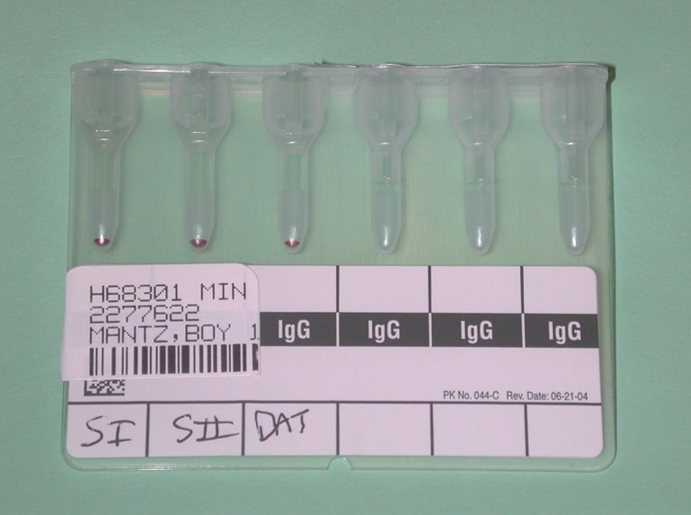

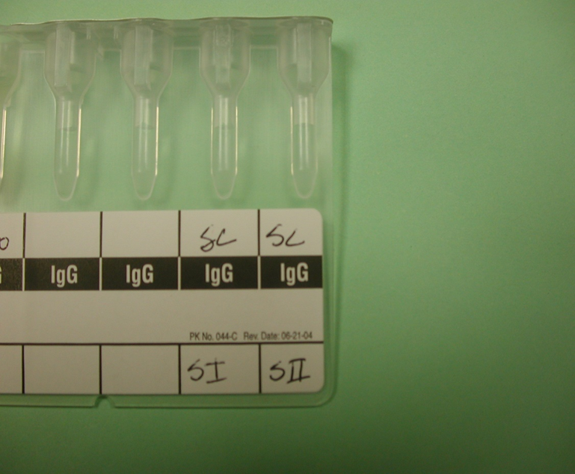

**Appendix B: Examples gel card failures**

