Direct Antiglobulin Test – Anti IgG, Manual Gel Testing

Purpose | This procedure provides instruction for how to perform a direct antiglobulin test (DAT) using IgG gel cards. Direct Coombs Test
Policy Statements | - Direct antiglobulin testing with Anti-IgG is appropriate as:  - Testing for infants under 4 months old (due to the lack of complement activity)  - Reflex testing in patients with a positive direct antiglobulin testing using polyspecific coombs reagents  - Direct antiglobulin testing with Anti-IgG is NOT appropriate as initial testing for patients over 4 months old.  - Testing performed only on the Minneapolis campus.
Test Codes | DIGGE  CDIG-credit code
Related  Documents | TS 4.9 Grading and Interpretation of Gel Card Reactions  TS 4.2 Making a 1.0% Patient Cell Suspension  TS 4.37 Investigating a Positive Direct Coombs
Materials | Equipment |  |  |  | Reagents |  |  | Supplies
 | - 50 μl MLA  - 10 μl MLA  - 1000 μl MLA  - IH-Centrifuge L |  |  |  | - IH-Card AHG Anti- IgG Gel  - IH-LISS |  |  | - MLA pipette tips  - 10 x 75 mm tubes
Sample | No special preparation of the patient is required prior to specimen collection. Blood should be collected and labeled according to approved policies and procedures. Collection of Patient Specimens  - EDTA preferred to prevent in vitro complement binding.  - Specimens drawn into ACD, CPD, or CPDA-1 are preferable to non-anticoagulated clotted specimens.  - Non-anticoagulated samples should not be refrigerated prior to testing. Positive test results using a non-anticoagulated sample must be confirmed using an EDTA sample.  - Red cells should be tested with 24 hours after collection.  - Red blood cells that are stored for extended periods of time may become coated in vitro with complement and globulin proteins.  - Some samples stored for extended periods of time, or blood that has been incompletely  anticoagulated may develop fibrin clots or particulates. Testing should be performed using  packed red blood cells that have been washed to remove the clots or particulates.  - Hemolyzed or grossly icteric samples may cause difficulty in interpretation.  - Grossly lipemic samples containing particles that clog the gel may be clarified by centrifugation.  - Rouleaux may cause false positive results.
Quality Control | Reagents must be evaluated each day of use with appropriate controls. TS 18.2 Performing Daily Reagent Quality Control
Procedure
 | Step |  | Action
 | 1 |  | Allow reagents and samples to reach room temperature (18-25 °C) before use.
 | 2 |  | Prepare cell suspension by pipetting 1000 µL IH-LISS into an appropriately labeled test tube and adding 10 µL patient/donor packed red blood cells to the IH-LISS and mix.
 | 3 |  | Inspect the IH-Cards for evidence of damage to the foil or drying of the gel. Do not use if such evidence is observed. IH-Cards with splashes of gel in the reaction area may be centrifuged prior to use.
 | 4 |  | Label the IH-Card according to procedure TS 4.7 Inspection and Labeling of Gel Cards
 | 5 |  | Carefully peel back the foil seal from the individual microtubes of the IH-Card being used for the testing, leaving the seal in place for microtubes not being used.  Note: Once the foil has been removed from the microtubes, testing must be initiated as soon as possible (recommended within 20 minutes), to prevent drying of the microtubes.
 | 6 |  | Add 50 µL of patient or donor red blood cell suspension to the correspondingly- labeled microtube on the IH-Card taking care to maintain the air gap between the cells in the upper reaction chamber and the AHG reagent in the column of the microtube.
 | 7 |  | Centrifuge the IH-Cards in the IH-Centrifuge L at the pre-programmed time and speed for the 24-card head (10 minutes 85 x G).
 | 8 |  | When centrifugation cycle is complete, remove card and read the reactions according to procedure TS 4.09 Grading and Interpretation of Gel Card Reactions
 | 9 |  | Record reactions and interpretations per procedure. Refer to interpretation section below.
 | 10 |  | Use the following table to determine the next appropriate action.  If the Anti-IgG DAT interpretation is Then  Negative Store the patient sample  Positive - Refer to TS 4.37 Investigating a Positive Direct Coombs - Consult with the patient’s physician or pathologist regarding the need to forward to the blood center reference laboratory for elution studies.  Inconclusive Repeat with testing by tube or Gel card. Forward to Reference lab as if unresolved.
Interpretation | Negative Result – No agglutination is observed as a smooth surfaced button at the bottom of the gel column. This is a negative result and that no unexpected antibody was detected.  Positive Result – Agglutination of the red blood cells as seen by clumps of cells caught within the gel column is a positive test and indicates the presence antibody(ies) on the red cells. Grade the reaction following procedure TS 4.09 Grading and Interpretation of Gel Card Reactions
Limitations | Erroneous and abnormal results may be caused by:  - Bacterial or chemical contamination of the blood specimens, reagents supplementary materials and/or equipment.  - Patient medication or disease yielding a cross-reaction  - Incomplete re-suspension of the red blood cells  - Sample or reagent red blood cell hemolysis prior to testing  - Contamination between microtubes through pipetting errors.  - Grossly icteric blood samples, blood samples with abnormally high concentrations of high molecular weight may give false positive results.  - Fibrin, clots, particulates or other artifacts may cause some red blood cells to be trapped at the top of the gel and cause an anomalous result. They may appear as a pinkish layer. In a negative reaction, the false appearance or a mixed field could lead to misinterpretation.  - If red blood cells (pellet at the bottom of the microtube) are too low in concentration, they become difficult to visualize and a weak positive reaction may fail to be detected.
Result Reporting

 | Step | Action
 | 1 | Enter Blood Order Processing by the patient sample accession number.
 | 2 | Click on the Patient Specimen tab.
 | 3 | If Then  Test DIGGE already part of the order Proceed to step 4  Needing to add test DIGGE in the Add Spec. Test box enter ;DIGGE or pressing key g
 | 4 | Click in the GGEL reaction result entry cell or press Home from the DIGGE order field.
 | 5 | In the GGEL reaction result grid press the key assigned to the reaction result for the phase.  KEY MEANING  - No agglutination  - 1+  2 2+  3 3+  4 4+  M MF-mixed field  H HEM-hemolysis  NT Not tested  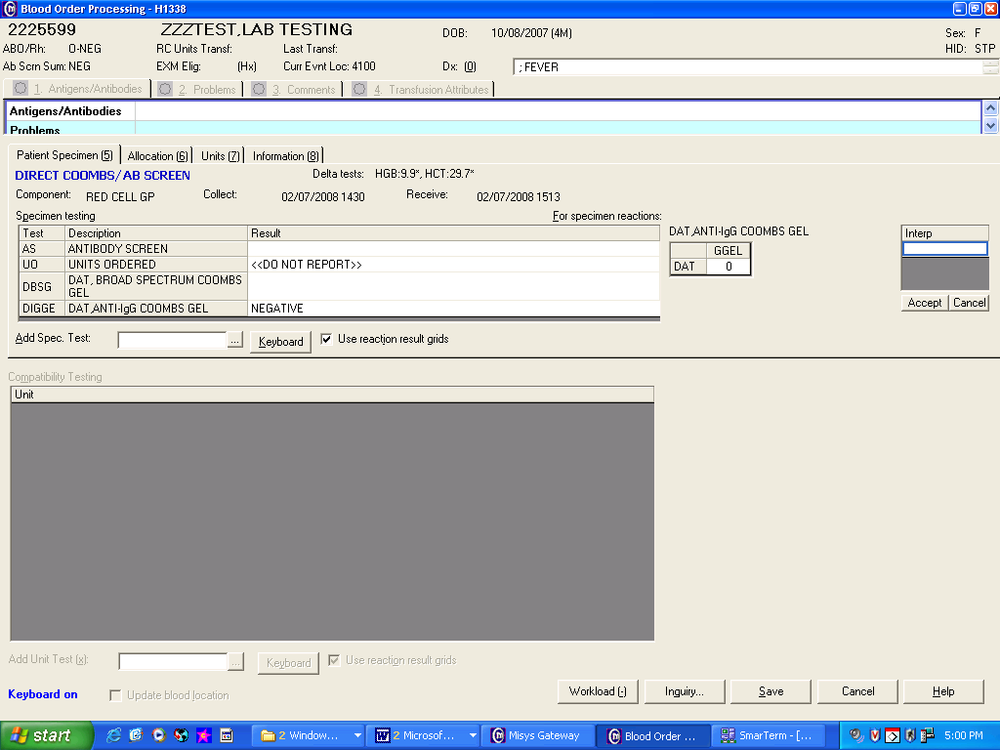
 | 6 | Enter an interpretation using the keyboard.  KEY MEANING  N Negative  P Positive  ;NRQ Not Required Testing not performed must be credited by adding test code  CDIG to the Add Spec.Test field.  ;ICLR Inconclusive results, repeat testing  Note: If entering results as Inconclusive and planning to repeat with tube testing (DIG) then enter the interpretation as ;ICLR press TAB and enter ;HIDE into the next field to prevent the Inconclusive result from filing to Cerner.  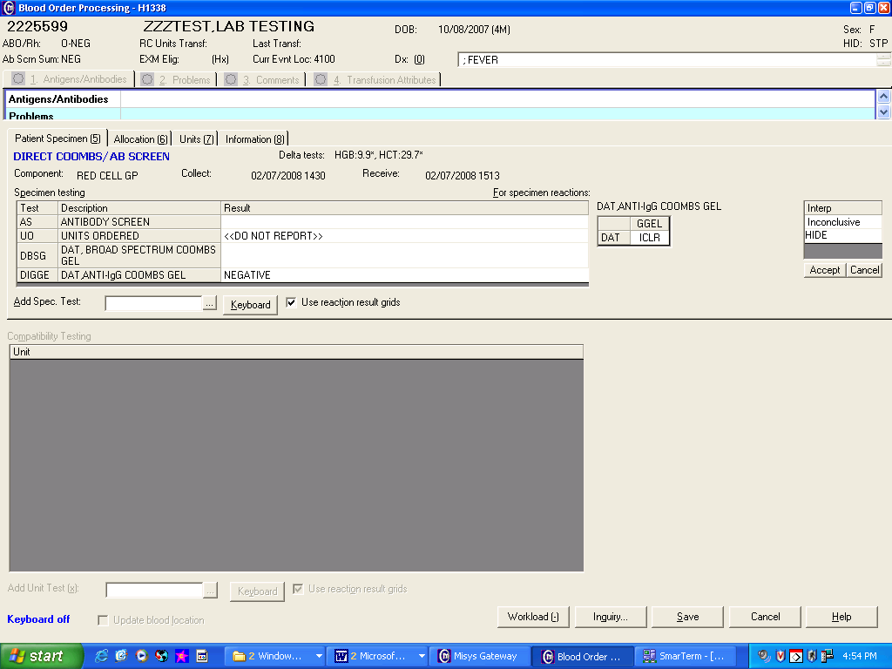
 | 7 | Save results.
References | AABB Technical Manual, current edition  AABB Standards for Blood Banks and Transfusion Services, current edition  Package insert: IH-Card Anti-IgG Bio-Rad Medical Diagnostics GmbH, current version  Package insert: IH-LISS solution, Bio-Rad Medical Diagnostics GmbH, current version
Approval  Workflow | Transfusion Service/Laboratory Director
Historical Record | Version |  |  | Written/Revised by: |  | Effective Date: | Summary of Revisions
 | 1 |  |  | J Wenzel |  | 02/08/2008 | Initial Version
 | 2 |  |  | N Poupard |  | 11/06/2009 | Omitted Lui elution
 | 3 |  |  | J Bjorklund |  | 4/10/2012 | Added TS 5.14 as Results Reporting steps
 | 4 |  |  | S. Cassidy |  | 02/17/2023 | Updated procedure for new reagents

