Working with IH-Com

Purpose | To ensure that all IH-Com users understand how the software functions and how it interacts with the IH-500 and IH-Reader 24
Procedure
 | Step | Action
 | 1 | IH-Com Connector supports communication between the instrument and the IH-Com database.  - Connections:  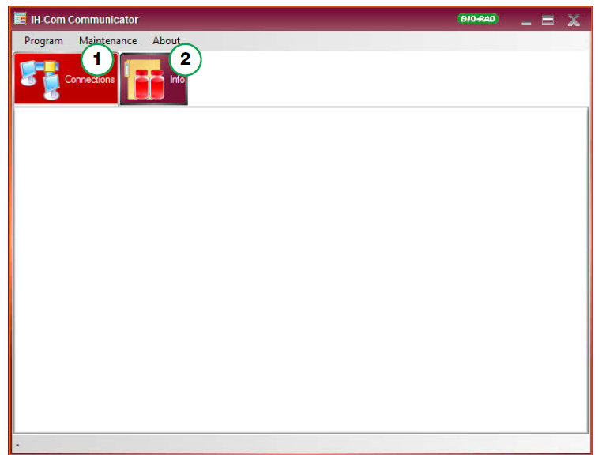
 | 2 | IH-Com Connector controls the communication between connected devices, the LIS and the IH-Com database.  - The ‘Connections’ tab displays all active connections to the LIS and to any interfaced devices.  - The “Log’ tab displays current logs.  - The ‘Info’ tab displays the version and link to log files
 | 3 | IH-Com Client allows the user to process requests and results, plus manage patient data and quality controls.  - The main screen of IH-Com Client has a menu bar, search field, selection tabs, a search information area, patient information area, results area and status bar  - The menu bar consists of the following:  - Program-used for manual login and logout and to close IH-Com Client  - View-used to switch between main screens  - Work list-actions that affect the Work list  - Reader Devices-settings and control of the reader devices  - Print-print daily journals, results, quality controls, system logs, system configurations and various statistical reports  - Configuration-used for system configuration and user administration  - Language-used to define the interface languages  - About-information of the version and license  - The selections tabs are:  - Patients  - Work list  - Manual work  - Results  - QC  - State (Status)
References | - IH-Com User Manual NA V1.2-02/2021, Chapter B, Sections 1.1 to 1.5
Approval  Workflow | Transfusion Service/Lab Director
Historical Record | Version |  | Written/Revised by: | Effective Date: | Summary of Revisions
 | 1 |  | S. Cassidy | 02/17/2023 | Initial Version

