Working with IH-500 Software

Purpose | This procedure guides and ensures all users understand the IH-500 software functions.
Policy Statements | - This procedure applies to navigation and understanding of the IH-500 software capabilities and functions. The software is operated via the touch screen monitor or by attaching a keyboard.
Before  You Begin | - The IH-500 software automatically opens when the instrument is turned on.
Procedure
 | Step | Action
Keyboard | 1 | Using the Touch Screen Monitor  - Touching the screen with a finder or a blunt object such as a pencil eraser has the same effect as a mouse click.  - Select a button to execute a command.  - To activate a box for input, touch the box. The cursor appears in the text box allowing data entry via the virtual keyboard or an attached keyboard.  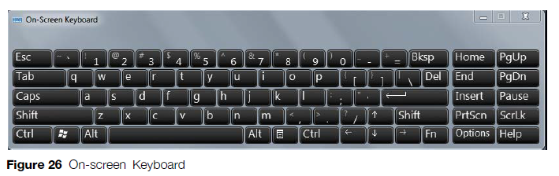
 | 2 | Common Functions and Screens:  - The ‘Back’ button is available on all screens except for the Main Screen. It allows the user to return to the previous screen.  - Select a column title to sort ascending or descending.  - List selection can be done by single selection or extended selection by using the buttons in the bottom right of the screen.
Main Screen | 3 | 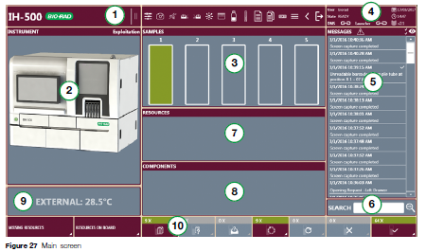  - Header  - Instrument Area (Interactive Image)  - Samples Screen  - Instrument Status Area  - Messages List  - Search Area  - Resources Area (error or warning)  - Components Area (error or warning)  - Temperature display and access to temperatures screen  - Footer
Instrument Area (Interactive Image) | 4 | 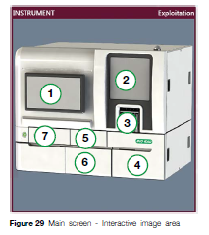  - Access to resources on board  - Access to components screen and opening of the pipetting area door (a representative image of the hardware inside the instrument and its status)  - Access to samples screen (shows status of all samples, tests, & assays in progress)  - Access to solutions/wastes screen (liquid containers door)  - Access to right drawer/details (screen and opening button)  - Access to solutions/wastes screen (solid waste area door)  - Access to left drawer/details (screen and opening button)  If there is an error, one of the 7 areas will highlight red. Choose the section highlighted in red for detailed information.
 | Step | Action
Header Strip | 1 | Header Strip & Shortcut Bar  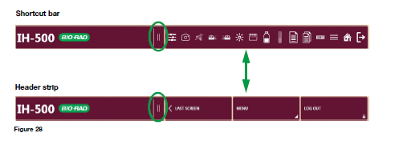  The header strip is always visible and provides access to available options, depending on the system status.  Pressing the expanding button toggles between the shortcut bar or the header strip.
Shortcut Bar | 2 | Shortcut Bar  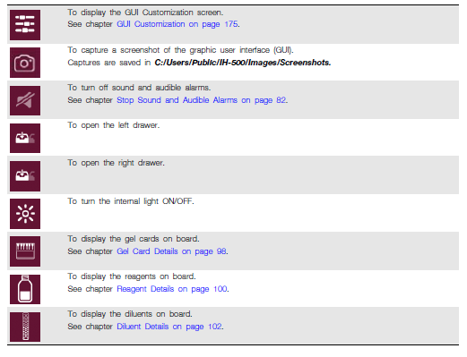
Header Strip | 3 | Header Strip  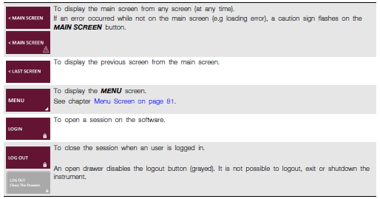  The ‘Login’ or ‘Logout’ will display depending on whether a user is logged in or not. An open drawer disables the logout button.
Menu | 4 | Menu Button  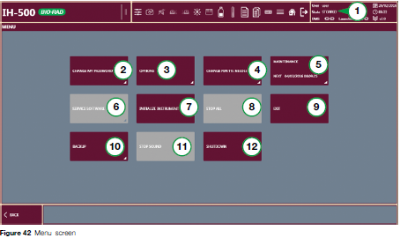  The ‘Menu’ button gives access to the following functions. Some functions may be unavailable depending on user rights:  - Instrument Status  - Change my Password  - Options  - Change Pipette Needle  - Maintenance  - Service Software (service engineer restricted user rights only)  - Initialize Instrument  - Stop All  - Exit  - Backup  - Stop Sound (audible alarms)  - Shutdown
Stop Sound and Audible Alarms

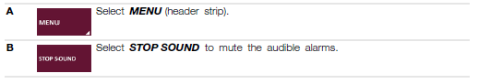

Low-pitched tone: Error occurred (red), user action is required
High-pitched tone: Error occurred (orange warning), user action is recommended
Footer |  | Footer Strip  1. The footer strip is only visible from the main screen. The footer strip icons can be text or pictogram depending on what option is set.  2. The ‘Sample Management’ and ‘Tests in Progress’ and ‘Tests without Resources’ are only accessible if the corresponding button displays a number other than 0.  3. Clicking on ‘Tests Without Resources’ will display first the assay(s) that are unable to run due to the missing resources.  4. Clicking on ‘Missing Resources’ will then display what resources must be added to the instrument for the assays to run.  5. The ‘Tests in Progress’ button displays the number of tests in progress, the status of these tests when the button is selected, and how much time is elapsed until completion.  6. The ‘Tests to Repeat’ button displays all tests to repeat. To show canceled tests also, select the canceled button on the bottom right corner of the screen.  7. The ‘Tests Completed’ displays all tests completed. This number resets every 60 days.  8. The ‘Samples Management’ button displays all samples on board with assigned tests in progress as well as samples without requests.
Samples |  | Samples Area  - The samples area displays the status of all loaded sample racks.  - To view all loaded samples, remove racks or ignore samples with an error; select the samples area to access the Samples screen.  - It is also possible to access the SAMPLES screen from the instrument interactive image.  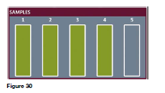
Search Area |  | Search Area  - To view the history of a particular sample, type the sample barcode with the keyboard or scan it with the hand-held barcode scanner.  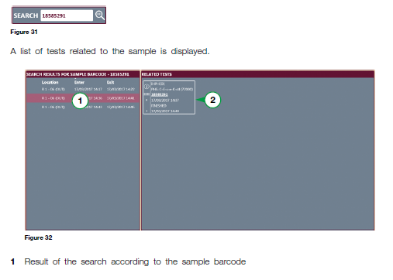  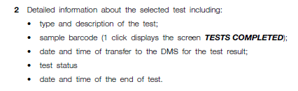
Temperatures |  | Components Temperature Area  - The components temperature area cycles each component temperature (°C) display.  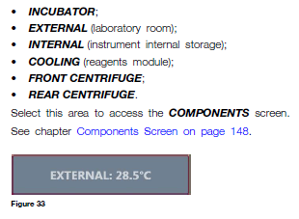
Instrument Status |  | Instrument Status Area  - The Instrument Status Area at the top right corner of the screen displays the name of the connected user, the instrument status, the data management software status, the launcher status, the date, time and software version and the IH-500 system information.  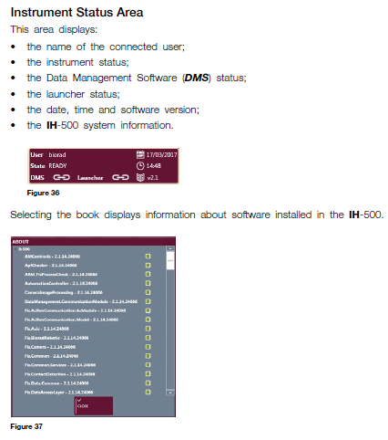
Resource Area Icons |  | Resources Area Icons & Errors  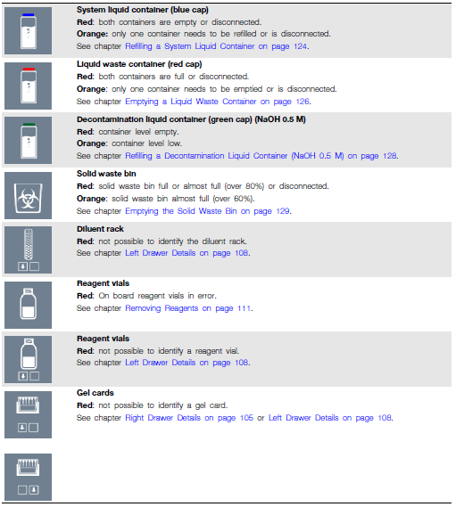
Components Area Icons |  | Components Area Icons  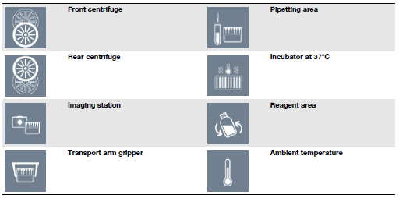
Common Functions &Screens |  | - Column Sorting & List Selection  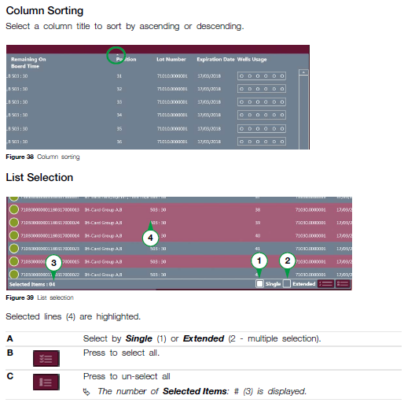
Weekly Maintenance Reminder |  | The weekly maintenance has to be done once a week. The icon will display red or orange.  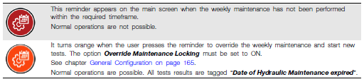
Instrument State |  | If the IH-500 displays one of the following states, it is not possible to perform ANY tests.  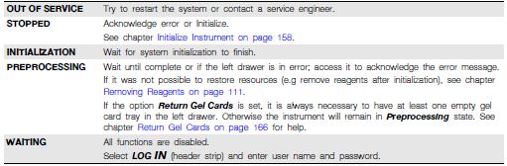
Main Screen in Error |  | Main Screen in Error (Red/Orange)  - When an error or warning occurs, the concerned area is highlighted in red or range. The system also generates an audible alarm and the status light is red or orange.  - Orange (Warning): The instrument continues to work but informs about a minor problem e.g. one full liquid waste container. A user action is recommended.  - Red (Error): The instrument has stopped. A user action is required.  NOTE: After a stop, it is necessary to initialize the instrument to continue testing. The system removes sample racks and unloads reagent vials (canceled tests are displayed in the test to repeat screen.) Diluent racks are re-identified.  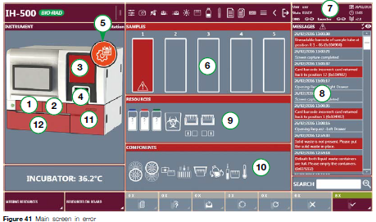  - Error in left drawer  - Error in right drawer  - Error in component area  - Error in the sample area  - Weekly maintenance reminder icon  - Samples area in error  - Instrument state  - Messages area (error information is highlighted in red or orange)  - Resources area in error  - Components area in error  - Error in the liquid containers door  - Error in the solid waste area door
References | - IH-500 User Manual NA V1.0-07/2017, Chapter 4
Approval  Workflow | Transfusion Service/Lab Director
Historical Record | Version |  | Written/Revised by: | Effective Date: | Summary of Revisions
 | 1 |  | J. Hudgens | 02/17/2023 | Initial Version

