Managing Liquid Containers and Card Waste

Purpose | This procedure provides instructions to ensure that the containers for the liquid used or generated by the IH-500 are appropriately filled and emptied. System Liquid may remain on the analyzer for 7 days. After 7 days the system liquid containers should be emptied and refilled. This may be done during weekly maintenance or at other times determined by the facility.
Policy Statements | - The operator is responsible for filling and emptying the containers as necessary in the manner specified in these instructions.  - This procedure applies whenever the analyzer is in use.
Procedure
 | Step | Action
 | 1 | From the main screen, select the Liquid/Waste Area or Solid Waste Area of the interactive image.  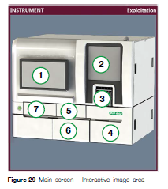  4. Access to solid/waste screen (liquid containers door)  6. Access to solutions/waste screens (solid waste door)  NOTE: If a container is full or empty during a run, it is highlighted orange or red.
 | 2 | Solutions/Waste Screen  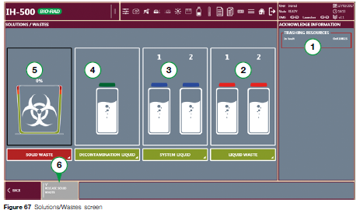  - Information Area  - Liquid Waste Container Status  - System Liquid Container Status  - Decontamination Liquid Container Status  - Solid Waste Bin Status  - To open the solid waste bin
 | 3 | Filling a System Liquid Container  NOTE: If the tubing appears dirty (visually), the container and tubing must be replaced.  NOTE: System liquid is stable for 7 days  1. Open the door and disconnect the thumb latch from the empty container. Remove the container.  2. Remove the cap of the empty container.  3. Empty any residual liquid and rinse the container with DI water.  4. Add 2 L of DI water.  5. Fill the container with 1 bottle (100 mL) Wash Solution A, Mix gently.  6. Replace the cap and return the container to the same position on the instrument.  7. Reconnect the thumb latch.  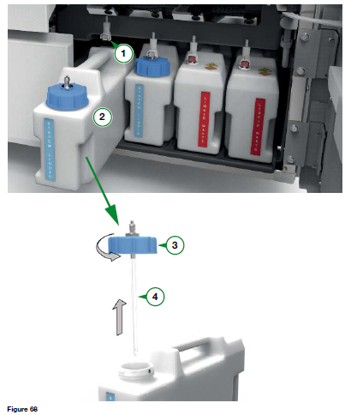  Liquid Container  Tubing  Cap  Thumb Latch  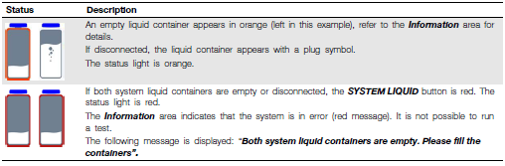
 | 4 | Filling the Decontamination Container  - Open the solid waste area door.  - Remove the cap from the container.  - Do not remove the container itself. It does not come out of the analyzer.  - Pour 0.5 M NaOH into the container up to the Max mark.  - Replace the cap.  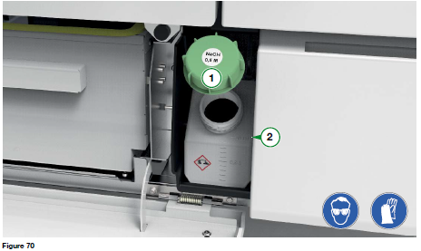  - Cap  - Max fill line (1 L)
 | 5 | Emptying a Liquid Waste Container  - Display the screen SOLUTIONS/WASTE  - Open the liquid containers door  - Disconnect the thumb latch from the full container and remove the container.  - Remove the cap of the full container  - Dispose of the waste in accordance with laboratory procedures.  - Dry the outside of the container.  - Replace the cap and return the container to the same position on the instrument.  - Reconnect the thumb latch  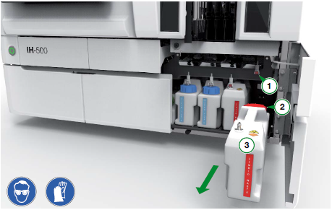  In diagram (1) thumb latch (2) cap (3) liquid waste container
 | 6 | Emptying the Solid Waste Bin  - Select the solid waste bin area on the instrument interactive image.  - Select the image of the solid waste bin.  - Select the ‘Release Solid Waste’ button.  - The latch will release and the bin may be removed.  - Dispose of the solid waste in the biohazard bin and according to laboratory procedures.  - Replace the bin and secure the latch  - The solid waste bin latch will automatically release when the instrument is shut down.  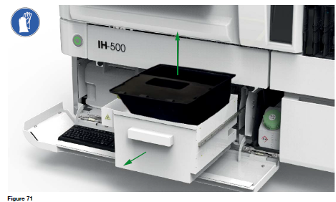
References | - IH-500 User Manual NA V1.0-07/2017, Sections 7.5.2, 7.5.3, 7.5.4, and 7.5.5
Approval  Workflow | Transfusion Service/Lab Director
Historical Record | Version |  | Written/Revised by: | Effective Date: | Summary of Revisions
 | 1 |  | J. Hudgens | 02/17/2023 | Initial Version

