Managing Gel Cards on the IH-500

Purpose | This procedure provides instructions for proper handling of gel cards used for testing.
Policy Statements | - This procedure applies whenever the analyzer is in use.  - The operator is responsible for ensuring the gel cards are in good condition prior to use and are used within manufacturer specifications.
Procedure
 | Step | Action
Prior to loading gel cards | 1 | Prior to loading gel cards on the IH-500  - Check the protective foil of each gel card to ensure it is not damaged. The right free end of the protective foil must be down, not pointing up or out.  - Check that the barcodes of each gel card are clean and not scratched.  - Verify the gel cards are in good condition and show no signs of drying, bubbles or damaged foil.  - Do not use opened or partially used cards.  - If needed, you are allowed to centrifuge the gel cards in manual centrifuge ONE time to set the supernatant inside the wells if the card appears shaken up.
Loading gel cards | 2 | To load gel cards  - Load gel cards in the right drawer.  - From the main screen of the IH-500 software, select the right storage drawer on the interactive image.  - Select the ‘Open Drawer’ button.  - The drawer will unlock.
 | 3 | Loading gel cards  - Place the gel card trays in the drawers  - The most efficient way to load the cards is with the barcode facing to the right or facing you. See image below, number 2 and 4 indicate the barcode and the direction it is facing.  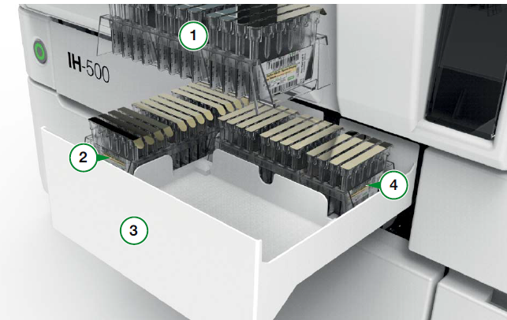  - Take care that the cards and trays are seated correctly in place. Be careful to remove any old empty plastic trays if there are any in the drawer. Do not stack trays.  - Close the drawer by pushing it manually until it is completely closed  - The transport arm will scan the drawer(s) and automatically start picking up the gel cards one at a time  - Once gel cards are scanned, they will be placed in the gel card storage area of the IH-500  Sealed gel columns are stable for 21 days on board the IH-500
Removing Gel Cards | 4 | To Remove Gel Cards  - Select the “Resources on Board’ button then select the Gel Card Details  - Select gel card(s) to remove  - There is also the option to remove all of a selected type of gel card.  - Select ‘Yes’ to confirm  - Ensure there is an empty tray in the designated drawer for the gel cards to be placed once removed. More than one tray may be necessary depending on the number of cards.  - Once the card(s) are removed, the designated drawer will display red on the interactive image.  - Open the drawer and remove the gel card(s)  - Partially used cards will not be returned to the gel card drawer and must be discarded.
 | Step | Action
Removing a Gel Card in Error | 1 | If an error occurred, the drawer (9) is highlighted red. It is also possible to select the right  drawer icon (8) in the RESOURCES area.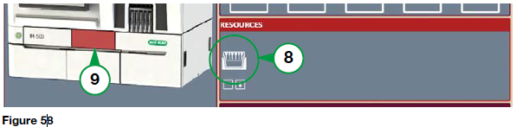
 | 2 | Open the drawer to remove the gel card in error.
 | 3 | Dispose of the damaged gel cards in the biohazard waste.
 | 4 | Close the right drawer.
Limitations | - Do not pile gel card trays on top of each other in the drawer.  - Only wells needed for testing are pierced.  - DO NOT reload gel cards once they have been removed from the instrument. The on board time is reset and will be incorrect.
References | - IH-500 User Manual NA V1.0-07/2017, Chapter 7.1-7.3
Approval  Workflow | Transfusion Service/Lab Director
Historical Record | Version |  | Written/Revised by: | Effective Date: | Summary of Revisions
 | 1 |  | J. Hudgens | 02/17/2023 | Initial Version

