Managing Reagents IH-500

Purpose | This procedure provides instructions to ensure proper handling, loading, and unloading of reagents used for testing.
Policy Statements | - This procedure applies whenever the analyzer is in use.
Stability | On board stability of diluent racks is 30 days.  On board stability of reagents is 7 days.
Procedure
 | Step | Action
Diluent Racks | 1 | NOTE:  - only non-pierced (unused) diluent racks can be loaded  - diluent racks MUST be loaded in the left drawer only  - 4 diluent racks can be stored on the instrument at one time, but only 2 of the same type of diluent rack may be on board
 | 2 | Open the left drawer by pushing the ‘open left drawer button’
 | 3 | Place the diluent rack(s) in the appropriate position(s) on the right side of the left drawer with the barcode facing to the right as shown in image below.  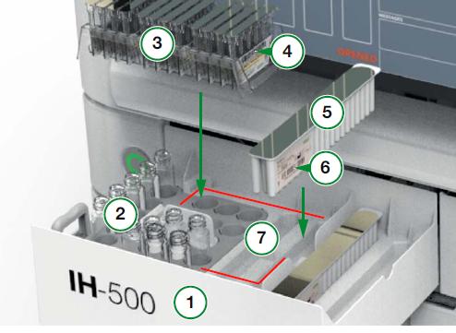  5= diluent pack 6=barcode on diluent pack 7=reagent loading zone
 | 4 | Close the drawer, the transport arm will scan the drawer and identify reagents.
 | 5 | The loaded rack will be displayed in the ‘Diluent Details’ screen. This screen provides information on the rack type, lot, expiration, and number of free wells.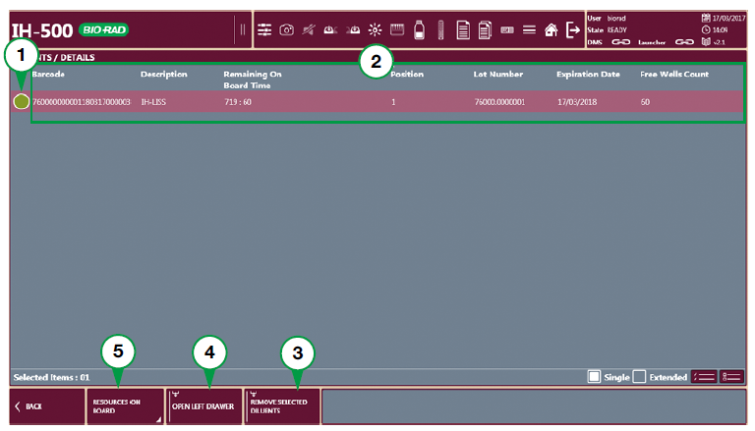  1= status of diluent rack 2=detailed info of the rack 3=remove selected diluents 4=open left drawer 5=resources on board
 | 5 | To unload diluent racks, select the rack you wish to remove and select ‘Remove Selected Diluents’, this will discard the diluent rack if the rack was used at all. If the rack was not used at all, it will be returned to the left drawer for removal.
 | Step | Action
Reagents | 1 | Examine reagents for integrity (ex: cloudiness). Gently swirl the vials so that the reagents are in suspension. Allow to sit at room temp for 5-10 minutes.
 | 2 | Open the left drawer. Remove the caps and place the vials in the reagent tray so that the barcode is facing the barcode alignment mark (black curved line next to each vial well). Be sure reagents don’t have excess bubbles on surface, if so, remove bubbles before loading.  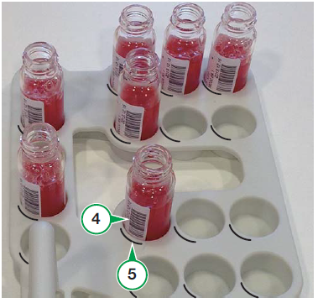
 | 3 | Close the left drawer. The transport arm will scan the drawer and identify reagents loaded.
 | 4 | To remove reagents, select the ‘Resources on Board’ button, then the ‘Reagents’ area. 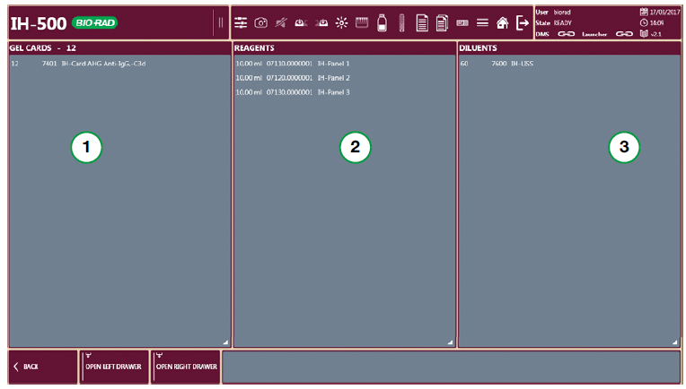
 | 5 | Select the reagent(s) to be removed and then select ‘Remove Selected Reagents’
 | 6 | Selected reagents will be removed in the left drawer. The drawer will be highlighted red until the unloaded reagents are removed. DO NOT load reagents back onto the analyzer after they have been unloaded, this will reset the stability time of the reagent and it will no longer be accurate.
Limitations | - If on board tracking is activated, diluent racks and reagents reloaded on the instrument will display inaccurate on board shelf life. An alternate method of tracking on board shelf life should be implemented.  - Diluent racks that have any used wells will be sent directly to the solid waste bin if selected to be removed.
References | - IH-500 User Manual NA V.1.0 – 07/2017, Chapter 7.2, 7.3.2 and 7.3.3
Approval  Workflow | Transfusion Service/Lab Director
Historical Record | Version |  | Written/Revised by: | Effective Date: | Summary of Revisions
 | 1 |  | J. Hudgens | 02/17/2023 | Initial Version

