Managing Sample Racks IH-500

Purpose | This procedure provides instructions for use of sample racks on the IH-500.
Policy Statements | - The operator is responsible for performing the procedure in the manner specified in these instructions.  - This procedure applies to all sample racks used on the IH-500.
Procedure
 | Step | Action
Sample Rack Info and Loading | 1 | Sample racks may be loaded at any time into any free position (1-5).  - A green light indicates that the slot is available.  - A red light indicates that a rack is already loaded in that lane.  - A blinking red light indicates the rack is moving (unloading).  Each rack can hold 2 sample tube holders. Each sample tube holder can hold 5 tubes. It is not necessary to have both sample blocks in a rack in order to load it.  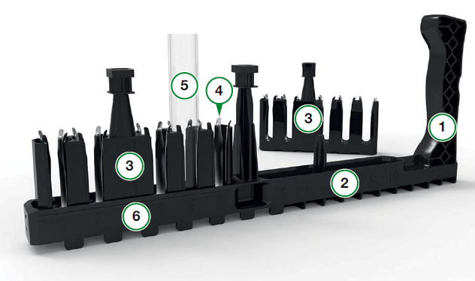  (1) Sample rack (2) Position 6-10 (3) Sample tube holder (4) Sample tube spring (5)Tube (6) Position 1-5
 | 2 | Use a rack appropriate for the sample type.    STAT samples Regular samples
 | 3 | Place the sample in the rack with the barcode visible on the left side of the rack. Load onto the analyzer.
 | Step | Action
Samples Screen | 1 | Once samples are loaded, they can be viewed in the samples screen. 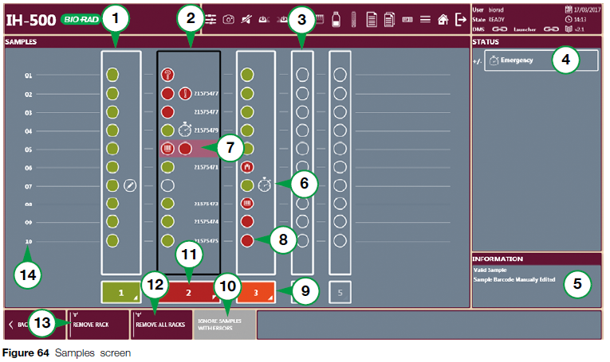  (1) valid sample rack (2) sample rack in error (2) empty sample rack lane (4) status area (5) information (6) sample tube with priority status (7) selected sample tube (8) sample tube in error (9) rack removed for re-identification (10) function to ignore samples with error (11) sample rack selected
 | 2 | The sample details for all rack positions will display.  - Any remarks, errors, sample barcodes, etc are viewable here  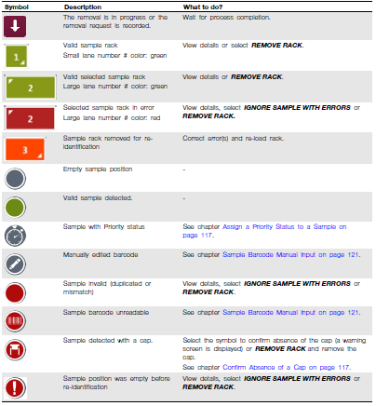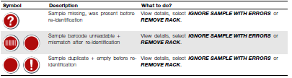
 | 3 | Do NOT manually pull off racks. To remove a rack, select the rack and push the ‘Remove Rack’ button. If the selected rack is in use, a warning message prompts that the system will remove the rack once it is finished with the process.
Limitations | - Samples with errors are automatically ignored according to the time set in the general configuration. This time is set at 10 minutes.  - Only sample racks not currently pipetting are able to be removed.  - A rack may be removed manually ONLY when the IH-500 is shutdown.  - Racks automatically eject themselves after pipetting of all the samples has completed.
References | - IH-500 User manual NA V.1.0-07/2017, Chapter 7.4
Approval  Workflow | Transfusion Service/Lab Director
Historical Record | Version |  | Written/Revised by: | Effective Date: | Summary of Revisions
 | 1 |  | J. Hudgens | 02/17/2023 | Initial Version

