Manual Sample Barcode Entry on IH-500

Purpose | This procedure provides instructions for manually entering a sample barcode on the IH-500.
Policy Statements | - This procedure applies to anyone who operates the IH-500.
Procedure
 | Step | Action
 | 1 | Load sample onto analyzer.
 | 2 | Select the sample with the barcode unreadable symbol.   The screen ‘Manual Barcode Input’ is displayed.
 | 3 | Remove the rack to identify the sample.
 | 4 | Input the barcode or scan with the handheld scanner. The barcode must be scanned or entered twice. 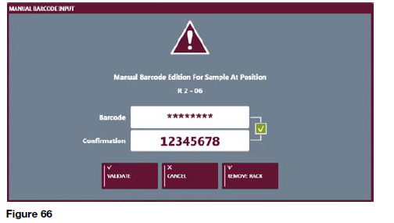
 | 5 | Confirm the entry and re-load the sample in the same rack in its original position. Failure to do so may cause an error on the analyzer.
 | 6 | Sample will be rescanned and will begin processing.
References | - IH-500 User Manual NA V1.0-07/2017, Chapter 7.4.8
Approval  Workflow | Transfusion Service/Medical Director
Historical Record | Version |  | Written/Revised by: | Effective Date: | Summary of Revisions
 | 1 |  | J. Hudgens | 02/17/2023 | Initial Version

