Auto Control-Gel Testing

Purpose | This procedure provides instructions for performing an auto control by gel method. Reactivity of patient’s plasma with autologous cells may indicate the presence of warm or cold autoantibodies, antibodies to certain drugs, alloantibodies to recently transfused red blood cells, or antibodies to the test medium.
Policy Statements | - If the autocontrol is positive a direct antiglobulin test should be performed.  - The use of autologous control is not part of routine pretransfusion testing. Testing should be limited to:  - Diagnosis of autoimmune hemolytic anemia or immunologic abnormalities associated with drug therapy.  - The serologic evaluation of reactive antibody screen and/or compatibility test.  - On physician order in evaluating patients with unexplained anemia.
Test Codes | ACGEL-Auto Control Gel
Related  Documents | TS 4.9 Grading and Interpretation of Gel Cards  TS 4.2 Making a 1.0% cell suspension
Materials | Equipment |  |  |  | Reagents |  |  | Supplies
 | - 50 μl MLA pipet  - 25 μl MLA pipet  or  - Biohit electronic pipet  - IH-Incubator L  - IH-Centrifuge L  - IH-Reader 24-Stp only |  |  |  | IH-Gel IgG Card |  |  | - MLA pipet tips  - Biohit pipet tips
Sample | No special preparation of the patient is required prior to specimen collection. Blood should be collected and labeled according to approved policies and procedures. Collection of Patient Specimens  EDTA or clotted specimen should be tested within 14 days and stored at 2-8°C.
Quality Control | Refer to TS 18.2 Performing Daily Reagent Quality Control
Before  You Begin | - Confirm sample acceptability and review patient history per procedure.  - Label gel card per TS 4.7 Inspection and Labeling of Gel Cards.  - Bring samples and reagents to room temperature (18-25°C)
Procedure
 | Step |  | Action
 | 1 |  | Inspect and label gel card per procedure.
 | 2 |  | Remove the foil seal from the top of the gel card from the labeled microtubes to be used.
 | 3 |  | Prepare a 1.0% cell patient’s cells according to procedure.
 | 4 |  | Add 50 μL of 1.0 % patient’s cells to the upper well of the labeled microtube holding the pipet at a 45° angle.  Note: Do not let the pipet tip touch the gel card. Carryover of sample may cause false results.
 | 5 |  | Add 25 μL of patient plasma to the upper well of each labeled microtube holding the pipet vertical to the well.  Note: Do not let the pipet tip touch the gel card. Carryover of sample may cause false results.
 | 6 |  | Check that the volume or appearance of cells and plasma is consistent in each microtube.  Note: For any microtube that appear inconsisitent, repeat the test set-up.
 | 7 |  | Note the MTS incubator temperature. Acceptable range: 35-39°C
 | 8 |  | Incubate the anit-IgG gel card for 15 minutes.  Note: Incubation time cannot exceed 20 minutes.
 | 9 |  | Remove the gel card(s) from the incubator and centrifuge as follows:
 | 10 |  | Read and grade reactions of microtube.
 | 11 |  | Record reactions and interpretations per procedure.
Interpretation | If the tube shows Then Interpret autocontrol as  No hemolysis or no agglutination Antibodies were not detected or were undetected Negative  Hemolysis or agglutination of any strength An auto-antibody is present Positive  Positive results may be followed with a direct antiglobulin test. Negative DATs with mix-field positive auto-control may be indicative of a delayed hemolytic transfusion reaction if the patient has been previously transfused. Reference lab elution studies are warranted.
Alternate Procedure | TS 4.30 Auto Control- Tube Testing
Result Reporting

 | Step | Action
 | 1 | Enter Blood Order Processing by the patient sample accession number.
 | 2 | Add test ACGEL to the Add Spec. Test box.  - Enter :ACGEL for gel or press key x
 | 3 | Click in the Auto control reaction result entry cell or press Home from the ACGEL order field.
 | 4 | Entered the graded reaction in the grid cell.  ATGEL= Autocontrol gel  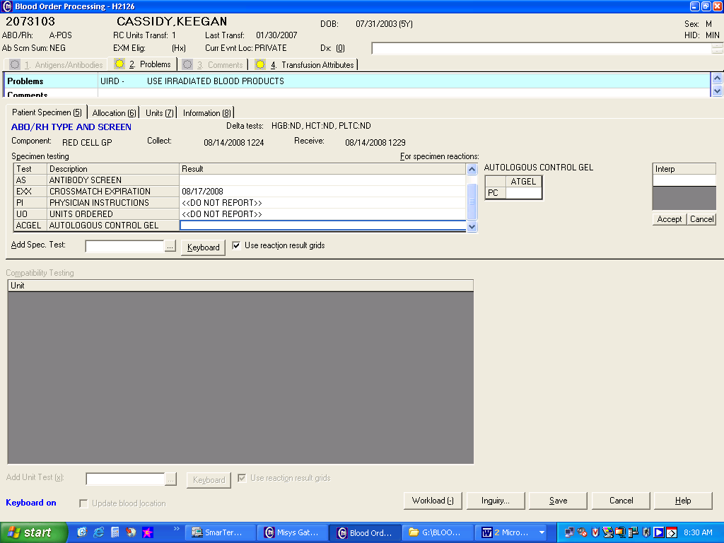
 | 5 | Enter the test interpretation using the keyboard.  KEY MEANING  N Negative  P Positive  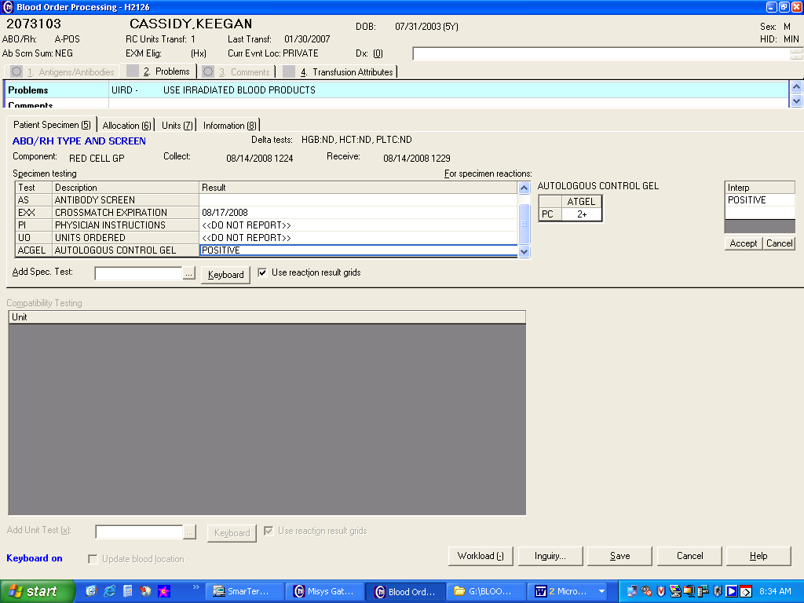
 | 6 | Save results
References | AABB Standards for Blood Banks and Transfusion Services, current edition
Approval  Workflow | Transfusion Service/Laboratory Director
Historical Record | Version |  |  | Written/Revised by: |  | Effective Date: | Summary of Revisions
 | 1 |  |  | S Cassidy/ J Wenzel |  | 10/19/2009 | Initial Version
 | 2 |  |  | J Wenzel |  | 4/10/2012 | Combine with TS 5.20 for Result Reporting
 | 3 |  |  | S. Cassidy |  | 02/17/2023 | Updated for new reagents

