Performing Quality Control on the IH-500

Purpose | This procedure provides instructions to ensure that quality control testing is performed on the IH-500 according to specifications.
Policy Statements | - Blood Bank reagents must be tested for potency and specificity on each day of use.  - News lots of reagents must be tested before or concurrently with first use.  - Quality control testing should be performed after service and/or repair of the analyzer and after reading calibration  - Quality control testing will be performed according to the manufacture’s recommendations.  - All Blood Bank reagents in use will be visually checked for expiration date and appearance prior to quality control testing and before and testing use. Any reagent that has expired or shows evidence of contamination or deterioration (turbidity or hemolysis) will be discard as biohazard waste.  - All QC records will be printed and reviewed and place in the reagent QC book  - All quality controls must fall within the “acceptable results”. If test results differ from the “acceptable results”, then the Out of Control Plan must be implemented.  - The Transfusion Service Technical Specialist or Medical Director will review quality control.  - Blood bank reagents should be stored according to the manufacture’s recommendations  - ABO/Rh card, Antibody Screen/IgG card, and Newborn card will be QC’d daily with their respective reagents. Weak D/Poly DAT/IgG DAT will be QC’d every Monday and as needed.
Materials | Equipment |  |  |  | Reagents
 | - IH-500 |  |  |  | - Solidscreen II Negative Control  - IH-Basic QC  - IH-Cell I, II  - IH-Cell A1, B  - IH-LISS  - IH-Card ABO/D(DVI-)+Rev A1,B  - IH-AHG Anti-IgG  - IH-Card ABD(DVI+)  - IH-Card Newborn  IH-Anti-D Blend
Procedure
 | Step | Action
 | 1 | The “QC” tab of IH-Com displays the list of all reagents that require QC. The current lot of each reagent will be listed along with the expiration date and time of the QC for that reagent. If QC has expired, has not yet been performed on the lot, or failed, and red flashing symbol will appear beside that reagent and the QC tab itself flash red.
 | 2 | Reagents listed in the QC tab will flash with a yellow caution sign 2 hours prior to QC expiring.  - Samples will not be flagged during this time.  - This is only a warning 2 hours prior that QC is necessary.
New lot # | 3 | If a new lot of Bio-Rad QC samples will be put in to use:  - Open the QC tab in IH-Com. Select the ‘Control Samples’ button.  - Select ‘New Lot’.  - Scan the barcode on the Bio-Rad QC samples.  - Verify and/or enter the correct target values and expiration date.  - Select ‘Save.  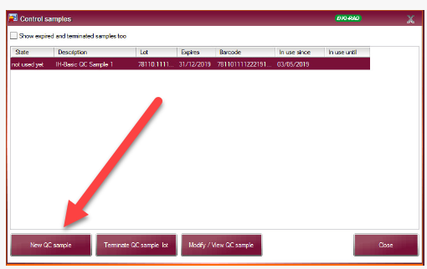
 | 4 | IH-Basic QC and Solidscreen II negative for ABO/Rh, Antibody Screen and Weak D:  - IH-Basic QC contains 2 samples  - Sample 1  - RhD negative, K positive and containing Anti-B and Anti-D  - Sample 2  - RhD positive, K negative and containing Anti-A and Anti-Fya  - Opened tubes have a shelf-life of 7 days, or the original expiration date, whichever is shorter.  - Solidscreen II Negative Control: Negative Antibody Screen Control  - Expiration of this sample is the same as the expiration date on the bottle.  - Lab Internal QC 1 for Poly, IgG, and Newborn Card DATs  - Expiration of this sample is the same as the expiration date on the bottle
 | 5 | Requesting Controls Manually:  - Open the “QC” Tab in IH-Com.    - Select the “Order Controls” button.  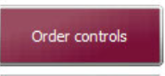  - Place a checkmark if not already there on all the control assays you want to order.  - Scan each control sample.  - Once scanned, all tests for that control sample will be highlighted with a green background.  - Once all control samples are scanned, select the “Order” button.  - All QC Tests orders are now place in the IH-Com Worklist.
 | 6 | Ensure all necessary reagents and gel cards are loaded on the IH-500. Load the sample rack with the control samples
 | 7 | Once control samples are finished processing, select the “Results” tab in IH-Com.  
 | 8 | Select the “To Read” tab and click on the first result.  
 | 9 | Review results of the control samples. If acceptable, select “Accept All” then “Save. Repeat for each control sample. See TS 24.21 Validating and editing sample results
 | 10 | Select the “QC tab and then select the “Print” button to print a daily control report. Place printout in the QC book.
Interpretation | Positive test-Agglutination of red cells  Negative test- No agglutination of red cells
Limitations | - False negative or positive reactions can occur due to contamination, improper storage, improper test performance or failure to add reagents. The cause(s) of a failure should be investigated and resolved.  - Reaction strength using the same method and lot of red cells and anti-sera should be comparable. A significant decrease in the reaction strength should be investigated.
References | - IH-Com User Manual NA V1.2-02/2021, Chapter C, Section 4.8 and 4.10  - Product Insert, IH-Basic QC, Bio-Rad Medical Diagnostic, current version  - Product Insert, Solidscreen II Negative Control, Bio-Rad Medical Diagnostic, current version
Approval  Workflow | Transfusion Service/Lab Director
Historical Record | Version |  | Written/Revised by: | Effective Date: |  | Summary of Revisions
 | 1 |  | S. Cassidy/J. Hudgens | 02/17/2023 |  | Initial Version

