Vitek 2 Quality Control for ID and AST

Purpose | This procedure provides instruction for how to perform: VITEK 2XL Quality Control for ID and AST cards.
Policy Statements | Vitek QC is performed on each new lot and/or shipment of ID and AST cards before put into use.  AST QC is performed weekly thereafter.  Vitek QC (all types AST cards and GN ID card) is performed after biennial Preventative Maintenance (PM), and/or repairs or replacement of critical components, major maintenance or service, to ensure the cards perform according to expectations.  If there is a QC failure, document observation, notify technical specialist and call bioMérieux technical service at 1-800-682-2666.
Materials
 | Reagents |  | Supplies |  | Equipment |  | Media
 | - AST -GP67 bioMérieux product number 22226  - AST-YS09 bioMerieux product number 423331  - AST-ST02  bioMérieux product number 420915  - AST-GP74 bioMérieux product number 414971  - AST-GN95 bioMerieux product number 421982  - AST-XN08  bioMerieux product number 421983  - GN ID cards, bioMérieux product number 21341  - GP ID cards, bioMérieux product number 21342  - YST ID cards, bioMérieux product number 21343  - NH ID cards, bioMérieux product number 21346  - ANC ID cards, bioMérieux product number 21347 |  | - 0.45% Saline, Cardinal Healthcare product number 3D0775  - 0.45% IV saline, Cardinal Healthcare product number 2B16314X  - 10 mm x 75 mm polystyrene tubes, bioMérieux product number 69285  - Sterile, cotton-tipped applicator swabs, warehouse product |  | - Vitek 2 instrument, bioMérieux product number 530052-1  - DensiChek, bioMerieux product number 27207  - Adjustable volume dispenser, bioMérieux product number V1200  - Smart Carrier Cassette bioMérieux product number 27700  - Vortex Mixer, Barnstead International, model # M37615 |  | - CHOC  - SB  - SAB  - MAC
Storage | - Cards should be stored in factory sealed pouches at 2-8 °C.  - All other supplies are stored at room temperature.
Special Safety Precautions | Microbiologists are subject to occupational risks associated with specimen handling.  - Biohazard Containment  - Biohazardous Spills  - Safety in the Microbiology Laboratory
QC Organisms | AST-GP67:  - Enterococcus faecalis, ATCC 29212  - Enterococcus faecalis, ATCC 51299  - Staphylococcus aureus, ATCC 29213  - Staphylococcus aureus, ATCC BAA-976  - Staphylococcus aureus, ATCC BAA-977  - Staphylococcus aureus, ATCC BAA-1026  AST-YS09  - Candida parapsilosis ATCC 22019  - Candida krusei ATCC 6258  AST-ST02:  - Streptococcus pneumoniae, ATCC 49619  - Staphylococcus aureus, ATCC 29213  - Staphylococcus aureus, ATCC BAA-977  AST-GP74:  - Streptococcus pneumoniae, ATCC 49619  AST-GN95:  - Escherichia coli, ATCC 25922  - Escherichia coli, ATCC 35218  - Pseudomonas aeruginosa, ATCC 27853  - Klebsiella pneumoniae, ATCC 700603  AST-XN08:  - Escherichia coli, ATCC 25922  - Escherichia coli, ATCC 35218  - Pseudomonas aeruginosa, ATCC 27853  - Klebsiella pneumoniae, ATCC 700603  GN ID cards:  - Escherichia coli ATCC 25922 for after Preventative Maintenance  - Enterobacter cloacae ATCC 700323  - Stenotrophomonas maltophilia ATCC 17666  GP ID cards:  - Enterococcus casseliflavus, ATCC 700327  - Staphylococcus saprophyticus ATCC BAA-750  YST ID cards  - Candida albicans, ATCC 14053  NH ID cards  - Eikenella corrodens, ATCC BAA-1152  ANC ID cards:  - Clostridium septicum, ATCC 12464  - Bacteroides ovatus, ATCC BAA-1296
Add cards to Inventory | - In the Vitek 2 Systems Web window, click on the Tools icon in upper right corner. It looks like a wrench.   - Click on Shipments icon.  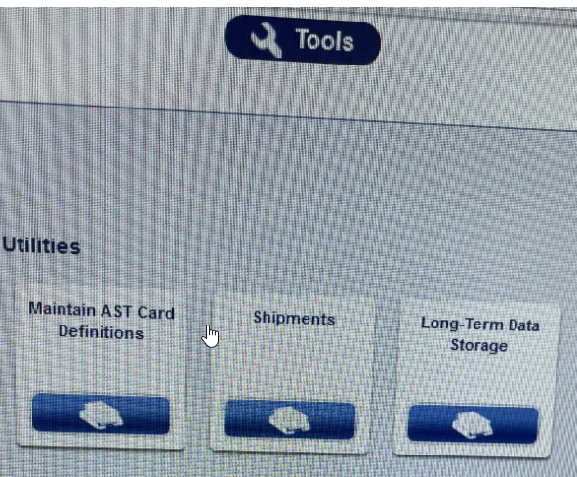  - Under Shipments, scan the lot number to fill in the fields in the window.  - Enter the number of boxes in the lot received.  - Click ‘Add Shipment’. You will see the shipment added to the list. 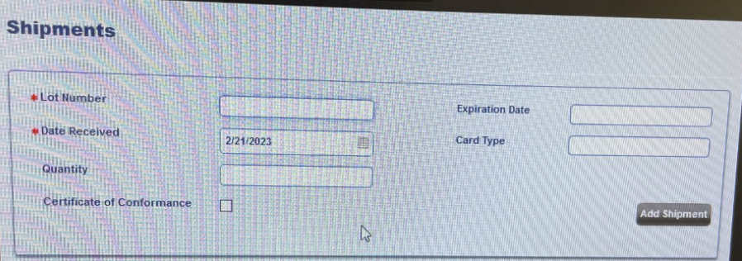  - Click OK at the bottom of the screen.
Procedure-Sample Preparation | - Refer to the Vitek 2 Systems Product Information document for organism media and incubation requirements.  - Organisms subcultured from frozen stock should be sub-cultured twice prior to testing.  - Allow test cards and saline to reach room temperature.  - Obtain Smart Carrier Cassette and place on bench top.  - Enter FlexPrep. Log in at user name with labadmin and password with labadmin.  - Enter Cassette ID and hit Enter  - Click on the QC box  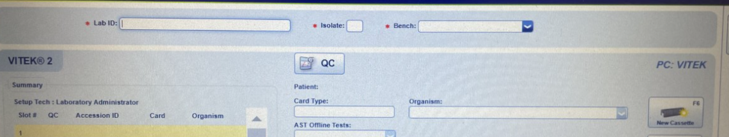  - Scan the barcode of the QC card being tested. Lot number and expiration date will appear.  - Select the correct QC organism in the Organism box.  - Click Validate of F12 after each entry.  - Refer to Vitek 2 procedure MC 7.00 for further information on suspension preparation.  - Once all setup is complete, click on the Send Cassette or F10.  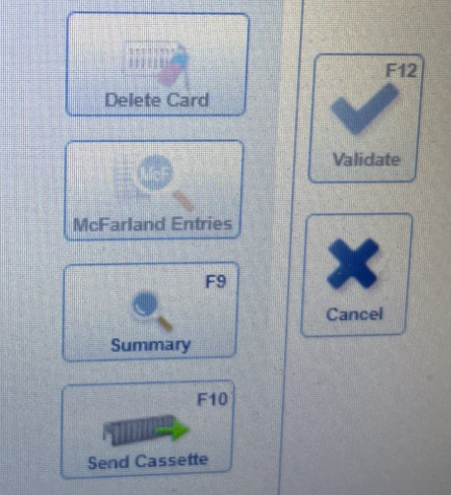  - Record card setup with panel type and date and initials on Vitek Weekly and New Lot QC Review Log  - Refer to MC 7.00 Vitek 2XL Procedure for placement of cassette in the Vitek 2XL.
Verifying and Printing QC Results | - Vitek 2 Systems Web window, under Accession number, click on Select a QC Reference ID to Filter and then Apply Filter.  - Click QC Deviation to search for deviations.  - If any deviations are noted, click on the Card Comment i icon. 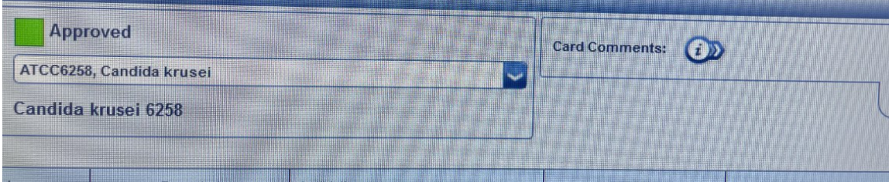  - Record “Pass/Fail”, tech, date, and description of problem (if “Fail”) and Problem resolution. Explain occurrence and next steps.  - It must be noted if the failure affected patient test results. Notify micro staff and Micro Technical Specialist.  - After documenting deviations, all isolates need to be reviewed.  - Enter each QC isolate to review. Click on check mark to review and arrow to go to next QC isolate.  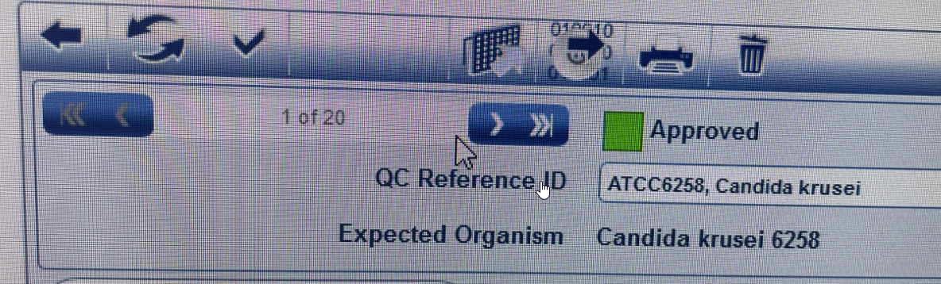  - After all isolates are reviewed, Click on Tools icon -> QC Cumulative Report  - Fill in date range for desired results.  - Click the printer icon near the upper right corner of the screen to print the report.  - Initial and date each organism column, double-checking for deviations. Acceptable ranges are listed alongside actual result.  - Monthly Review: Each month QC data will be reviewed and assessed by the Micro Technical Specialist or designee.  - Person assessing initials the log for monthly review and notifies Microbiology Technical Specialist of any ongoing or critical issues.
Out of Control Results due to obvious error | - Document the reason and retest the strain on the day.  - If the repeated result is within range, no further corrective action is necessary.  - Examples of obvious error include: Use of wrong card, Use of wrong control strain, Contamination, Wrong incubation temperature or conditions.
Out of Control Results not due to obvious error | - Investigate possible procedural problems: Standardization of the inoculum, Storage and expiration dates of the cards, incubation conditions, control strain was not contaminated, and control organism was more than 24 h old.  - Retest the strain on the same day.  - If the repeated result is within range, no further corrective action is necessary.  - If QC fails second day, test the antimicrobial agent for 5 consecutive days. Record all results.  - If all 5 results are within range, no additional corrective action is necessary.  - If the problem is not resolved (1 or more parameters out of range), daily QC testing must be done until the problem is resolved.  - It may be necessary to obtain a new QC organism either from the frozen stock or from BD.  - Call BD technical service at 1-800-638-8663 if it may be a manufacturer problem.  - Perform alternate test method until the problem is resolved.  - Suppress the results for the individual antimicrobial agent.
References | - Vitek 2 Instrument User Manual, bioMérieux, 2008.  - Vitek 2 Product Information Manual, 2009.  - Vitek 2 Customer Training Course manual, bioMérieux, 2014.
Training Plan/ Competency Assessment | Training Plan |  |  |  | Initial Competency Assessment
 | - Employee must read the procedure.  - Employee will observe trainer performing the procedure.  - Employee will demonstrate the ability to perform procedure, record results and document corrective action after instruction by the trainer. |  |  |  | - Direct observation.
Historical Record
 | Version | Written/Revised by: |  | Effective Date: |  | Summary of Revisions
 | 1 | Kristin Renner |  | 10/1/2005 |  | Initial Version
 | 1.1 | Kristin Renner |  | 7/17/2006 |  | Added hyperlinks
 | 1.2 | Becky Carlson |  | 10/6/2009 |  | Updated product information and organism information
 | 1.3 | Brian Howell |  | 6/18/2011 |  | Reworded sections to reflect new software.
 | 1.4 | Becky Carlson |  | 5/15/2003 |  | Updated product information
 | 2 | Becky Carlson |  | 4/7/2015 |  | Updated product information; Re-formatted to CMS; Re-numbered from MC 1002
 | 3 | Becky Carlson |  | 9/28/2015 |  | Added Vitek Weekly and New Lot QC Review Log for recording of QC results
 | 3 | Becky Carlson |  | 3/23/2017 |  | Added biennial PM required QC statement to Policy Statement section.
 | 3 | Susan DeMeyere |  | 5/23/2017 |  | Removed XN06 cards, discontinued
 | 3 | Susan DeMeyere |  | 5/31/2017 |  | Removed 30 day QC for Vitek ID cards per Cap requirement COM.50500-Does not apply to ID systems.
 | 4 | Susan DeMeyere |  | 3/2/2018 |  | Biennial Review
 | 5 | Susan DeMeyere |  | 2/15/2019 |  | Add AST-GN95, remove AST 69 and 79 and update Vitek Web Viewer.
 | 6 | Susan DeMeyere |  | 12/14/2020 |  | Add AST-ST02, change AST-GP74 QC to day of use.
 | 7 | Susan DeMeyere |  | 10/4/2021 |  | Add AST-YS09
 | 8 | Susan DeMeyere |  | 6/8/2022 |  | Removed GP74 day of use QC, go back to weekly QC.
 | 9 | Susan DeMeyere |  | 3/3/2023 |  | Updated instructions for software update.

