VITEK MS/MYLA Reporting Procedure

Purpose | This procedure provides instructions on how to report the identification of organisms with the Vitek MS.
Vitek MS  FDA  Cleared Organisms  2019 V3 | Vitek MS IVD is a FDA 510(k) cleared system. The instrument is cleared for identification and release of results for a majority of clinically relevant organisms. Refer to the following lists of organisms that are covered. IMPORTANT: Always review the Vitek MS Reporting Scheme (see below) before reporting claimed organisms.  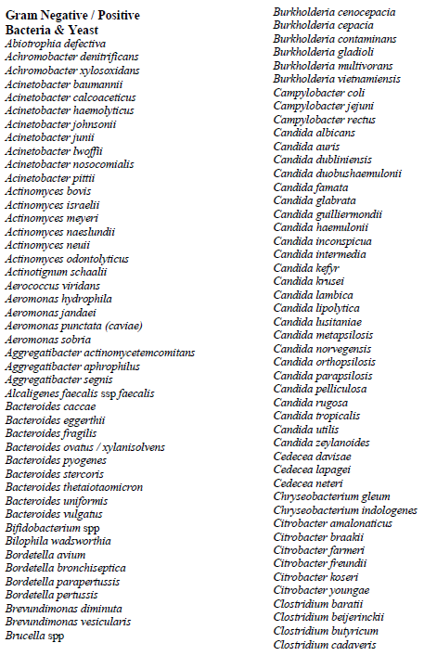  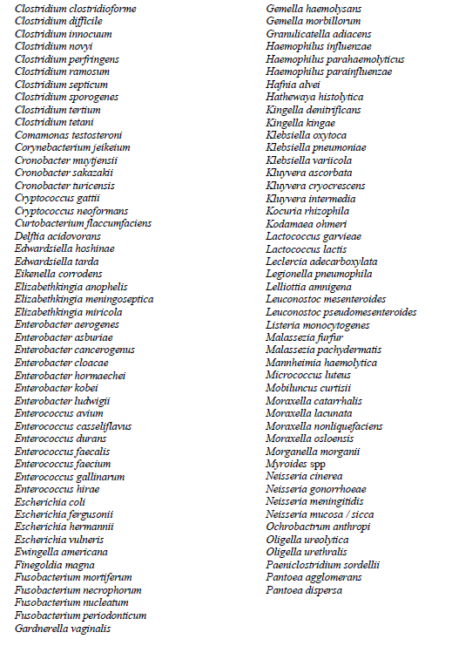
Confidence Levels | 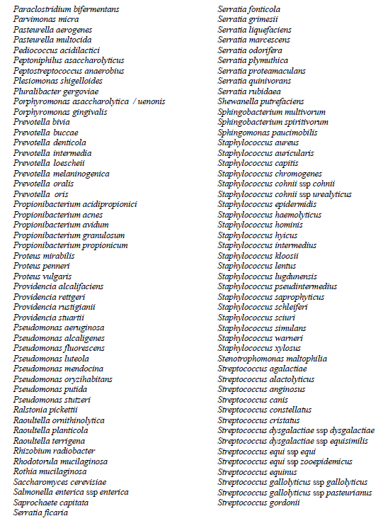  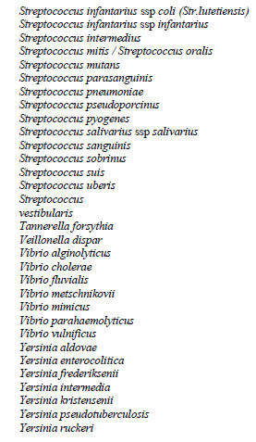  Identifications for Mycobacteria, Nocardia or Mold were not included in validation of the instrument and are not included in the above list of approved organisms to report. If an identification is claimed on the MALDI but not included in the above list, report the organism as ‘most closely resembling’ the MALDI result and send the organism to MDH for confirmation. Use Sunquest code MOST after the Gram stain result. You will need to manually enter the result into Sunquest as the result will not cross MYLA into Sunquest. A code can be requested from LIS if warranted.  Reporting example: GPR-MOST-;Mycobacteria smegmatis  The Vitek MS displays confidence level scores for each organism that is being run. The manufacturer’s suggested cut-off values are as follows:  Confidence Level Choice % Probability Comments  High: 1 60 to 99.9 Report to species level.  Medium: 2 to 4 Sum = 100 Refer to reporting scheme. If organism not listed, separate by further testing if necessary.  No ID: NA NA No significant choice  >4 Sum < 100 Inconclusive identification  Non-clinically Validated Isolate icon – identification does not transfer to the LIS or VITEK 2. Perform an alternate method of identification.  ***ALWAYS use caution when releasing results. Ensure that plate morphology/gram stain matches the result that is displayed. If this is not the case, complete further confirmatory testing.
MYLA: Releasing  Vitek  MS Results | - Using the prep station or a network PC, double click the MYLA icon on the desktop.  *MYLA can also be utilized by launching Internet Explorer and typing the following: http://mpmyla or 10.22.18.82  - Enter your unique user name, password, and click the login button.  - Ensure that the Technologist Dashboard tab is chosen.  - In the lower portion of the screen (“To Do” tab), click the VITEK MS Review button (Figure 1).  Figure 1.  - The “To Be Reviewed” tab will display results needing review. A confidence level is displayed for each isolate (Figure 2).  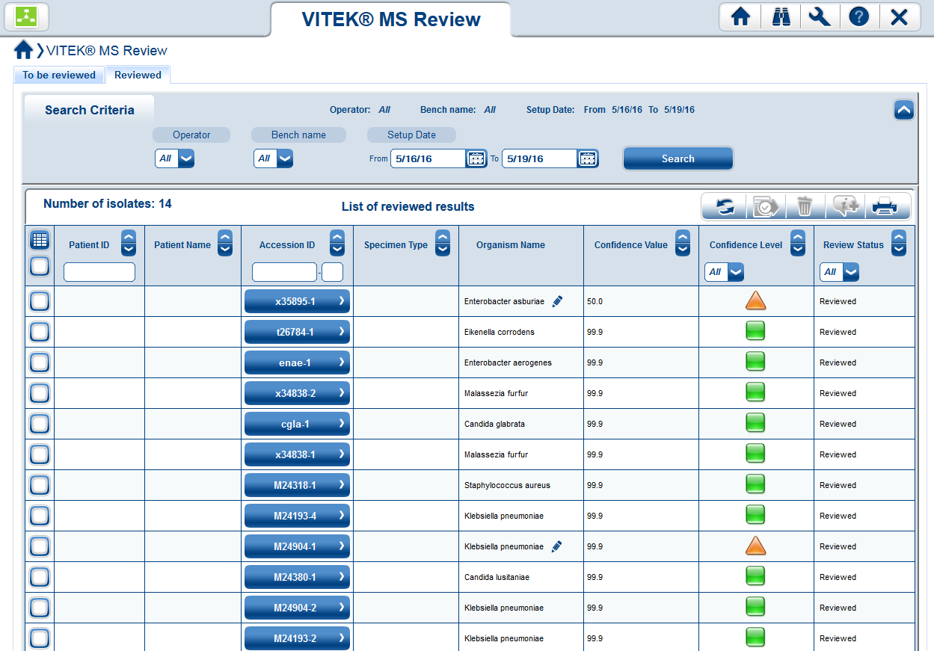  Confidence Level  Accession Number (ID)  Figure 2.  - A Confidence Level is determined for the spectrum of each individual slide deposit (spot).  - When isolates are deposited on two or more spots (i.e. run in duplicate), a Confidence Level is determined for each individual deposit. MYLA consolidates the results based on the confidence level of each deposit and the similarity of the identification results.  - Select and individually review all High Confidence results.  - Click the Review icon: . This includes any isolates that are recognized as highly pathogenic or critical: . Reviewed results will be sent through the interface into Sunquest.  - Individually review each Medium Confidence isolate.  - Click the Accession Number (ID) button to display the Review Detail screen.  - For discrepant isolate results, first reacquire (re-shoot) the spectrum. If this does not help, perform additional testing or retest in a new acquisition group. See step 18 below for instructions on reacquiring the spectrum.  - Select an identification by utilizing the General Reporting Scheme found at the end of this procedure. Click the validate button to accept this result (Figure 3).  Validate  Select Identification  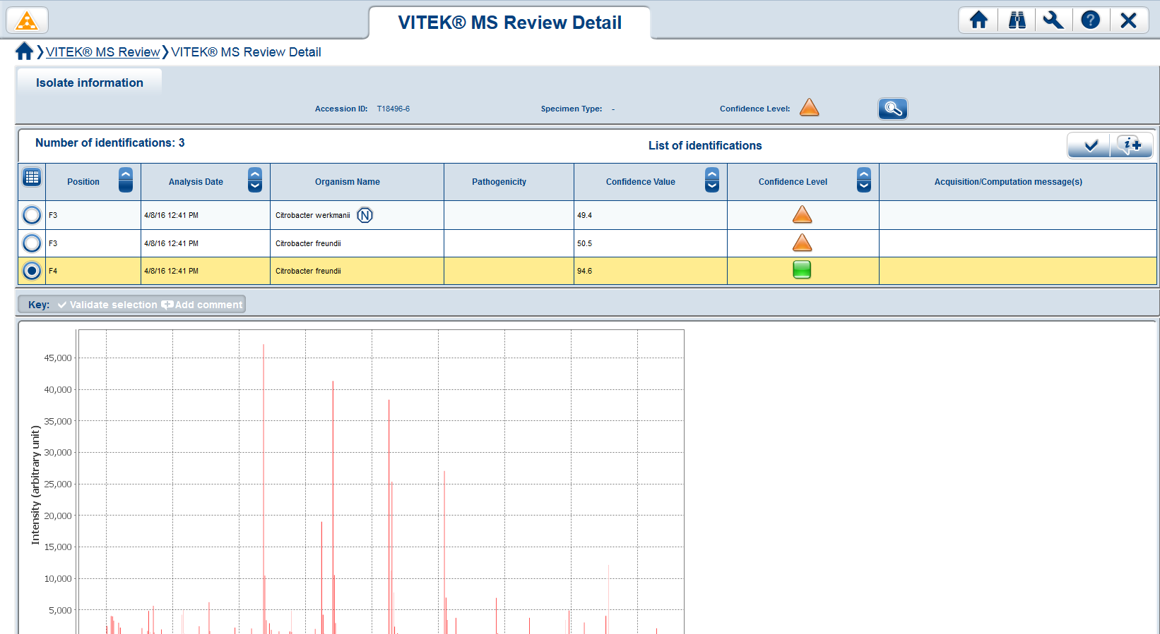  Figure 3.  - In the “To Be Reviewed” tab, select the Medium Confidence isolate and review individually. The isolate should have an identification chosen with a pencil icon next to it, confirming that it has been edited.  - Select each isolate that has No ID.  - If necessary, click the Accession ID button to display the Review Detail screen and note the Acquisition/Computation Messages in the last column.  - Discard the isolate by clicking the trash can icon: .  - To reacquire spectra (repeat) for isolates that have Low Confidence levels or have no ID, utilize the Acquisition Station. Select the spots that need to be re-shot and click Start. The calibration needs to pass again. Once the organism(s) have been re-shot, repeat steps 4-16 for resulting.  Additional Icons  Print Icon – print a single page report for each isolate.  Comment – enter a result comment for an isolate. This can be used to refer to additional testing that has been or needs to be performed.  Information Icon – read a comment that has been entered.
VITEK  MS  Reporting  Scheme | What to do: Escherichia coli readouts on VITEK MS  Source Additional Testing Reporting Instructions  ALL sources (except stool) If MSID = Escherichia coli Lactose Fermenter Escherichia coli  β- hemolysis on SB agar Escherichia coli  Non-Lactose Fermenter & non-hemolytic on SB agar: Indole (+) or Indole (neg) Run GN ID card on VITEK 2 for identification  Stool If MSID = Escherichia coli Then do: MILS & SB subculture For the following combinations, report NSSY: *MOT (+) IND (+) LYS (P/P) *MOT (+) IND (+) LYS (P/Y) *MOT (neg) IND (+) LYS (P/P) *MOT (+) IND (neg) LYS (P/P) *MOT (+) IND (neg) LYS (P/Y) *MOT (neg) IND (neg) LYS (P/P) For the following combinations, run a GN ID on VITEK 2 for identification: *MOT (neg) IND (neg) LYS (P/Y) *MOT (neg) IND (+) LYS (P/Y)  Vitek MS Reporting Scheme  Vitek MS Identification Reporting Instructions Sunquest Code  Achromobacter denitrificans Achromobacter xylosoxidans (50.0 confidence / 50.0 confidence) Achromobacter denitrificans/Achromobacter xylosoxidans ACHDX  Acinetobacter baumannii Acinetobacter calcoaceticus Acinetobacter nosocomialis Acinetobacter pittii (can be slashline between species) Acinetobacter baumannii complex ABAUC  Aeromonas hydrophila/caviae Aeromonas sobria Aeromonas jandaei (can be slashline between species) Aeromonas species AERO  Burkholderia cenocepacia Burkholderia cepacia Burkholderia contaminans Burkholderia multivorans Burkholderia vietnamiensis (can be slashline between species) Burkholderia cepacia complex BCEP  Candida metapsilosis Candida orthopsilosis Candida parapsilosis Candida parapsilosis complex CPARC  Citrobacter braakii Citrobacter freundii Citrobacter youngae (can be slashline between species) Citrobacter freundii complex CIFC  Brucella sp. DO NOT test or report by VITEK MS. Perform rule-out testing under the hood. Tape plates.  Enterobacter asburiae Enterobacter cloacae Enterobacter hormaechei Enterobacter kobei Enterbacter ludwigii (can be slashline between species) Enterobacter cloacae complex ENCLC  Francisella sp. DO NOT test or report by VITEK MS. Perform rule-out testing under the hood. Tape plates.  Nesseria cinerea Nesseria mucosa/sicca Perform gram stain & oxidase, then report as: Neisseria sp. NEIS  Proteus penneri Proteus vulgaris (can be slashline between species) Proteus penneri/Proteus vulgaris PRVP  Vitek MS Identification Reporting Instructions Sunquest Code  Raoultella ornithinolytica Raoultella planticola Raoutella terrigena (can be slashline between species) Raoultella species RAOSP  Salmonella group Salmonella species SALM  Staphylococcus auricularis Staphylococcus capitis Staphylococcus cohinii Staphylococcus epidermidis Staphylococcus haemolyticus Staphylococcus hominis Staphylococcus schleiferi Staphylococcus sciuri Staphylococcus simulans Staphylococcus warneri Report from the following sources: UC, Blood, CSF, RESP, Misc. (DSK1), Sterile body fluids, and surgical tissue specimens. Include comment TCINS: (“This is a coagulase negative Staphylococcus.”) Not every species is listed. There are over 50 species listed as coagulase negative Staphylococcus.  Staphylococcus lugdunensis Staphylococcus saprophyticus Report with all sources. DO NOT include comment TCINS. SLUG SSAP  Veillonella dispar Veillonella species VEIL  Yersinia pestis Yersinia pseudotuberculosis DO NOT test or report by VITEK MS. Perform rule-out testing under the hood. Tape plates. *Yersinia pseudotuberculosis is similar in spectra to Yersinia pestis.  - Frequently seen organisms in the laboratory with a probability score at > 60% may be released as long as colonial morphology and/or gram stain morphology matches.  - Uncommon organisms in the laboratory should be reported as presumptive or by genus only until further testing can confirm the result. This includes FDA cleared organisms that are not identified to species level for which there are no reporting rules in place.
Unclaimed Validated Results | Unclaimed MALDI results may go through a validation process to obtain approval to be reported without further testing. Submit requests of selected organisms to the Technical Specialist and Medical Director. The list of unclaimed, validated organisms approved for reporting are:  - Turicella otitidis  - Aerococcus urinae  - Acinetobacter ursingii  - Dolosigranulum pigrum  - Bacillus cereus group
Trust but Verify Plan | A Trust by Verify Plan was put into place after the validation in 2016 to confirm organisms that were not included in the validation. All organisms encountered in this laboratory were tested by another method and have been confirmed. The Trust But Verify plan was retired in December 2022.  If organisms are identified that you are unfamiliar with or sounds weird, consult with the Technical Specialist or Medical Director. Most closely resembling (MOST) may be used if Gram stain and colony morphology matches. List the organisms resulted as MOST on the Trust but Verify Spreadsheet under the Most Closely Resembling Tab. These will be reviewed by the Medical Director if encountered frequently.
References | MYLA Customer Training Course manual, 2016.  VITEK MS Clinical Workflow User Manual,  VITEK MS Customer Training Course manual, 2016.  VITEK MS “The Basics” manual, 2014.  - Employee must read the procedure and training documentation.  - Employee will observe trainer performing the procedure.  - Employee will demonstrate the ability to perform procedure, record results and document corrective action after instruction by the trainer.
Training Plan/ Competency Assessment

Historical Record | Version | Written/Revised by: | Effective Date: | Summary of Revisions
 | 1 | Andrew Fangel/  Dr. Phillip Heaton | 10/07/16 | Initial Version
 | 2 | Andrew Fangel/ Susan DeMeyere | 4/20/2018 | Added caution message to Confidence Level section.  Updated General Reporting Scheme instructions.
 | 3 | Susan DeMeyere | 12/1/2022 | Added unclaimed organisms approved to report after validation. Removed Trust but Verify plan to report claimed organisms. Added instructions for Mycobacteria, Nocardia or Mold results.
 | 4 | Susan DeMeyere | 3/3/2023 | Added Burkholderia multivorans to cepacia complex.

