Vitek 2XL Operating Procedure and Maintenance

Purpose | This procedure provides instruction for VITEK 2XL Card Setup, Resulting and Maintenance. The Vitek 2XL serves as the main instrumentation for the definitive biochemical identification of bacteria and yeasts as well as broth dilution susceptibility testing of select bacteria. The system provides an accurate and time effective method for providing this information to clinicians.
Principal | The Vitek 2XL instrument, manufactured by bioMérieux (bioM) is an integrated system, combining the tasks of sample preparation and test card inoculation, incubation and optical measurement. The Vitek 2XL performs identification and susceptibility analyses by continually monitoring the growth and biochemical activity of organisms as they grow in card test wells.
Policy Statements | - The procedure applies to staff responsible for operation and maintenance of the Vitek 2XL instrument.  - The Vitek 2XL (VT XL) Instrument Manual is maintained electronically as the primary reference.  - Customer support can be reached at 1-800-682-2666. Be sure to have customer number and system numbers available. These are located on the left side of the instrument. Be sure to inform Technical Services that the instrument is connected to Myla.  - Instrument start-up and shutdown is done with bioMérieux phone technical support, phone customer service listed above. The shutdown procedure can also be found in the VT 2XL Instrument Manual binder (on shelf above instrument), section 7.  - Susceptibility testing limitations are built into the Vitek 2XL software. Appropriate flags are generated automatically from these algorithms.  - MicroScan products are the designated backup for any problems with the Vitek 2XL instrument where use of the instrument is going to be down for at least an overnight period.
Materials
 | Supplies |  |  |  |  |  | Equipment
 | • GP Card, bioM, product/part number (P/N)-21342  • GN Card, bioM, P/N-21341  • NH Card, bioM, P/N-21346  • ANC Card, bioM, P/N-21347  • YST Card, bioM, P/N-21343  • AST-GN95 card, bioM, P/N-421982  • AST-XN08 card, bioM, P/N-421983  • AST-GP67 Card, bioM, P/N-22226  - AST-ST02 Card, bioM P/N 420915  • AST-GP74 Card, bioM, P/N-22231  • 0.45% Saline, Cardinal Healthcare (CHC), P/N-3D0775  • 0.45% IV Saline, CHC, P/N-2B16314X  • 12mm x 75mm polystyrene tubes, bioM, P/N-69285  • sterile, cotton-tipped applicator swabs: storeroom  • pipetter/diluter accessory kit, bioM, P/N-21219  • Chocolate II Agar (CHOC), BBL, P/N-4321267  • Columbia Agar with 5% Sheep Blood (SB), BBL, P/N-4321263  - Colistin Nalidixic Acid Agar (CNA) BBL; P/N-43221352  • MacConkey II Agar (MAC), BBL, P/N-4321270  • Sabouraud Dextrose Agar, Emmons; (SAB); BBL; P/N- 4321849  • CDC Anaerobe 5% Sheep Blood Agar; (ASB2, ASB1); BBL; P/N-4321734  - Blood Brain Heart Infusion Agar (BBHI) BBL; P/N-43221843  - Modified Thayer Martin Agar (MTM) BBL; P/N-43221567  - Chrome Candida (CCAN) BBL; P/N-43254093 |  |  |  |  |  | - Vitek 2XL instrument, bioM, P/N-526317 serial # VTK2XL4731  • DensiChek, bioM, P/N-27207  • Adjustable volume dispenser, bioM, P/N-V1200  • Smart Carrier Cassette (SCC) with button memory, bioM, P/N-27700  • Vortex Mixer, Barnstead International, (model # M37615) or Scientific Industries,  (model Vortex Genie 2G560)
Storage | Storage conditions are listed on each product. However, some heavily used products are removed from refrigeration each day for ready access.  Culture Requirements Table  Vitek 2 Card Media Age of Culture  GN GN and AST pair GN AST only CHOC, SB, MAC, BBHI 18-24 hour 8-24 hours (AST only)  GP (only) GP and AST pair or AST only CHOC, SB, CNA, BBHI GP (only) 12-48 hrs. GP and AST pair or AST only 18-24 hrs.  ANC-Aerobic GPR ANC-- Anaerobes CHOC, SB, CNA, BBHI ASB1, ASB2, CNA Aerobic GPR 18-24 hours Anaerobes 18-72 hours  NH CHOC, SB, MTM, 18-24 hours  YST SB, SAB, CCAN 18-72 hours
Special Safety Precautions | Microbiologists are subject to occupational risks associated with specimen handling.  - Biohazard Containment  - Biohazardous Spills  - Safety in the Microbiology Laboratory
Quality Control | - Identification cards are tested upon arrival of a new lot or shipment  - Susceptibility cards are tested upon arrival of a new lot or shipment AND weekly once put into use.  - Vitek QC (all types AST cards and GN ID card) is performed after biennial Preventative Maintenance (PM), and/or repairs or replacement of critical components, major maintenance or service, to ensure the cards perform according to expectations.  - Refer to Vitek 2 Quality Control Procedure for further information.
Procedure for Card Setup | - Allow test cards and saline to reach room temperature.  - Obtain Smart Carrier Cassette and place on bench top.  - Click on Vitek 2 FLEXprep icon. Log in user name with labadmin and password with labadmin.  - Enter your initial or tech number at Cassette ID.  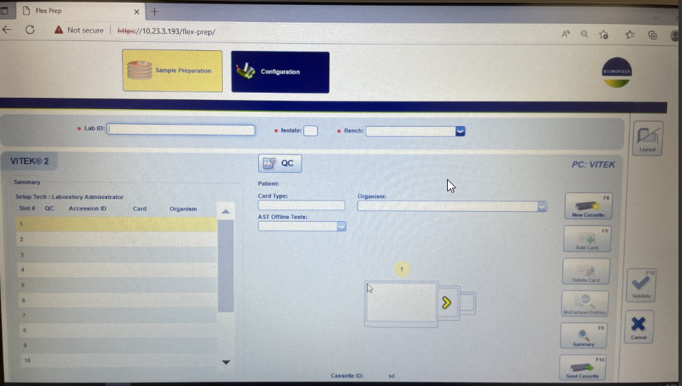  Figure 1 Vitek 2 FLEXprep  - Enter Bench number using drop down arrow.  - Use the barcode reader to scan the patient’s accession barcode or enter the accession number manually at Lab ID. Select isolate number. Isolate 1 will default so adjust according.  - Aseptically transfer 1.8 to 3.0 mL of sterile 0.45% saline into a properly labeled 12 x 75 polystyrene tube.  - Use a sterile cotton swab to emulsify in the saline a sufficient amount of well-isolated colonies to make a suspension of an appropriate McFarland (McF) turbidity as follows:  - For GP, GN, and bacterial AST cards: McFarland value must be between 0.50 – 0.63  - For YST cards: McFarland value must be between 1.80 – 2.20  - For NH and ANC cards: McFarland value must be between 2.7 – 3.3  - Verify suspension concentration using DensiCheck instrumentation as follows:  - Insert suspension tube fully into the Densicheck.  - Rotate at least one complete turn within 2 seconds.  - Observe digital readout to ensure the desired McF value is obtained.  - If only <<< is displayed, a reading error occurred. Take suspension tube out, and repeat above steps.  - Once appropriate density is achieved, place the suspension tube into the slot indicated. The indicated slot has its position number next to it on the FLEXprep screen.  - Label and inoculate a purity plate for each card.  - Select the appropriate card, open the pouch at one of the two available tears being careful not to allow anything to touch the aspiration straw and scan the barcode.  - For identification card only: open and scan the barcode of the ID card at the Card Type box and place it in the slot that contains the suspension tube.  - For susceptibility card only: place an empty 12x75 tube in the next slot. Open and scan the barcode for the required susceptibility card at the Card Type box and place it in the slot containing the empty tube.  - For identification and susceptibility cards, open and scan the barcode for the ID card at the Card box and place it in the slot that contains the suspension tube. Place an empty 12x75 tube in the next slot. Click on Add Card. Open and scan the barcode for the required susceptibility card at the Card box and place it in the slot containing the empty tube.  - Susceptibility only setups should also have the ‘Organism’ fields and, in the case of Gram Pos cards, the ‘Offline Tests’ fields answered.  - ANC cards require the following entries in the ‘Offline Tests’ field: AEROTOLERANCE, GRAM REACTION, and CELL MORPHOLOGY  - Click on Validate box or F12 after each card is entered.  - Use the yellow arrows to review. You cannot edit once an isolate has been validated. You can delete a card by clicking on the picture of the card. It will turn yellow and then you can delete it. Then you can add the card again.  - The Summary box F9 is only a spread out version of the cassette view. Use the back button to return, not the cancel button.  - Once all setup is complete, click on the Send Cassette icon to send to Vitek 2 System.  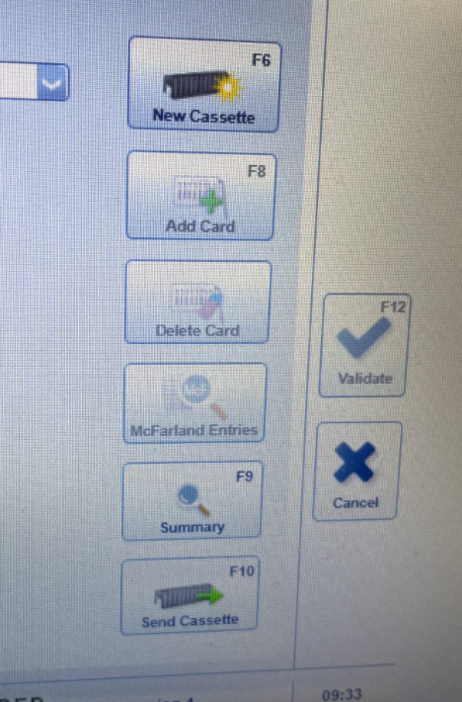  Figure 2 Vitek 2 FLEXprep  - If the GREEN indicator light below the cassette load station is ON, Open door and load the Smart Carrier with tube side facing toward you.  - If the GREEN indicator light is OFF, wait for light to turn on and then proceed as above. Instrument is busy moving boats.  - If the GREEN indicator light is BLINKING, a processed Smart Carrier Cassette is at the load station. Remove the processed Smart Carrier Cassette and without closing the load door and load the unprocessed Smart Carrier Cassette.  - Close the load station door and wait for the instrument to emit six ascending beeps. The instrument will accept the carrier even if patient information was not sent.  - When a Smart Carrier Cassette is finished processing, it is left at the load station to be removed. The GREEN indicator light will be blinking and indicates the presence of a processed Smart Carrier Cassette. Open cassette load door and remove the SCC from the boat. Dispose of materials in the cassette in an appropriate biohazard waste container.  - Red cassettes are caused when patient demographic information is not sent to the Vitek. Red cassettes on the Vitek 2 should be fixed ASAP to ensure proper analysis of card data.  - On the Vitek 2 Web, click on the Cassette icon to screen for red cassette. There will be a red ‘Incomplete’ cassette in the left side column. This will be monitored daily in the morning and at the end of the shift.  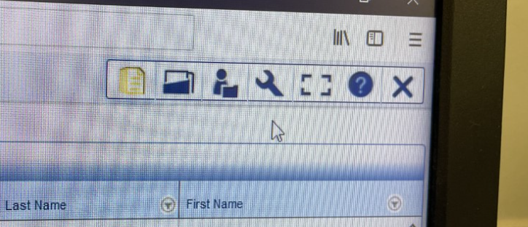  - Intervention is required because ALL of the cards on the Red cassette will not be analyzed by the Vitek 2. The raw data is in instrument, the cards do not need to be re-run, but analysis has not performed and results do not go into the “Results” screen.  - Red cassettes can be caused when QC data entered on the Smart Carrier Cassette is not in the expected format.  - An example would be calling a QC bug isolate 2. The instrument is programmed for the QC to always be isolate 1.  - One more example is if a QC organism that is run on a card that is not defined for that QC organism. (SAUR 25923 on the GP74 card)  - Lot number of cards has not been added to the inventory.  - How is a red cassette turned into a black cassette?  - Click on the Incomplete red cassette. A listing of the contents of the slots will be displayed.  - You can edit to add patient information, add if it was QC or print to compare date to the  Flex Prep screen.  - If the lot has not been added in Shipments, add to inventory by scanning the lot #.  - If the issue resolution has been successful, all the slots are then analyzed and the QC lab reports will auto-print and then the QC will be in the QC program.
Daily Maintenance Procedure | - Follow the activities below for Vitek 2 Daily maintenance.  - Get the 0.45% saline dispensers and card boxes out of refrigerator #1 (three-door).  - Clean the tip of each dispenser with alcohol pads and rinse by fully dispensing 3 times.  - The Vitek 2 computer is setup to automatically perform an End-of-Day routine. At the end of this procedure, the computer automatically restarts. Ensure that an automatic restart of the computer has occurred:  - Ctrl, Alt, Del.” box is on the screen, a restart has occurred.  - Press Ctrl-Alt-Del and login using user name: Lab_Admin and password: Lab_Admin  - If the computer is still logged in: Check for errors and consult with appropriate personnel if unsure. Irresolvable errors will require contact with bioMérieux technical support. Current contact and system information is located on the left side of the instrument.  - Check Qualified and To be Reviewed isolates: Double click on the ‘VITEK 2 Systems Web’ icon (V2) to open the application. Log in as LabAdmin. Password labadmin.  - Double click on the VITEK 2 Web icon. Upper right corner, find the ‘Work List’ icon.  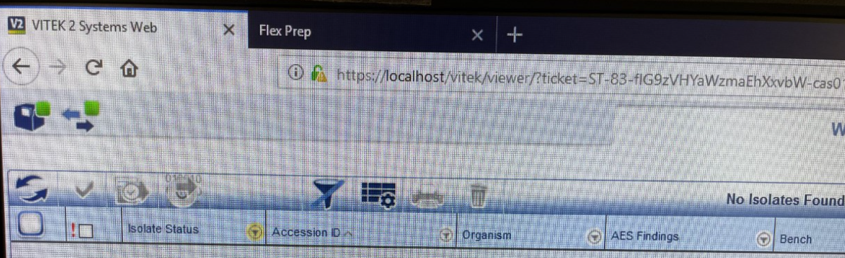  - Any yellow color on a filter icon means a filter has been applied. Clear all filters by clicking on the large funnel.  - Click on Test Date to sort by descending order or click on Bench to sort by bench.  - Click anywhere in the line of the isolate to get to the Isolate Detail. In Isolate Detail, you can  - Re-analyze  - Review  - Transfer to Myla  - Go to next isolate  - Combine or separate ID and AST cards  - Look for icons that are not solid green and open by clicking on the accession number. Review and approve as appropriate: Examples are MRSA, ESBL, VRE, Salmonella, Shigella, etc. Review those results for uncomplicated issues and click the review icon (check mark) so that the will be in Sunquest online data for the benches. If the results need more than cursory review, leave them for the bench tech to resolve.  Indicates that one or more cards within the isolate group are “preliminary”. Isolate is not final. Most often these will be YST cards still analyzing. However, this is where defective cards will be picked up. If upon review it is seen that the card terminated or there was insufficient growth for analysis, make note of card type and bar code.  Indicates that all cards within the isolate group are final and information is missing that is required to complete analysis. Most likely beta-lactamase or other offline test is missing. Add offline test results as necessary. Missing patient data may cause the results to be transferred to the incorrect patient. Print new results as needed.  Indicates that all cards for the isolate are final and the information has been sent to Myla and Sunquest.  Acceptable confidence levels are only: ‘Excellent’ or ‘Very Good’. Other confidence levels need to be noted in order for confirmatory testing.  Indicates that the isolate needs to be reviewed. If unsure that information is okay, consult with coworkers or with the bench to whom the results belong.  - Examine purity plates. Note any possible contamination and notify appropriate bench  - Sort the reports according to bench. Review and make appropriate notations before delivering.  - Check Vitek and Myla status.  - Perform Carousel Temp check and Transmittance Optics check.  - Check for red cassettes.  - Zero the Densichek.  - Empty card waste trays for Carousels A and B. If any cards were noted as ‘Insufficient growth’ or ‘Terminated’ examine cards for seal defects or under-filled wells. If there are no issues or once any issues are resolved, dispose of cards. Step-by-step removal below:  - Open the waste collection station door by pulling downwards.  - Place finger on sliding retaining bar to prevent it from snapping back into place.  - Remove waste collection tray by lifting front edge slightly and then pulling toward you.  - When tray is clear of the station, allow sliding retention bar to slowly slide back into place.  - Remove cards and set aside or dispose when all testing has been confirmed completed without problems  - Close the waste collection tray door.  - Complete the Maintenance check-off sheet.
Result Reporting for Identification and Susceptibility | 1. When results are transferred to Sunquest, they are accessible in MRE under the Online tab.  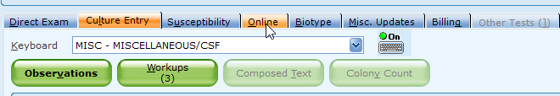  2. Click on the Online tab to view results. Click on Select Online Results to Accept.  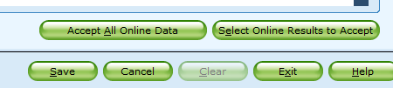  3. Click on the corresponding Culture Observation line  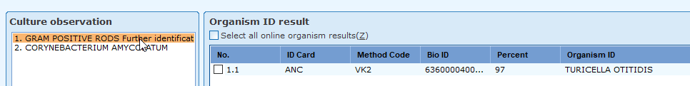  4. Click on the corresponding Organism ID Result or Select all Online Organism result  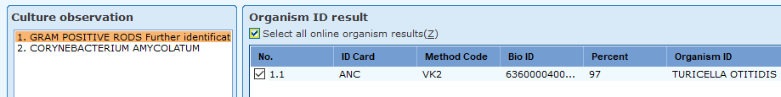  - Click in Accept Selected in the bottom right corner of screen.  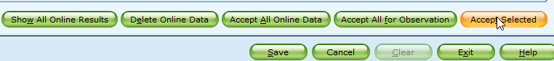  - Click back to Culture Entry tab to view results.  - To access susceptibility results, Click on the corresponding Culture Observation and click on Select all Online susceptibility results.  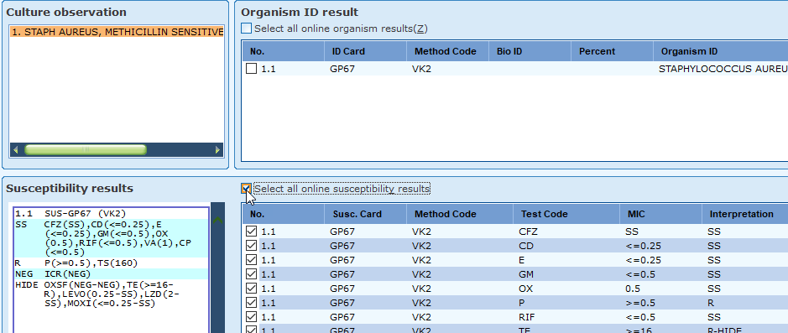  - Click on Accept Selected.  - A plus sign will be visible under the S when the results are accepted.  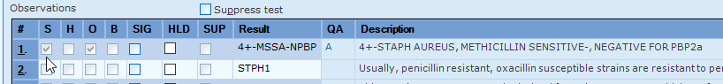
Weekly/Monthly Maintenance | - Optics cleaning and saline sterility check are performed weekly and documented on the Maintenance Chart.  - Maintenance (customer cleaning) is done every month and documented on the Maintenance Chart. Refer to Vitek 2 Instrument User Manual section 7 Maintaining the Vitek 2 Instrument for instructions.  - VT2 shutdown is done while performing customer cleaning. The shutdown procedure can be found in the VT2 Instrument User manual section 7.
Performance Modifications | - The Vitek AES (Advanced Expert System) validates the identification and susceptibility results by applying knowledge of organism resistance mechanisms and phenotypes to the patient results. It tries to match the patient results to a known pattern, comparing the information in its Knowledge Base.  - Vitek AES will make interpretation modifications from susceptible to resistant based on the patterns and CLSI guidelines. MIC values will not be reported when there is modification of the interpretation. The MIC value will appear in brackets [ ] in the Vitek 2 system and with an asterisk * on the paper printout.  Figure 1 Vitek printout  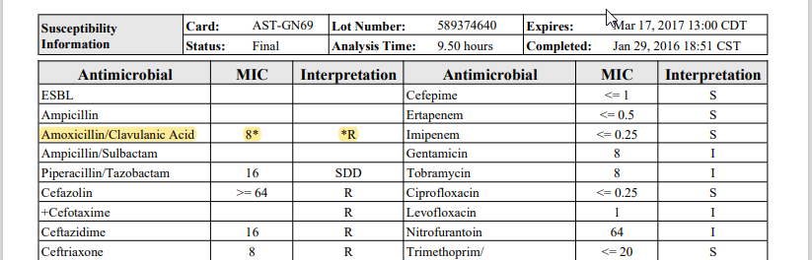  Accept Online Instrument Data in Sunquest. Use the Susceptibility Tab in MRE to remove the MIC value and replace it with the interpretation. Only the interpretation will be reported.  Figure 2 Susceptibility Tab in Sunquest  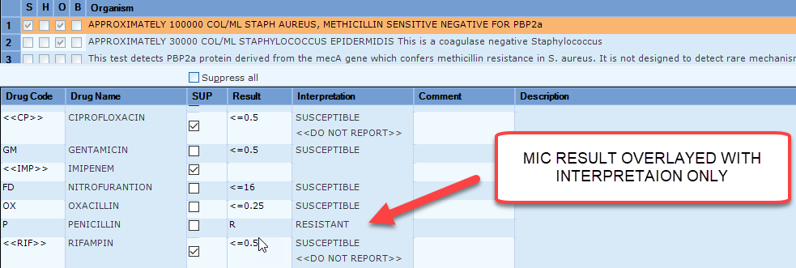  3. Use caution when accepting susceptibilities and the Select Organism box pops up.  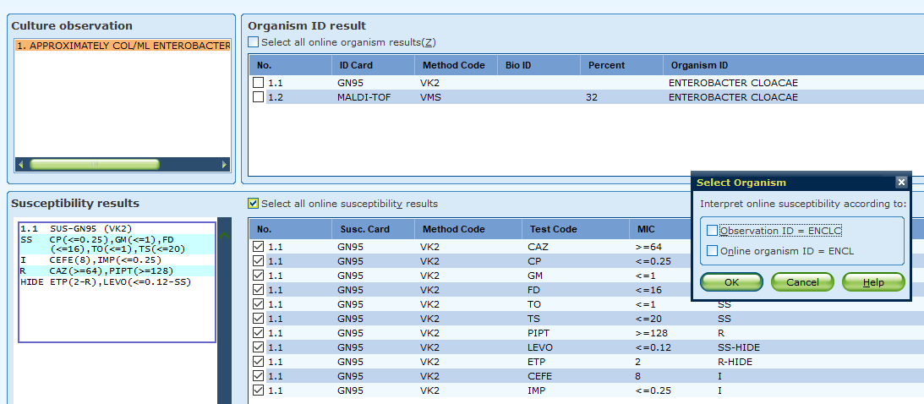  Select the Online organism ID box to accept Vitek interpretations. This will not change your ID in Observations.  Selecting the Observation ID box makes Sunquest re-interpreted the susceptibilities instead of taking the interpretations from the Vitek which can cause mistakes. In these particular case, cefepime went from intermediate to susceptible.
Alternate Method | In case of instrument failure, use backup identification and susceptibility methods as required; MicroScan NC68, MicroStrep, manual Kirby Bauer disk diffusion or Etest MICs.
References | Vitek 2 Customer Training Course manual, BioMérieux, 2014.  Vitek 2 Instrument User Manual, BioMérieux, 2008.  Vitek 2 Systems Product Information, BioMérieux, 2009.
Training Plan/ Competency Assessment | Training Plan |  |  |  |  | Initial Competency Assessment
 | - Employee must read the procedure.  - Employee will observe trainer performing the procedure.  - Employee will demonstrate the ability to perform procedure, record results and document corrective action after instruction by the trainer. |  |  |  |  | - Direct observation.
Historical Record
 | Version | Written/Revised by: |  | Effective Date: |  |  |  | Summary of Revisions
 | 1.0 | K. Renner |  | 10/01/2005
 | 1.1 | K. Renner |  | 07/17/2006
 | 1.1 | B. Howell |  | 06/25/2009 |  |  |  | Updated product information section to include new cards and removed discontinued cards.  Limitations updated.
 | 1.2 | B. Howell |  | 6/18/2011 |  |  |  | - Transcribed and revised wording into new department-wide format.  - Merged ‘LIMITATIONS’ and ‘PROCEDURE NOTES’ into a new ‘Policy Statements’ section.  - Updated ‘Materials’ section for new products.  - ‘Daily Maintenance Process’ added to provide thorough and consistent direction for daily data and instrument maintenance.  - ‘RESULTS AND INTERPRETAION’ section incorporated into new ‘Daily Maintenance’ section.  - ‘STORAGE’ updated to incorporate daily use storage.
 | 1.3 | Becky Carlson |  | 9/26/2011 |  |  |  | Added red cassette identification and resolution and DVD formatting.
 | 1.4 | Becky Carlson |  | 3/05/2013 |  |  |  | Updated product information to include new cards and removed discontinued cards.  Added download warning regarding cards with missing patient data may be linking results to the wrong patient.
 | 2 | Becky Carlson |  | 4/7/2015 |  |  |  | Updated product information to include new cards and removed discontinued cards.  Re- numbered to MC 7.0 for CMS upload
 | 3 | Becky Carlson |  | 12/2/2016 |  |  |  | Revised for Myla interface
 | 3 | Becky Carlson |  | 3/26/2017 |  |  |  | Added start-up/shutdown info, and Periodic Maintenance section.
 | 3 | Susan DeMeyere |  | 5/23/17 |  |  |  | Removed XN06 cards, discontinued
 | 4 | Susan DeMeyere |  | 3/5/2018 |  |  |  | Biennial Review
 | 5 | Susan DeMeyere |  | 2/15/2019 |  |  |  | Removed Smart carrier station, job aide card, remove ast-69 and 79 and added AST-GN95
 | 6 | Susan DeMeyere |  | 9/9/2019 |  |  |  | Updated maintenance schedule
 | 7 | Susan DeMeyere |  | 11/7/2019 |  |  |  | Added Vitek AES information and instruction for modifications.
 | 8 | Susan DeMeyere |  | 3/6/2023 |  |  |  | Updated instructions after software update.

