Sweat Collection by Macroduct Advanced Pilocarpine Iontophoresis

Purpose | This procedure provides instructions to install, operate, and maintain the Macroduct® Advanced Sweat Collection System for the purposes of SWEAT COLLECTION BY PILOCARPINE IONTOPHORESIS. Anyone operating the Macroduct Advanced Sweat Collection System must be thoroughly familiar with the procedures and cautionary information detailed in this manual before attempting to use this equipment.  Macroduct Advanced Sweat Collection System is intended for laboratory use by qualified personnel for stimulation and collection of sweat from humans to assist in the laboratory diagnosis of cystic fibrosis. The system safely and efficiently accomplishes the stimulation of human sweat through pilocarpine iontophoresis using the Macroduct Advanced Model 3710. The Macroduct advanced Sweat Collector collects a sample of the stimulated sweat. Markings on the tube indicate if a sufficient sweat rate was achieved during the collection of sweat. The sample can then be analyzed for indications of cystic fibrosis with the ChloroChek® Chloridometer® using the principle of coulometric titration.  The Macroduct Advanced Sweat Collection System consists of the Macroduct Advanced Model 3710, which is a microprocessor-controlled device powered from a rechargeable lithium-ion battery, battery charging power supply and cord for charging the battery, electrode cable assembly, and a kit of single-use supplies (Pilogel discs and collectors). The Macroduct Advanced Model 3710 automates and controls the sweat collection process used to detect cystic fibrosis. In that sweat collection process, pilocarpine ions are ‘pushed’ into the sweat glands of the skin by a small electric current (1.5 mA DC) where they stimulate sweat in the same way as the chemicals released by the brain to control body heat through sweating on a hot day. After sweating has been stimulated in a particular area, the electrodes are removed and the skin is cleaned. A plastic Macroduct Advanced Sweat Collector is strapped to the stimulated area so that the emerging sweat is directed into plastic tubing coiled on the surface of the collector. The pure sweat collected in this tubing may be analyzed by methods that are compatible with the sample volume.
Policy Statements | - Sweat testing is performed on patients who are > 48 hours old  - Sweat testing is not performed on patients receiving oxygen by an open delivery system  - This procedure and related policies regarding disinfection of equipment and facilities are reviewed at least biennially.  - Children’s Biomed department annually inspects battery units for current leakage and current control. Biomed maintains the documentation.  - The incidence of insufficient sweat samples is monitored routinely
Sunquest Test Code | SWCL: sweat chloride  SWCD: sweat chloride collection duration
Documents | Sweat Inducer Maintenance Log
Supplies | Supplies and Accessories  Supply Product Number CHC # Description/Stability  MacroDuct Advanced Inducer 3710 N/A Sweat Inducer  MacroDuct Advanced supply Kit SS-268 TBD Kit including collectors, discs, small sealable containers.  Pilogel Discs Included in SS-268 N/A QTY 12, must be kept at 2-8 C. Valid until lot expiration.  MacroDuct Advanced collectors Included in SS-268 N/A QTY 6  Small Sealable Containers Included in SS-268 N/A QTY 6, deliver to chemistry department.  Straps SS-269 TBD QTY 18, for electrodes and collector  Electrode Cable assembly AC-203 TBD Electrodes  Nippers RP-066 TBD Nippers  Alcohol prep pads N/A N/A  Deionized Water N/A N/A  Gauze or Kimwipes N/A N/A  Electrode Cleaning Pads SS-271 TBD QTY 10, for cleaning electrodes  Power cord & charging supply N/A N/A  USB cord N/A N/A  3 channel timer/alarm N/A N/A
 | 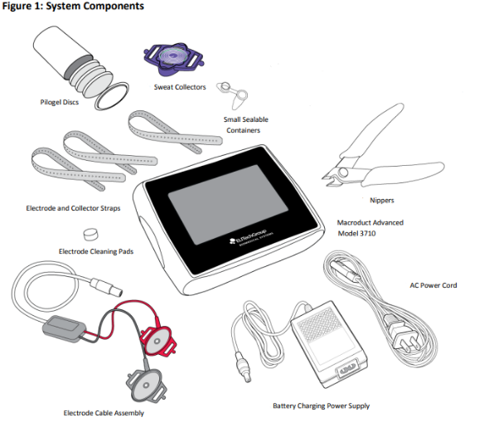
Safety & Precautions | - Pilocarpine may cause inflammation. Do not ingest. See MSDS for more information.  - Burn possibilities are reduced by using undamaged pilogel discs, appropriate strap pressure so discs are not crushed, and leaving the skin moist where the electrode is to be placed.  - Always use PPE when working with or handling blood and body fluids.
Sample | Patients suitable for sweat collection are:  - Must be at least 48 hours old.  - Well-hydrated  - Clinically stable  - Free of acute illness  - Not receiving mineralocorticoids  - Not on oxygen by open delivery (headbox or nasal prong is OK)  - Free of diffuse skin inflammation, such as eczema, which can increase contamination of sweat with serous fluid after stimulation.  Postpone sweat collection on patients that do not meet these criteria. Consult patient’s provider.
Procedures:
Sweat Inducer Maintenance | Each Day of Use:  - Clean the inducer after use with alcohol wipes or hospital approved disinfectant wipes.  - Clean the electrodes before and after each use with alcohol wipes.  - Charge the inducer after use and after cleaning.  Monthly or more often as needed  - Clean the electrode surface with cleaning pads (SS-271) when electrode appears dirty. Never use steel wool or other abrasives. If electrode is scratched, damaged, or pitted, then replace.  - Download data files. Data will be saved electronically with other sweat related records, such as scanned maintenance charts, for a minimum of 2 years. This will be completed by the chemistry department or supervisor.  Troubleshooting  - For errors or problems not listed, please see User’s Manual
Infection Control | Step | Action |  |  |  | Related Document
 | 1 | After each patient collection, use alcohol or a hospital-approved disinfectant wipe to clean the surfaces of the sweat inducer, the cables, the nippers, and any other re-usable equipment. Document on Maintenance Log. |  |  |  | SA10.7.3 Cleaning Laboratory Equipment
 | 2 | Leave the collection tray outside the patient’s room if the patient is in transmission-based precautions. Take only the required supplies into the patient’s room. Keep the inducer in plastic bag.
 | 3 | Patient rooms and facilities are maintained according to organizational policy. |  |  |  | Org Policy #1201.09  Worksite Cleanliness for Infection Prevention and Control.
Patient and Family Preparation | Step | Action
 | 1 | Prior to stimulation educate the patient and family about the procedure and possible risks involved.  - The procedure typically takes approximately 45 minutes, and includes collection from 2 locations (left and right arm).  - The procedure does not hurt; most discomfort is due to restricting movement of the arms.  - If sufficient sample is not collected, you may be asked to return at a later date for another collection attempt.  - Results should be available same-day, through your patient care provider.  - A sweat-inducing drug called pilocarpine is delivered through the surface of the skin to the sweat glands by means of a small electric current.  - Most children will exhibit sensitivity to pilocarpine that manifests as “redness” under the electrodes.  - Occasionally one or more blister like welts may form as a reaction to the pilocarpine and will disappear in 2-3 hours.  - Although the incidence is very rare (less than 1 in 50,000), minor skin burns are a possibility with this procedure.  - You or your child may be referred to Children’s Emergency Department after consulting your physician in the event of a reaction.
 | 2 | Please direct ALL questions regarding CF disease and diagnosis to the patient’s physician. Refrain from discussing anything other than the collection procedure with the family.
 | 3 | Advise families that have concerns about the procedure to consult with their physician before proceeding with the sweat stimulation.
Stimulation | Step | Action
 |  | All sweat orders are bilateral collection, i.e. stimulation and sample collection from both the left and right arms. Stimulate one site and begin collection, then stimulate and collect from the second site during the collection from the first site.
 |  | Verify all supplies are on hand and ready for iontophoresis.
 |  | Always wear powder-free gloves to prevent contamination.
WARNING! Due to the possibility of an explosion, never attempt iontophoresis on a patient receiving oxygen-enriched respiratory therapy in an enclosed space, such as an oxygen tent (nasal cannula is acceptable). With medical approval, remove the patient from that environment during iontophoresis.

WARNING! Do not stimulate or collect sweat from the following sites:
• Head, including forehead (possible burns).
• Trunk (current crossing heart).
• Any area of inflammation (e.g. eczema or rash); serous or bloody discharge (contamination).
 |  | Turn on the Device by holding the power button down for 2-3 seconds. The power button is located on the top of the device. |  |  |  | 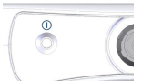
 |  | Tap  to begin the step-by-step iontophoresis procedure. Tap this icon again after each step to advance to the next step.
 |  | Enter information on the next screen.  Operator: Enter your name or tech code  Test: Enter the patient MRN  Kit LOT: Enter the kit lot number from the supplies box.  Also verify the kit has not expired at this time. |  |  |  | 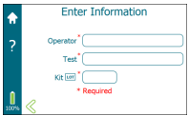
 |  | Inspect electrodes and attach to the sweat inducer. Clean prior to attaching. |  |  |  | 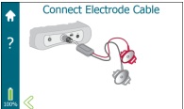
 |  | Select limb: ensure the skin at the selected site is free from breaks, cuts, inflammation, etc. This should be as wrinkle free or hairless as possible. Tap the to indicate which limb is being used for collection. It will show a white check when selected. The lower arm or upper leg is to be used for collection sites, and the skin must be intact and free from diffuse inflammation or rash. Avoid areas where tendons or bone are prominent. Iontophoresis current must not cross the heart. |  |  |  | 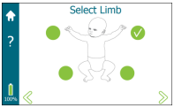
 |  | Clean the skin with alcohol pad, then clean with DI water, and dry.
 |  | Install a Pilogel disc into each electrode. Before use inspect for cracks, damage, or contamination. Discard if unacceptable.
 |  | Add one drop of DI water to the skin and attach the red electrode with disc.  NOTE: Ideal placement is on the lower portion of the flexor aspect of the forearm, where a high density of sweat glands is located. |  |  |  | 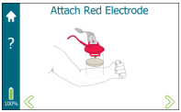
 |  | Secure the red electrode and disc with a disposable strap. Attach both ends of strap as shown. Ensure this is tight enough that it does not move side to side with moderate force. |  |  |  | 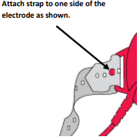
 |  | Add one drop of DI water to the skin and attach the black electrode with disc above the red electrode using a disposable strap, this may be placed on the forearm or the bicep. Ensure the red and black electrodes are not touching and there is no water bridge. Both electrodes should be secure such that they do not move side to side with moderate force
 | - 6 | Tap to begin the induction. The instrument is programmed to deliver 1.5 mA of current for 5 minutes (300 seconds), it will count upwards in seconds up to 300. Stay with the patient during iontophoresis. During this time, observe for signs of allergic reaction. When stimulation is complete an audible tone will alert the operator, and the screen will state Iontophoresis Complete.  NOTE: If cancelled for any reason, Iontophoresis must be re-started and completed before any sweat collection can begin. |  |  |  | 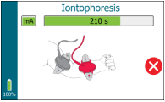
Remove the black electrode, the red electrode, and then immediately dispose of Pilogel discs in a secured biohazard container. There should be a distinct redness under the red electrode. Discard straps after use.

WARNING: Pilocarpine is a POISON and ingestion must be prevented. Dispose of gel in a non-patient care area, or in a patient safe sharps container. See MSDS for more information.
 |  | Clean with DI water to remove salts and then blot dry.
 |  | Tap on the inducer to see a collection summary, then tap to return to the home screen. |  |  |  | 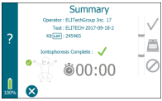
Collection | Step | Action |  |  |  | Related Document
 |  | Wear powder free gloves during the collection process to prevent contamination of the collector and sample. If contamination occurs, discard collector and replace with new. Prepare the collection device by attaching one end of the strap.
 |  | Attach the collector.  - Place the concave surface of the collector precisely over the area of skin contacted by the Pilogel disc that was under the red electrode.  - While applying slight pressure to the collector, wrap the strap around the limb and thread it up through the slot on the opposite side of the collector. Pull the free end out and then down, aligning a suitable hole in the strap with the attachment knob. Press the selected hole in the strap down over the knob to lock it in place.  - Verify that the collector is firmly attached.  - If necessary, grip the collector and lift it briefly above the skin to equalize strap tension on each side of the collector. Then lower the collector to the skin surface, ensuring that the collector is still positioned over the sweat-stimulated area. Adjust strap tension on either side, as needed, to ensure even contact.  - For neonate sweat collections where the limbs are extremely small: Overwrap the collector firmly with a 5-8 cm (2 or 3 inch) wide elastic bandage. This ensures continuous and firm contact between the collector and the skin, and greatly improves the probability of successful collection. |  |  |  | 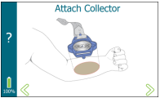
 |  | Skin should push up to sides of collector and strap and collector should not move when sideways pressure is applied. Avoid restriction of circulation. Re-adjust strap as necessary. Advise patient, parent, or guardian to not loosen strap. If there is concern or discomfort, you may adjust the strap at any point for them.
 |  | Observing the center of the collector, watch for sweat (blue) to emerge into the tubing. This may take between 2-7 minutes. Start the 30 minute timer at this point.  NOTE: Detect inadequately tightened collector straps by pressing the collector very firmly against the skin. If the advancing meniscus of sweat in the spiral tube moves by more than 2-3 mm (1/16-1/8 inch), attach the strap more firmly.  WARNING! During collection, watch for any signs of interference with blood circulation in the limb, such as cyanosis, swelling, or unusual pallor, and discontinue the test on that limb if any of those conditions should occur. |  |  |  | 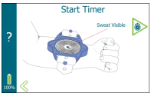
 |  | Sweat collection will end at the 30 minute timer. Remove the clear cover. While holding the collector firmly in place with slight downward pressure, Snip the tubing at the center of the coil. This ensures no sweat is lost below the collection device due to vacuum pressure.  NOTE: Sweat collection may be ended before the 30 minute timer ends IF 1) sweat has accumulated at least one full revolution past both black marks and 20 minutes has passed, OR 2) sweat has filled the tubing completely. |  |  |  | 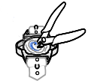
 |  | Remove the straps and collector from patient limb. Clean the collection location with DI water.
Receive the sample into Sunquest (see Sweat Collection Order Receipt, below). Label the collection with a small (foot) label, and transport promptly to the lab in a sealed plastic bag to prevent evaporation and minimize exposure to air.

NOTE: In St Paul Outpatient Lab, if there are many patients waiting to be drawn and time does not allow for transport to the lab, call the Operations Supervisor or main lab number and ask someone to pick up the specimens. Never send via pneumatic tube.
 |  | The chemistry lab tech must evaluate samples for adequate and inadequate specimen(s). Submit all collection devices to lab in a sealed plastic transport bag, appropriately labeled with patient information and times collections were started and stopped.
 |  | The chemistry tech will evaluate sample volume and acceptability, and perform any cancellations or credits as necessary. Do not attempt a second stimulation or collection if volume is inadequate.
 |  | Inform families that inquire about results, “You can speak with your physician or the genetics counselor at your appointment today about the availability and meaning of the sweat chloride results.”
 |  | Cancel SWCL in GUI, General Laboratory only if no collection is attempted (for example, the patient failed to arrive for the appointment).
Sweat collection  Order Receipt | Step | Action |  |  |  | Related Document
 | 1 | When receiving the sweat collection in GUI, function General Laboratory complete the following:  Arrow 1)  - Enter the start time under collection time then TAB down to Phlebotomist code  - PHLEBOTMIST CODE: Enter tech code  - ORDER WORKLOAD CODE: enter SWC for Sweat Collection  Arrow 2) click the receive button  Arrow 3) Add test SWCD
 | 1.a | 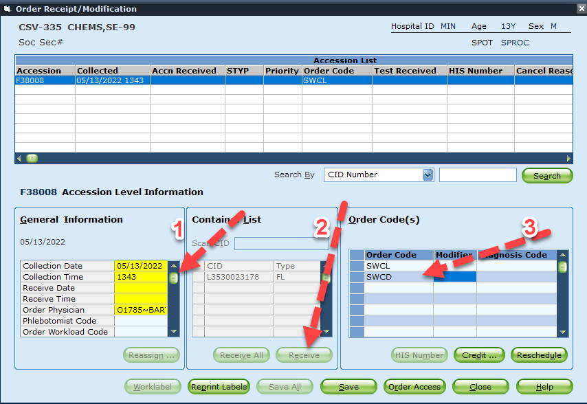
 | 2 | After selecting save a secondary box will appear. Enter the Following information about collection times:  See 2.a  BGIN1: enter the time the first collection device was placed on the patient  BGIN2: enter the time the second collection device was placed on the patient  END1: enter the time the first collection device was removed from the patient  END2: enter the time the second collection device was removed from the patient  This difference between the Begin Time and End Times must not exceed 30 minutes.
 | 2.a | 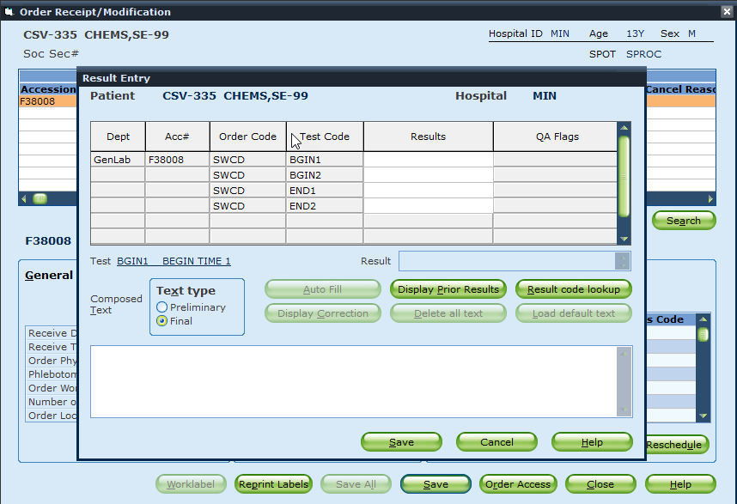
Limitations | - Burn possibilities are reduced by using undamaged pilogel discs, appropriate strap pressure so discs are not crushed, and leaving the skin moist where the electrode is to be placed (or adding a drop of water to the discs.)  - While allergic reactions to Pilocarpine iontophoresis are unusual, if diffuse inflammation, burns, or urticaria (hives) occurs:  - Immediately discontinue the procedure  - Contact the patient’s physician  - Notify the Pharmacy.  - Complete an on-line Patient Safety Report, and include a description of the appearance of the area, and any conversation with the family.  - Do not assay the sweat sample due to possible contamination with serous fluid.  - If the patient is experiencing discomfort during the iontophoresis, it may be due to an uneven current distribution. This can be corrected by tightening the bands to apply even pressure across the gel.  - Collections from more than one site should never be pooled.  - Iontophoresis current must never cross the patient’s trunk.  - The minimum rate of sweating is 1 gm/m²/minute. A longer collection time would require a larger volume of sweat. The 15 μL sample size corresponds to a maximum 30-minute collection time for the area stimulated by the Macroduct system.  - The incidence of insufficient samples must be measured, investigated and resolved if it exceeds 5% for ages >90 days, and if it exceeds 10% for ages 6 weeks to 90 days. Only when there are 2 QNS samples in one collection will it be counted in the collection failure rate, per CLSI and CF Foundation guidelines.
References | - College of American Pathologists, Chemistry and Toxicology Checklist, revised October 24, 2022.  - Cystic Fibrosis Foundation Sweat Testing guidelines.  - CLSI. Sweat Testing: Specimen Collection and Quantitative Chloride Analysis. 4th ed. CLSI Guideline C34. Wayne, PA: Clinical Laboratory Standards Institute; 2019  - ELITech Group. MacroDuct Advanced User’s Manual Model 3710 SYS. ELITechGoup Inc. 370 West 1700 South, Logan, Utah, 84321
Appendices | CH 1.19.T1 Sweat Collection Training
Historical Record
 | Version |  | Written/Revised by: | Effective Date: | Summary of Revisions
 | 1 |  | Matt Johnson | 4/18/2023 | New Procedure

