Reference Lab Encounter Creation Tipsheet

How to create or edit a

“Register Patient OP (Add Encounter)” encounter

1. **Open Revenue Cycle Ambulatory P0033 application**

**Launch the Revenue Cycle Ambulatory P0033 application** from the start menu of your computer, found under the Cerner folder

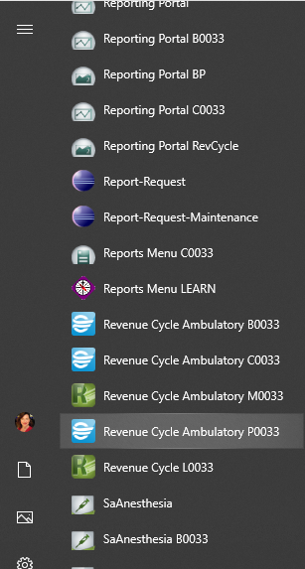

or from the Revenue Cycle category folder from Cernerworks [Welcome to CernerWorks! (cernerasp.com)](http://cernerworks.cernerasp.com/Citrix/ProdWeb/)

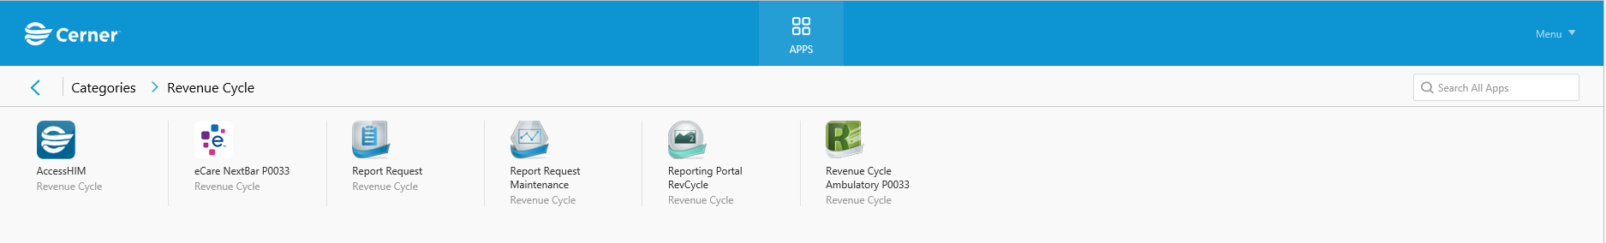

1. **Search for the patient** by name or MRN in the Search box in the top left.

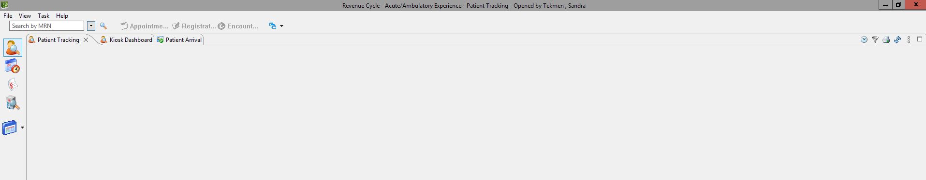

1. If you aren’t automatically brought to the “Patient Perspective” when you enter the program, click the  icon. The other view options are “Resource View”  and three other functions you won’t need.
2. Confirm you have the correct patient by comparing other identifiers such as date of birth.
3. **Navigate to the Encounters function**

There are three primary functions within the Patient Perspective: Appointments, Registration and Encounters. These options are to the right of the patient search box.

1. **Select Encounters function**

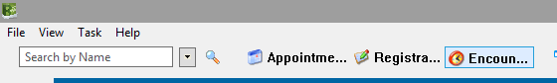

1. The system may automatically send you to the second tab, the Encounters Detail tab. You want to instead **select the first Encounters tab.**



1. **Click the Add Encounter icon** on the right of the screen 

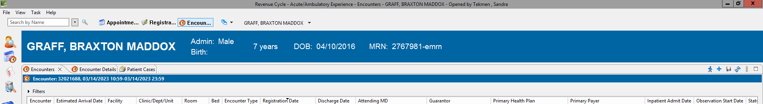

1. **Begin the new encounter data entry**

TIPS:

* See Sendouts Procedure 1.20 for further details.
* Yellow highlighted fields with an asterisk are mandatory. Pink highlighted fields are optional and should be ignored by lab staff for this procedure.
* Use search icons or drop down menus for guidance and quick access.
* Avoid using the mouse scroll wheel to navigate the page because you may inadvertently change an answer. Instead, drag the scroll bar on the right of the screen.
* There are fields in each of five tabs to be completed: A) **Encounter Info**, B) **Person Info**, C) **Related Persons & Guarantor**, D) I**nsurance** and E) **Consents**
* Click OK to navigate from window to window if that is an option or click on the next tab. The SAVE button is only for after you’ve completed data entry in all tabs.
* Clicking the Cancel button at any time will allow you to start over from the beginning.

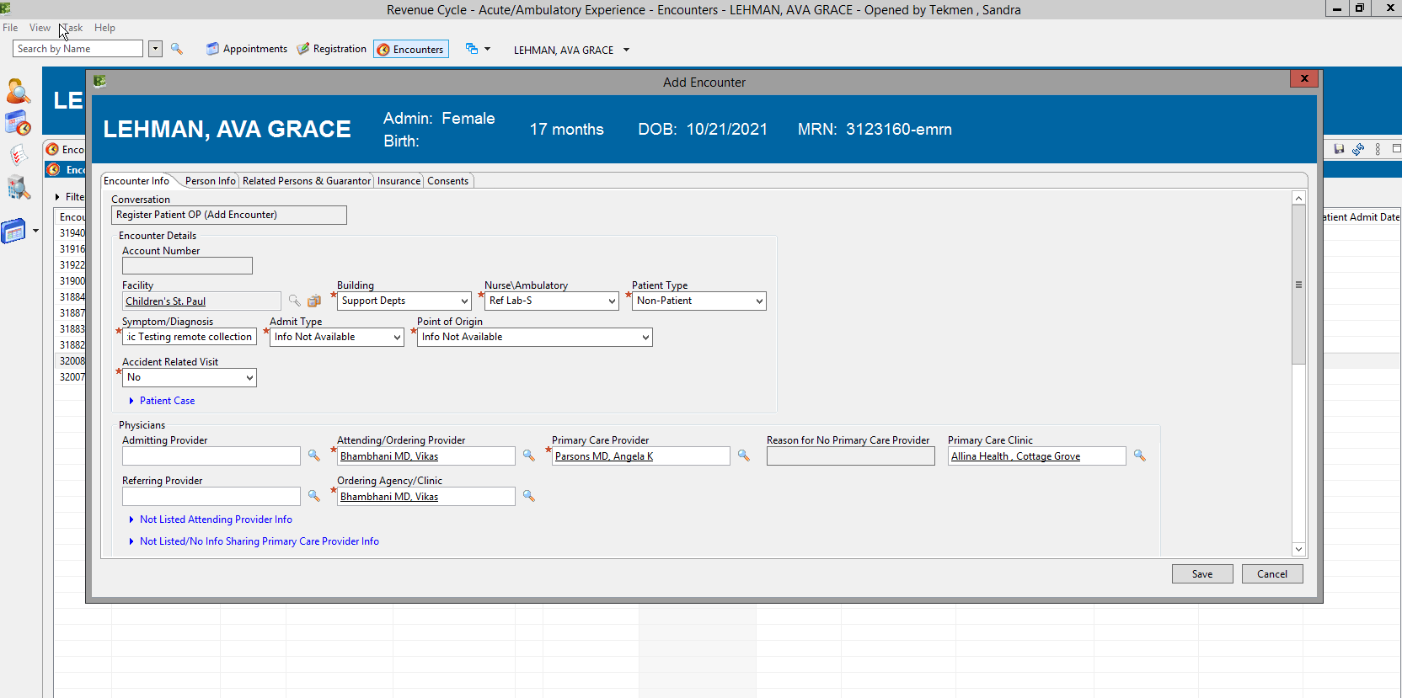

1. **Encounter Info tab**

* Facility = **Children’s St. Paul**
* Building= **Support Depts**
* Nurse/Ambulatory = **Ref Lab-S**
* Patient type = **Non-patient**
* Symptoms/Diagnosis
  + For standard genetic testing result reports, enter “**Genetic Testing Remote Collection**”
  + For Dietary Screening result reports from Wisconsin State Lab of Hygiene (PKUD order), enter “**Dietary Screening Remote Collection**”
  + For result reports from OneOme (RPHA order), enter “**Pharmacogenomics Remote Collection**”
* Admit type = **Info not available**
* Point of Origin = **Info not available**
* Accident Related Visit = **no**
* Attending/Ordering Provider = Type in the name of the **Ordering provider** (Note: you may need to check the Future Cerner order to determine who this is. The provider on a result report may be outdated especially if you are working with an Amended report from an old collection date)
* Primary Care Provider = in most cases will be filled in already. If not, type “**NOT**” and hit the search to select **Not Listed Provider**
* Ordering Agency/Clinic = same as **Ordering provider**
* **IMPORTANT!** Scroll down in Encounter Info tab to Account Data Section. Enter the Date of Collection for both the Estimated Arrival Date and the **Registration Date** (Reg date defaults to today’s date). *The Reg Date will be the date that the encounter is created for*. The times don’t matter.

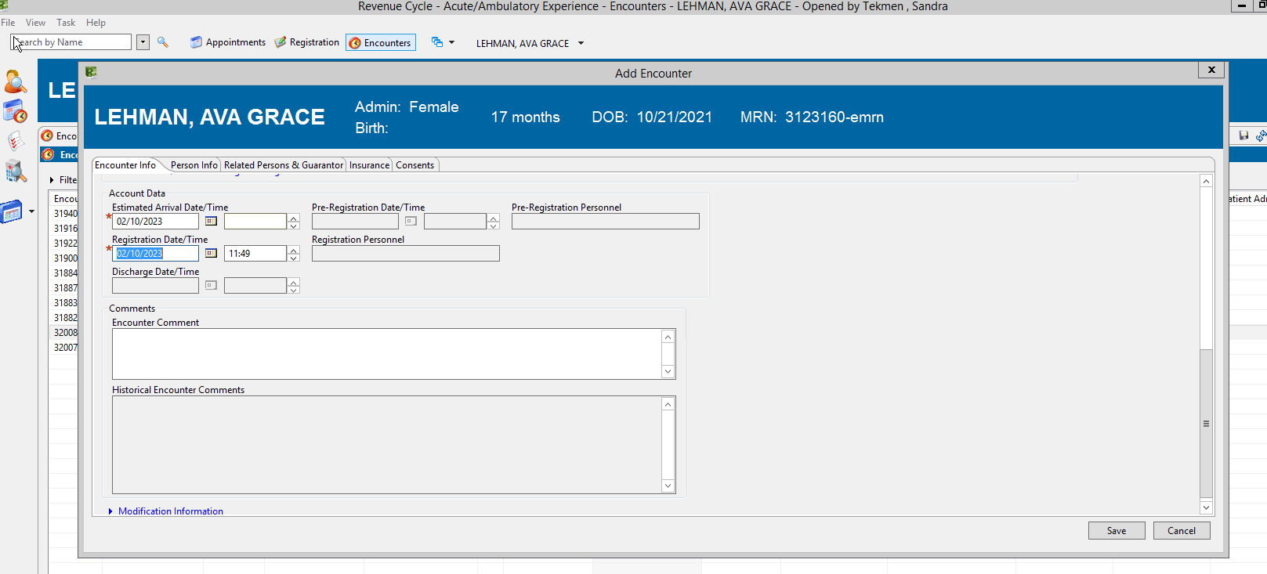

1. **Person Info tab**



* + If any required (yellow) demographic information is needed in Person Info, select Unknown or Unavailable from the lists of options.

1. **Related Persons & Guarantor tab**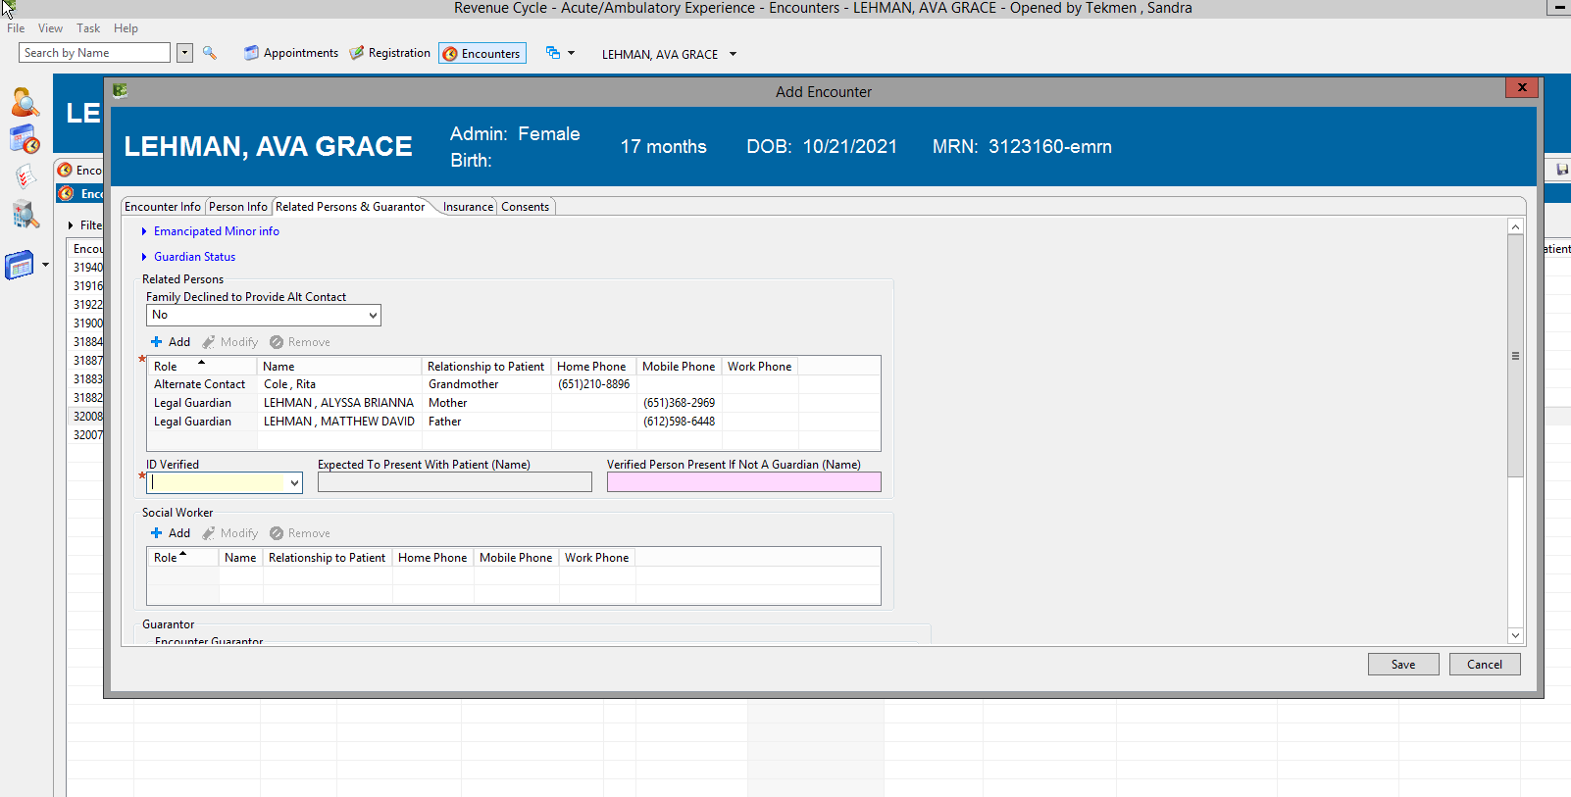
   1. ID verified **= No**
   2. **Notice who is listed as the legal guardian and remember that name for the next step.** If more than one legal guardian is listed, the standard is to use the Mother in the next step. Do not use any alternate contact. If there is no guardian other than Social Services, use that.
   3. **Scroll down to Guarantor section.** Click **+Add**

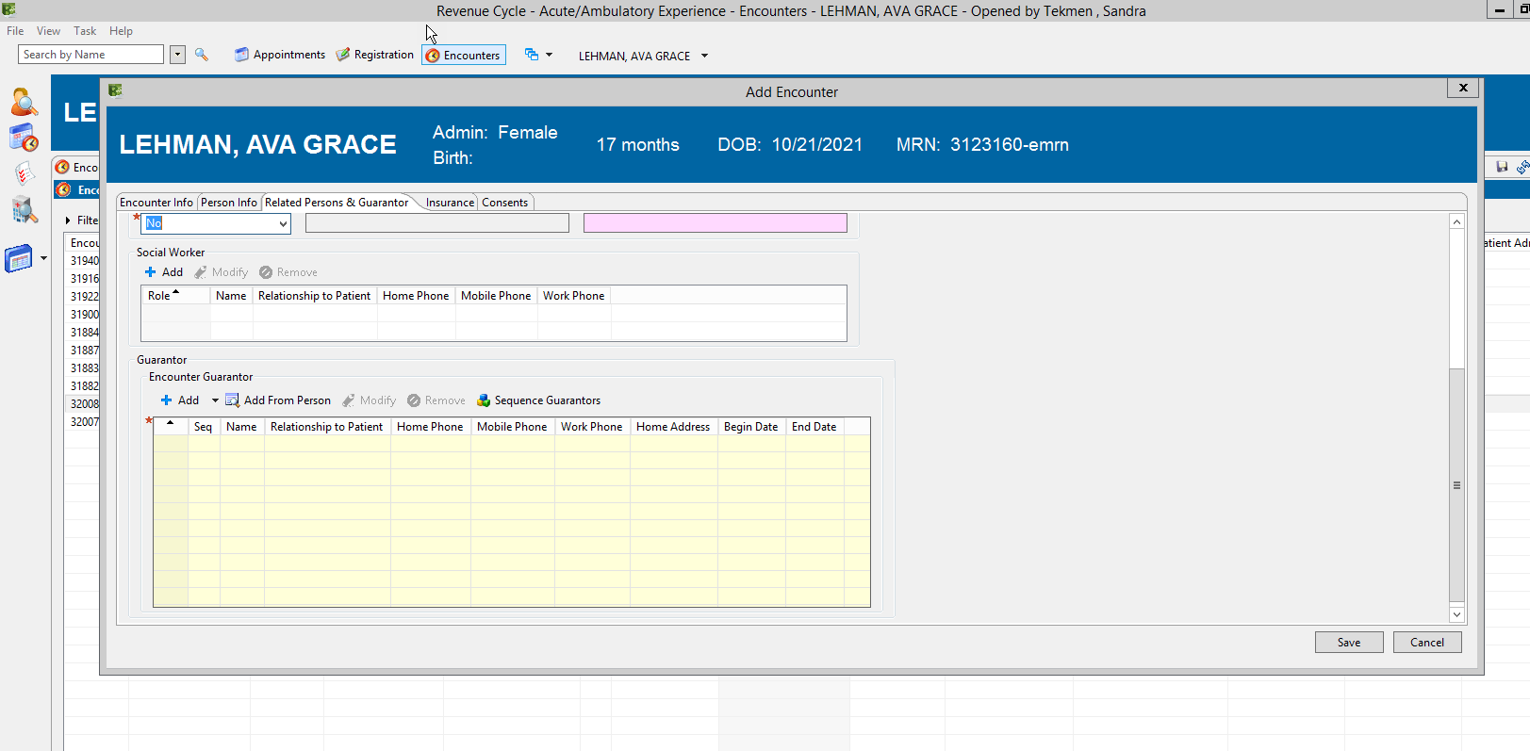

* In the pop-up, click the radio button for **Current relationship**. In the Current Related Persons field, select the name of a person who was listed as a legal guardian in the previous window.

Ensure you are selecting a Legal Guardian and not an Alternate Contact.

* If **Permission to Text** is not already filled out, select **No**

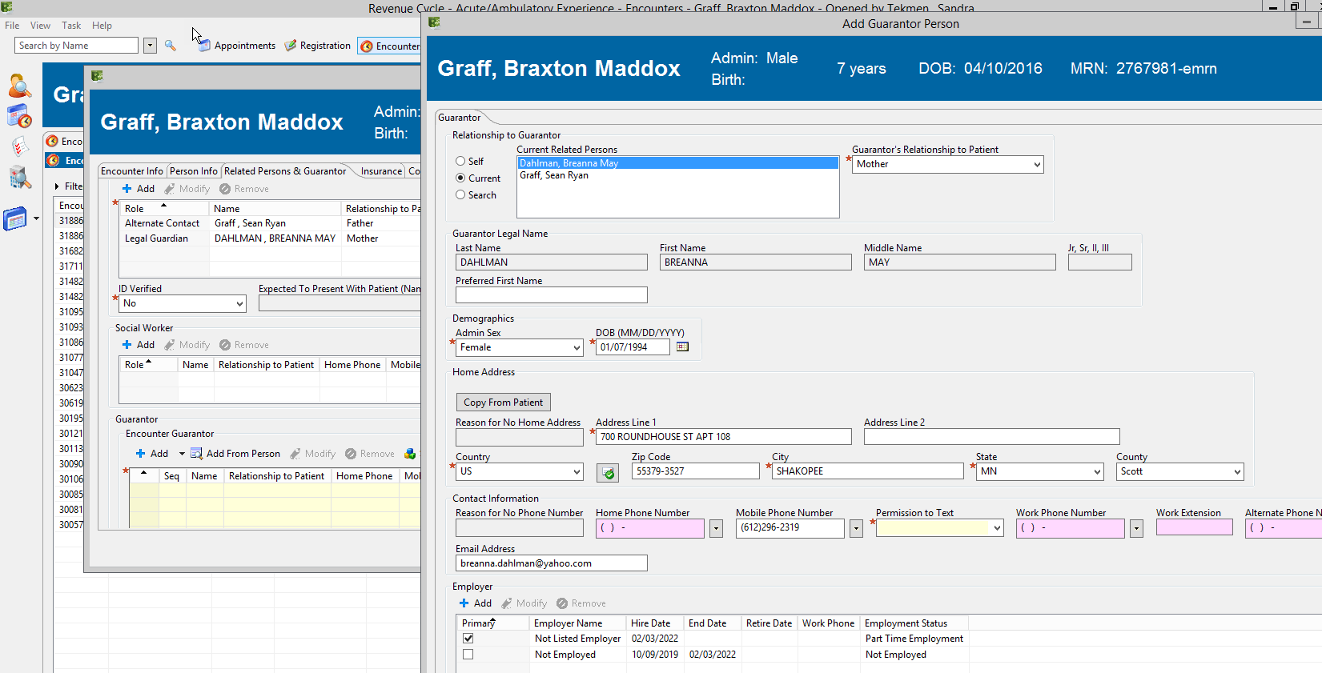

1. **INSURANCE TAB**
2. Even if you see an insurance health plan listed, click **Select Profile** (not *+Add*)

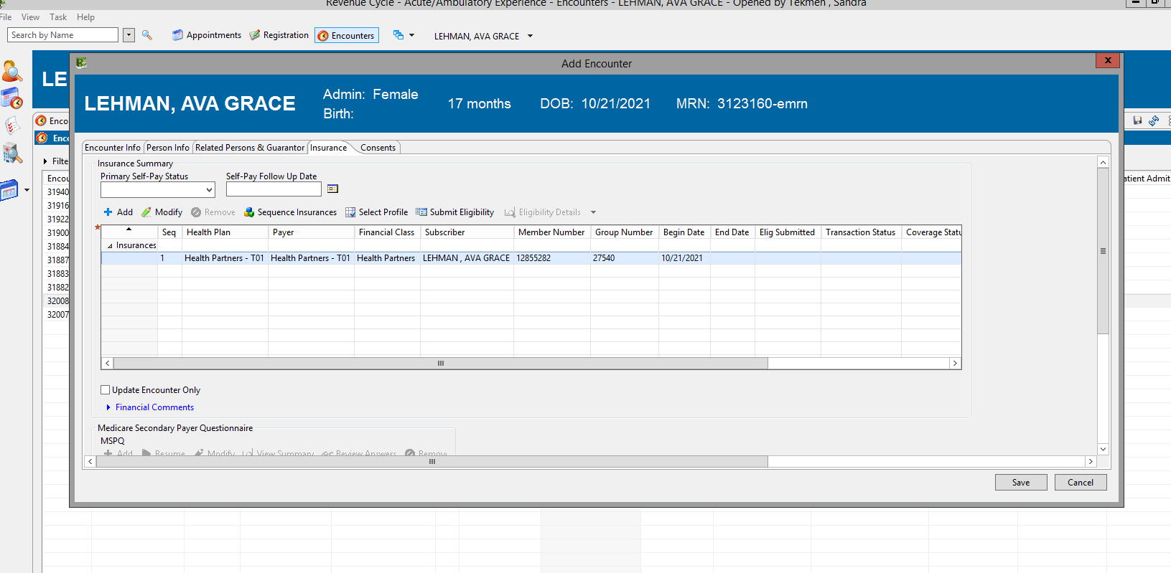

1. Select the box next to **Medical Insurance** to associate the plan to the visit, then go to Consents tab. If there is not a plan listed under Medical Insurance, go to scenarios for c) or d) below.

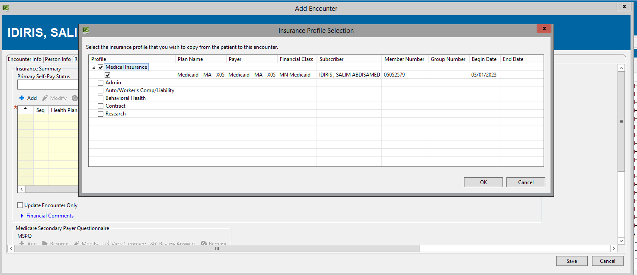

1. If there is no insurance plan name **and the order is a billable (e.g., MBATG)** order, **STOP** and click Cancel. Consult with Technical Specialist. If T.S. is not available, notify Genetic Counseling Assistants and/or GC On-Call to notify them that registration must be completed with insurance information before we can proceed.
2. If there is no insurance plan name **AND** **the order is a no charge 3MBAT** (this will be most scenarios) you may proceed as below:
   * Click +Add

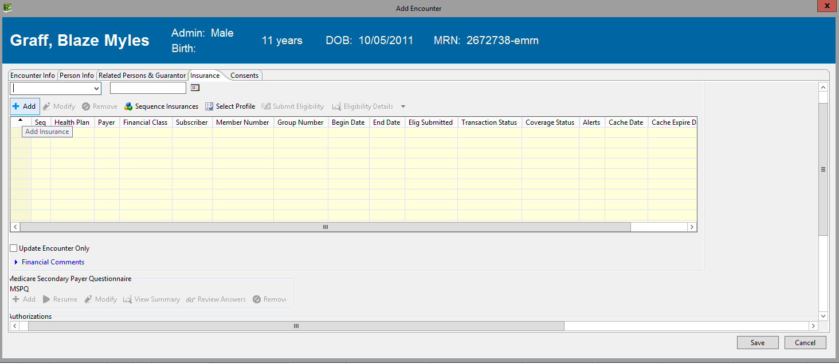

* + In Subscriber tab, leave Relationship as Self, then click on Insurance tab then click the next to the **Search for Health Plan** field

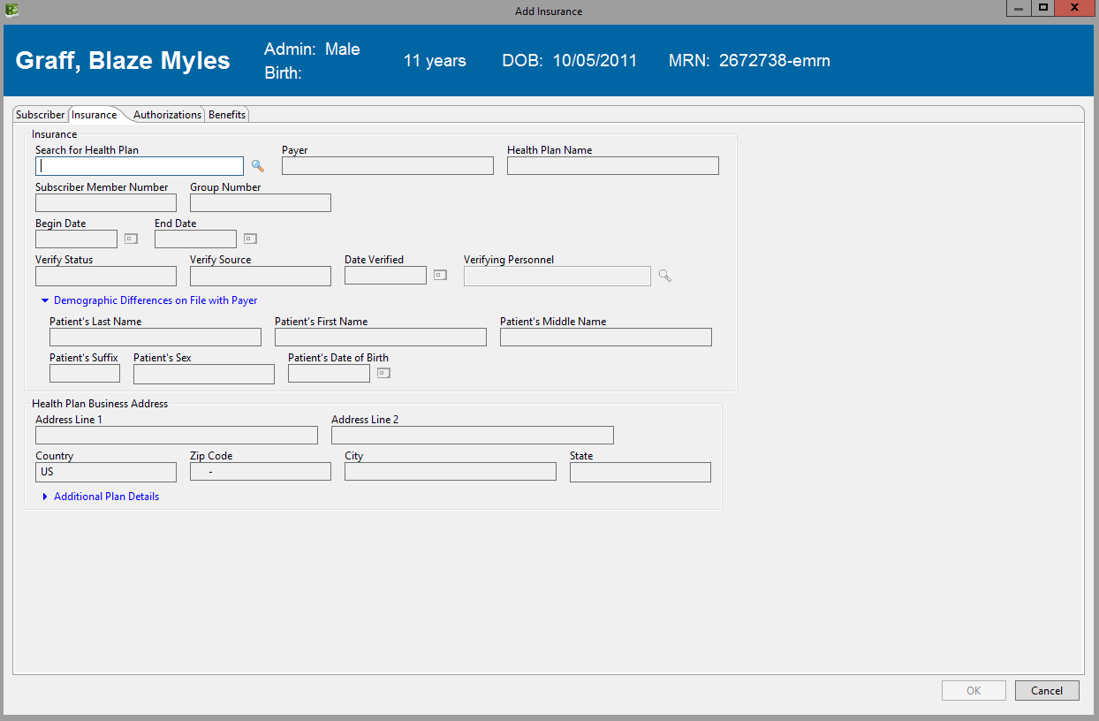

* + Change Search by field to **Payer Name**, then type **ADMIN** in search box

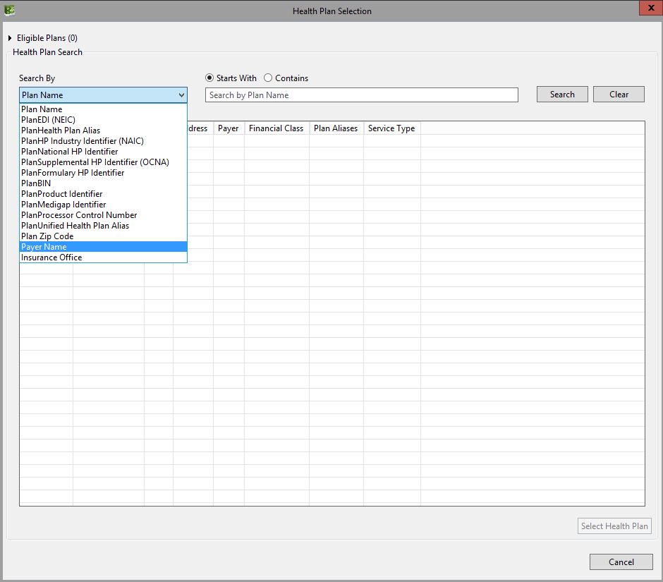

* + Expand the arrow next to **Not Listed Guarantor Organization (AE8**), click on the option listed there and click **Select Health Plan** button

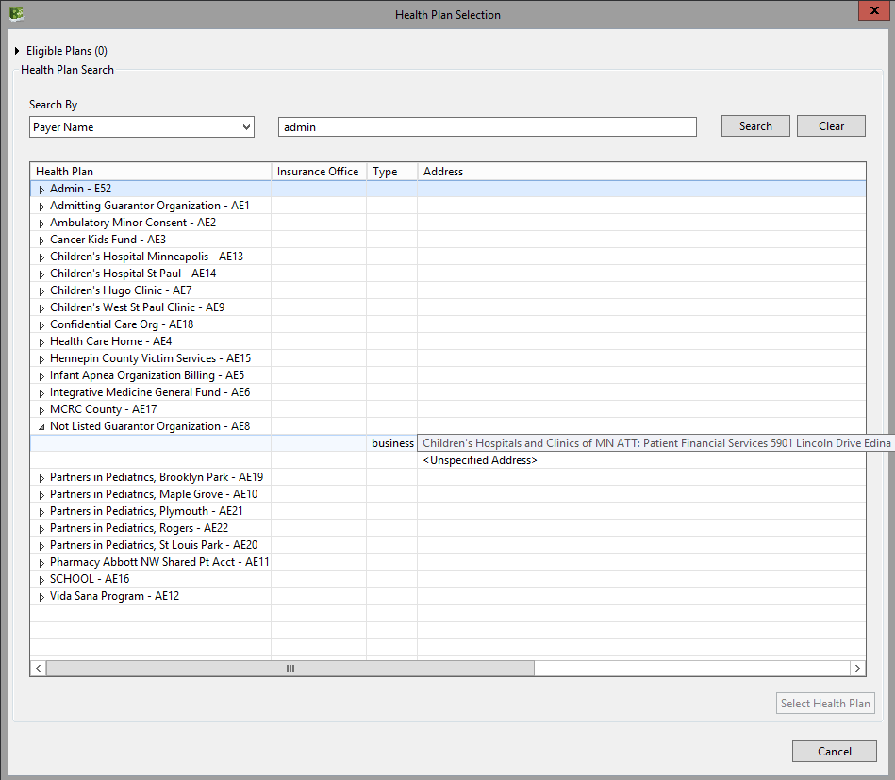

* + Enter the **Date of Collection** for the mandatory **Begin Date** field. Enter **one day after the Begin Date** in the **End Date**, then click OK

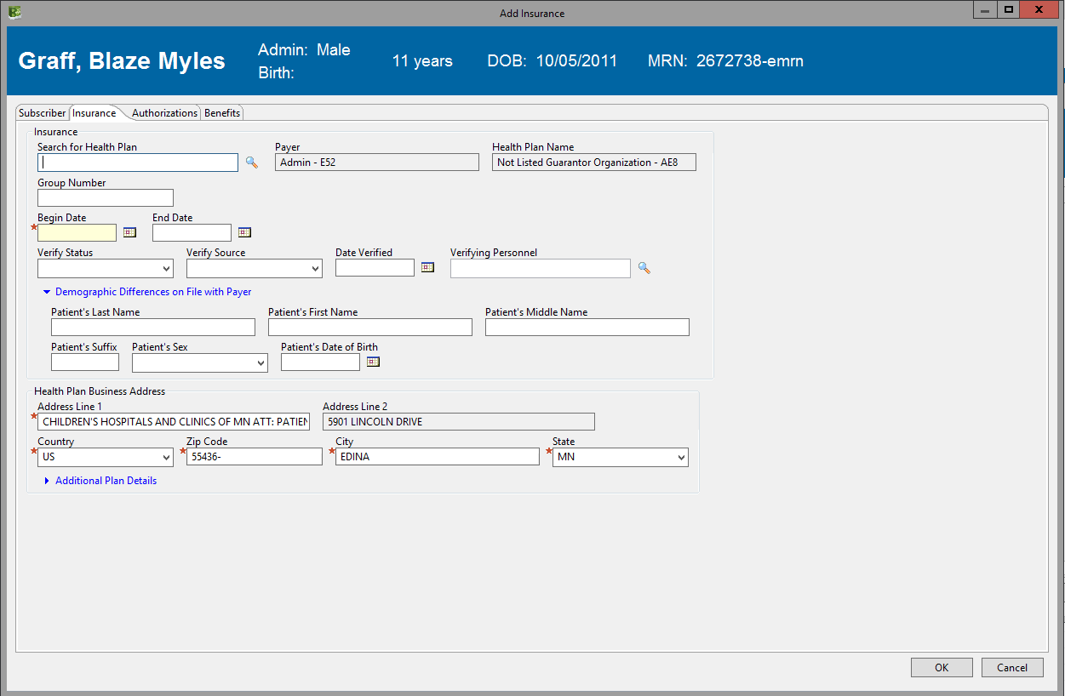

* + **IMPORTANT** – In next window, check the **Update Encounter Only** box. Then expand the Financial Comments arrow and type “No Charge Testing” in the **Financial Comments** box. Now proceed to the Consents tab.

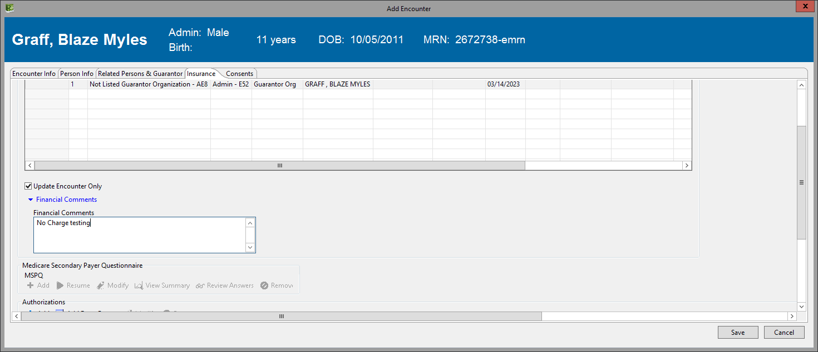

1. **CONSENTS TAB**

* In some cases you won’t have to enter anything. Pink highlighted fields are optional and should be left blank. Yellow highlighted fields with a red asterisk are mandatory.
* **HIE consent** – If completed, leave it. If pink, leave it blank. If date is yellow, set date for one year in the past.
* **Plain Language Summary** – If completed, leave it. If yellow, select Unable to Provide from the drop down then set date for one year in the past if that is still mandatory, leave blank if not mandatory.
* **Yearly Consent** – If completed, leave it. If yellow, select Not Available from the drop down and set the date for one year in the past if mandatory, leave blank if not mandatory.
* **Notice of Privacy Practices (NOPP)** – If completed, leave it. If yellow, select Patient Not Available and set date to one year in the past if that is still mandatory, leave blank if not mandatory.
* **TPO** and **Research** consents are usually completed or not required so leave them.

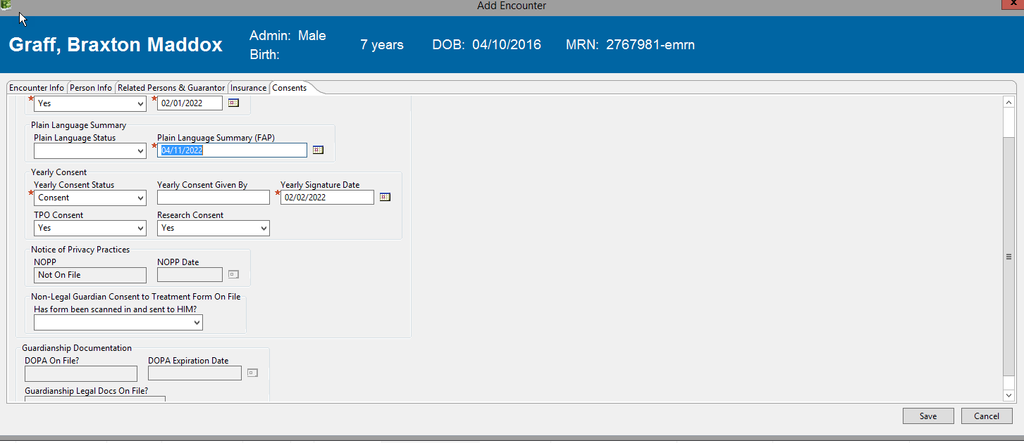

If you get a pop up after clicking **Save**, click **No** (you do **not** want to update other existing encounters).

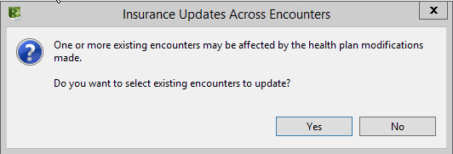

You are done! Click **SAVE**. If anything mandatory was missed, the system will prompt you to complete the required fields.

* Tip: Anytime you get a *pop up* about validating addresses, select **Proceed** and you can get past it. If you get a *pop up* that says something is expired, click ok and you should be able to get past it. If not, select a date one year in the past.

1. **Quality Check**

After saving, you will then be taken to the Encounter Details tab for the patient. You will be able to see that you completed the process because there will be an encounter number with the date of collection in the blue bar, you’ll see the same encounter number in the Account Number field and see the date of collection in the Registration Date/Time field.

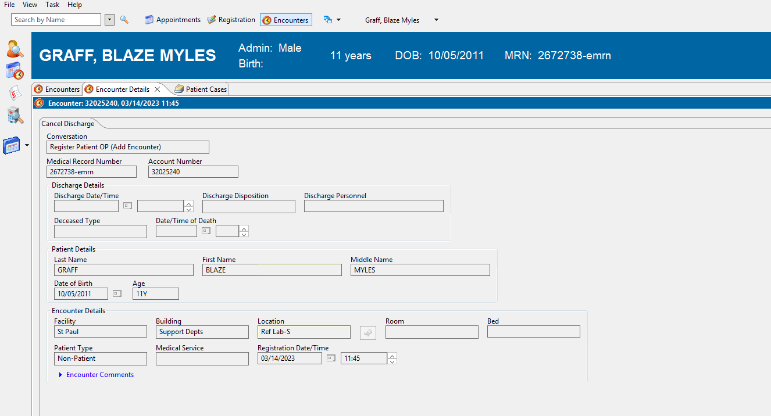

Next, you can complete the order activation steps in Powerchart. Notice the encounter (account) number matches in Revenue Cycle and Powerchart.

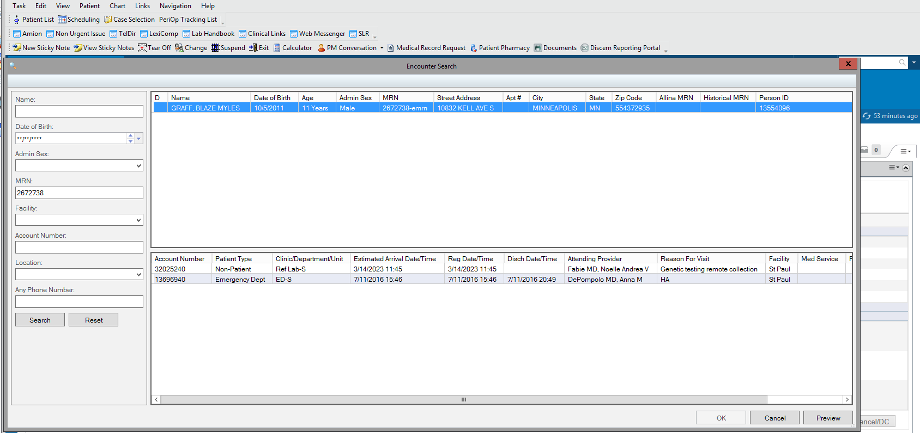

1. **How to edit an encounter on the same day**

*If you need to make an edit to an encounter, you can do so on the same day you made it while it’s still active. This is useful if you forgot to change the Registration Date to the date of collection instead of the defaulted today’s date.*

1. Search for the patient by name or MRN and verify correct identity.
2. Highlight (single click) the desired existing encounter from the pop up window and click Select.
3. Click on the Encounter function at the top (see step 3a).
4. From the **Encounter Details** tab, click on the **Change Conversation** (pencil and paper) **icon** on the right and select **Register Patient OP (Modify Encounter)** from the dropdown.

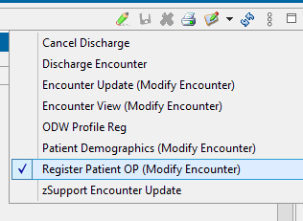

1. Then click the **Modify** (pencil) **icon**



1. You may then make edits to certain fields as necessary.

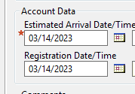

1. Click the Save icon (or cancel X)



*If you need to make an edit to an encounter made on a previous day that is now discharged, do not make a new encounter. Call IT support at 4-5000 and ask them to place a ticket to change the Registration Date for an encounter. Provide the encounter (aka account) number, the patient MRN, and the correct date (i.e., the specimen collection date). You may proceed with your other order activation, receiving and scanning work before the encounter is corrected. Please check at a later time to ensure the encounter registration date was corrected.*

**APPENDIX**

Special note regarding Social Services as a guarantor:

If you selected Social Services as Guarantor and you get a pop-up like below, cancel and contact your Technical Specialist.

