|  |  |  |
| --- | --- | --- |
| **Children’s Minnesota****RStarBlack** | | |
|  | | |
| **Biologic Product Recall and Look-back Notification** | | | | |
|  | | | | |
| **Policy Number:** | 358.00 | **Version #:** | | 8 |
| **Site:** | System | | | |
| **Responsible for Review:** | Transfusion services | | | |
| **Original Effective Date:** | 09/01/1998 | | | |
| **Version Date:** |  | | | |
| **Next Review Date:** |  | | | |

|  |  |
| --- | --- |
| **Policy:** | Children’s Minnesota (Children’s MN) will assess each product recall notice or look-back notice received from the product supplier or initiated internally regarding biologic products received and/or administered at Children’s MN facilities. Children’s MN will determine the risk and appropriateness of patient/family notification for all products involved in a recall or look-back that have been utilized in the care and treatment of our patients. Evaluation of appropriateness of notification will occur based on an evaluation of the benefits and burdens of notification to the patient and family and to Children’s MN and its staff.  If it is deemed appropriate to notify the patient/family, Children’s MN will work with the provider who ordered the product to notify and coordinate appropriate follow-up for the family. By providing notification, Children’s MN does not assume liability for any harm which may have resulted from the affected product. |

|  |  |  |  |  |  |  |
| --- | --- | --- | --- | --- | --- | --- |
|  | | | |  | | |
| **Procedure:** | |  | | |
| **Determining patient/family notification:** | | 1. Upon receipt of a product recall notice or look-back notice, the Children’s MN agent deemed responsible for the receipt, storage, and distribution of the said product (e.g., Transfusion Service Technical Specialist, Pharmacy Manager) will determine if any patients received the affected product(s). If such patients exist, the Children’s MN agent will assess the risk and appropriateness of notification. This process is outlined on page 1 of Appendix I: Notification Procedure Flow Chart. Note: Transfusion Service look-back review is initiated by the transfusion service technical specialist and completed by the transfusion service medical director to determine whether provider notification is indicated. The consignee notification form from the blood supplier will be completed by the transfusion service medical director, as indicated. The original form is retained in the Transfusion Service and a copy is forwarded to Risk Management with the hospital look-back notification record for the completion of the process. 2. If it is determined that no notification is required, a summary report will be provided for transfusion and surgery committees. 3. If it is determined by the Risk Management department that a notification is required and/or notification should occur, or that precedent exists in favor of notification, they will immediately begin the process of preparing for notification. Infection Prevention & Control, Risk Management, Data and Record Services, Communications, and other departments as appropriate will assist in this procedure. This process is outlined on page 2 of Appendix I: Notification Procedure Flow Chart. 4. If the agent determines that the risk or requirement of notification is unclear and that no precedent exists, they will coordinate an assessment panel as outlined in 5, below. 5. When necessary, assessment of risk and appropriateness of notification will be carried out by an “assessment panel” involving the parties deemed appropriate to the situation, which may include:  Blood Products  * + 1. Transfusion service technical specialist     2. Children’s MN infectious disease clinician or designee     3. Transfusion Service Medical Director and/or Laboratory Medical Director     4. Hematologist     5. Hospital Ethicist or designee     6. Risk manager     7. Provider who ordered blood (if a single patient) or representative of ordering provider (if a group of patients).     8. Others, as needed  TissuesTransfusion service technical specialistChildren’s MN infectious disease clinician or designee  * + 1. Transfusion Service Medical Director and/or Laboratory Medical Director  Surgery clinical director and/or chief of surgeryRisk managerHospital ethicist or designeeProvider who ordered Tissue (if a single patient) or representative of ordering providers (if a group of patients).Others, as neededPharmaceuticalsPharmacy managerChildren’s MN infectious disease clinician or designeePharmacy directorRisk managerHospital ethicist or designeeProvider who ordered Pharmaceutical product (if a single patient) or representative of ordering providers (if a group of patients).Others, as needed This assessment panel may review written materials, meet by phone, or meet in person as is warranted by the situation.   1. The assessment of appropriateness of notification will weigh the benefits and burdens of notification to the affected patient and family and Children’s MN and its staff. 2. The assessment panel will review relevant information regarding at least the following issues:  Risk of transmissionRisk of disease process as a result of transmissionPotential for identifying affected individualsPotential treatment for affected individualsRisks to patient/family of not informing themRisks to patient/family of informing themRisk to Children’s MN and its staff of not informing or informing the patient/family  1. The assessment panel will assess the harm and benefits of notification and decide whether or not to notify the patient/family. 2. If the assessment panel recommends not informing the patient/family, they must notify the following individuals of their decisions:  Transfusion committee and surgery divisionBoard quality oversight committeeChief medical officer  1. The assessment panel may recommend other actions, such as maintaining lists of affected patients or reconsidering the issue. 2. When a decision has been made to notify patients/families, notification will occur as outlined on pg. 3 of Appendix I: Notification Procedure Flow Chart. | | |
|  | |  | | |
| **Physician Notification:** | | | | In cases in which patients will be notified, physicians are notified as specified in the Appendix I: Notification Procedure Flow Chart and given the opportunity to notify the patient directly. | | |
|  | | | |  | | |
| **Version Dates:** | | | | New Policy: 09/01/1998 Reviewed system policy: 10/03/2000 No changes Revised: 12/08/2003 Revision 3: 06/27/2007 Rev. 4: 09/20/2010 Version 5:01/13/2014  Version 6: 02/01/2017  Version 7: 02/28/2020  Version 8: | | |
|  | | | |  | | |
| **Approval Group(s)** | | | | | | |
| **Version #** | | **Group** | | | **Date** | |
| 8 | | Transfusion Committee | | |  | |
| 8 | | Clinical Policy Committee | | |  | |
| 8 | | Patient Care Practices Committee | | |  | |
| 8 | | PEC | | |  | |

Appendix I: Biologic Product Look-back Notification Assessment Process-Page 1

Transfusion service look-backs; Transfusion Service Medical Director will review and sign Consignee Notification for return to supplier

Biologic Product Look-back Notification Assessment Process-Page 2

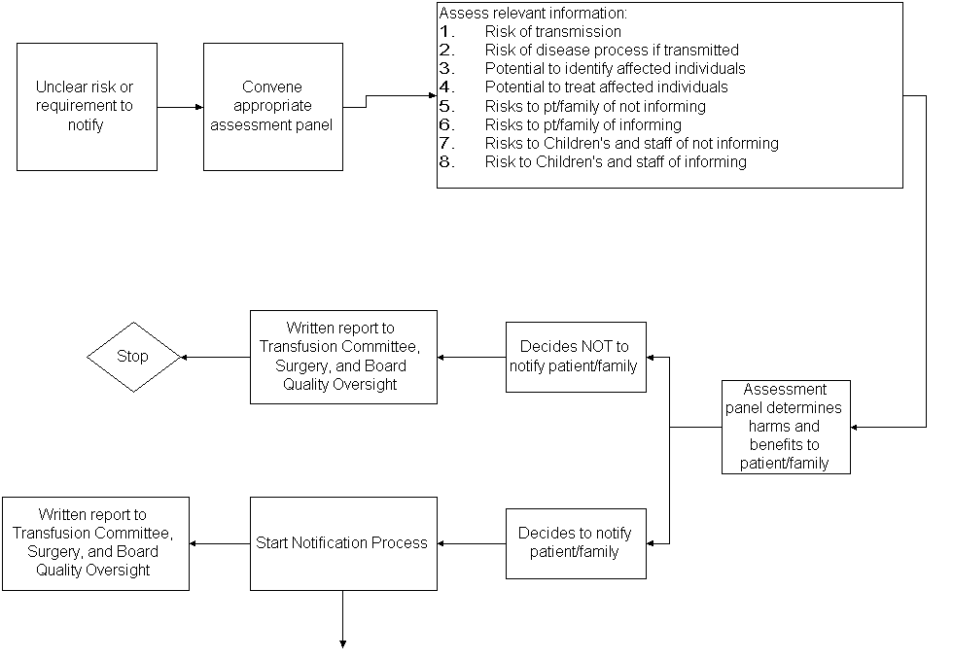

Biologic Product Look-back Notification Process-Page 3

