Acid-Fast Bacilli Resulting and Susceptibility Add-On

Purpose | The purpose of this procedure is to provide documentation on positive smears and positive preliminary results for acid-fast bacilli (AFBB & MYCOB) cultures in Sunquest/Cerner.
Principal and Clinical Significance | Positive preliminary results will help providers see an up-to-date result with required documentation. The procedure also explains how to utilize MayoACCESS and the Mayo Clinic Laboratories website so that updated culture reports can be easily obtained and susceptibility requests are able to be added on.
Policy Statements | This policy documents and provides instructions for Microbiology critical result notification. Positive AFB smears and cultures are considered critical values and are required to be verbally reported to patient providers as soon as the results are available (Refer to MCVI 4.0 Critical Results).
Test Code | AFBB (SAFB and CUTB) for non-blood samples, MYCOB for blood samples  - Acid-fast bacilli smears and cultures are performed by Mayo Clinic Laboratories (MCL).
Procedure | Documentation of Positive Smears  - Obtain the “Preliminary (Verbal) Test Results” slip that contains the patient information and result provided by MCL.  - Obtain official updated report from MayoACCESS. Refer to the section later in this procedure, MayoACCESS Report Retrieval and Updates, for information on retrieving reports.  - Open SmarTerm and enter function “MEM”.  - Return past worksheet (leave empty).  - Under the “Test” prompt, enter the appropriate test code (SAFB) and accept (Figure 1).  Figure 1. Utilizing MEM in SmarTerm (smear).  - Enter “M-”and then the patient’s accession number to allow for modification of the preliminary information (Figure 2).  Figure 2. Entering patient accession number.  - Return to SMAF. Code SEMAY will be present in this line, which indicates to providers to look for the Mayo result that has crossed over.  - Call provider with result. Underneath the test code, add hyphen, CAL, hyphen and semi-colon to free text full documentation of the phone call (name, date, time). Begin with “Called to and read back by” (CAL). Add the comment “Semi Urgent Result” (SURE) after the call information (Figure 3).  Figure 3. Documentation of result to provider with semi-urgent comment.  - Accept documentation. The positive smear result from Mayo will be automatically sent into Sunquest via the laboratory interface.  Preliminary Result Reporting (Culture)  - Obtain the “Preliminary (Verbal) Test Results” slip that contains the patient information and result provided by MCL.  - Obtain official updated report from MayoACCESS. Refer to the section later in this procedure, MayoACCESS Report Retrieval and Updates, for information on retrieving reports.  - Open SmarTerm and enter function “MEM”.  - Return past worksheet (leave empty).  - Under the “Test” prompt, enter the appropriate test code (CUTB or MYCOB) and accept (Figure 4).  Figure 4. Utilizing MEM in SmarTerm (culture).  - Enter “M-”and then the patient’s accession number to allow for modification of the preliminary information.  - After initially ordering AFBB and MYCOB cultures, <HIDE> will be automatically resulted under the preliminary category. This will be removed as positive results are entered.  - Preliminary results are to be entered under CTB1P for the AFBB test code or under MYCBP for the MYCOB test code.  - Use the organism code corresponding to the result provided by Mayo. This can be AFO (Acid Fast Organism) or a more specific organism code, i.e. MTB or MAV  - Replace <HIDE> with appropriate organism code. (Figure 5 & 6).  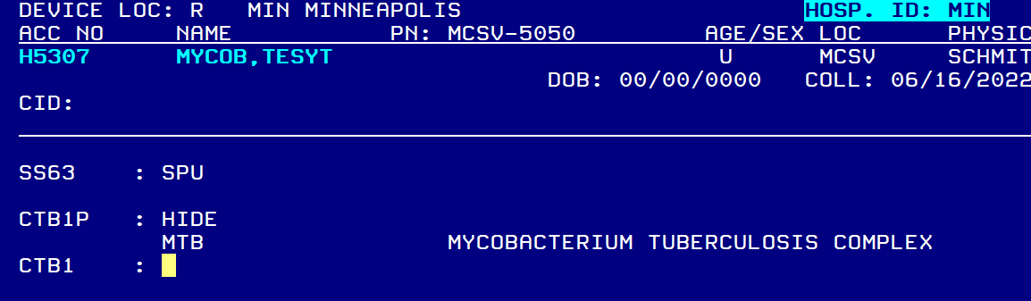  Figure 5: Preliminary result update for AFBB  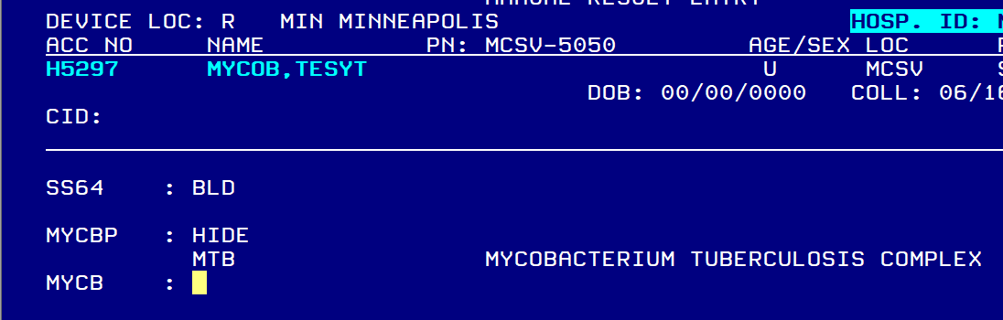Figure 6. Preliminary result update for MYCOB.  - Return past CTB1 or MYCB (leave empty) and accept result. The result is now visible before a phone call is made.  - Return to SmarTerm MEM where an accession number can be entered.  - Enter “M-”and then the patient’s accession number to allow for modification of the preliminary information.  - Return to CTB1P or MYCBP. Call provider with result. Underneath the organism code, add hyphen, CAL, hyphen and semi-colon to free text full documentation of the phone call (name, date, time). Begin with “Called to and read back by” (CAL). Add the comment “Semi Urgent Result” (SURE) after the call information (Figure 7).  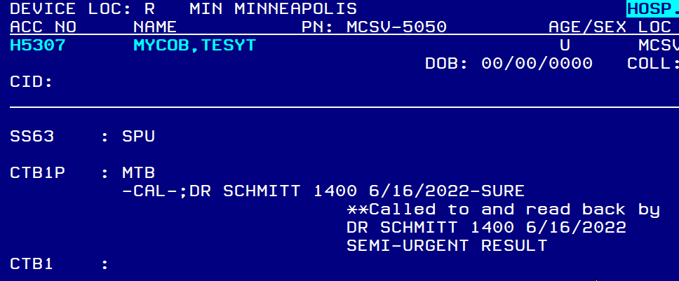  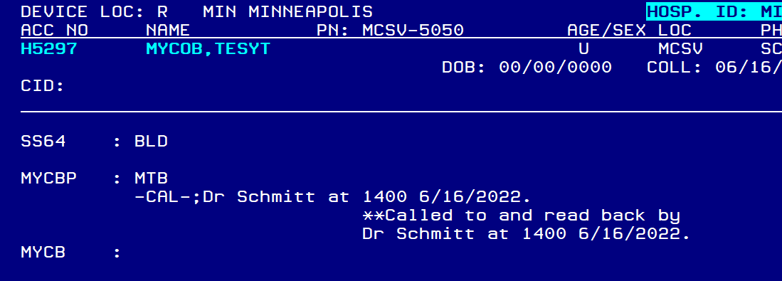  Figure 7. Documentation of result to provider with semi-urgent comment.  - Ask the provider if susceptibilities are desired. If so, refer to the following section of the procedure: Susceptibility Add-On Requests.  - Return past CTB1 or MYCB (leave empty) and accept result.  Susceptibility Add-On Requests  - Open SmarTerm and enter function “MEM”.  - Return past worksheet (leave empty).  - Under the “Test” prompt, enter the appropriate test code (CUTB or MYCOB) and accept.  - Enter “M-”and then the patient’s accession number to allow for modification of the preliminary information.  - Return to CTB1P or MYCBP. Add hyphen and semi-colon to free text “Susceptibilities requested” (Figure 8). If the add-on is being requested at a later time (not during initial phone call of positive result), add the provider’s name, date and time.  Figure 8. Documentation of susceptibility request.  - Enter past CTB1 or MYCB and accept result.  - A test add-on form needs to be completed and submitted to MCL.  - Open up an Internet page and go to the Mayo Clinic Laboratories website (http://www.mayocliniclabs.com/)  - Under the ‘Ordering Search’ tab, select ‘Add Tests to an Order”. It is located in the bottom right corner.  - Fill out all appropriate and required information.  - You will need the account number. Use C7024166 for Minneapolis patients and C7024167 for St Paul patients.  - A confirmation notice from MCL should be requested by phone (612-813-5866).  - Select the box indicating that the susceptibilities will be added to the same order number.  - Add the appropriate Mayo test code(s) for the susceptibility test panel(s) that the provider has requested (if applicable).  - MMLRG- Rapidly Growing Acid-Fast Bacilli  - Antimicrobials tested = Amikacin, cefoxitin, ciprofloxacin, clarithromycin, doxycycline, imipenem, tobramycin, trimethoprim/sulfamethoxazole, linezolid, moxifloxacin, minocycline and Tigecycline.  - MMLSG- Slowly Growing Acid-Fast Bacilli  - Antimicrobials tested depend on the organism that is recovered. Refer to the Mayo Medical Laboratories website for this information.  - TB1LN- Mycobacterium tuberculosis Complex, First Line  - Anti-mycobacterial drugs tested = Isoniazid, rifampin, and ethambutol.  - TBPZA- Susceptibility Mycobacterium tuberculosis Complex, Pyrazinamide -Also order in Sunquest using code TBPZA  - Commonly ordered along with TB1LN (first line agent)  - Check Mayo Medical lab website to ensure test is available (it frequently is unavailable)  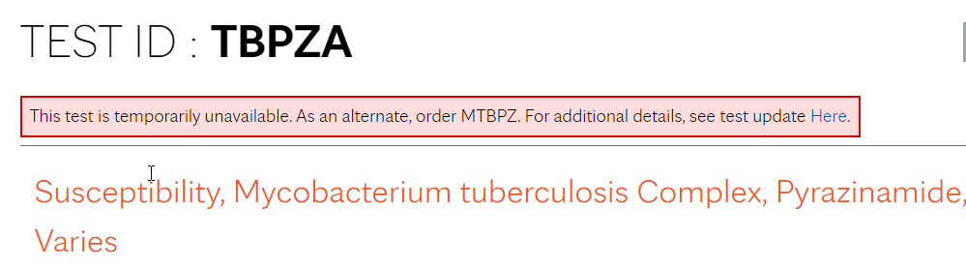  - If TBPZA is unavailable, please order MTBPZ instead.  - The code TBPZA (first choice) and MTBPZ (second choice if TBPZA is unavailable) are orderable in Sunquest. Order separately so it can be resulted when completed.  - TB2LN- Mycobacterium tuberculosis Complex, Second Line  - Antimycobacterial drugs test = Amikacin, cycloserine, ethionamide, kanamycin, moxifloxacin, ofloxacin, p-aminosalicylic acid, rifabutin, and streptomycin.  - If the organism is still unknown and a susceptibility test code cannot be chosen, enter the following message in the ‘Additional Notes’ section: “Please perform appropriate susceptibilities. Contact Children’s Microbiology at 612-813-5866 if susceptibility ordering needs further confirmation.  - In the ‘Additional Notes’ section at the bottom of the form, add the comment “Result the susceptibility directly under the specific susceptibility order code”. Result the TBPZA under the new order. (Figure 9).  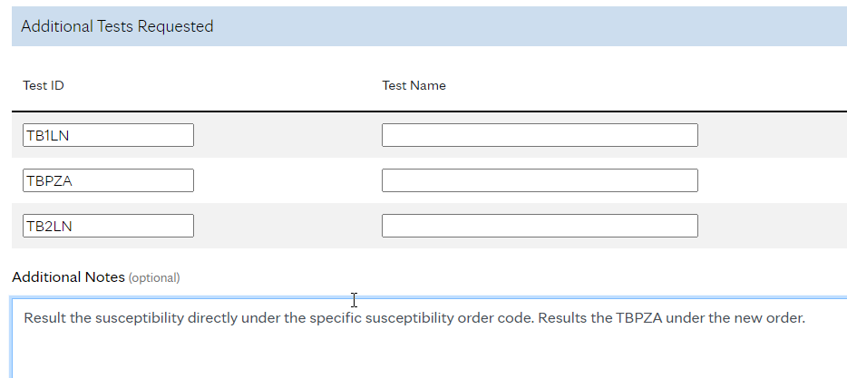  Figure 9. Documentation of MCL test add-on form.  - Submit the form to MCL. Print a copy and hold to confirm that susceptibilities have been added on.  - A confirmatory phone call will be made by MCL indicating that the add-on has been received. Document this call on the copy of the add-on request form that has been printed (MCL representative’s name, date, time).  MayoACCESS Report Retrieval & Updates  - Open MayoACCESS by clicking the shortcut on the desktop or by entering the following web address into an Internet Explorer browser: https://mmlaccess.com/  - Log on using a unique user name and password.  - Username is your email address. Access must be set up with Mayo at https://www.mayocliniclabs.com/. Click Register to register on the mayocliniclab.com website. Notify Children’s Microbiology Supervisor to be granted access to the Children’s accounts.  - Passwords must be at least 6 alphanumeric characters and case specific (no special characters). Passwords must be changed after 180 days.  - Users must log on to MayoACCESS at least once every 60 days to avoid inactivation of an account. A bi-monthly reminder will be sent out to ensure that this is performed.  - Choose the appropriate account number based off which campus the patient is registered under.  - Minneapolis = C7024166  - St. Paul = C7024167  If you wish to change accounts, users are able to change this on the following home screen (Select ‘User’ → ‘Other Sites’ → Choose Appropriate Account # → Click ‘Change’)  - On the home screen, choose the dropdown menu ‘Orders’ and select ‘Order Search’  (Figure 9).  Figure 9. MayoACCESS order search.  - Choose the ‘Search Criteria’ tab.  - To limit the search criteria, utilize the ‘Contains Test’ box. Use code “CTB” for Mycobacterial Cultures or “CTBBL” for Mycobacterial Blood Cultures. Hit enter or choose either of these from the dropdown menu. A date range may be used if desired (Figure 10).  Figure 10. Customized search for Mycobacterial cultures.  - Click the ‘Search’ button.  - All CTB orders will be displayed. Search for the patient name and accession number that matches the positive results from the MCL phone call. Children’s accession numbers can be found under the ‘Order #’ category. Children’s MRN numbers will fall under the ‘ID’ category.  - Once the patient is selected, an updated report needs to be printed and held in the Microbiology Laboratory. Select the dropdown menu next to ‘Report’ and choose ‘Print Report’ (Figure 11). You can also set the ‘Report’ button as a default print option by selecting ‘Toggle Default Action’.  Figure 11. MayoACCESS report view.  - In order to obtain an updated culture result as it becomes available, confirmation of a faxback report needs to be completed under the order number. Select ‘Set Faxback’.  - On the following screen, select ‘New Fax Number’. The fax number for Children’s Laboratory will be automatically added. Select ‘Save Fax Number’. Then, click ‘Close’ (Figure 12).  Figure 12. MayoACCESS faxback.  - Click ‘Refresh Grid’. The patient should now display an icon at the end of the row that shows that a faxback has been requested (Figure 13).  Figure 13. MayoACCESS faxback symbol.  - Obtain the printed report. Document on the report that a “faxback” has been requested. If applicable, attach to susceptibility test add-on form. Hold preliminary results in the “AFB Prelim” folder.  - Once an updated identification has been received, the new information needs to be entered into the preliminary result line.  - Refer back to the Preliminary Result Reporting section and perform steps 1-5.  - Edit the culture information by appending the updated identification at the bottom of the preliminary result (Figure 14). Avoid modification of the original result, as this will call for a corrected report.  Figure 14. Appending an updated identification.  Final Report  - Once the culture is finalized through MCL, results will be dynamically downloaded into Sunquest under the “CTB1” category. This will allow for provider access in Cerner.
Training Plan/ Competency Assessment | Training Plan |  |  | Initial Competency Assessment
 | - Employee must read the procedure.  - Employee will observe trainer performing the procedure.  - Employee will demonstrate the ability to perform procedure, record results and document corrective action after instruction by the trainer. |  |  | - Direct observation.
Historical Record
 | Version | Written/Revised by: | Effective Date: |  | Summary of Revisions
 | 1 | Susan DeMeyere, Andrew Fangel | 10/13/2017 |  | Initial Version
 | 2 | Susan DeMeyere, Andrew Fangel | 12/8/2017 |  | Added how to document positive smear result call comment. Added obtain report from MayoACCESS before resulting in MEM.
 | 3 | Susan DeMeyere | 5/31/2023 |  | Added instructions for when TBPZA testing is unavailable

