Anaerobic Culture

Purpose | This procedure provides instruction for the Anaerobic Culture for the Microbiology laboratory.
Principal and Clinical Significance | Anaerobic bacteria are a significant component of the normal microbiota of the human host. There are anaerobes present on most body surfaces and mucous membranes; they exist in large numbers throughout the entire gastrointestinal tract, from the mouth to the colon, with the exception of the stomach and esophagus; they are found in large numbers in the female genitourinary tract.  Anaerobic bacteria can cause a wide variety of infections, including wound infections as a result of trauma or surgery, abscesses of the liver, brain, lung, and other local sites; appendicitis; peritonitis, chronic otitis media an sinusitis, bacteremia, endocarditis, myonecrosis; gas gangrene; and dental and oral infections. Incidence is reported as 0.5-9%, depending on location, age and demographics of the population.  Proper collection of specimens to avoid contamination with organisms of the normal microbiota and prompt transport to the laboratory for processing are essential.  Interpretation of the culture results should be based on the aerobic culture gram stain and number and type of anaerobes isolated.
Policy Statements | This procedure applies to Microbiologists who perform culture set-up and plate reading.
Test Code | ANAC
Materials
 | Reagents |  | Supplies |  | Equipment |  |  | Media
 | - Gram Stain reagents  - MALDI reagents  - Vitek 2 cards |  | - Glass slide  - MALDI slides  - Palladox catalyst  - Anaerobic Gas Pack  - Anaerobic indicators |  | - Ambient Air Incubator  - Anoxomat  - Anoxomat jars  - Anaerobic GasPak EZ Bag  - Anaerobic Jar/GasPak  - Incinerator  - Inoculating loop  - Microscope  - MALDI  - Vitek 2XL |  |  | Refer to the Sunquest specimen label for media information. The specimen site determines appropriate media. Media code in parentheses.  - CDC Anaerobe Blood agar (ASB2)  - Laked Kanamycin  Vancomycin agar (AKV)  - Phenylethyl Alcohol Agar (PLAA)  - Bacteroides Bile Esculin Agar (BBE)  - Enriched Thioglycolate broth (THIO)  Aerotolerance testing media  - Chocolate (CHOC)  - Anaerobic SB (ASB1 or ASB2)
Specimen | - Acceptable specimens:  - Aspirates or biopsy from deep wound, abscess, lung, bone or joint.  - Suprapubic aspirate.  - Body fluids.  - Preferred swab specimen: Specimens submitted on swabs in Port-A-Cul anaerobic transport media  - Specimens submitted on swabs with the ESwab collection device.  - Refer to Lab Test Directory Anaerobic Culture for collection and transport instructions.  - DO NOT refrigerate specimens.
Special Safety Precautions | Microbiologists are subject to occupational risks associated with specimen handling.  - Biohazard Containment  - Biohazardous Spills  - Safety in the Microbiology Laboratory
Procedure | A. Inoculation  - Allow all media to come to room temperature before inoculation. Use media that has been pre-reduced for 24 hours in the nitrogen holding tank or anaerobic jar.  - Store 3-5 sets of anaerobic media in the nitrogen holding tank or anaerobic jars.  - Label all plates, tubes and slides properly with the patients name, accession number and date. Write tech code on one of the labels.  - Inoculate the media in the order of the least selective first to prevent carryover of inhibitory substances to another medium. Refer to the Sunquest specimen label for the order of inoculation.
B. Specimen processing
- Specimens received on swabs:
- Remove swab from Port-A-Cul tube, using clean gloved hands or using a disposable forceps to reach the swab.
- Using clean gloved hands, roll swab directly onto plates, covering one third of each plate.
- Place swab in Thioglycolate media, breaking off the shaft of the swab under the area that was touched with gloved hands.

- Specimens received on ESwabs
- Vortex ESwab.
- Place 1-2 drops of liquid media directly on each plate and into THIO.

- Aspirates, tissue, bone and fluids:
- If specimen is received in a syringe, transfer the entire amount into a sterile tube and mix thoroughly. Vortex on low speed to limit introduction of oxygen.
- If the specimen is received in a syringe and the volume is small, rinse syringe with a small amount of THIO or sterile saline (SLNE) to remove the specimen from the syringe. Mix well.
- Tissues should be stomached in a stomacher bag with 0.5 ml sterile saline.
- Grind bone with grinder in 0.5 ml sterile saline.
- If specimen is clotted, put clot in stomacher bag and add 0.5ml sterile saline and gently homogenize to disperse clot and release bacteria.
- Place 1-2 drops directly on each plate and into a THIO.

- Streak plates semi-quantitatively for primary isolation.
- Sterilize the inoculating loop in the incinerator for 5 to 10 seconds. Allow loop to cool.
- Pass the loop back and forth through the inoculum in the first quadrant several times, covering approximately 1/4 of the plate.
- Flame the loop, turn the plate a quarter turn and pass the loop through the edge of the first quadrant 4 times while streaking into the second quadrant. Continue streaking in the second quadrant without going back into the first quadrant 3-4 times.
- Flame loop again, turn the plate another quarter of a turn, and pass the loop through the edge of the second quadrant approximately four times while streaking into the third quadrant. Continue streaking in the third quadrant without going back into the second quadrant 4-5 times. See Figure 1 for an illustrative example.


Figure 1. Semi-quantitative plate streaking.

C. Incubation
- Using the Anoxomat instrument, close plates in jar directly after processing, using the Anaerobic setting.
- If Anoxomat jar is not available, place anaerobic plates into GasPak EZ bag or GasPak jar. Each bag can hold up to 4 plates. Open sachet and place in bag and immediately seal bag.
- Incubate all plates in anaerobic jar or bag at 35º C for 48 hours before initial opening and reading. (Anaerobes are most sensitive to oxygen during the log phase of growth.)
- Incubate Thioglycolate broth in ambient air at 35º C with cap tight.

D. Culture examination
- Day 1 from set up
- Check anaerobic jars for new cultures plates to compare to ANAC worksheet. Do not open jars. Note in workup if plates appear to be missing.

- Day 2 from set up.
- Examine anaerobic plates after 48 hours incubation.
- Exposure of media plates to air should be kept to a minimum. Open anaerobic jars when ready to work on anaerobic cultures. Plates can be compared to aerobic culture work that has been completed. Work with a focus on the anaerobes and then close jar, as to not have plates exposed to oxygen all day on the bench.
- Plated media
- Examine culture for and perform identification on:
- Single isolate from any source.
- Predominant pathogens.
- Look for Bacteroides fragilis group and Clostridium perfringens.
- Refer to Method Performance Specifications section for further instructions.
- Examine each plate carefully for different colony types.
- PEA-pick colonies that are different from the colonies isolated in the CDC anaerobe SB agar.
- BBE-pick all the different colonies growing that are >1 mm in diameter. Record the Esculin hydrolysis reaction (black=positive).
- LKV-pick all colony types.
- Note characteristics such as pitting, swarming, hemolysis, pigment and greening of the agar.
- If predominant and well isolated on ASB2 plate, set up definitive biochemical or identification procedures on significant organisms (i.e. VITEK MS, VITEK2) after performing a gram stain.
- If not isolated, select a single colony of each morphology type to subculture for aero tolerance (ATT) and Gram stain.
- Subculture each morphology type to CHOC agar and anaerobic SB (ASB1 or ASB2) and streak for isolation.
- Incubate the CHOC plate at 35°C in a CO2 incubator for 24 hours.
- Incubate anaerobic SB (ASB1 or ASB2) in anaerobic conditions for 24 or 48 hours. Slow growing organisms should be incubated for 48 hours. Ana bags may be used for ASB1 plates.

- Correlate colony types with the direct Gram stain from the aerobic culture.
- Use the initial aerobic Gram stain and culture source to help determine the extent of work-up required on the culture. The presence of many WBC’s indicates an infectious process.
- Re-incubate remaining plates anaerobically.
- Keep all original and subculture plates together, in the same anaerobic jar, unless placing an ASB1 plate into anaerobic GasPak EZ bag.

- THIO broth
- Visually inspect THIO daily until there is growth on plated media. The THIO can be discarded (code TOSS) when growth is observed on plates. Hold THIO if Actinomyces is suspected or other special requests have been made.
- If plates are negative and the THIO is turbid, subculture and Gram stain at 7 days. Subculture aerobically and anaerobically to CHOC, ASB2, LKV, PEA, BBE.
- Perform gram stain and subculture the THIO only if plated media reveals no growth or if the anaerobic jar or bag failed. Never rely on broth exclusively for isolation of anaerobes.

- Day 3 from set up.
- Examine CHOC aerotolerance plate. Growth on CHOC indicates the organism is not an anaerobe.
- Record ATT test as AER for aerobic organism.
- Correlate with corresponding aerobic culture to confirm same growth. No further work is necessary on the isolate.
- If aerobic organism is not present on the aerobic culture and is significant, report the organism. Add code IANAC to state the organism was only isolated from the Anaerobic Culture. Susceptibilities may be performed if warranted.
- If present, examine growth on ASB1 aerotolerance plate. If there is good anaerobic growth, proceed with identification.
- Record ATT test as ANA for anaerobic organism.
- Slow growing organisms should be incubated for 48 hours.

- Day 4 from set up
- Examine growth on ASB2 aerotolerance plate. If there is good anaerobic growth, proceed with identification.
- Record ATT test as ANA for anaerobic organism.
- Continue to monitor growth on anaerobic plates on days 4, 6 and 7.
- Discard any selective agar, such as, LKV, PEA and BBE at 4 days, as these plates lose their selectivity.
- Continue to incubate and examine remaining plates once every 48 hours.
- Examine culture and work up any additional isolates as needed.
- Plates may be held for up to 14 days by special request if Actinomyces species or Cutibacterium species are suspected.
- Save a representative primary plate in an anaerobic bag, whether a complete work-up was performed or not, at room temperature for 7 days in case a physician calls for further studies.

- Additional days
  - Complete identification procedures until all significant isolates are finished.
  - Send updated report and finalize.
Method Performance Specifications | - Perform definitive identifications using the following guidelines.  - Single isolates from any source.  - Predominate pathogen with mixed anaerobes. Perform identification on predominate anaerobic organism. Report others as “MIXED ANAEROBIC FLORA: (MIXA)  - Rule out Bacteroides fragilis group and Clostridium perfringens in a mixed culture with no organisms predominant.  - Cultures with 3 or more anaerobic organisms present can be reported as “MIXED ANAEROBIC FLORA, No further identification” (MIXA).  - The clinical value of reporting the presence of anaerobic bacteria is directly related to the speed of reporting those results. Also, reporting mixed anaerobic flora from sites such as rectal fistula and intra-abdominal abscess, may be of clinical utility, and no further identification is necessary.  - Consult with physician on identification and susceptibility testing. Susceptibilities will be done on physician request only. Organisms will be sent to U of M lab for susceptibility testing. Bill as appropriate according to referral testing.  - CDC Anaerobe Blood agar with 5% sheep blood supplemented with vitamin K and hemin for the isolation of most organisms.  - Phenylethyl alcohol (PEA)-sheep blood for the inhibition of enteric and other facultative anaerobic Gram-negative bacilli that may overgrow the anaerobes. PEA also reduces the spreading or swarming characteristic of some anaerobes.  - Kanamycin-vancomycin-laked blood agar for the selection of pigmented Prevotella and other Bacteroides spp.  - Bacteroides Bile Esculin agar for the selection of Bacteroides fragilis group organism and Bilophila wadsworthia. Fusobacterium mortiferum/varium group organisms may also grow on the media. Bacteroides fragilis group organisms form brown to black colonies. Bilophila wadsworthia produces small, transparent colonies with black dot in the center.  - Bacteroides fragilis group is defined as including:  - Bacteroides fragilis  - Bacteroides distasonis  - Bacteroides thetaiotaomicron  - Bacteroides vulgatus  - Bacteroides ovatus  - Bacteroides eggerrthii  - Bacteroides merdae  - Bacteroides stercoris  - Bacteroides uniformis  - Bacteroides caccae  - Use CHOC only for aerotolerance testing. Haemophilus spp will grow anaerobically on an ASB1 and therefore will be mistaken for anaerobic Gram-negative rods if CHOC is not used. Incubate in CO2 to detect slow-growing aerobic organisms such as Capnocytophaga, Haemophilus, Actinobacillus and Eikenella spp.  - Anaerobic Media Growth  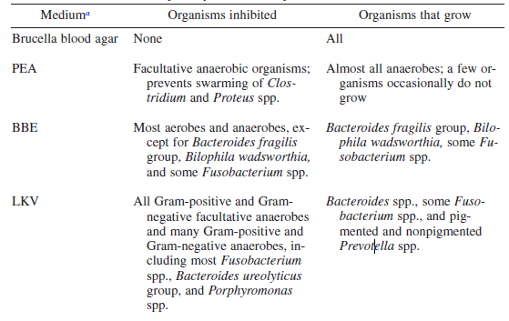  - Anaerobic media and their uses.  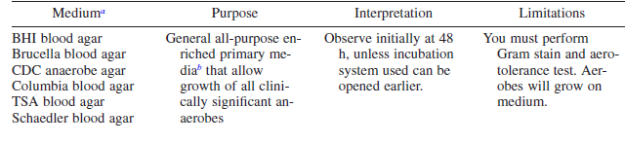  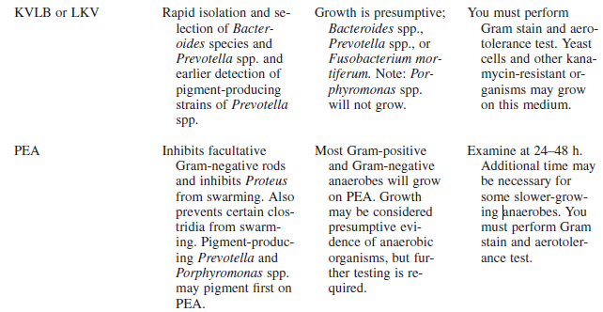  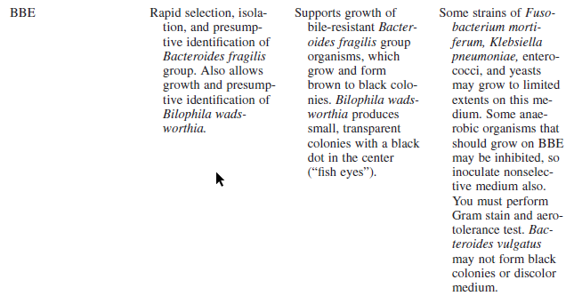  - Anaerobic organism clues from primary culture plates  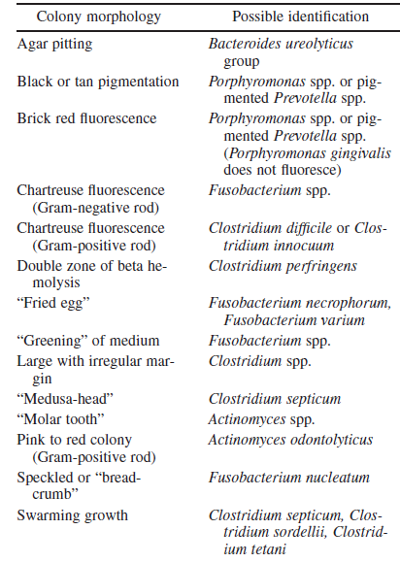
Result Reporting | - Positive Culture results: Record culture results and culture work-ups in Sunquest MRE Culture Entry tab in Observations or Workups by using customized keyboards or by entering a code in the result box.  Observations: 1. 4+ BACTEROIDES FRAGILIS  Workups: Wkup #1 Workup Components  Med :ASB2 GMS :GNR  Desc :GR ATT :ANA  Id :BAFR MSID :1  - Report results semi quantitatively, i.e., 1+, 2+, 3+ or 4+.  Quantity 1st quadrant # colonies 2nd quadrant # colonies 3rd quadrant # colonies  1+ <10  2+ >10 <5  3+ >10 >5 <5  4+ >10 >5 >5  Example: 4+ Bacteroides fragilis  2+ Mixed Anaerobic Flora  - Culture in Progress (CIP) may be used when there is growth and are waiting for the identification.  - Bill appropriately after anaerobic identification is confirmed.  - No growth cultures:  - Use code NATD (No anaerobes isolated to date) starting on day 2.  - Final at 7 days as NOAN (No Anaerobes isolated)  6. If growth is only in the THIO, report as:  Observations: 1. GRAM NEGATIVE RODS ISOLATED FROM BROTH ONLY  Further identification to follow (GNR-BO-FID)  Workups: Wkup # 10 Workup Components  Med : THIO SC : SB MAC  Desc : CLDY GMS : GMNR  ID : GNR  - Add comment code BRPA (Bacteroides species are intrinsically resistant to penicillin and ampicillin) when Bacteroides species is isolated.  - Add comment CSPC (Cutibacterium species is susceptible to penicillin and cefotaxime and most are susceptible to clindamycin) when Cutibacterium species is isolated.  - Review Culture Summary for accuracy before filing report.  - Add appropriate billing for identifications using codes AID1, AID2, AID3, AID4 for anaerobic identification billing.  - If a culture requires a correction, the code CORR (corrected report) must be reported on an observation line in the Direct Exam or Culture Entry tab. Refer to policy MCVI 5.1 LABELING ERRORS/SPECIMEN MIXUP for Sunquest report entry information.  - If additional testing is requested after the culture is finalized, remove the final status and send out a supplementary report. Do this by adding the code SRPT to either the SREQ or Culture Observations along with an explanation, i.e. susceptibilities requested or further identification needed. Re-final the culture once testing is complete, leaving the SRPT code in place.
References | - Leber, Amy, Clinical Microbiology Procedures Handbook, 4th Ed. Vol 1, 2016. American Society for Microbiology, Washington D.C., Sections 4, Anaerobic Bacteriology.
Appendices | Photo images credit to microbe-canvas.com Search bacteria by features (microbe-canvas.com)  1. Fusobacterium nucleatum is part of the normal flora of the mouth and pharynx, upper respiratory tract, sexual organs and GI tract. Colonies can be white, breadcrumb like, large speckled and produce greening of the agar upon exposure to air.  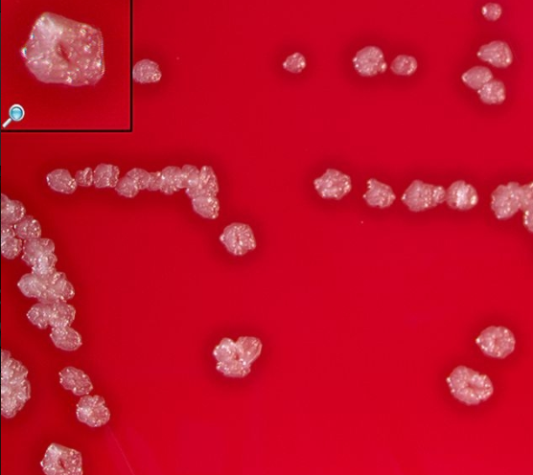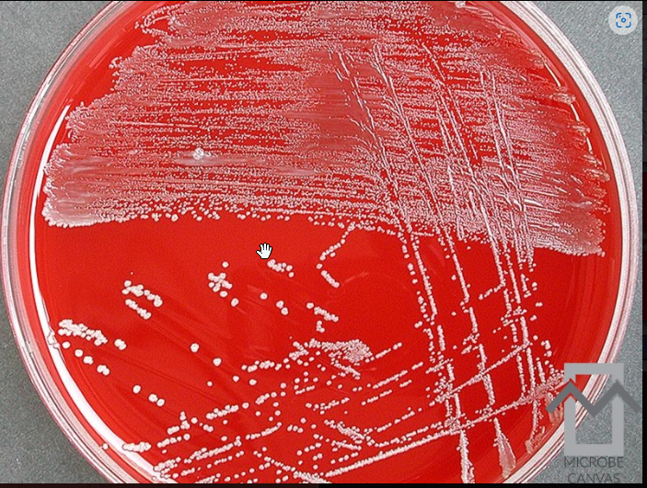  - Fusobacterium necrophorum is mainly isolated from oral cavity and is found in tonsillar abscesses and causes Lemiere’s syndrome. Colonies are grey to yellow, umbonate, often β-hemolytic. They produce greening of the agar upon exposure to air.  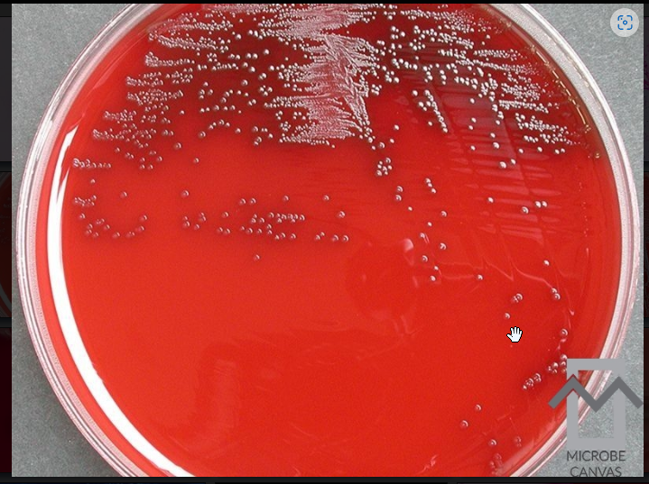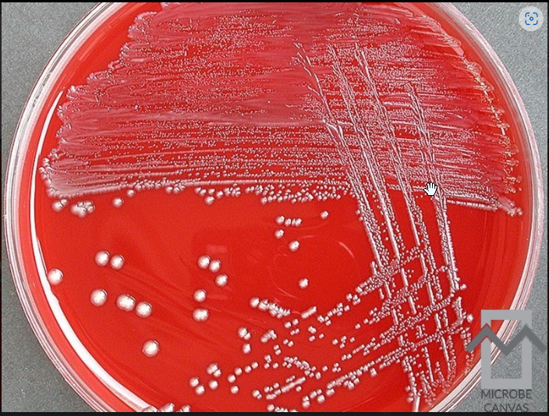  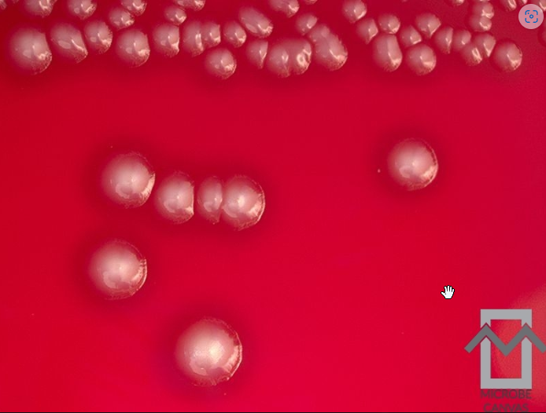  - Bacteroides fragilis inhabit mucosal surfaced of the oral cavity, GI tract and gut. Frequently encountered, it is more virulent and drug resistant than most other anaerobes, therefore it is important to identify. Growth on BBE agar is black.  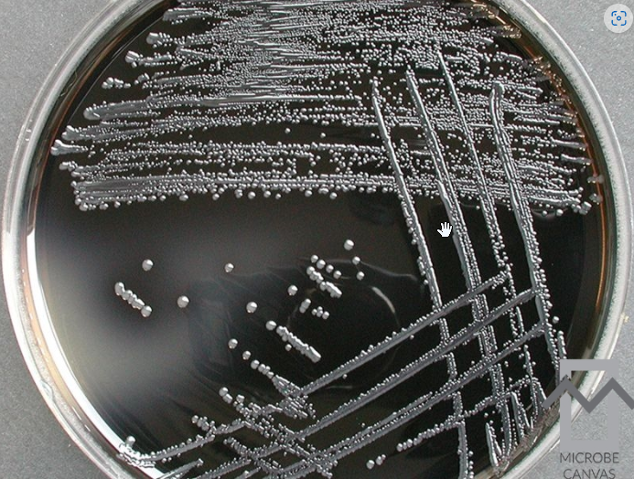  - Clostridium perfringens is widely spread in nature and can be normal flora. It is most commonly isolated in colonic flora (peritonitis, intra-abdominal abscess and soft tissue below the waist) as well as being the cause of gas gangrene. Most strain produce a zone of hemolysis.  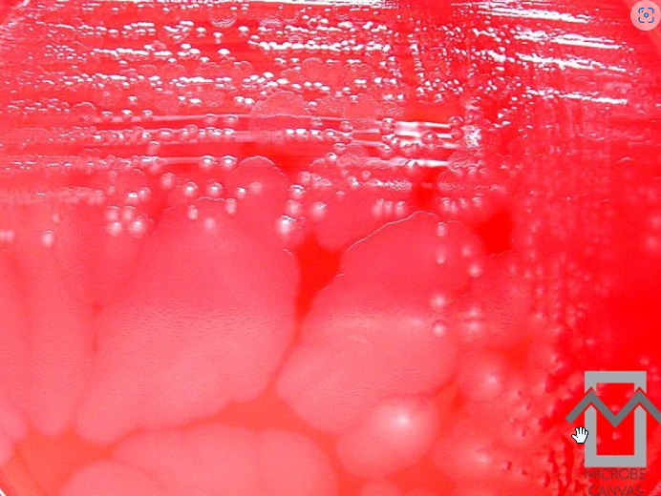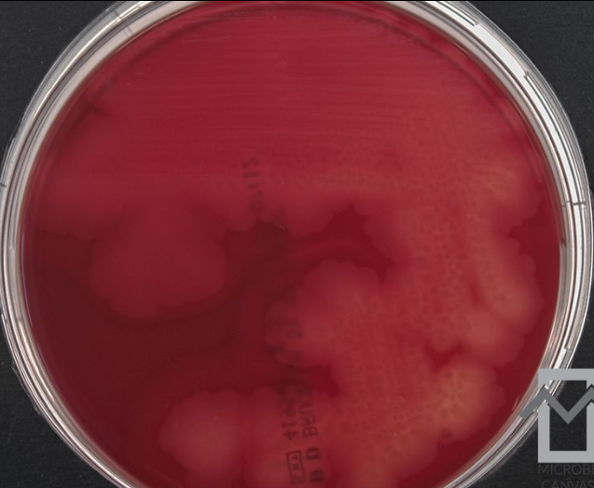  - Actinomyces odontolyticus (Schaalia odontolytica) colonies are small, whitish, smooth to slightly granular.  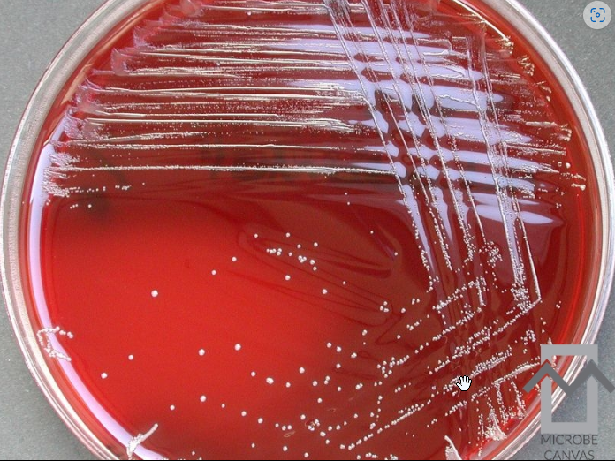
Training Plan/ Competency Assessment | Training Plan |  |  |  |  | Initial Competency Assessment
 | - Employee must read the procedure.  - Employee will observe trainer performing the procedure.  - Employee will demonstrate the ability to perform procedure, record results and document corrective action after instruction by the trainer. |  |  |  |  | - Direct observation.
Historical Record
 | Version | Written/Revised by: |  | Effective Date: |  |  | Summary of Revisions
 | 1 | Susan DeMeyere |  | 1/10/2023 |  |  | Initial Version
 | 2 | Susan DeMeyere |  | 7/5/2023 |  |  | Revised Culture Examination and Method Performance Specifications sections. Removed reporting of aerobic MF. Added media information, pictures and organism information.

