Sunquest Downtime Procedures

Purpose | This procedure provides instructions for SUNQUEST DOWNTIME PROCEDURES.  In the event of a hardware or software failure, there is a manual process for placing lab orders and sending lab results to ordering providers.
Policies | - This procedure applies to all users of the Laboratory Information System, and to systems that send orders to/receive results from the LIS.
Procedure | Follow the activities in the table below for SUNQUEST DOWNTIME PROCEDURES.
 | Step | Action |  |  |  |  |  | Related Documents
 |  | If this is a HIS (Cerner) Downtime only, please skip to section 29.
 |  | Pre-Steps: Scheduled Sunquest Downtime
 | 1 | Month prior to scheduled downtime, Supervisors to schedule extra staff, if necessary.
 | 2 | Weeks prior to a scheduled downtime, LIS will check that there is an adequate supply of pre-printed downtime labels. The labels are stored in the downtime toolkit. ITS will notify nursing units to print downtime forms. Forms can be printed from StarNet. |  |  |  |  |  | Downtime forms
 | 3 | LIS will print a collection list within an hour of scheduled downtime to encompass the entire timeframe of the downtime. These labels can be used to collect and label already ordered testing. |  |  |  |  |  | Collection Batch
 | 4 | LIS will print reports from Sunquest and EMR prior downtime, to confirm no data corruption after downtime. IR and CUM
 | 5 | Ask Sunquest to remove the IX processor from the start up table
 |  | Unscheduled Sunquest Downtime
 | 6 | In the event of an unscheduled downtime, notify the LIS on-call immediately.  - LIS On-Call will call Sunquest Customer Support 1-877-239-6337, then determine if LIS Supervisor, Manager on-call and/or Help Desk also need to be notified.
 | 7 | LIS to ensure Sunquest documents the appropriate LIS contact info for callback. Your name, phone number (best number to communicate) and a description of the problem.
 | 8 | If LIS On-Call cannot resolve issue, LIS will call the Help Desk at x4-5000 (952-992-5000).  The ITS Help desk will notify nursing units to create manual requisitions for orders that will be drawn while the lab system is down. |  |  |  |  |  | Downtime forms
 | 9 | Alert Operations Supervisor and/or Charge Tech that the system is down. Locate the Downtime Toolkit. Downtime Toolkit and be found in the following locations:  - Minneapolis - located on the top shelf across from "clean" lab coat rack  - St. Paul - located in the cabinet above the OPS supervisor desk  - Some lab departments also keep a separate supply of downtime labels  - If you do not know where to find the downtime labels and blank worksheets, contact your department supervisor.
 | 10 | Revert to manual procedures. Lab will receive downtime requisitions, the result will be entered on the requisition and faxed back to the unit.  - Supervisor of Endpoint Services is able to provide current fax list.
 | 11 | Appoint a downtime captain (LIS, Operations Supervisor or Charge Tech). Downtime captain will be the main contact for IT and Sunquest Customer Support.
 | 12 | All specimens coming into the department during the downtime period should be documented on the downtime Specimen Log. Found on StarNet > Lab Test Directory > Downtime Forms (bottom of page)  The downtime log needs only MRN and CID label in order to make sure all samples are accounted for in recovery. The orders that existed prior to the downtime (all orders if unscheduled) will be received based on the requisition.  This log is used as a double check during the recovery phase.  During a scheduled event, extra staff (techs or LIS) will be available to log samples. |  |  |  |  |  | Lab Test Directory – Downtime Specimen Log
 |  | Downtime Process
 | 13 | Nursing units should fill out a manual requisition (downtime order form) in place of entering the orders into the HIS. They should use an ADT label for the patient information. |  |  |  |  |  | Downtime forms
 | 14 | Phlebotomy will collect patient specimens utilizing the manual requisitions and use pre-printed collection labels (if available) or Cerner Patient Labels.  Specimen processing will label specimens with pre-printed collection labels (if available) or downtime labels. Each specimen/tube type must have its own Downtime CID.  Each specimen without a previously assigned accession number must be assigned a downtime CID number. The labels should have the patient name, medical record number, Date/Time and tests requested written below the barcode label. Blood bank samples need either initials or tech code included. Putting the patient location on the labels is optional.  Put the correct collect date and time, tech code, workload code, receive date and time on each manual requisition (downtime order form).
 | 15 | Complete requested testing. Record the results on the requisition and fax it to the appropriate unit. Note the time the result was faxed on the requisition.  Note: All results that are STAT or critical must be called to the requesting unit. You will need to document this so it can be appended to the result when it is entered into the system.  For blood bank-See Transfusion - Downtime section of the procedure manual |  |  |  |  |  | Critical Limits  Tranfusion Services Procedure Manual
 | 16 | Downtime Captain will attempt to give an hourly update for downtime status.
 |  | Post Downtime Validation – LIS Only
 | 17 | System validation, Do not use the system until LIS has given permission.  LIS will start interface 2 (ADT/Orders).  For scheduled downtimes Rhapsody will send in a couple of transactions and notify the LIS that the transactions should be validated. LIS will look at the transactions and make sure they posted properly. At this point, Rhapsody will send in all queued transactions. The Sunquest system will process priority 0 transactions first. Type 0 are ADT transactions and will prevent order transactions from processing before ADT.  After this interface has processed all incoming transactions, the outbound interface can be started.
 | 18 | Interface 22 will be started to send outbound transactions to Rhapsody and Cerner. LIS will validate the first transactions post properly. LIS will watch for SQ created encounters and interface errors.
 | 19 | When the system comes back up notify Helpdesk. They will call each nursing unit to let them know they can start placing computerized orders.
 |  | Post Downtime – System Available to Users
 | 20 | Once the system has been validated, you can have Sunquest enable users. Then the lab can start placing orders.
 | 21 | After all ADT transactions have processed, orders for testing will be placed by LIS/technical lab staff using the requisitions in each department.  For ordering tests after a downtime:  - In Order Entry, enter in specimen collection information and order code. Before clicking save, in the bottom left hand corner check the box for Manually Assign CIDs. Then Click Save.  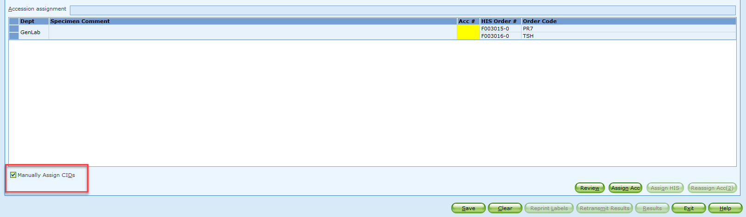  Note: Each different tube type will need its own CID.  - In the Manually Assign Container IDs pop up, confirm tube type in order box. If the tube type is the same for all listed tests, enter in the Downtime CID into the Internal CID box and Click add. Skip the Change Tube Type sub steps.  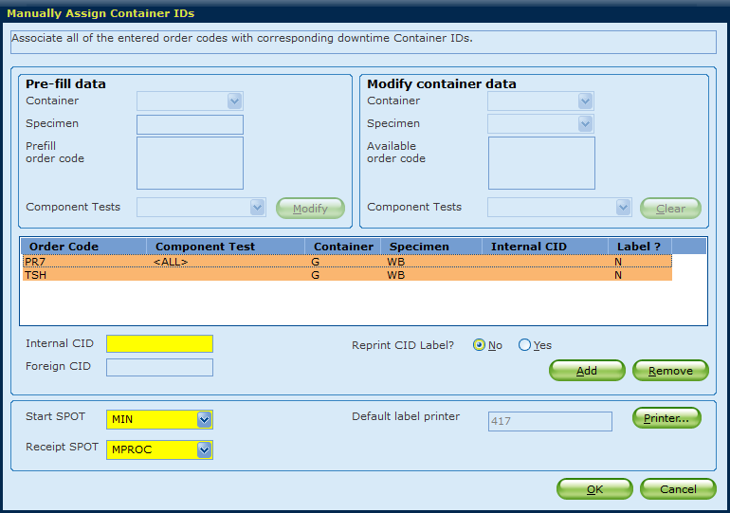  Change Tube Type:  - If tube type is different than default, click remove for the test you want to change, which will remove the information in the order code box.  - In order to change the container type you will need to click the modify button, which opens the Modify Container data box. Note: A pop up message will say the Modify action will clear prefill data. Do you want to continue? Click Yes.  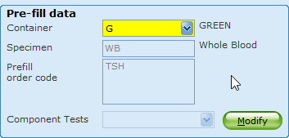  - Choose the container that was received from the drop down menu. If you are not sure of the correct container code for the test, please refer to MIQ for information.  - Enter in the Downtime CID into the Internal CID box, then click Add. Each different specimen/tube type needs its own CID, same tube types will route to a single CID.  - Click OK to finish ordering the test/tests.  - Check Yes for Reprinting CID Labels to relabel the original containers.  - Click Ok to assign the CID to the new accession and print labels.
 | 22 | After all orders are entered, LIS will manually start the IX processor. After the testing has been ordered, it can be resulted through the computer system through any resulting function (OEM, MEM, GUI Result Entry).  Any testing that was done on an online instrument will be queued on the SIM server. When the result processor is restarted, the results will be processed by the system and can be verified in OEM without manually entering each result.  Instruments defined to autofile will autofile all results that meet criteria. This can be done as long as an online file cleanup has not been done since the system went down.
 | 23 | LIS to start other additional interfaces  - CoPath interfaces can both be started watching for errors.  - POCT interfaces can be started. LIS will watch for errors.  - Interfaces 12, 601 and 602 and 603 can be started last.  - Closely monitor the interfaces according to procedure
 | 24 | If there are any unusual errors or you cannot connect any of the interfaces, LIS will call Sunquest support at 1-877-239-6337.Site code: MIN
 | 25 | Each department must call up a pending log to make sure that all testing has been completed. Investigate anything that is still pending for a past time.
 | 26 | LIS will collect all downtime forms. LIS will make sure all orders were placed and will validate orders/results in the EMR
 | 27 | LIS staff will be responsible for calling up an unreceived specimen list and canceling all orders that represent orders that had been placed after the downtime period began, but before the nursing units were notified to discontinue computer system ordering (these will be duplicate orders to those receiving downtime numbers in the lab).  This is why it is important for ITS to notify the nursing units as soon as possible to stop ordering in the system during a downtime period.  Any other specimens still appearing on this list will need to be investigated.
 | 28 | LIS will balance the census with Cerner.  Compare printed reports in LIS pre/post downtime in Sunquest and EMR. IR and CUM?
 | 29 | Communicate the status of the downtime situation to the Operations Supervisor/Charge Tech of the incoming shift (e.g., what time the system went down, and what testing is pending, and if to either continue the downtime or catch up with the backlog of work that was created during the downtime period).
 |  | Cerner Downtime Only (Sunquest Available)
 | 30 | During an unscheduled or scheduled Cerner downtime, manual requisitions will be used from the units. |  |  |  |  |  | DT-Printer List  Downtime forms
 | 31 | Unscheduled or Scheduled downtimes < 4 hours - Enter new orders into Sunquest utilizing priority of "DT" in the modifier box.  Note: Lab results will print to designated printers based on location in Sunquest
 | 32 | Major downtimes > 4hours  LIS staff will schedule results to print to units. Use of priority DT is not necessary
 | 33 | Receive faxes of Downtime Admit, Transfer and Discharge notices from Admitting Department at time of Admit, Transfer or Discharge  Note: Enter updates into Sunquest – not sure regular techs know what to do with these.
 |  | Post – Cerner Downtime
Collect all manual downtime forms for review by LIS staff for data entry.
LIS - Print Cerner Alpha Census and Sunquest Census and balance

Procedure  Notes | - Daylight Savings Fall Scheduled downtime will be communicated the week before. Text code CEN needs to be added to results.
References | - Sunquest Version Manual  - Cerner Downtime Steps StarNet Page
Training Plan/  Competency  Assessment | Downtime Drill
Historical Record | Version |  | Written/Revised by: |  | Date: | Summary of Revisions
 | 1 |  | Paula Mattson |  | 02/15/2010 | Initial Version
 | 2 |  | Roxann Gulke |  | 07/25/2006 | Replaces Downtime Clerical Duties and Downtime
 | 3 |  | Roxann Gulke |  | 12/1/2009 | Replaces Version 2
 | 4 |  | Roxann Gulke |  | 05/01/2013 | Online Version
 | 5 |  | Roxann Gulke |  | 7/14/2019 | Added use of admin tools
 | 6 |  | Joel Anderson |  | 10/13/2023 | Updated due to SMART label change. Added additional clarifying information and steps.

