Accepting Patient Results into Sunquest from the IH-Com Interface

Purpose | This procedure provides instruction for accepting results from the IH-Com interface into Sunquest
Procedure
 | Step | Action
 | 1 | Review patient results in the IH-Com and accept if the results are valid per procedure TS 24.21 Validating and Editing Sample Results in IH-Com (childrenshc.org)
 | 2 | Enter Blood Order Processing by the patient sample CID number (preferred) or Accession number.  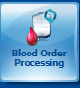
 | 3 | Either click on “Load” to load results into Sunquest or click cancel to not load results.  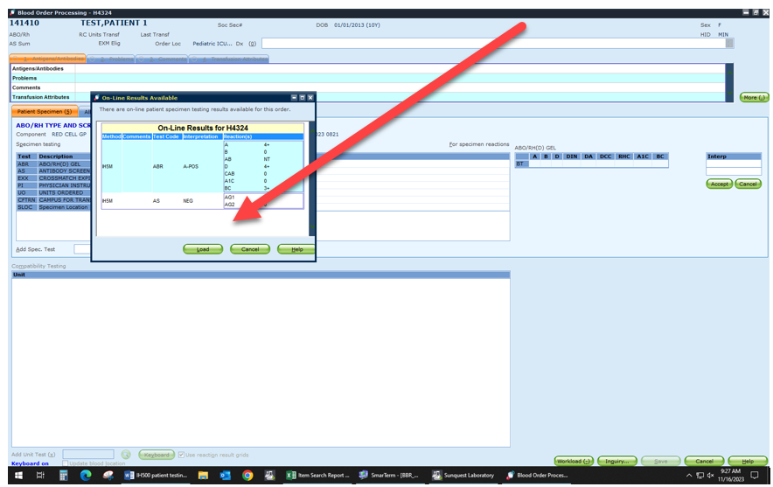
 | 4 | Results will file. If QA failure is generated follow policy and procedures to investigate QA failure.  Note: You are unable to change reaction grids from instrument. However you can change the interpretation of the reactions but this will generate a QA failure that will need a comment of why you are changing the interpretation.  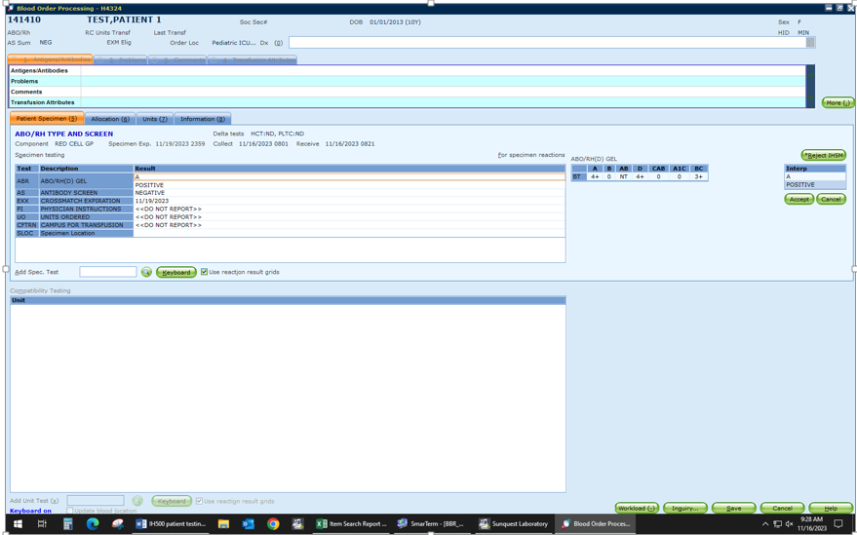
 | 5 | If you need to reject results for the instrument, click “Reject sample” above interpretation grid.  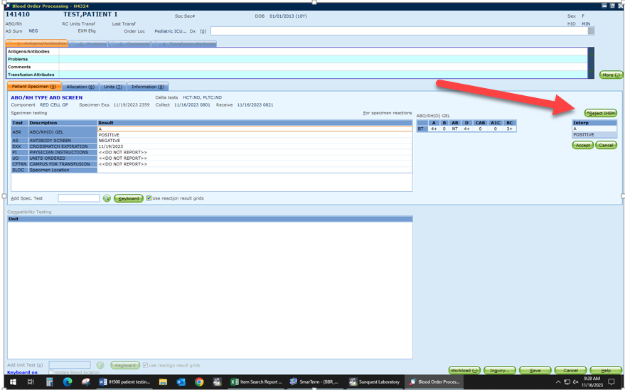
 | 6 | Do an OFC (Online File Clean-up) to clear the interface results if needed.  Method: IH5M (Mpls) and IH24S (STP)
References | Sunquest Users Manual, current edition
Approval  Workflow | Transfusion Service/Laboratory Director
Historical Record | Version |  | Written/Revised by: | Effective Date: | Summary of Revisions
 | 1 |  | S. Cassidy | 12/12/2023 | Initial Version

