Temperature and Humidity Monitoring

Purpose | This policy provides procedures to be followed for temperature and humidity monitoring of laboratory storage devices, equipment, and environments.
Policy Statements | Laboratories must follow manufacturer's instructions for temperature and humidity for proper functioning of instruments, equipment, and test systems.  Temperature-dependent storage devices and temperature-dependent environments where reagents, supplies, and patient specimens are stored within a specified temperature range must be checked daily. Temperature-dependent equipment used for procedures at a specified temperature range must be checked on each day of use. Corrective action must be taken and documented when appropriate.  Thermometric devices must be calibrated. Devices must be recalibrated, recertified, or replaced before the expiration date of the guarantee of calibration.  The Lab is responsible for ensuring all devices are defrosted, as necessary.  Continuous Monitoring  Use of the Children’s MN continuous monitoring system is acceptable. Laboratory personnel have ongoing immediate access to data, so that appropriate corrective action can be taken if readings are out of the acceptable range.  The laboratory has defined ranges and notification procedures are identified for each monitored asset. The laboratories will receive notification of out-of-range alerts per departmental notification trees. BioMed will manage the call tree and will send automatic alerts to the lab.  BioMed is responsible for installation and replacement of electronic temperature monitoring devices and preventative maintenance. Sensor batteries are good for the life of the sensor or will be replaced by BioMed if necessary.  Manual Monitoring  If temperatures are recorded manually, the identity of the individual recording temperatures must be recorded (initials of the individual are adequate).  If manual temperature monitoring is required, an appropriate thermometric standard device of known accuracy (certified to meet NIST Standards or traceable to NIST Standards) is available.  Thermometers should be periodically evaluated for damage. Thermometers with obvious damage must be rechecked for continued use. All non-certified thermometers in use are checked against an appropriate thermometric standard device before initial use.  Settings and Out of Range Limits  Alerts will occur when an asset is out of range for 30 minutes. Back up plans will be implemented if asset is still out of range after 1 hour.
Corrective Action | All staff are responsible for responding to alerts and taking the necessary corrective action when a device is found to be out of range.  - Someone must physically go and look at the alarming asset.  - Make sure the door is tightly closed.  - Is there too much product in the asset? There must be room for air to circulate and for the sensor to work correctly.  - Look for ice buildup in freezers – a defrost may needed.
 | Step | Action
 | 1 | 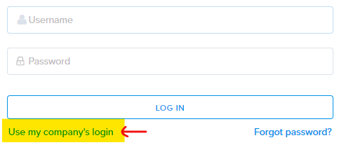  Open Starnet, proceed with the following;  - Single Sign On:  - If on generic log in PC – log into  Outlook first  - Navigate to Smartsense on Starnet, under Applications  - Click on “use my company’s login”  - Enter code “chmn” and Next  - The system may auto-log you in or you will need to sign in with your network log in.  - All employees have access to both campuses. Toggle between campuses by using the drop-down arrow in the upper left corner. 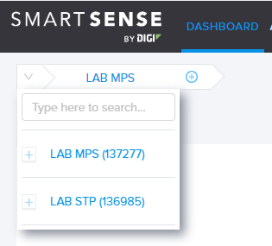
 | 2 | 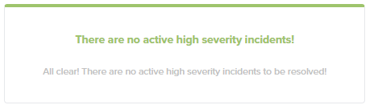  If there are no alerts you will see a green card, indicating that there are “No Active High Severity Incidents.”
 | 3 | Undocumented corrective actions are found at the top of the page. Select the incident to document the corrective action.  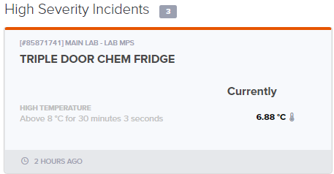  - Click on Corrective Actions – Select from the drop-down list or enter Custom Text and Save.  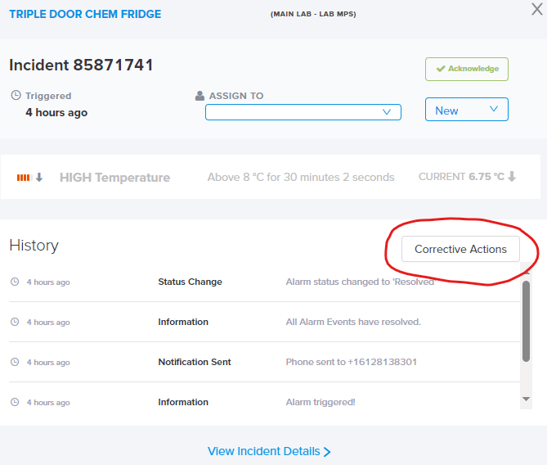  Drop down options are:  - Closed Door  - Stocking Supplies  - No issue found, will monitor  - Supplies moved to back up location, Biomed ticket placed
 | 4 | If the problem is resolved and the asset is back in range, the incident may be closed.  - Click on the Incident, use the blue drop down box, change to Closed  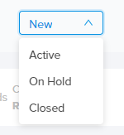  You will be alerted of a new incident if the asset goes out of range again.
 | 5 | If unable to get the asset in range after 1 HOUR or if device is broken:  - Relocate contents to a different location, per the asset back up plan.  - Place a Biomed request – Starnet > Requests  - Place the asset in MAINTENANCE MODE to avoid continual alarms.  Room Temp or Humidity Alerts:  - Place STAT facilities request to investigate – Starnet > Requests  Gateway Alerts:  - Gateways are the white boxes on the ceiling that the sensors send data to.  - Check to see if the gateway has been unplugged.  - Place STAT BioMed request if solution is not found.  - Notify the operations supervisor and/or the department leader so follow up can be completed.
Hibernate (Maintenance Mode) | 1 | The Maintenance mode is not available to all staff. Supervisors, tech specialists, lead techs, and charge techs have access.  Select the asset you wish to silence.  Select the Settings icon, then choose Maintenance Mode.  If you do not see the Settings icon, you do not have access to this area.  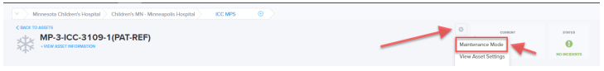
 | 2 | Choose the start date, end date and enter the reason you are changing to Maintenance Mode. NOTE: Choosing NOW will start maintenance mode immediately. Click TURN ON.  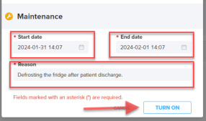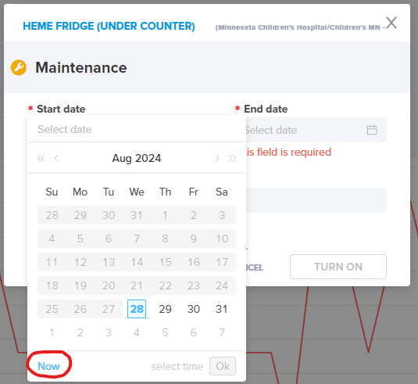
Daily Monitoring | Day shift operations supervisor will complete the once per day review in SmartSense. The task will be completed by a charge tech if operations supervisor is not available.  Any pending incidents must be communicated to the department leader or other available staff to resolve. All incidents must be Closed before completing the daily check off.  To generate a daily check off report:  - On the Dashboard, click on Daily Checklist Results  - Select the Campus  - Select Date Range
 | 1 | Select Dashboard to complete the check off when all incidents have been Closed.  - Click on “COMPLETE” under AM (if after 1200, select PM Checklist)  - Scroll through all assets to bottom of page.  - Check off both Tasks at bottom of page  - Add your digital signature  - Select “COMPLETE”  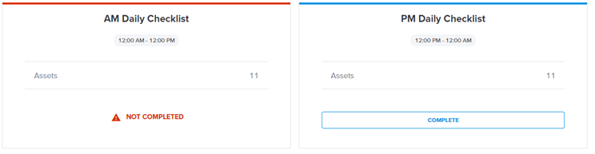  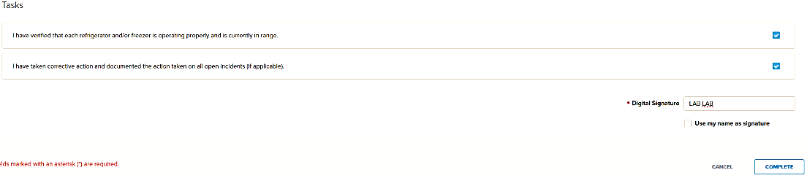
Monthly  Review | All assets must be reviewed at least monthly. If problems are identified, the reviewer must record corrective action.
 | 1 | Choose “Reports” at top of page. Choose “Compliance Report”.
 | 2 |   Click on the funnel/filter icon in the top right corner of the page.  These filter options will pop up on the top of the page.  Click on “asset name” filter – You can choose only the assets you are the owner of. Click Apply.  Click on “Date” filter - choose the date range and click Apply.
 | 3 | To filter the columns included on the report use these filters:  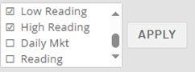
 | 4 | 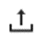  Click on the “upload” symbol on the far-right side of screen to export via CSV or PDF.  Save to desired location.
 | 5 | The report will indicate if there were any incidents in the “new incident” column but does not include details. To review:  - Click on Incidents at the top of the page – Find the incident by looking for the asset name/date/etc.  - Click on the incident to review for correct follow up.
 | 6 | Document review on the report.
NIST Calibration Certificates | 1 | Select the asset of choice.  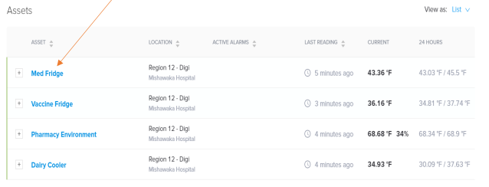
 | 2 | Scroll down until you see the SENSORS section. Select the icon next to the calibration date. A PDF of the calibration certificate will appear.  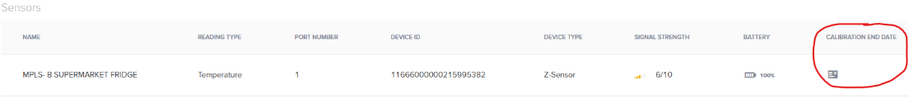

Historical Record | Version | Written/Revised by: | Effective Date: | Summary of Revisions
 | 1 | Al Quigley | 4/1/22 | Initial Version,  Smart Sense application
 | 2 | Danyel Olson  Andrew Fangel  Matthew Johnson | 11/30/24 | Update policy statements  Create a settings, limits, and back up plan document.  Implement single sign on  Add steps to Corrective Actions  Add daily checkoff  Update monthly report steps

