VITEK MS / Maestria Reporting Procedure

Purpose | This procedure provides instructions on how to report the identification of organisms with the Vitek MS.
Vitek MS  FDA  Cleared Organisms V3.3 | Vitek MS IVD is a FDA 510(k) cleared system. The instrument is cleared for identification and release of results for a majority of clinically relevant organisms. Refer to the following lists of organisms that are covered. IMPORTANT: Always review the Vitek MS Reporting Scheme (see below) before reporting claimed organisms.  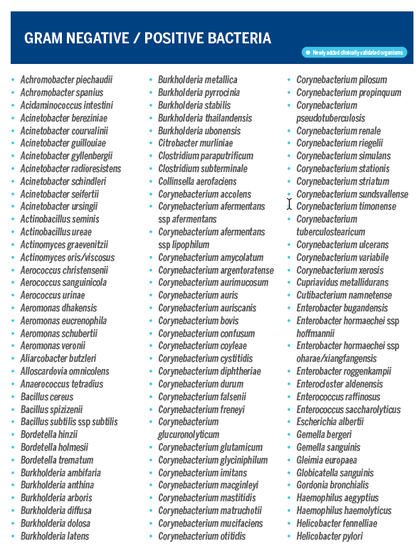  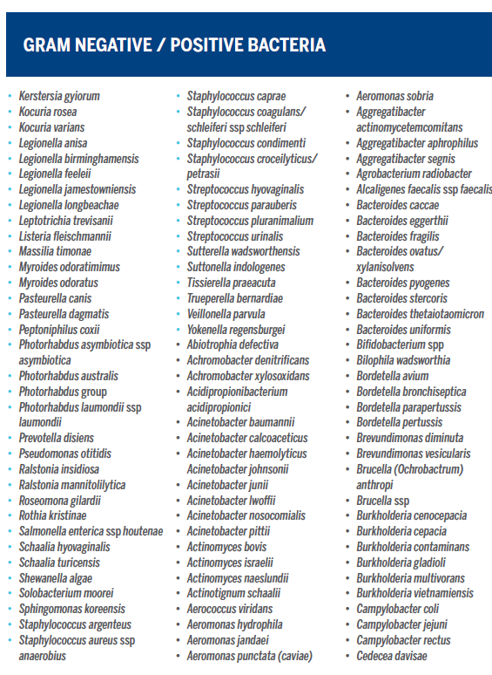  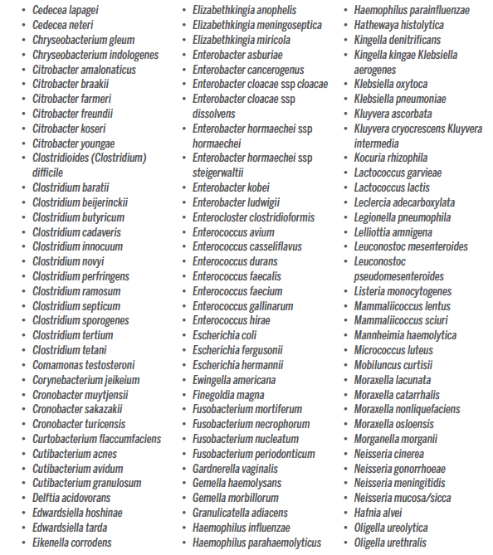  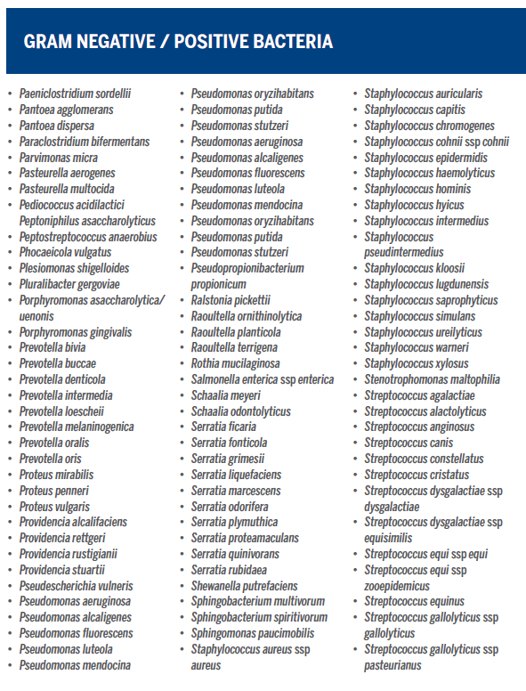  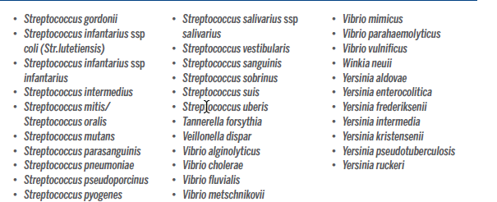  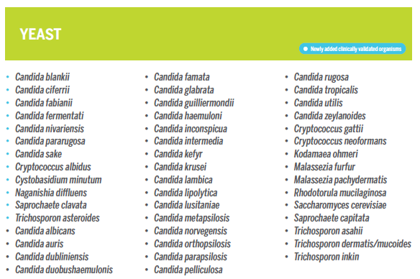
Not Claimed/ Not Validated Organisms | - Do not report results with the unclaimed symbol.  - Identifications for Mycobacteria, Nocardia or Mold were not included in validation of the instrument and are not included in the above list of approved organisms to report.  - If an identification is claimed on the MALDI but not included in the above list, report the organism as ‘most closely resembling’ the MALDI result and send the organism to MDH for confirmation.  - Use Sunquest code MOST after the Gram stain result.  - You will need to manually enter the result into Sunquest as the result will not cross Maestria into Sunquest. A code can be requested from LIS if warranted.  - Reporting example: GPR-MOST-;Mycobacteria smegmatis
Instructions for suspected Bacillus species  Confidence Levels | - Perform a Motility test on any large GPR, that is non-hemolytic and catalase positive before performing MALDI for identification. Do not perform MALDI on motility negative, GPR, non-hemolytic, catalase positive organisms. Send isolate to MDH for identification.  - If MALDI is performed on suspected Bacillus species organisms, Bacillus is not identified, and an unclaimed identification is obtained:  - Report ‘GPR-Most Closely resembling-unclaimed MALDI ID-Previously known as- Bacillus species, not B. anthracis or B. cereus.'  - Example: GPR-MOST-;Priesta megaterium-PVKA-BACAN  - Use code PVKA for ‘Previously known as’  The Vitek MS displays confidence level scores for each organism that is being run. The manufacturer’s suggested cut-off values are as follows:  ***ALWAYS use caution when releasing results. Ensure that plate morphology/gram stain matches the result that is displayed. If this is not the case, complete further confirmatory testing.  Do not report results with the symbol. These are considered not claimed and are not approved for use.
  Confidence Level | Choice | % Probability | Comments
  High: | 1 | 60 to 99.9 | Report to species level.
  Medium:  | 2 to 4 | Sum = 100 | Refer to reporting scheme. If organism not listed, separate by further testing if necessary.
  No ID:  | NA | NA | No significant choice
   | >4 | Sum < 100 | Inconclusive identification
   | Non-clinically Validated Isolate icon – identification does not transfer to the LIS or VITEK 2. Perform an alternate method of identification.
Maestria: Releasing  Vitek  MS Results | - Using a network PC, double click the Maestria icon on the desktop.    *Maestria can also be utilized by launching Internet Explorer and typing the following: https://10.28.17.253/portal/p  - Enter your unique user name, password, and click the login button.  - Click the Vitek MS button (Figure 1).  Figure 1  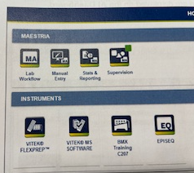  - This will bring you the Vitek MS Software website. IP address is 10.28.17.253.  - Under the Results tab, the “To Review” will display results needing review (Figure 2).  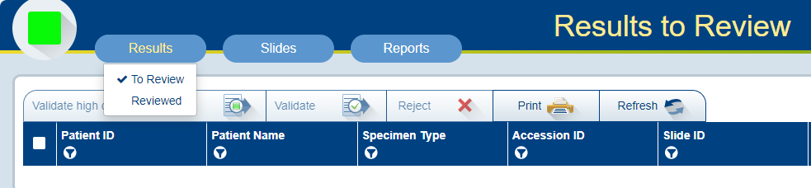  Figure 2  - A confidence level is displayed for each isolate (Figure 3).  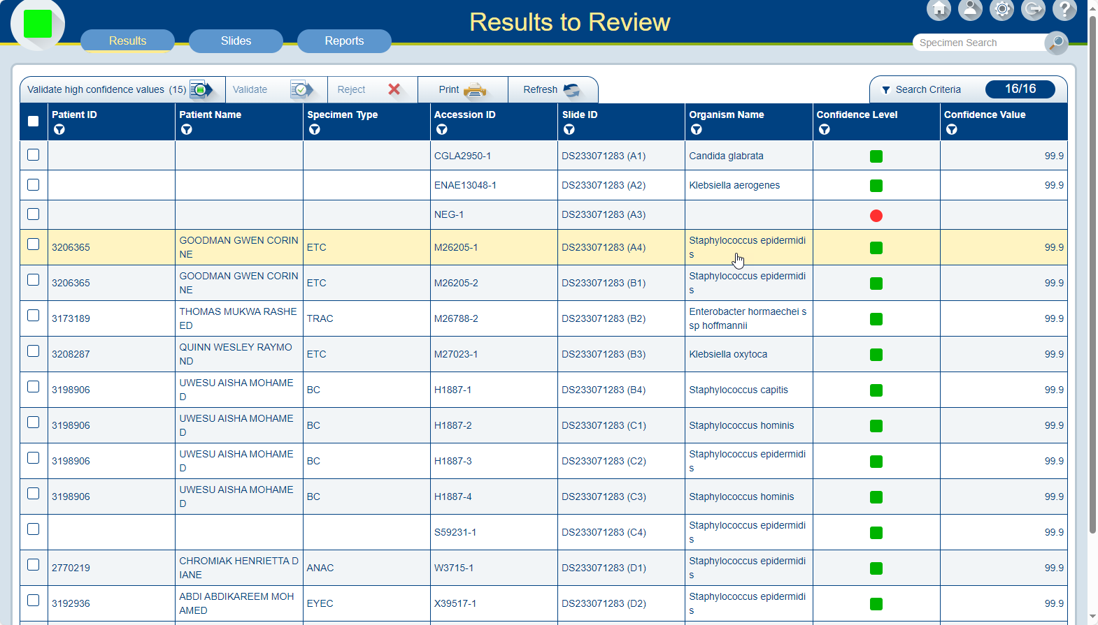  Accession Number  (ID)  Confidence Level  Figure 3  - Select and individually review all High Confidence results with a green box. Click on Validate with green check mark.  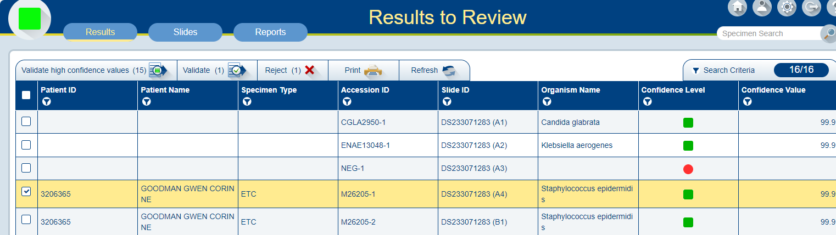Figure 4  - Isolates that are recognized as highly pathogenic or critical will have this icon .  - Reviewed results will be sent through the interface into Sunquest.  - Individually review each Medium Confidence isolate with an orange triangle in the “To Review” tab.  - Click the Accession Number (ID) button to display the Review Detail screen.  - For discrepant isolate results, first reacquire (re-shoot) the spectrum. If this does not help, perform additional testing or retest in a new acquisition group. See step 20 below for instructions on reacquiring the spectrum.  - Click the validate button to accept this result (Figure 5).  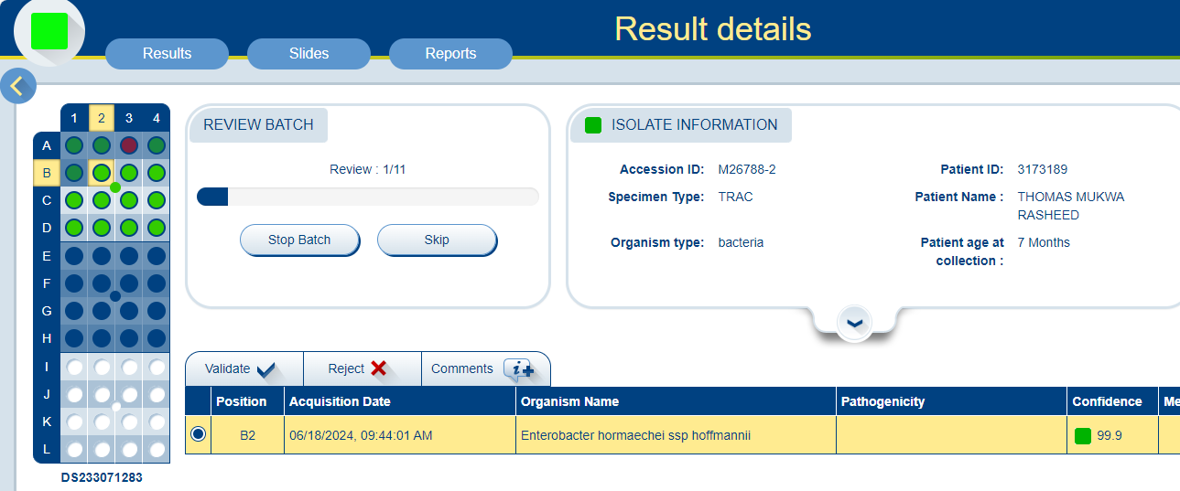  Figure 5.  - Select each isolate that has No ID.  - If necessary, click the Accession ID button to display the Result Detail screen and note the Acquisition/Computation Messages in the last column.  - Discard the isolate by the Reject tab with red X.  - Before an isolate is reviewed, you will the ability to edit the isolate number.  - Select an identification by utilizing the General Reporting Scheme found at the end of this procedure.  - To reacquire spectra (repeat) for isolates that have Low Confidence levels or have no ID, utilize the Acquisition Station. Select the spots that need to be re-shot and click Start. The calibration needs to pass again. Once the organism(s) have been re-shot, repeat steps 4-19 for resulting.
  Additional Icons
   | Print Icon – print a single page report for each isolate.
   | Comment – enter a result comment for an isolate. This can be used to refer to additional testing that has been or needs to be performed.
 | Vitek MS Reporting Scheme
VITEK  MS  Reporting  Scheme
  What to do with Escherichia coli on VITEK MS
  Source | Additional Testing | Reporting Instructions
  ALL sources (except stool)  If MSID = Escherichia coli | Lactose Fermenter | Escherichia coli
  ALL sources (except stool)  If MSID = Escherichia coli | β- hemolysis on SB agar | Escherichia coli
  ALL sources (except stool)  If MSID = Escherichia coli | Non-Lactose Fermenter & non-hemolytic on SB agar:  Indole (+) or Indole (neg) | Run GN ID card on VITEK 2 for identification
  Stool  If MSID = Escherichia coli | Then do:  MILS & SB subculture | For the following combinations, report NSSY:  *MOT (+) IND (+) LYS (P/P)  *MOT (+) IND (+) LYS (P/Y)  *MOT (neg) IND (+) LYS (P/P)  *MOT (+) IND (neg) LYS (P/P)  *MOT (+) IND (neg) LYS (P/Y)  *MOT (neg) IND (neg) LYS (P/P)  For the following combinations, run a GN ID on VITEK 2 for identification:  *MOT (neg) IND (neg) LYS (P/Y)  *MOT (neg) IND (+) LYS (P/Y)
  - Frequently seen organisms in the laboratory with a probability score at >60% may be released as long as colonial morphology and/or gram stain morphology matches.
  - Uncommon organisms in the laboratory should be reported as presumptive or by genus only until further testing can confirm the result. This includes FDA cleared organisms that are not identified to species level for which there are no reporting rules in place.
  - Use the following table to help determine the correct code to report for organisms included in a ‘Complex’. Examples include some species of
  - Acinetobacter
  - Aeromonas
  - Burkholderia
  - Citrobacter
  - Candida
  - Enterobacter
  - When reporting an organism ‘complex’, ensure the organism is included in the ‘complex’.
  - Example: there are Citrobacter species not included in the Citrobacter freundii complex.
  - Report the appropriate complex with identifications from the Vitek MS and Vitek 2XL (ID cards).
  Vitek MS Identification | Alternate Reporting Instructions | Sunquest Code | Claimed ID versus complex
  Achromobacter denitrificans  Achromobacter xylosoxidans  (50.0 confidence / 50.0 confidence) | Achromobacter denitrificans/Achromobacter xylosoxidans | ACHDX | Can report individual organism with High Confidence (60%)
  Acinetobacter baumannii  Acinetobacter calcoaceticus  Acinetobacter nosocomialis  Acinetobacter pittii  (can be slashline between species) | Acinetobacter baumannii complex | ABAUC | Always report as ABAUC
  Aeromonas hydrophila/caviae  Aeromonas sobria  Aeromonas jandaei  (can be slashline between species) | Aeromonas species | AERO | Always report AERO
  Bacillus cereus | Bacillus cereus | BACE
  Unclaimed Bacillus result- GPR, morph consistent with Bacillus, BH or NH, motility positive | Bacillus, not anthracis | BNA
  GPR, morph consistent with Bacillus, non-hemolytic, motility negative | Send to MDH to rule out anthracis | If anthracis ruled out, report BNA
  Burkholderia cenocepacia  Burkholderia cepacia  Burkholderia contaminans  Burkholderia multivorans  Burkholderia vietnamiensis  (can be slashline between species) | Burkholderia cepacia complex | BCEP | Always report as BCEP
  Candida metapsilosis  Candida orthopsilosis  Candida parapsilosis | Candida parapsilosis complex | CPARC | Always report CPARC
  Citrobacter braakii  Citrobacter freundii  Citrobacter gilleni  Citrobacter sedlaki  Citrobacter youngae  Citrobacter werkmanii  (can be slashline between species) | Citrobacter freundii complex | CIFC | Always report as CIFC
  Brucella sp. | DO NOT test or report by VITEK MS.  Perform rule-out testing under the hood. Tape plates.
  Enterobacter asburiae  Enterobacter cloacae  Enterobacter hormaechei  Enterobacter kobei  Enterbacter ludwigii  (can be slashline between species) | Enterobacter cloacae complex | ENCLC | Always report at ENCLC
  Francisella sp. | DO NOT test or report by VITEK MS.  Perform rule-out testing under the hood. Tape plates.
  Klebsiella variicola  (not claimed) | Klebsiella pneumoniae/variicola  (with BCID results of KLPNG)  Klebsiella species most closing resembling K. variicola  (with unclaimed MALDI result) | KLPV  --add comment KPAV when KLPNG was previously reported from the BCID  KLEB-MOST-KVAR
  Vitek MS Identification | Alternate Reporting Instructions | Sunquest Code | Claimed ID versus complex
  Nesseria cinerea  Nesseria mucosa/sicca | Perform gram stain & oxidase, then report as: Neisseria sp. | NEIS | Can report individual organism with High Confidence (60%)
  Proteus penneri  Proteus vulgaris  (can be slashline between species) | Proteus penneri/Proteus vulgaris | PRVP | Can report individual organism with High Confidence (60%)
  Raoultella ornithinolytica  Raoultella planticola  Raoutella terrigena  (can be slashline between species) | Raoultella species | RAOSP | Always report RAOSP
  Salmonella group | Salmonella species | SALM
  Staphylococcus auricularis  Staphylococcus capitis  Staphylococcus cohinii  Staphylococcus epidermidis  Staphylococcus haemolyticus  Staphylococcus hominis  Staphylococcus schleiferi  Staphylococcus sciuri  Staphylococcus simulans  Staphylococcus warneri | Report from the following sources:  UC, Blood, CSF, RESP, Misc. (DSK1), Sterile body fluids, and surgical tissue specimens.  Include comment TCINS: (“This is a coagulase negative Staphylococcus.”)  Not every species is listed. There are over 50 species listed as coagulase negative Staphylococcus.
  Staphylococcus lugdunensis  Staphylococcus saprophyticus | Report with all sources. DO NOT include comment TCINS. | SLUG  SSAP
  Streptococcus mitis  Streptococcus sanguinis  Streptococcus parasanguinis  Streptococcus gordonii  Streptococcus cristatus  Streptococcus oralis | Streptococcus mitis group | SMITG  (use with slash line results) | Can report individual organism with High Confidence (60%)
  Streptococcus mutans  Streptococcus sobrinus | Streptococcus mutans group | SMUTG  (use with slash line results) | Can report individual organism with High Confidence (60%)
  Streptococcus salivarius  Streptococcus vestibularis | Streptococcus salivarius group | SSALG  (use with slash line results) | Can report individual organism with High Confidence (60%)
  Streptococcus bovis  Streptococcus equinis  Streptococcus gallolyticus  Streptococcus infantarius  Streptococcus alactolyticus | Streptococcus bovis group | SBOVG  (use with slash line results) | Can report individual organism with High Confidence (60%)
  Streptococcus anginosus  Streptococcus constellatus  Streptococcus intermedius | Streptococcus anginosus group  Report species in sterile body sites | SANGG  (use with slash line results) | Can report individual organism with High Confidence (60%)
  Veillonella dispar | Veillonella species | VEIL
  Yersinia pestis  Yersinia pseudotuberculosis | DO NOT test or report by VITEK MS.  Perform rule-out testing under the hood. Tape plates.  *Yersinia pseudotuberculosis is similar in spectra to Yersinia pestis.
Unclaimed Validated Results | Unclaimed MALDI results may go through a validation process to obtain approval to be reported without further testing. Submit requests of selected organisms to the Technical Specialist and Medical Director. The list of unclaimed, validated organisms approved for reporting are:  - Dolosigranulum pigrum  - Paenibacillus species  Organism validated that are now claimed on version 3.3.  - Aerococcus urinae  - Acinetobacter ursingii  - Bacillus cereus  - Pasteurella canis  - Corynebacterium otitidis (Turicella)
Trust but Verify Plan | A Trust by Verify Plan was put into place after the validation in 2016 to confirm organisms that were not included in the validation. All organisms encountered in this laboratory were tested by another method and have been confirmed. The Trust But Verify plan was retired in December 2022.  If organisms are identified that you are unfamiliar with or sounds weird, consult with the Technical Specialist or Medical Director. Most closely resembling (MOST) may be used if Gram stain and colony morphology matches. List the organisms resulted as MOST on the Trust but Verify Spreadsheet under the Most Closely Resembling Tab. These will be reviewed by the Medical Director if encountered frequently.
References | Maestria Customer Training Course manual, 2024.  VITEK MS Clinical Workflow User Manual,  VITEK MS Customer Training Course manual, 2016.  VITEK MS “The Basics” manual, 2014.  - Employee must read the procedure and training documentation.  - Employee will observe trainer performing the procedure.  - Employee will demonstrate the ability to perform procedure, record results and document corrective action after instruction by the trainer.
Training Plan/ Competency Assessment

Historical Record | Version | Written/Revised by: | Effective Date: | Summary of Revisions
Historical Record | 1 | Andrew Fangel/  Dr. Phillip Heaton | 10/07/16 | Initial Version
Historical Record | 2 | Andrew Fangel/ Susan DeMeyere | 4/20/2018 | Added caution message to Confidence Level section.  Updated General Reporting Scheme instructions.
Historical Record | 3 | Susan DeMeyere | 12/1/2022 | Added unclaimed organisms approved to report after validation. Removed Trust but Verify plan to report claimed organisms. Added instructions for Mycobacteria, Nocardia or Mold results.
Historical Record | 4 | Susan DeMeyere | 3/3/2023 | Added Burkholderia multivorans to cepacia complex.
Historical Record | 5 | Susan DeMeyere | 12/12/2023 | Added code KLPV for when K. variicola is identified and add comment KPAV after BCID KLPNG
Historical Record | 6 | Susan DeMeyere | 2/27/2026 | Add section for suspected Bacillus species.

