Objectives – 1

Pages 627-630, 634-635

At the end of lecture 1, the student should be able to:

1. Define the following:
   1. Hemostasis
   2. Coagulation
   3. Vasoconstriction
   4. Primary Hemostasis
   5. Hemorrhage
2. Identify and discuss the 4 phases of hemostasis.
3. Identify the vessel types that comprise the vascular system and compare and contrast their similarities and differences.
4. List and explain 3 functions of the vascular system.
5. List the two primary anatomical areas affected by vascular disorders.
6. Define/describe the 2 most common clinical findings in vascular disorders.

Lecture 1 Outline

1. Hemostasis Overview
   1. General
      1. Define Coagulation:
      2. Define Hemostasis:
   2. Phases of Hemostasis—4 Major
      1. Vasoconstriction:
      2. Platelet plug:
      3. Fibrin formation:
      4. Fibrinolysis and vessel repair:
   3. Stages of Hemostasis
      1. Primary hemostasis:
      2. Secondary hemostasis:

Response time

* + - * vasoconstriction- immediate
      * adhesion- 1-2 seconds
      * aggregation- 10-20 seconds
      * plug formation- 1-3 minutes
      * fibrin formation- 3-5 minutes
      * fibrin stabilization- 5-10 minutes

1. Vascular System
   1. General
      1. Capillaries:
      2. Venules:
      3. Veins:
      4. Arteries:
      5. Arterioles:
   2. Functions of the Vascular System (as related to hemostasis)
      1. Normally has anticoagulant properties
         * Smooth so that blood can flow right through
         * Act as a barrier to the subendothelium collagen
         * Secrete a substance called prostacyclin (potent inhibitor of agulance)
      2. Has procoagulant properties when damaged
         * Secretes a substance called Plasminogen Activator Inhibitor-1 (PAI-1)- regulates Tissue Plasminogen Activator (TPA) so that breakdown of clot is appropriate
         * Collagen🡪vWF🡪Platelet Plug
         * Secretes Tissue Factor (TF)
      3. Helps with fibrinolysis
         * How?
   3. Vascular Disorders/Vessel Problems
      1. Petechiae:
      2. Purpura:
      3. Hemorrhage:
   4. Vessel Structure

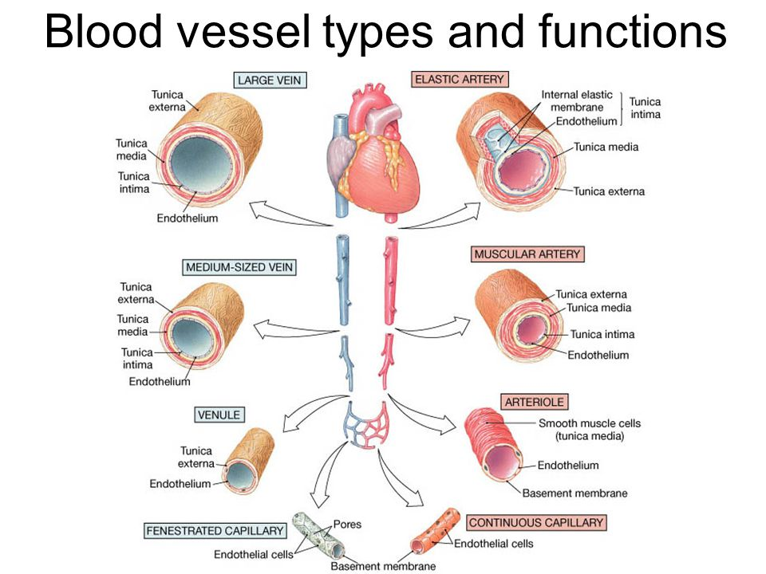

Tunica Intima:

Tunica Media:

Tunica Adventitia: