At the end of this unit of study, the student should be able to:

Objectives—Level I
1. Define hemostasis and identify the three physiologic compartments involved in the
hemostatic mechanism.
2. Differentiate primary and secondary hemostasis.
3. List the coagulation factors using roman numerals and determine how each factor is
evaluated in lab testing.
4. Classify the coagulation factors in groups and discuss their characteristics.
5. Evaluate the importance of vitamin K in hemostasis.
6. Describe the mechanism of action of the coagulation proteins.
7. Diagram the sequence of reactions in the coagulation cascade according to the historic concepts of intrinsic, extrinsic, and common pathways.
8. Identify the factors involved in contact activation.
9. Diagram the physiologic pathway of blood coagulation.
10. Define fibrinolysis, identify the major components of the fibrinolytic system, and explain
why fibrinolysis is a necessary component of hemostasis.
11. List the fragments resulting from fibrinolytic degradation; compare and contrast the fragments resulting from the degradation of fibrinogen and fibrin.
12. List the major biochemical inhibitors that regulate secondary hemostasis.

Objectives—Level II
1. Explain the interactions of the three physiologic compartments involved in hemostasis.
2. Describe the domain structure of the coagulation factors, determine how this structure affects the action of the serine proteases, and explain the significance of the non-catalytic regions.
3. Summarize the formation of complexes on a phospholipid surface and explain the significance of these complexes to hemostasis.
4. Integrate the role of contact factors with other systems (complement activation, fibrinolysis, inflammation).
5. Describe the multiple roles of thrombin in hemostasis.
6. Explain the physiologic functions of ADAMTS-13, A2, LRP, EPCR, and uPAR.
7. Compare and contrast physiologic and systemic fibrinolysis.
8. Describe the physiologic controls of hemostasis including blood flow, feedback inhibition, liver clearance, and inhibitors (antithrombin, TFPI, protein C, protein S,
and TAFI)
9. Evaluate a case study from a patient with a defect in hemostasis and, using the medical history and laboratory results, determine the diagnosis.

Beyond the Book

- Fibrin Formation – the system in which a series of plasma coagulation factors interact to form a clot.
  - General information:
**Secondary hemostasis is the process of fibrin formation occurs only at the site of vessel injury plasma proteins circulate in an inactive form.

- Nomenclature – grouping by size, characteristics, processes
  - General
    - Originally 13 factors
    - Named in order of discovery
    - Half-life can be affected by drugs etc.
  - Table
Roman Numeral | Name | Half-life | Additional Comments
Factor I
Factor II
Factor III |  | N/A
Factor IV |  | N/A
Factor V
Factor VI |  | N/A
Factor VII
Factor VIII
Factor IX
Factor X
Factor XI
Factor XII
Factor XIII
Fitzgerald Factor
Fletcher Factor

- Physical Properties
  - Fibrinogen group
    - Low or high molecular weight proteins? ____________________
    - Factors involved: _______________________
    - Used in clotting? Yes or No
    - Absorbed by Barium Sulfate (BaSO4)? Yes or No
    - Activated by thrombin? Yes or No
    - Vitamin K dependent? Yes or No
    - Additional information:
      - Factors lose their activity during storage
      - Concentration of these factors are increased by inflammation, pregnancy, or birth control.
  - Prothrombin group
    - Low or high molecular weight proteins? ____________________
    - Factors involved: _______________________
    - Used in clotting? Yes or No
    - Absorbed by Barium Sulfate (BaSO4)? Yes or No
    - Activated by thrombin? Yes or No
    - Vitamin K dependent? Yes or No
      - Vitamin K must be absorbed from the digestive tract (get by eating or by manufactured in GI tract by bacteria) – in cabbage, cauliflower, soybeans, spinach, green leafy vegetables.
      - If no vitamin K, or blocked, won’t synthesize these factors properly
      - Drug Coumadin (also known as Warfarin) – when given, hinders vitamin K; therefore prevents from being formed properly
      - Mechanism
        - Vitamin K necessary for the gamma carboxylation of glutamic acid
        - This results in the formation of a unique amino acid called gamma carboxyglutamic acid
        - This is necessary for both Ca++ binding and attraction of these factors to surface of activated platelets, which is where fibrin clot formation occurs
        - Without vitamin K, lack necessary binding sites for Ca++; factors defective and can’t be activated to cause clotting to occur
    - Additional information:
      - Individuals with qualitative disorders will produce these factors, but will not function right w/o vitamin K.

  - Contact group
    - Low or high molecular weight proteins? ____________________
    - Factors involved: _______________________
    - Used in clotting? Yes or No
    - Absorbed by Barium Sulfate (BaSO4)? Yes or No
    - Activated by thrombin? Yes or No
    - Vitamin K dependent? Yes or No
    - Additional information:
      - Factors in this group are very stable.
      - The only time there is a problem is with contact group, means there is a congenital deficiency.

- Cascade
  - General information – Need 3 things to form fibrin clot
    - Plasma proteins
    - Calcium
    - Phospholipids – comes from PF3 (Platelet Factor 3)
**Two pathways to activate cascade In Vitro
- Intrinsic system
- Extrinsic system
  - Intrinsic system
    - XII (activated by collagen) XIIa (involves other contract factors)
    - XIIa acts on XI Xia
    - Xia (with Ca++) acts on IX IXa
    - IXa + VIII + Ca++ & PF3 (called tenase complex)
    - X Xa
    - Xa + V + Ca++ & PF3 (prothrombinase complex)
    - Prothrombin Thrombin
    - Fibrinogen Fibrin (soluble fibrin monomer)
    - Thrombin also activates XIII XIIIa, which stabilizes fibrin clot
    - Thrombin also feeds back to further activate V, VIII, and platelet plug formation by promoting platelet aggregation
    - All required phospholipid in intrinsic system provided by PF3

  - Extrinsic system
    - VII = presence of III
    - VIIa
    - X Xa

  - In Vivo Formation
    - At the site of vessel damage, VII exposed to TF; with Ca++ plus PF3 VIIa/TF
    - VIIa/TF complex causes X Xa
    - Xa + V + Ca++ & PF3 convert prothrombin thrombin
    - TF/VIIa also activates IX IXa
    - Some of Xa formed complexes with circulating TFPI (Tissue Factor Pathway Inhibitor) to bind to and inactivate the TF/VIIa, making it inactive

    - Thrombin which has formed does several things:
      - Fibrinogen fibrin
      - Activates V and VIII so they may function in activating complexes with their respective enzymes, Xa and IXa
      - Also activates XI XIa, to continue generating IXa, since TF/VIIa now inhibited
      - Also remember, activates platelets
      - Has major inhibitory role – will see with naturally occurring anticoagulants
    - This theory says if you are deficient in XII, you won’t bleed.

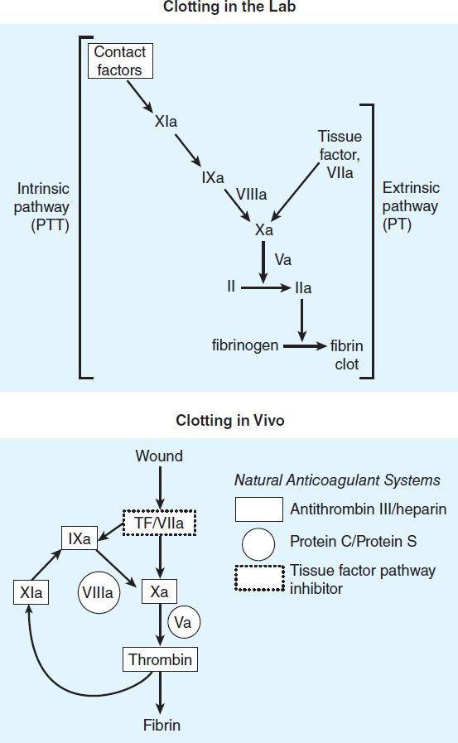

  - Additional Considerations – snake venom activates the cascade, particularly factor X.
    - Calcium is needed for bleeding. There are several steps in cascade that needs calcium.
    - Factor VIII molecule – largest protein in cascade
      - VIII: vWF
      - VIII: c procoagulant
      - Diagram – Platelet membrane binding sites include: GP Ib/V/IX and GPIIb/IIIa

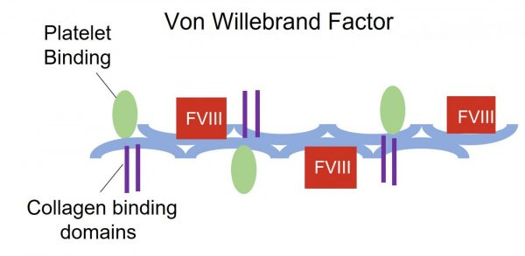

    - Fibrinogen molecule
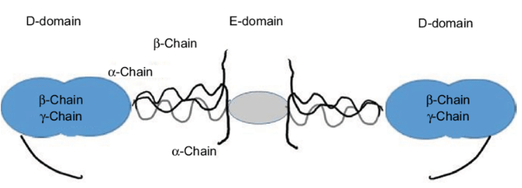

      - Aminoterminal ends of half molecules are connected by disulfide linkages
      - Thrombin cleaves part of each of the alpha and beta chains: parts cleaved off called fibrinopeptides A and B
      - After removal of FP A & B, remaining subunits of molecule can form a fibrin strand (by spontaneous polymerization), called fibrin monomer [weak hydrogen bonding; with further H – bonding, becomes a polymer which is soluble in 5 M urea]
      - XIIIa + calcium allows strands to line up side to side as well as end to end to form a stable fibrin clot [H bonds to crosslinked disulfide bonds = parallel or covalent bonds
      - More fibrinogen than any other clotting factor

Normal Fibrin formation

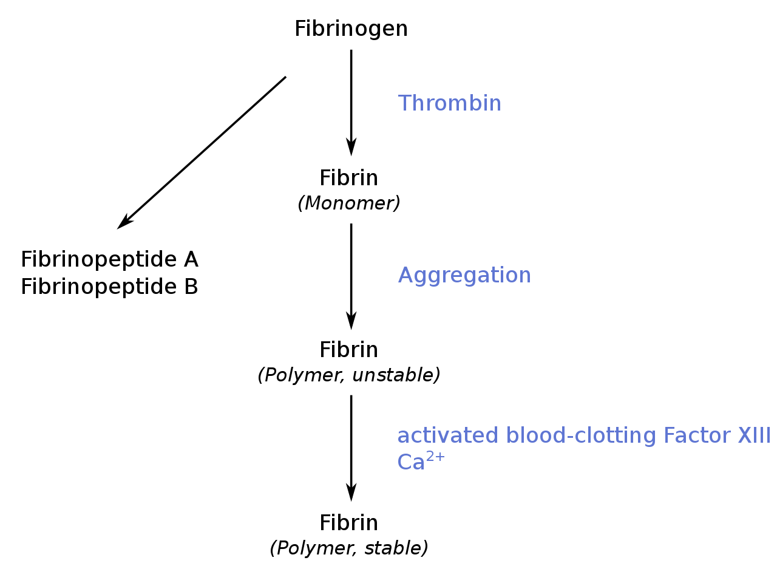
- Fibrinolysis (define): ____________________________________________________________________________________________________________________________________________

  - General information:
    - Most important enzyme in fibrinolysis is _________________.
    - Precursor for plasmin is ___________________.
      - Where is it produced in the body? _________________________
      - Where does it circulate? ___________________________.
  - Plasmin
    - What’s its role?
    - When ________________ gets into circulation, it activates plasminogen to plasmin, which will break down free fibrinogen.
      - Would this be a good or bad thing? And why?

    - What is Tissue Plasminogen Activator?

      - When is it released?

      - Is it in circulation?

      - How does it differ from urokinase?

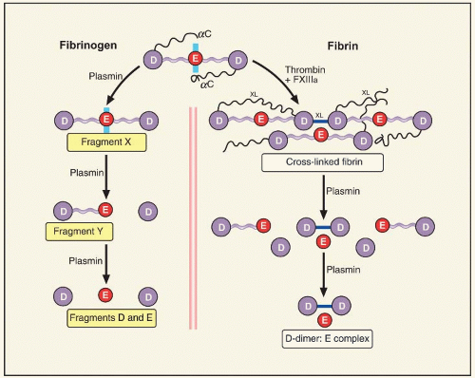

- When breaking down fibrinogen (D-E-D) (will split D domains). It leaves whats called X monomer (where clotting can still occur).
- Plasmin splits D fragment to leave Y fragment.
- Plasmin will split D fragment off Y fragment, leaving just E.

  - Other Considerations – Contact Factors other than XI
    - Contact factors and activation of FXII important in the interaction of 3 systems: fibrinolytic, complement, and kinin systems (see last page).
    - Contact factor activation
      - In vitro, XII activated by contact with negatively charges surfaces (e.g. glass, kaolin, ellagic acid).
      - In vivo activation of XII caused by contact with contents of cell membranes or negatively charges subendothelial structures, such as collagen. Foreign materials such as stents or valve prostheses may activate contact factors to cause thrombosis.
      - In the process of activation, XII undergoes a conformational change which exposes its active site. XIIa transforms PK (which circulates bound high molecular weight kininogen (HMWK)) into kallekrein subsequently activates F XI. This reaction feeds back to further accelerate/amplify the conversion of XIIXIIa.
    - In the fibrinolytic system, XIIa, Xia, and kallekrein stimulate the conversion of plasminogen (PMG) to plasmin.
    - In the kinin system:
      - Once kallekrein is formed, it will convert HMWK to bradykinin.
      - Bradykinin has actions related to pain and inflammation.
      - Kinin system important to chemotaxis (movement toward a stimulus, especially that displayed by phagocytic cells toward a bacteria and sites of cell injury), vascular permeability, and inflammation.
    - Complement system
      - Finally, through plasmin, kallekrein also activates certain components of the complement system (C3 and C5)
      - Composed of 22 serum proteins that, working together with antibodies and clotting factors, play an important role as mediators (something or someone that acts as a link between two parties or systems) or both immune and allergic reaction.

Lecture 4 – Fibrin Formation and Fibrinolysis
Other Considerations

Although Factor XII does not participate in the actual CLOTTING process, it acts as a common link between several aspects of the hemostatic mechanism, including the fibrinolytic system, the kinin system, and the complement system.

In the fibrinolytic system, XIIa XIa, and kallekrein help to stimulate the conversion of plasminogen to plasmin.

In the kinin system - when F XII is activated in vivo, it will activate prekallekrein → kallekrein. Kallekrein will then convert HMWK to bradykinin, which has actions related to pain and inflammation.

Kallekrein also activates certain components/proteins of the complement system. These play a role/link in both immune and allergic reactions.

VI. Vessel Repair:

After a vessel is damaged, it needs to be repaired. Fibroblasts will synthesize the disrupted connective tissue and collagen (beneath the endothelium). The endothelial cells will proliferate to replace the ones lost when the vessel was damaged. Platelets produce PDGF (platelet-derived growth factor) which helps in this repair process (but also plays a role in atherosclerosis – which we will discuss later).

