Lecture 5 Outline

Naturally Occurring Inhibitors/Anticoagulants/Regulators

- Introduction

  - General

- 3 physiological mechanisms to protect against this
- BLOOD IS ALWAYS FLOWING
  - since flows rapidly, chance of fibrin formation minimized because procoagulant material removed before it can be activated
  - flow rate important, because can have thrombus develop in situations where there is venous stasis
- ONCE ACTIVATED, COMPONENTS ARE RAPIDLY REMOVED VIA LIVER (activated enzymes) AND RES (particulate matter)
- BODY HAS NATURALLY OCCURRING INHIBITORS
  - platelet plug formation
  - coagulation (fibrin formation)
  - fibrinolysis

- Anticoagulants/Inhibitors

  - Vascular Endothelium

    - Normally,

    - Endothelial cells are

    - Endothelial cells form

    - Endothelial cells synthesize

      - prostacyclin

    - platelet plug formation
        - initial wave of aggregation (in vivo) caused by release of ADP from injury and adjacent platelets
        - binding of ADP to platelet membrane causes release of fatty acids such as arachidonic acid
        - arachidonic acid, via cyclooxygenase, forms prostaglandin endoperoxides. Then, via thromboxane synthetase (in platelets), forms TXA2, a potent aggregator
    - inhibitor mechanism
        - when no injury to vessel, different reactions occur in endothelium. Arachidonic acid (which is contained in the endothelium and not being released) forms prostaglandin endoperoxides
        - however, enzyme prostacyclin synthetase converts prostaglandin endoperoxides to prostacyclin (PGI2)
- potent inhibitor of aggregation and is a vasodilator
        - therefore, as long as endothelium is intact and PGI2 is made and secreted, amount of platelet aggregation will be limited
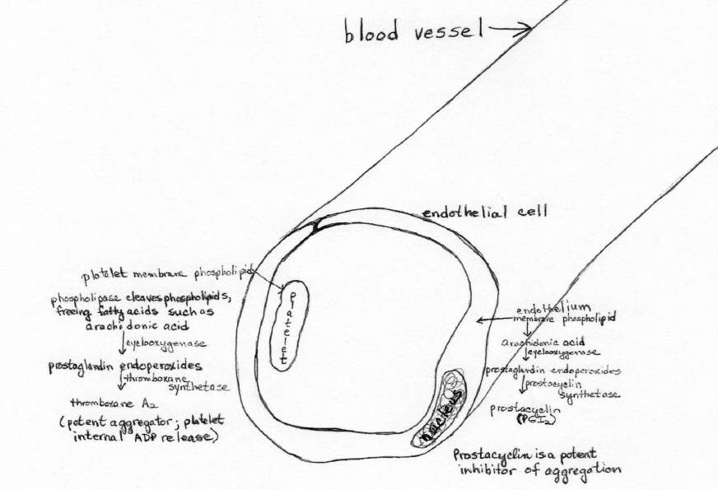

  - nitric oxide –

  - TFPI –

  - thrombomodulin –

  - heparan sulfate –

  - Inhibitors of Coagulation

- General Information

- TFPI

- AT III

- Heparin Cofactor II

- Protein C and Protein S

  - Inhibitors of Fibrinolysis

    - alpha-2 antiplasmin

    - PAI-1

    - TAFI (Thrombin Activatable Fibrinolysis Inhibitor)

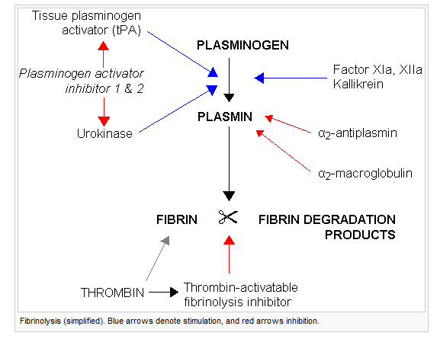

- Deficiencies of Naturally Occurring Inhibitors

  - PGI₂ -

  - Clotting inhibitors

  - Fibrinolytic System Inhibitors

